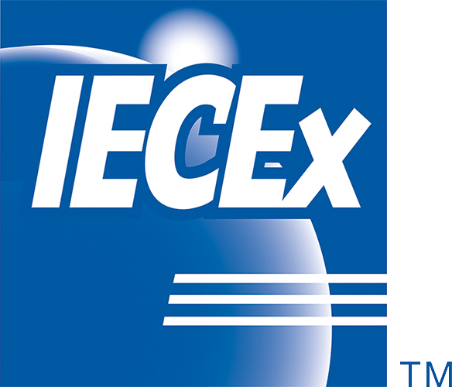

ExMC/1974/R

July 2023

**INTERNATIONAL ELECTROTECHNICAL COMMISSION IEC SYSTEM FOR CERTIFICATION TO STANDARDS RELATING TO EQUIPMENT FOR USE IN EXPLOSIVE ATMOSPHERES (IECEx SYSTEM)**

### **Title: Report from IECEx WG 2 – Technical Capability Documents**

**To: Members of the IECEx Management Committee, ExMC**

**INTRODUCTION**

This document contains a report from the IECEx Working Group, ExMC WG2 – Technical Capability Documents, following their remote meeting held October 20, 2022.

These documents will be presented during the September 2023 Edinburgh ExMC meeting by the Convener Ms Katy Holdredge, where the meeting will be asked to support an update to Recommendation 3 from Decision 2018/67.

|  |  |
| --- | --- |
| **Visiting address:**  **IECEx Secretariat**  **Level 33 Australia Square 264 George Street Sydney NSW 2000 Australia** | **Contact Details:**  **Tel: +61 2 4628 4690**  **Fax: +61 2 4627 5285**  **E-mail: info@iecex.com**  [**http://www.iecex.com**](http://www.iecex.com/) |

IEC SYSTEM FOR CERTIFICATION TO STANDARDS

RELATING TO EQUIPMENT FOR USE IN EXPLOSIVE

ATMOSPHERES (IECEx SYSTEM)



**2022 Meeting of ExMC WG02,**

**‘Technical Capability Documents’**

**Thursday 20th October 2022, 12:00 PM – 3:00 PM UTC**

**Report and Agenda**

1. Opening by Convenor, Ms Katy Holdredge

The Convener opened the meeting at 12:00 PM welcoming members as well as invited guest, Richard Schuller from DEKRA Certification B.V.

1. Approval of the agenda

The meeting approved the agenda as presented.

1. Review of Membership – See Membership of ExMC WG2.xlsx.

No new members since last meeting.

1. Review Terms of Reference (Description) - <https://www.iecex.com/members-area/working-groups/?WorkingGroup=7&action_doWorkingGroupSearch=Search>

Working Group 2 performs the role of a maintenance team revising TCDs as new standards and new editions of the standards are issued.

The meeting reviewed the terms of reference and agreed no revisions were needed.

1. Review of item from last meeting of ExMC WG02 in 2021

Update on status of IECEE work on the verification of temperature / humidity (test) chambers

* + - March 2020 - Publication of [ExTAG DS 2020/002](https://www.iecex.com/publications/extag-decision-sheets/downloaddocument/3221)
    - August 2020 IECEE CTL meeting - It was decided to convert the proposed draft document OD 5015 to a guidance document for a couple of years
    - February 2021 - [IECEE OD-G-5015](https://www.iecee.org/documents/refdocs/downloads/od-g5015ed.1.0.pdf) published. The document is supposed to be converted to an OD in 2023. There are some adjustments that need to be made with regard to the reference documents to limit the requirements to certain paragraphs within those documents.
    - October 2022 - Convenor for IECEE CTL Working Group 1 is now Heribert Schorn ([Heribert.Schorn@I2PS.DE](mailto:Heribert.Schorn@I2PS.DE)). Determine if OD will be published shortly. If not, update [ExTAG DS 2020/003](https://www.iecex.com/publications/extag-decision-sheets/downloaddocument/3221) to refer to IECEE OD-G-5015.

IECEE PDSH 2141 has been cancelled and replaced with IECEE OD-G-5015, which has a review date of 2024-06-01. A draft update, ExTAG DS 2020/003A, to revise the reference will be submitted by ExMC WG2 convenor to ExTAG for consideration prior to the 2023 ExTAG meetings in Edinburgh.

1. Actions for ExMC WG02

Maintenance for new editions of standards as well as new standards:

* + IEC 60079-5, Ed. 4.1;
  + IEC 60079-11, 31G/352/FDIS available, forecast publication date of 2023-02;
  + IEC 60079-31, Ed. 3.0;
  + Annex A of OD 290, [ExMC/1842B/DV](https://www.iecex.com/members-area/documents/exmc/downloaddocument/4121) available, voting closes on 2022-10-28 – prepare draft for next ExMC WG19 meeting?

Draft Ed. 9.0 of the TCD [ExMC/1966/DV](https://www.iecex.com/members-area/documents/exmc/downloaddocument/4237) was circulated for voting with a due date of 2023-08-07.

Under Decision 2018/67 *(ExMC/1436/DL)* the Meeting accepted ExMC WG2 Recommendation #3 on the basis that the Secretariat circulates revised TCDs to ExMC for information.

Recommendation 3: That ExMC allow updates for all new editions of existing standards to be processed by the convenor of ExMC WG02 with approval from the working group members, as needed, and without the approval of ExMC to more easily keep the TCD up-to-date. Updates for new standards will still be approved by ExMC.

Due to the expansion of the TCD to include IECEx OD 290, ExMCWG2 proposes the following update to the original recommendation shown in red.

Recommendation 3: That ExMC allow updates for all new editions of existing standards and ODs to be processed by the convenor of ExMC WG02 with approval from the working group members, as needed, and without the approval of ExMC to more easily keep the TCD up-to-date. The Secretariat will circulate TCDs revised for new editions to ExMC for information. Updates for new standards will still be approved by ExMC.

1. Other Business

Proposal from DEKRA for possible tests to remove asterisks – See IECEx-TCD-02-Scheme-Ed-8.2 draft DEKRA proposal.docx.

The meeting discussed the DEKRA proposal and did not agree to the removal of asterisks as originally proposed. However, the working group proposed to resolve the issue by clarifying Clause 2.3 of the TCD to add reference to ATF(s). The text is in the draft Ed. 9.0 circulated for voting.

1. Next meeting of ExMC WG02

At this point in time the members did not see a need for a meeting unless matters arise in the meantime.

1. Close of meeting

The Convener closed the meeting at 3:00 PM thanking members for their time and input.