INTERNATIONAL ELECTROTECHNICAL COMMISSION (IEC) SYSTEM
FOR CERTIFICATION TO STANDARDS RELATING TO EQUIPMENT FOR USE
IN EXPLOSIVE ATMOSPHERES (IECEx SYSTEM)

Title: Report from Tim Krause, Convenor ExTAG WG 10, Proficiency Testing
Circulated to: Ex Testing and Assessment Group (ExTAG)

INTRODUCTION

This document, ExTAG/708/R is a report prepared by Tim Krause the Convenor of ExTAG WG10, Proficiency Testing. The report will be presented by Mr. Tim Krause during the ExTAG 2023 IECEx Annual Meetings (Edinburgh, United Kingdom) for discussion and consideration.

IECEx Secretariat

Visiting address:  IECEx Secretariat  Level 33, Australia Square  264 George Street  Sydney NSW 2000  Australia | Contact Details:  Tel: +61 2 4628 4690  Fax: +61 2 4627 5285  E-mail: info@iecex.com  http://www.iecex.com

Report by the convenor of ExTAG WG 10 “Proficiency Testing”, Tim Krause, for the Annual ExTAG Meetings 2023 (Edinburgh, United Kingdom). The content of this report was discussed at the ExTAG WG10 meeting, which was held as a remote meeting on July 3, 2023.

- News about the IECEx/PTB Ex PT Scheme

- The second phases (Phase II) of the programs/test rounds of program cycle 2021/2022 “Flameproof Joints – Test Round 2021” (FJ2021) and “Small Component Temperature – Test Round 2021” (SCT2021) have been completed on schedule and the final reports have been published (in November 2022)

- Start of program cycle 2023/2024 with the roll out of two new programs “Connection and Junction Boxes (CJB2023) & Explosion Pressure (EP2023) - Test Round 2023” in March 2023

- The following programs of the previous program cycles are closed:
- Explosion Pressure - Test Round 2010
- Spark Ignition - Test Round 2010
- Flame Transmission - Test Round 2013
- Temperature Classification - Test Round 2013
- Electrostatic Charge - Test Round 2015
- Intrinsic Safety - Test Round 2015
- Pressurized Enclosure - Test Round 2017
- Explosion Pressure - Test Round 2017
- Tests of Enclosures - Test Round 2019
- Battery Testing - Test Round 2019

The programs that are currently available are:

- Flameproof Joints - Test Round 2021
- Small Component Temperature - Test Round 2021
- Connection and Junction Boxes - Test Round 2023
- Explosion Pressure - Test Round 2023

- Niels Springer has left the PT Team at the end of the 2021/2022 cycle (is still available as an expert for the program FJ2021)

- Lisa Ostermann returned to the team after her parental leave (since August 2023)

- The IECEx peer assessment that demonstrates technical competence, facilities and management systems comply with ISO/IEC 17043 of PTB as the IECEx PTS Provider is scheduled for November 2023
- Review and results of the IECEx/PTB Ex PT Program “FJ2021” of cycle 2021/2022

- Normative background: For the program “Flameproof Joints (“FJ2021”) - Test Round 2021” the general routine procedure is described by the standard “Explosive atmospheres - Part 1: Equipment protection by flameproof enclosures “d”” - IEC 60079-1, Edition 7
- Participation: 86 Ex laboratories (77 out of 90 IECEx test laboratories; 13 IECEx test laboratories have not registered). 75 out of 77 registered IECEx laboratories have uploaded results and are included in the final report or in an individual report. The non-registration has been agreed with the IECEx secretariat (not part of the scope of the IECEx laboratory, or is currently being followed up)
- Results of the IECEx laboratories: According to OD202 all action signals reported shall be investigated by the IECEx test laboratory as part of their planning of corrective and preventive actions. In Phase I, there were 11 participants with a warning signal and 12 participants with an action signal. In Phase II there were 6 participants with a warning signal and 4 participants with an action signal. 2 participants have already been able to remove their action signal. The remaining 2 participants are currently revising their results to remove the action signals.

- Review and results of the IECEx/PTB Ex PT Program “SCT2021” of cycle 2021/2022

- Normative background: For the program “Small Component Temperature (“SCT2021”) - Test Round 2021” the general routine procedure is described by the standard “Explosive atmospheres - Part 0: Equipment - General requirements” - IEC 60079-0, Edition 7
- Participation: 83 Ex laboratories (77 out of 90 IECEx test laboratories; 13 IECEx test laboratories have not registered). 68 out of 77 registered IECEx laboratories have uploaded results and are included in the final report or in an individual report. The non-registration has been agreed with the IECEx secretariat (not part of the scope of the IECEx laboratory, or is currently being followed up)
- Results of the IECEx laboratories: According to OD202 all action signals reported shall be investigated by the IECEx test laboratory as part of their planning of corrective and preventive actions. In Phase I, there were no participants with a warning signal and 13 participants with an action signal. In Phase II there were 2 participants with a warning signal and no participants with an action signal.

- Results of the evaluation of the participant survey for the program cycle 2021/2022

- To continuously improve the IECEx/PTB Ex PT Programs, PTB as IECEx PTS Provider was interested in the opinion of the participants after completion of a program cycle. For this purpose, the participants were asked to complete a questionnaire concerning program cycle 2021/2022
- The feedback from 31 participants for program “Flameproof Joints – Test Round 2021” and from 30 participants for program “Small Component Temperature – Test Round 2021” was helpful for a critical analysis and significantly important for the improvement of the design, description, and analysis of future programs. However, it should be noted that the number of responses from participants in the survey was rather low. Nevertheless, it is assumed that participants who were completely or partially unsatisfied with the programs or wanted to express criticism did so
- The detailed analysis of the evaluation can be found in the following file:

- Status of the current programs 2023/2024

- Description of program “Explosion Pressure (EP2023)”: The determination of the explosion pressure as a reference pressure for the overpressure test in order to prove that an enclosure can withstand pressure is one of the essential tests of this type of protection (clause 15.2). Here, it is the task of the test laboratory to find the combination of the location of the ignition source and the pressure measuring devices that produces the highest pressure. Therefore, in the program "Explosion Pressure - Test Round 2023", the ability to find this combination is analyzed and the explosion pressure (reference pressure) is selected as the quantity to be compared

- Normative background: For the program “Explosion Pressure (“EP2023”) - Test Round 2023” the general routine procedure is described by the standard “Explosive atmospheres - Part 1: Equipment protection by flameproof enclosures “d”” - IEC 60079-1, Edition 7.0

- Participation: 89 Ex laboratories (78 out of 90 IECEx test laboratories)

- Description of program “Connection and Junction Boxes (CJB2023)”: A general-purpose connection and junction boxes shall be allocated a rating determined by the method in clause 6.8 to ensure that the limiting temperature not exceeded in service. To simplify the program, a junction box is fitted with the number of 'worst case' terminals that are wired using conductors of the maximum size specified in the datasheet. The maximum current of the junction box should be determined for the temperature class T6 according to IEC 60079-7, clause 6.8 and Annex E. Therefore, the maximum current has been selected as the characteristic of interest which is to be compared in the program “Connection and Junction Boxes (CJB2023)- Test Round 2023”

- Normative background: For the program “Connection and Junction Boxes (CJB2023) - Test Round 2023” the general routine procedure is described by the standard “Explosive atmospheres – Part 7: Equipment protection by increased safety “e”” - IEC 60079-7 Edition 5.1

- Participation: 89 Ex laboratories (78 out of 90 IECEx test laboratories)

- Timetable of the program cycle 2023/2024 using the example for program EP2023 (identical for CJB2023):

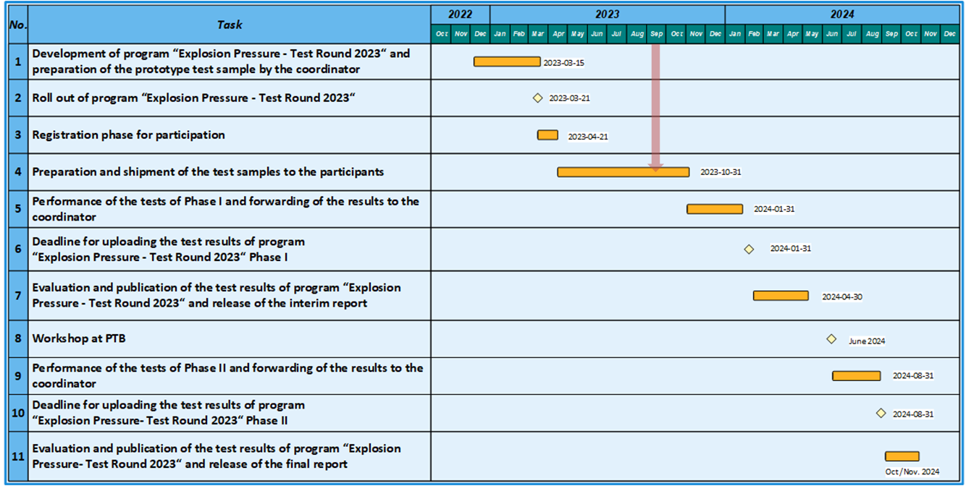

- PTB Ex PT Workshops 2024

- After the last two PTB Ex PT Workshops (2020 & 2022) in online format, an on-site workshop at PTB (in Braunschweig, Germany) is planned again for 2024
- Programs “EP2023” & “CJB2023”; Theory & Practice; Three days
- Date: Week starting 17 June 2024

- Adjustment of the participation fees for future IECEx/PTB Ex PT Programs

- PTB as the IECEx PTS Provider covers part of the personnel costs of the core PTS Team with the participation fees. All other costs such as further personnel costs, material and preparation costs for the test samples as well as shipping costs are borne by PTB
- Since the program cycle 2015/2016, the participation fees have been at the same level
- In the last years and especially during this period, there were significant increases in costs in the areas of personnel, materials, energy, shipping, etc. In order to be able to continue to finance the IECEx/PTB Ex PTS in a way that does not fully cover the costs, but is reasonably sufficient, the participant fees must be increased accordingly. For this reason, there will be an increase in participant fees for the program cycle 2025/2026

