**INTERNATIONAL ELECTROTECHNICAL COMMISSION SYSTEM FOR CERTIFICATION TO STANDARDS RELATING TO EQUIPMENT FOR USE IN EXPLOSIVE ATMOSPHERES (IECEx SYSTEM)**

**TITLE: Re-assessment Report for the continued acceptance of** **Korea Gas Safety Corporation, KGS, an Accepted ExCB and an Accepted ExTL within the IECEx Equipment Scheme 02 and the IECEx Certified Service Facility Scheme, 03.**

**Circulation to: Members of the IECEx Management Committee, ExMC**

**INTRODUCTION**

In accordance with the 5 Year re-assessment plan for the surveillance and monitoring of bodies within the IECEx System, the following document contains the IECEx Reassessment Report for the continued acceptance of Korea Gas Safety Corporation, KGS, an Accepted ExCB and an Accepted ExTL within the IECEx Equipment Scheme 02 and the IECEx Certified Service Facility Scheme, 03.

This report is hereby submitted for endorsement during the 2024 ExMC Meeting.

***Chris Agius***

**IECEx Secretariat**

|  |  |
| --- | --- |
| **Address:**  **IECEx Secretariat**  **Level 17 Angel Place**  **123 Pitt Street**  **Sydney, NSW 2000**  **Australia** | **Contact Details:**  **Tel: +61 2 4628 4690**  **Fax: +61 2 4627 5285**  **e-mail: info@iecex.com**  **http://www.iecex.com** |

IEC System for certification to standards relating to equipment for use in Explosive Atmospheres (IECEx System)

IECEx Assessment Report Form, F-003

IECEx assessment report form for use by IECEx assessment teams to report assessments conducted according to the relevant IECEx assessment procedures of:

Operational Document IECEx OD 003-2 for the Certified Equipment Scheme

Operational Document IECEx OD 316-* for the Certified Service Facility Scheme

Operational Document IECEx OD 422 for the IECEx Conformity Mark Licensing Scheme

Operational Document IECEx OD 501 for the Personnel Competence Scheme

IECEx ExCB/ExTL assessment report for

Korea Gas Safety Corporation, KGS

November 2022

INTERNATIONAL  
ELECTROTECHNICAL  
COMMISSION

CONTENTS

1 Assessment information 6

1.1 Type of body covered by this assessment: 6

1.2 Type of assessment: 6

1.3 Details of body 6

1.3.1 Country 6

1.3.2 Name of body 6

1.3.3 Name and title of nominated principal contact 6

1.4 Assessment information 6

1.4.1 Members of the assessment team 6

1.4.2 Place(s) of assessment 6

1.4.3 Assessment date(s) 7

1.5 Application information and background information on the assessment 7

1.6 Scopes 7

1.6.1 ExCB scope for equipment certification scheme 7

1.6.2 ExTL scope 7

1.6.3 ATF Scope 7

1.6.4 ExCB scope for Service Facilities Scheme 7

1.7 ExCB scope for Conformity Mark Licensing Scheme 7

1.8 ExCB scope for IECEx Personnel Competence Scheme 7

2 Common information 8

2.1 Legal entity of body 8

2.2 Financial support 8

2.3 History 8

2.4 Documentation 8

2.4.1 Quality manual 8

2.4.2 Procedures 8

2.4.3 Work instructions 8

2.4.4 Records (including test records where relevant) 8

2.4.5 Document change control 9

2.5 Confidentiality 9

2.6 Communication with public and customers (Hard copy and Electronic) 9

2.7 Recognitions and agreements 9

2.8 Internal audit 9

2.9 Management review 9

2.10 Contracting, subcontracting and witness testing 9

2.10.1 Contracting 9

2.10.2 Subcontracting 10

2.10.3 Off-site and Witness testing 10

2.11 Training and competence 10

2.12 Complaints and appeals (including appeals to IECEx) 10

2.13 Impartiality 10

2.14 Active involvement in development of Decision Sheets 11

2.15 Special facts to be noted 11

2.16 Supporting documentation 11

2.17 Recommendations 11

3 ExCB for IECEx Certified Equipment Scheme 12

3.1 Assessment references 12

3.1.1 General references 12

3.1.2 Additional references applied for this assessment 12

3.2 Candidate ExCB persons interviewed 12

3.3 Associated ExTL(s) 12

3.4 Associated certification functions 12

3.5 National marks and certificates 13

There is a national mark and certificate for 13

3.6 Standards accepted 13

3.7 National differences to IEC standards 13

3.8 Organisation 13

3.8.1 Names, titles and experience of the senior executives 13

3.8.2 Name, title and experience of the quality management representative 13

3.8.3 Name and title of signatories for certification 13

3.8.4 Other employees in ExCB activity 13

3.9 Organizational structure 13

3.10 Indemnity insurance 14

3.11 Resources 14

3.12 Committees (such as governing or advisory boards) 14

3.13 Certification operations 14

3.13.1 National approval/certification methods 14

3.13.2 Certification policy 14

3.13.3 Application for certification 14

3.13.4 Certification decision 15

3.13.5 Suspension and cancellation of certificates 15

3.14 Certificates issued 15

3.15 National accreditation 15

3.16 Assessment of manufacturers and issue of QARs 16

3.17 Comments (including issues found during assessment) 16

4 ExTL for IECEx Certified Equipment Scheme 17

4.1 Assessment references 17

4.1.1 General references 17

4.1.2 Additional references applied for this assessment 17

4.2 Candidate ExTL persons interviewed 17

4.3 Associated ExCB(s) 17

4.4 Organisation 18

4.4.1 Names, titles and experience of the senior executives 18

4.4.2 Name, title and experience of the quality management representative 18

4.4.3 Other employees in ExTL activity 18

4.5 Organizational structure 18

4.6 Resources 18

4.7 Test reports issued 18

4.8 National accreditation 18

4.9 Calibration 18

4.10 Tests witnessed during the assessment visit 19

4.11 Participation in IECEx Proficiency Testing Programs 19

4.12 Comments (including issues found during assessment) 20

5 ATF for IECEx Certified Equipment Scheme 21

6 ExCB for Certified Service Facilities Scheme 22

6.1 Assessment references 22

6.1.1 General references 22

6.1.2 Additional references applied for this assessment 22

6.2 ~~Candidate~~ ExCB persons interviewed 22

6.3 National marks and certificates 23

6.4 Standards accepted 23

6.5 National differences to IEC standards 23

6.6 Organisation 23

6.6.1 Names, titles and experience of the senior executives 23

6.6.2 Name, title and experience of the quality management representative 23

6.6.3 Name and title of signatories for certification 23

6.6.4 Other employees in ExCB activity 23

6.7 Organizational Structure 23

6.8 Indemnity insurance 24

6.9 Resources 24

6.10 Committees (such as governing or advisory boards) 24

6.11 Certification operations 24

6.11.1 National approval/certification Methods 24

6.11.2 Certification policy 24

6.11.3 Application for certification 24

6.11.4 Certification decision 24

6.11.5 Suspension and cancellation of certificates 24

6.12 Statistics 25

6.13 National accreditation 25

6.14 Assessment of service facilities and issue of FARs 25

6.15 Comments (including issues found during assessment) 25

7 IECEx Conformity Mark Licensing Scheme 26

8 ExCB for IECEx Personnel Competence Scheme 27

9 Annexes 28

Annex A Scope for IECEx Certified Equipment Scheme 29

A.1 Current standards 29

A.2 Superseded standards 29

Annex B Overall Organisation Chart 30

Annex C Organisation Chart of ExCB/ExTL 31

Annex D Accreditation Certificate for ISO/IEC 17065 32

Annex E Accreditation Certificate for ISO/IEC 17025 38

Annex F Accreditation Certificate for ISO/IEC 17024 45

# Assessment information

## Type of body covered by this assessment:

|  |  |
| --- | --- |
| ExCB for IECEx Certified Equipment Scheme |  |
| ExTL for IECEx Certified Equipment Scheme |  |
| ATF for IECEx Certified Equipment Scheme |  |
| ExCB for IECEx Certified Service Facilities Scheme |  |
| ExCB for IECEx Conformity Mark Licensing System |  |
| ExCB for IECEx Certification of Personnel Competency Scheme |  |

NOTE 1 ExCB - IECEx Certification Body

NOTE 2 ExTL - IECEx Testing Laboratory

NOTE 3 ATF - Additional Testing Facility

## Type of assessment:

|  |  |
| --- | --- |
| Pre-assessment for candidate body |  |
| Initial assessment for candidate body |  |
| Surveillance |  |
| Re-assessment |  |
| Scope extension. |  |

## Details of body

### Country

Republic of Korea

### Name of body

Korea Gas Safety Corporation (KGS)

### Name and title of nominated principal contact

|  |  |  |
| --- | --- | --- |
| Name | Title | E-mail address |
| Weondon, Joo | General Manager | jwd@kgs.or.kr |

## Assessment information

### Members of the assessment team

|  |  |
| --- | --- |
| Name | Role |
| Ajay MAIRA | IECEx Lead Assessor |
| Jeong-il, KANG | IECEx Assessor |

### Place(s) of assessment

|  |  |
| --- | --- |
| KGS (Korea Gas Safety Corporation) | 1390, Wonjung-ro, Maengdong-myeon, Eumseong-gun, Chungcheongbuk-do, 27738, Republic of Korea |

### Assessment date(s)

21 to 24 Nov, 2022, followed by discussions and review of further documents till Nov 2023.

## Application information and background information on the assessment

This re-assessment has been conducted as per the IECEx rules for IECEx Certification Bodies and Test Laboratories to be re-assessed in a 5 yearly cycle. There is no scope extension request.

While the assessment was planned to be carried out in person by the Lead Assessor and the Technical Assessor, but due to an outbreak of Covid XBB variant influenza and subsequent Australian Government warnings, IECEx OD-060 was employed and the assessment was carried out by the Lead Assessor conducting the audit by web-meeting tools while utilizing the Technical Assessor in person.

## Scopes

### ExCB scope for equipment certification scheme

The scope for the ExCB is shown in Annex A.

There were no changes in the scope during this reassessment.

### ExTL scope

The ExTL scope is the same as for the ExCB.

### ATF Scope

Not applicable.

### ExCB scope for Service Facilities Scheme

Equipment repair, including equipment repair standard and associated protection techniques.

|  |  |  |
| --- | --- | --- |
| IEC 60079-19  Edition 4.0 | Explosive atmospheres – Part 19: Equipment repair, overhaul and reclamation | Comments |
| **With the following types of protection** | **ID** |  |
| Flameproof Enclosure "d" | d | Current |
| Increased Safety "e" | e | Current |
| Type of Protection "n" | n | Current |
| Pressurisation "p" | p | Current |
| Dusts to IEC 60079-31 "t~~"~~ | ~~t~~ | Current |

## ExCB scope for Conformity Mark Licensing Scheme

Not applicable

## ExCB scope for IECEx Personnel Competence Scheme

Not applicable

# Common information

## Legal entity of body

KGS is a public body established under Article 28 of the High Pressure Gas Safety Control Law. There is a certificate of registration 133-82-02018 with the Taxation Department for KGS.

## Financial support

KGS receives about 40% financial support from the Government. The rest is met from inspection, training, R&D, testing and certification income.

## History

Initially established in 1974 with the name KGS being used since 1979.

In 1995, the Institute of Gas Safety Technology was established as an annex research centre.

In 1998, it became an affiliate of the Ministry of Commerce, Industry and Energy, and was designated as a certification body for electrical explosion-proof performance.

In 2003, KGS was accepted in the IECEx Certified Equipment Scheme as an ExCB and an ExTL

In 2012, KGS was accepted in the IECEx Service Facility Scheme as an ExCB

In 2018, KGS was accepted in the IEC 60079-46 “Equipment Assemblies” and IEC 60079-28 as an ExCB and an ExTL

In 2020, KGS was accepted in the Scope extension of IECEx Service Facility Scheme as an Ex CB (IEC 60079-31 “t”)

## Documentation

### Quality manual

KGS established a comprehensive quality management system to operate Ex certification and testing in accordance with ISO/IEC 17025 and ISO/IEC 17065 with each section numbered Ex-M-xx. The document number of the Manual, Procedures, Work instruction are identified as Ex-M/P/I-**, followed by a number

Checklists against ISO/IEC 17025 and ISO/IEC 17065 were prepared and found to meet the requirements of each section, . These were found to meet the requirements of the IECEx.

### Procedures

The next level in the system is the procedures which are numbered Ex-P-xx. See clause 2.4.1. These were found to meet the requirements of the IECEx.

### Work instructions

The next level in the system is the instructions which are numbered Ex-I-xx. See clause 2.4.1, These were found to meet the requirements of the IECEx

### Records (including test records where relevant)

KGS has established documented procedure Ex-P-13 to specify the requirement on records.

All records related to Ex testing and certification activities are retained a minimum of 10 years in hard copy. Normally the records are held in digital form for the full duration of the certificate as a minimum. This meets the requirements of IECEx OD 207 “Guidance on the Retention of Records”

### Document change control

Document control is covered in Ex-P-04. All procedures and related documents are in printed form and subject to a document change control process. Document control was reviewed during the assessments and found to meet the requirements of the IECEx

## Confidentiality

(For staff, contractors and members of advisory bodies)

Confidentiality is addressed in Ex-P-02. Each staff member is required to sign a confidentiality agreement. The file containing the signed forms was viewed and found to be acceptable in meeting IECEx Requirements.

## Communication with public and customers (Hard copy and Electronic)

Communication with the public and customers is available by website.

In Korean language: <https://www.kgs.or.kr/> and <https://kgs.or.kr/kgs/afde/view.do>

In English language: https://kgs.or.kr/eng/idh/view.do and email at international@kgs.or.kr

These were found to meet the requirements of the IECEx

## Recognitions and agreements

There are mutual recognition agreements in place with a number of bodies including

Baseefa, CSA (Sira) in the UK - current`

LCIE in France - current

NANIO CCVE in Russia - current

NEPSI, CQM(2018) in China - current

Simtars in Australia - current

FTZU in the Czech Republic - current

PTB, Dekra Exam in Germany - current

Dekra in the Netherlands - current

INTERTEK in US - current

CSA in Canada - current

IMQ in Italy - current

SIRIM QAS International in Malaysia - current

TestSafe in Australia - current

## Internal audit

The Internal audit is in Ex-M-14 and Ex-P-14

The internal audit for 15~16 Sept. 2022 was viewed and details were available. It used a lead ISO auditor and a technical expert who is also an internal auditor of KGS (not in the Ex field). The audit indicates it covers ISO/IEC 17025 and 17020. NCRs were found but not in the Ex department.

## Management review

The Management review is in Ex-M-15 and Ex-P-15 and which is carried out once a year. The review carried out on 4 Oct. 2022 was viewed and found to meet the requirements of the IECEx.

## Contracting, subcontracting and witness testing

### Contracting

Contracting is addressed in Ex-P-05 Application and Contract Review These were found to meet the requirements of the IECEx.

### Subcontracting

KGS subcontract with KTL for some specific tests in IEC 60079-0 and IEC 60079-7 in the table below. There is an agreement dated 2020-04-01 which shows the tests covered. These were found to meet the requirements of the IECEx.

The following tests are, or may be, subcontracted by the body:

|  |  |  |
| --- | --- | --- |
| Standard | Clause | Test |
| IEC 60079-0 | 9 | Measurement of screw threads |
| IEC 60079-7 | 6.3.5 | Sulphur dioxide test for the connection of bi-pin lamp caps to lampholders |
| IEC 60079-7 | 6.3.6 | Vibration test for luminaires ith bi-pin lamps |
| IEC 60079-7 | Annex G | Asymmetric pulse test |
| IEC 60079-7 | Annex G | Asymmetric power test |
| IEC 60079-7 | 6.6.3 | Mechanical shock test for Ex e batteries |

More details, including bodies to whom tests will be subcontracted, details of accreditation of those bodies and details of how the subcontracted bodies are checked, are included in the site assessment report.

### Off-site and Witness testing

Witness testing requirements are contained in Ex-P-18 Certification and Test These were found to meet the requirements of the IECEx.

A recent test has been conducted using the application form and agreement as required by OD 024. This has been registered in the IECEx system.

## Training and competence

Training and competence is addressed in Ex-M-17 and Ex-P-16.

Details of staff competencies are included in the site assessment report.

The computer system is used to record all external training, duty statements and qualifications.

A plan is developed for internal and external training each year and recorded in a file. The file shows the information about who attended the training and the information about what was covered.

Instruction Ex-I-04 Operating audit addresses the assigning of competency to staff members. Instruction Ex-I-06 Certification of Employee addresses the assigning of competency to staff members.

Ex-P-23 Assuring the Quality also covers how a plan is made for employees.

These were found to meet the requirements of the IECEx.

## Complaints and appeals (including appeals to IECEx)

Procedure Ex-P-09 addresses appeals, complaints and disputes. It includes specific reference to the potential use of the IECEx Board of Appeal by the ExCB or the applicant. The process is managed by the Quality Manager. There have not been any Ex related complaints.

## Impartiality

Ex-P-02 addresses impartiality requirements. These were found to meet the requirements of the IECEx.

Ex-P-18 Certification and Test. Prior to issuance of the IECEx certificate, when the certificate is in draft status, the certification committee is held to present and review opinions on the certification.

These were found satisfactory for IECEx requirements.

## Active involvement in development of Decision Sheets

KGS reviews the development of IECEx Decision Sheets. Mr Shin, KGS, manages the circulation and involvement. While presently no comments have been sent back, it has been recommended that KGS sends back an ‘Accept’ reply to IECEx or a comment if they do not agree. These were found to meet the requirements of the IECEx.

## Special facts to be noted

There are no special facts to be noted other than those note din the report..

## Supporting documentation

Copies of additional supporting information for this assessment have been provided to the applicant and the IECEx Secretariat. These are included in a site assessment report or provided separately and include:

* Details of issues raised and how these have been resolved
* Checklist for ISO/IEC 17065
* Checklist for ISO/IEC 17025
* Checklist for ISO/IEC 17024
* Completed Technical Capability Document (TCD)
* Photos of the facilities/tests witnessed are included in the above TCD
* Information on competencies
* Information on contracting/subcontracting
* Assessors’ notes
* Other

NOTE Assessors are to amend above list as appropriate

## Recommendations

Based on the assessment performed on 21/11/22~24/11/22, and subsequent discussions and changes in documents, KGS is recommended for (continued) acceptance in the IECEx scheme as:

* An ExCB in the IECEx Certified Equipment Scheme
* An ExTL in the IECEx Certified Equipment Scheme
* An ExCB in the IECEx Certified Service Facilities Scheme

This is according to the scope of the standards listed in this document (including the extension of scope), (subject to resolution of the issues found during the assessment).

|  |  |  |
| --- | --- | --- |
| Ajay Maira | Jeong-il, Kang |  |
| IECEx Lead Assessor | IECEx Assessor |  |

Date: 2023-12-02

# ExCB for IECEx Certified Equipment Scheme

## Assessment references

### General references

1. IECEx 02 IECEx Certified Equipment Scheme covering equipment for use in explosive atmospheres – Rules of Procedure
2. IECEx OD003-2 Assessment, surveillance assessment and re-assessment of ExCBs and ExTLs operating in the IECEx 02, IECEx Certified Equipment Scheme
3. ISO/IEC 80079-34 Explosive atmospheres – Part 34: Application of quality systems for equipment manufacture
4. IECEx OD 009 Issuing of CoCs, ExTRs and QARs
5. IECEx OD 025 Guidelines on the Management of Assessment and Surveillance programs for the assessment of Manufacturer’s Quality Systems in accordance with the IECEx Scheme
6. IECEx OD 026 IECEx Certified Equipment Scheme – Guidelines for the qualification of Lead Auditor and Auditors, in accordance with the IECEx System
7. ISO/IEC 17065 General requirements for bodies operating product certification systems Conformity assessment — Requirements for bodies certifying products, processes and services
8. IECEx OD 107 Harmonised check list for certification bodies ISO/IEC 17065
9. IECEx OD 060 IECEx Guide for Business Continuity – Management of Extraordinary Circumstances or Events Affecting IECEx Certification Schemes and Activities
10. IECEx Technical Capability Document (TCD)
11. ExTAG decision sheets (DSs)

NOTE The latest editions of the above documents were applied, unless otherwise specified

### Additional references applied for this assessment

NOTE To be added by assessment team. For example, ODs for non-electrical or Ex s where applicable

a) OD 280:2016 IECEx Certified Equipment Scheme – Guide to Certification of Non-Electrical Equipment and Protective Systems

## Candidate ExCB persons interviewed

|  |  |
| --- | --- |
| Name | Position |
| Weondon, Joo | General manager |
| Yunghwa, Lee | Quality Manger |
| Jonghyun, Kim | Manager |
| Taeho, Nam | Manager |
| Suyoung, Gwon | Manager |
| Giho, Shin | Manager |
| Haesong, Park | Assistant Manager |

## Associated ExTL(s)

The KGS ExTL is integral with the ExCB

## Associated certification functions

KGS issues certificates for gas appliances; it issues certification to ISO 9001 for all areas; to ISO 14000; and national Ex certification.

## National marks and certificates

## There is a national mark and certificate for



## Standards accepted

See Annex A of this report

## National differences to IEC standards

Where possible, Korea issues KS Standards that are identical to IEC Standards. National differences to IEC standards are those listed in the latest version of the IECEx Scheme Bulletin.

## Organisation

### Names, titles and experience of the senior executives

|  |  |  |
| --- | --- | --- |
| Name | Title | Experience (years) |
| Weondon, Joo | General Manager | 31 years at KGS |

### Name, title and experience of the quality management representative

|  |  |  |
| --- | --- | --- |
| Name | Title | Experience (years) |
| Yunghwa, Lee | Ex Testing and Certification Department and Quality Manager | 29 years at KGS and 6 years in Ex |

### Name and title of signatories for certification

|  |  |  |
| --- | --- | --- |
| Name | Title | Comments |
| Weondon, Joo | General Manager | Quality manager – Ex-M-02 |

### Other employees in ExCB activity

|  |  |  |
| --- | --- | --- |
| Name | Title | Experience in Ex (years) |
| Jonghyun, Kim | Manager | 9 years at KGS and 9 years in Ex |
| Taeho, Nam | Manager | 9 years at KGS and 5 years in Ex |
| Suyoung, Gwon | Manager | 6 years at KGS and 6 years in Ex |
| Giho, Shin | Manager | 5 years at KGS and 4 years in Ex |
| Haesong, Park | Assistant Manager | 4 years at KGS and 4 years in Ex |

## Organizational structure

The total staff of the ‘Hazardous Locations’ group in KGS is now 14 with 7 personnel in the ExCB. The most recent change in structure was in January 2022 when the reporting structure of the group was changed with Weondon, Joo General Manager of the group in addition to his role as head of the ExCB.

The organisational structures are shown in Annex B and Annex C of this report and also appear in Ex-M-02 of the Manual. These were found to meet the requirements of the IECEx.

## Indemnity insurance

KGS indemnity is covered by the government as it is a government agency. In addition it has an indemnity insurance cover for of KRW13,000,000,000. These were found to meet the requirements of the IECEx.

## Resources

Principally there are 5 dedicated persons in the ExCB plus additional technical resources used as KGS Audit Resources plus dedicated admin support. These resources cover both the IECEx 02 and 03 Schemes. 8 are auditors for Ex manufacturing facilities and 8 for Ex servicing facilities. These were found to meet the requirements of the IECEx.

## Committees (such as governing or advisory boards)

There is an internal audit group for auditing of finances and implementation of policies, compliance with regulations etc. The head of this group is appointed by the Government.

KGS also has a board that covers a range of high level functions, including supervision of finances, approval of major capital expenditure, major policy issues and the structure of KGS. It is not directly involved with certification functions.

An impartial third party committee that monitors the certification activities of KGS is available, with the Chair and majority being independent from KGS. The committee meets annually. It consists of manufacturers, users.

These were found to meet the requirements of the IECEx.

## Certification operations

### National approval/certification methods

Procedures Safety Certification Guidelines (2206-6) are used for national approval/certification activities. These were found to meet the requirements of the IECEx.

### Certification policy

The quality policy is defined in the Manual in Ex-M-0B. The policy includes reference to ISO/IEC 17025 and 17065 and specific reference to certification and testing. The policy is signed by the General Manager under delegation from the President. These were found to meet the requirements of the IECEx.

### Application for certification

KGS has an application form for clients to use when applying for IECEx certification Ex-P-05 Application and Contract Review. The procedures for dealing with applications for certification are contained in Ex-P-05 Application and contract review. This document defines the responsibilities of the relevant personnel and the scope.

Feedback is obtained in accordance with procedure Ex-P-08 Service to the Client. This is done by means of a questionnaire.

As seen in organisation charts in Annex B and C, separation between ExCB and ExTL is achieved through the use of different personnel in each area. In addition, as noted earlier, the certification committee also provides an independent role in the certification process.

These were found to meet the requirements of the IECEx,

### Certification decision

There is a Certification Committee with its terms of reference defined in the procedure Ex-P-18 Certification and Test (4.6, 6.5). The General Manager is the Chairman of this committee. It comprises minimum 5 members, including the General Manager from KGS and 4 other people both from within and outside the Ex Testing & Certification Service Department. There are no external people. These were found to meet the requirements of the IECEx.

### Suspension and cancellation of certificates

Ex-I-02 Maintenance of Certification Registration addresses suspension, withdrawal and cancellation of certificates and ExTRs. The decision on cancellation is taken by the Certification Committee. Since 2019, there have been 8 certificate cancellation and an official letter from manufacturer was received and internal approval was received. The IECEx Secretariat was notified of cancellation.

These were found to meet the requirements of the IECEx..

## Certificates issued

Number of certificates issued under for the preceding years for each type of protection in the IECEx scheme.

|  |  |  |  |  |  |
| --- | --- | --- | --- | --- | --- |
| Standard numbers | Type of protection or other identifying information | Number of issued certificates  (past 3 years data) | | | Total |
| 2021 | 2022 | 2023 |
| IEC 60079-1 | Explosive atmospheres – Part 1 :  Equipment protection by flameproof enclosures “d” | 25 | 6 | 14 | 45 |
| IEC 60079-2 | Explosive atmospheres – Part 2 :  Equipment protection by pressurized enclosure “p” | 0 | 0 | 0 | 0 |
| IEC 60079-6 | Explosive atmospheres – Part 6 :  Equipment protection by oil immersion “o” | 0 | 0 | 0 | 0 |
| IEC 60079-7 | Explosive atmospheres – Part 7 :  Equipment protection by increased safety “e” | 15 | 2 | 8 | 25 |
| IEC 60079-11 | Explosive atmospheres – Part 11 :  Equipment protection by intrinsic safety “i” | 1 | 2 | 0 | 3 |
| IEC 60079-15 | Explosive atmospheres – Part 15 :  Equipment protection by type of protection “n” | 3 | 0 | 0 | 3 |
| IEC 60079-18 | Explosive atmospheres – Part 18 :  Equipment protection by encapsulation “m” | 10 | 2 | 4 | 16 |
| IEC 60079-26 | Explosive atmospheres – Part 26 :  Equipment with protection level (EPL) Ga | 0 | 0 | 0 | 0 |
| IEC 60079-31 | Explosive atmospheres – Part 31 :  Equipment dust ignition protection by enclosure “t” | 13 | 2 | 3 | 18 |

NOTE Above include certificates to IEC 60079-0 unless otherwise shown

## National accreditation

The national accreditation certification for ISO/IEC 17065 is shown in Annex D. The Government authorises KGS to issue National Ex certificates. They also have formal accreditation as a certifying body to ISO/IEC 17065 from the Korea Accreditation System KAS

This is valid until April 19, 2025. The scope of accreditation that forms part of the certificate is stated to be relevant for Ex equipment. The scope Category covers sections:

03.052 – Manufacture of other electrical other electrical equipment

Mechanical (non-electrical) equipment is not mentioned. Therefore, on this basis an annual surveillance assessment is to be carried out.

The last assessment was conducted on 25.Oct.22. Witness assessments were not required to be conducted.

These were found to meet the requirements of the IECEx.

## Assessment of manufacturers and issue of QARs

The manufacturing assessments are generally done by ExCB staff, but use may be made by Ex experts from the ExTL. Staff are also under training as an IECEx auditor of manufacturers. The procedure for this is Ex-I-01 and 04.

These were found to meet the requirements of the IECEx.

## Comments (including issues found during assessment)

During the re-assessment, several certificates that have been issued were reviewed and all found satisfactory. Discussion was held regarding an independent mechanism for impartiality (third party committee that provides independent oversight of the KGS Certification activities) and records were obtained to the satisfaction of the assessment team.

# ExTL for IECEx Certified Equipment Scheme

## Assessment references

### General references

1. IECEx02 IECEx Certified Equipment Scheme covering equipment for use in explosive atmospheres – Rules of Procedure
2. IECEx OD003-2 Assessment, surveillance assessment and re-assessment of ExCBs and ExTLs operating in the IECEx 02, IECEx Certified Equipment Scheme
3. IECEx OD009 Issuing of CoCs, ExTRs and QARs
4. ISO/IEC 17025 General requirements for the competence of testing and calibration laboratories
5. IECEx OD 018 Harmonised check list for testing and calibration laboratories ISO/IEC 17025
6. IECEx TCD 60079, ISO 80079 Series and ISO 16852 Technical Capability Document
7. ExTAG decision sheets (DSs)
8. IECEx OD 202 IECEx Certified Equipment Scheme – IECEx Proficiency Testing Program

NOTE The latest editions of the above documents were applied, unless otherwise specified.

### Additional references applied for this assessment

OD 280:2016 IECEx Certified Equipment Scheme – Guide to Certification of Non-Electrical Equipment and Protective Systems

NOTE To be added by assessment team. For example, ODs for non-electrical or Ex s where applicable

## Candidate ExTL persons interviewed

|  |  |
| --- | --- |
| Name | Position |
| Jonggyoon, Jeon | Senior Manger |
| Myonju Choi | Senior Manger |
| Jonghyun, Kim | Manager |
| Taeho, Nam | Manager |
| Suyoung, Gwon | Manager |
| Giho, Shin | Manager |
| Haesong, Park | Assistant Manager |
| Hyunwoo, Park | Assistant Manager |
| Dongkeon, Lee | Assistant Manager |

## Associated ExCB(s)

The KGS ExCB is integral with the ExTL

## Organisation

### Names, titles and experience of the senior executives

|  |  |  |
| --- | --- | --- |
| Name | Title | Experience (years) |
| Weondon, Joo | General Manager | 31 years at KGS |

### Name, title and experience of the quality management representative

|  |  |  |
| --- | --- | --- |
| Name | Title | Experience (years) |
| Yunghwa, Lee | Ex Testing and Certification Department and Quality Manager | 29 years at KGS and 6 years in Ex |

### Other employees in ExTL activity

|  |  |  |
| --- | --- | --- |
| Name | Title/responsibility | Experience in Ex (years) |
| Jonggyoon, Jeon | Technical Manager of ExTL | 26 years at KGS and 8 years in Ex |

## Organizational structure

An adequate organisational structure has been set up for testing and assessment activities, with details inserted in relevant Annexes B, C. These were found to meet the requirements of the IECEx.

## Resources

The ExTL is well resourced with test equipment and details are in the TCD that was prepared during this assessment. These were found to meet the requirements of the IECEx.

## Test reports issued

The ExTL is integral with the ExCB, and hence the table in 3.14 showing the Standard numbers and the number of IECEx certificates issued applies.

## National accreditation

KGS has national accreditation according ISO/IEC 17025 from KOLAS number KT186 (see Annex E). The scope of this accreditation cover the latest editions. See Annex E. The assessment was carried out in 16 Dec. 2021 ~ 17 Dec. 2021 and it was noted that Mechanical (non-electrical) equipment is not mentioned. Therefore, on this basis an annual surveillance assessment is to be carried out.

The national accreditation certification for ISO/IEC 17025 is shown in Annex E.

## Calibration

All equipment used to take measurements is calibrated. Calibration is controlled by procedure Ex-P-20 Equipment control, Ex-P-21 Measurement Traceability. The certification is carried out by external laboratories having National Accreditation. Sample certificates were viewed and found to be in accordance with the requirements. These were found to meet the requirements of the IECEx.

## Tests witnessed during the assessment visit

The following tests were witnessed during the assessment visit:

|  |  |  |  |
| --- | --- | --- | --- |
| Standard and edition | Clause number | Test | Comments |
| IEC 60079-0  edition 7.0 | 26.5.1 | Temperature rise | Test completed. Satisfactory. |
| IEC 60079-0  edition 7.0 | 26.4.5 | IP66 test to IEC 60529 | IP6X test completed. Procedure revised. Satisfactory. |
| IEC 60079-1 edition 7.0 | 15.2.2 | Flameproof pressure determination | Test completed. Satisfactory |
| IEC 60079-1 edition 7.0 | 5.2 | Measurement of flamepaths – cylindrical and flange | Test completed. Satisfactory |
| IEC 60079-1 edition 7.0 | 15.2.3 | Flameproof Overpressure test | Test completed. Satisfactory |
| IEC 60079-0  edition 7.0 | 26.17 | Transferred charge test on non-metallic enclosure | Test completed. Charging cloths were not initially available.  Satisfactory |
| IEC 60079-0  edition 7.0 | 26.12 | Earth continuity test for cable gland | Test completed. Satisfactory |
| IEC 60079-11 edition 6.0 | 10.1.2 | Use of spark test apparatus | Test completed. Contact resistance was initially too high. Now satisfactory. |
| IEC 60079-11 edition 6.0 | 10.5.3 | temperature rise on a battery | Test completed. Satisfactory |
| IEC 60079-0  edition 7.0 | 26.5.3 | Small component ignition test (electronic component) in diethyl ether | Test completed. Satisfactory |
| IEC 60079-18 edition 4.0 | 8.1.2 | Dielectric strength test on compound for Ex m | Test completed. Satisfactory |
| IEC 60079-15 edition 5.0 | 11.3 | Restricted breathing test for Ex n | Test completed. Satisfactory |
| IEC 60079-0  edition 7.0 | 26.13 | Surface Resistance Test | Test completed.  Electrode attachment arrangement was improved. Now satisfactory |

Several discussions were held with the technical staff for other tests during the laboratory inspection

## Participation in IECEx Proficiency Testing Programs

Program: PTB Ex PT Scheme: KGS has participated in this program since 2010.

|  |  |  |
| --- | --- | --- |
| Year(s) of participation | IECEx Proficiency Testing program | General information about results |
| 2010 | Explosion Pressure | Completed - Acceptable |
| 2010 | Spark Ignition | Completed - Acceptable |
| 2013 | Flame Transmission (FT) | Completed - Acceptable |
| 2013 | Temperature Classification | Completed - Acceptable |
| 2015 | Electrostatic Charge (EC) | Not participated. It was not mandatory at that time. |
| 2015 | Intrinsic Safety (IS) | Finished - Acceptable |
| 2017 | Explosion Pressure | Finished - Acceptable |
| 2017 | Pressurized Enclosure (PE) | Finished during this assessment - Acceptable |
| 2019 | Battery Testing (BT) | Finished - Acceptable |
| 2019 | Tests of Enclosures (TE) | Finished - Acceptable |
| 2021 | Flameproof joints (FJ) | Finished - Acceptable |
| 2021 | Small component Temperature (SCT) | Finished - Acceptable |

## Comments (including issues found during assessment)

There were several issues that were cleared to the satisfaction of the assessment team.

These included:

* Procurement of test equipment for flameproof equipment inspection and measurement
* Improvements on test for protection from ingress of water
* Preparation of test jigs for surface resistance measurement
* Improvements of test jigs and measuring instruments for electrostatic charge transfer tests
* Improvements of the contact resistance for spark testing test equipment
* Preparation of test jigs to obtain better tungsten wire for spark test equipment
* Improvements in the jigs used for battery short circuit tests
* Improvements in the techniques used for measuring segregation distances on printed circuit boards
* Corrections made on issued test reports to more accurately describe the range of models covered by the IECEx report and certificate
* Participation in the IECEx proficiency test program for Pressurised Enclosures

# ATF for IECEx Certified Equipment Scheme

Not applicable

# ExCB for Certified Service Facilities Scheme

## Assessment references

### General references

1. IECEx 03-* IECEx Certified Service Facilities Scheme covering repair and overhaul of Ex equipment – Rules of Procedure for the Scheme (IECEx 03-0) and for “sub-Schemes” on particular service activities (IECEx 03-2, 03-3, 03-4 and 03-5)
2. IECEx OD 316-2 IECEx Certified Service Facilities Scheme – Part 2: Selection of Ex equipment and design of Ex installations Assessment procedures for IECEx acceptance of Candidate Certification Bodies (ExCBs) for the purpose of issuing IECEx Certificates to Ex Service Facilities providing selection of Ex equipment and design of Ex installations related services
3. IECEx OD 316-3 IECEx Certified Service Facilities Scheme – Part 3: Ex installation and initial inspection Assessment procedures for IECEx acceptance of Candidate Certification Bodies (ExCBs) for the purpose of issuing IECEx Certificates to Ex Service Facilities providing Ex installation and initial inspection service IECEx
4. IECEx OD 316-4 IECEx Certified Service Facilities Scheme – Part 4: Ex inspection and maintenance Assessment procedures for IECEx acceptance of Candidate Certification Bodies (ExCBs) for the purpose of issuing IECEx Certificates to Ex Service Facilities providing Ex installations related services
5. IECEx OD 316-5 IECEx Certified Service Facilities Scheme – Part 5: Repair, overhaul and reclamation of Ex equipment. Assessment procedures for IECEx acceptance of Candidate Certification Bodies (ExCBs) for the purpose of issuing IECEx Certificates to Ex Service Facilities involved in the repair, overhaul and reclamation of Ex equipment
6. ISO/IEC 17065 General requirements for bodies operating product certification systems Conformity assessment — Requirements for bodies certifying products, processes and services
7. IECEx TCD 60079-19, Technical Capability Document IEC 60079 -19: 2010, Explosive atmospheres - Parts 19: Equipment repair, overhaul and reclamation
8. IECEx OD 060 IECEx Guide for Business Continuity – Management of Extraordinary Circumstances or Events Affecting IECEx Certification Schemes and Activities
9. IEC 60079-17 Explosive atmospheres - Part 17: Electrical installations inspection and maintenance
10. IEC 60079-19 Explosive atmospheres – Part 19: Equipment repair, overhaul and reclamation
11. ExSFC Decision Sheets

NOTE The latest editions of the above documents were applied

### Additional references applied for this assessment

Nil.

## ~~Candidate~~ ExCB persons interviewed

|  |  |
| --- | --- |
| Name | Position |
| Myonju Choi | Senior Manager |
| Jonghyun, Kim | Manager |
| Taeho, Nam | Manager |
| Suyoung, Gwon | Manager |
| Giho, Shin | Manager |
| Haesong, Park | Assistant Manager |

## National marks and certificates

Not applicable. KGS don’t issue national certification.

## Standards accepted

See Annex A of this report

## National differences to IEC standards

KGS don’t issue national certification. But the latest version of the IEC standard has been translated and published as a KS (Korean standard).

## Organisation

### Names, titles and experience of the senior executives

|  |  |  |
| --- | --- | --- |
| Name | Title | Experience (years) |
| Weondon, Joo | General Manager | 31 years at KGS |

### Name, title and experience of the quality management representative

|  |  |  |
| --- | --- | --- |
| Name | Title | Experience (years) |
| Yunghwa, Lee | Ex Testing and Certification Department and Quality Manager | 29 years at KGS and 6 years in Ex |

### Name and title of signatories for certification

|  |  |  |
| --- | --- | --- |
| Name | Title | Comments (years) |
| Weondon, Joo | General Manager | 31 years at KGS |

### Other employees in ExCB activity

|  |  |  |
| --- | --- | --- |
| Name | Title/responsibility | Experience in Ex (years) |
| Myonju Choi | Senior Manager | 27 years at KGS and 10 years in Ex |
| Jonghyun, Kim | Manager | 9 years at KGS and 9 years in Ex |
| Taeho, Nam | Manager | 9 years at KGS and 5 years in Ex |
| Suyoung, Gwon | Manager | 6 years at KGS and 6 years in Ex |
| Giho, Shin | Manager | 5 years at KGS and 4 years in Ex |
| Haesong, Park | Assistant Manager | 4 years at KGS and 4 years in Ex |

## Organizational Structure

See Annex C

## Indemnity insurance

KGS indemnity is covered by the government as it is a government agency. In addition it has an indemnity insurance cover for of KRW13,000,000,000. These were found to meet the requirements of the IECEx.

## Resources

Principally there are 5 dedicated persons in the ExCB plus additional technical resources used as KGS Audit Resources plus dedicated admin support. These resources cover both the IECEx 02 and 03 Schemes. 8 are auditors for Ex manufacturing facilities and 8 for Ex servicing facilities. These were found to meet the requirements of the IECEx.

## Committees (such as governing or advisory boards)

There is an internal audit group for auditing of finances and implementation of policies, compliance with regulations etc. The head of this group is appointed by the Government.

KGS also has a board that covers a range of high level functions, including supervision of finances, approval of major capital expenditure, major policy issues and the structure of KGS. It is not directly involved with certification functions.

These were found to meet the requirements of the IECEx.

## Certification operations

### National approval/certification Methods

Not applicable. KGS don’t issue national certification.

### Certification policy

See Clause 3.13.2

### Application for certification

KGS has an application form for clients to use when applying for IECEx certification Ex-P-05 Application and Contract Review. The procedures for dealing with applications for certification are contained in Ex-P-05 Application and contract review. This document defines the responsibilities of the relevant personnel and the scope.

Feedback is obtained in accordance with procedure Ex-P-08 Service to the Client. This is done by means of a questionnaire.

Information related to application for IECEx Service facility is written in the Ex-I-10 Service Facility Certification work instruction.

These were found to meet the requirements of the IECEx,

### Certification decision

Information related to certification decision for IECEx Service facility is written in the Ex-P-18 “Certification and Test” & the Ex-I-10 “Service Facility Certification” work instruction. These were found to meet the requirements of the IECEx.

### Suspension and cancellation of certificates

Information related to suspension and cancellation of certificates for IECEx Service facility is written in the Ex-P-18 “Certification and Test” & the Ex-I-10 “Service Facility Certification” work instruction. These were found to meet the requirements of the IECEx.

## Statistics

Detail experience in assessment and certification of Ex related Service Facilities for the Ex Protection under this application during the past 2 years:

|  |  |  |  |  |
| --- | --- | --- | --- | --- |
| Types of protection | ID | 2021 | 2022 | Comments |
| Flameproof Enclosure "d" | d | 2 | 0 | Adequate capability |
| Increased Safety "e" | E | 2 | 0 | Adequate capability |
| Type of Protection "n" | N | 0 | 0 | Adequate capability |
| Pressurisation "p" | P | 2 | 0 | Adequate capability |
| Dusts to IEC 60079-31 "t" | T | 0 | 0 | Adequate capability |

## National accreditation

Not applicable

## Assessment of service facilities and issue of FARs

Service facilities assessments are generally done by ExCB staff, but use may be made by Ex experts from the ExTL. Staff are also under training as an IECEx auditor of service facilities. The procedure for this is Ex-I-01 and 04. These were found to meet the requirements of the IECEx

## Comments (including issues found during assessment)

No issues were found during the assessment.

# IECEx Conformity Mark Licensing Scheme

Not applicable

# ExCB for IECEx Personnel Competence Scheme

Not applicable

# Annexes

1. Scope for IECEx Certified Equipment Scheme
   1. Current standards

|  |  |
| --- | --- |
| **Number** | **Title** |
| IEC 60079-0  edition 7.0 | Explosive atmospheres – Part 0: Equipment - General requirements |
| IEC 60079-1 edition 7.0 | Explosive atmospheres – Part 1: Equipment protection by flameproof enclosures “d” |
| IEC 60079-2 edition 6.0 | Explosive atmospheres – Part 2: Equipment protection by pressurized enclosure "p" |
| IEC 60079-6 edition 4.0 | Explosive atmospheres – Part 6: Equipment protection by oil immersion "o" |
| IEC 60079-7 edition 5.0 | Explosive atmospheres – Part 7: Equipment protection by increased safety "e" |
| IEC 60079-11 edition 6.0 | Explosive atmospheres - Part 11: Equipment protection by intrinsic safety “i” |
| IEC 60079-15 edition 5.0 | Explosive atmospheres – Part 15: Equipment protection by type of protection "n" |
| IEC 60079-18 edition 4.0 | Explosive atmospheres – Part 18: Equipment protection by encapsulation “m” |
| IEC 60079-26 edition 4.0 | Explosive atmospheres – Part 26: Equipment with equipment protection level (EPL) Ga |
| IEC 60079-28 edition 2.0 | Protection of equipment and transmission systems using optical radiation |
| IEC 60079-31 edition 3.0 | Explosive atmospheres – Part 31: Equipment dust ignition protection by enclosure "t" |
| IEC/TS 60079-46  Edition 1.0 | Explosive atmospheres - Part 46: Equipment assemblies |
| ISO 80079-36  Edition 1 | Explosive atmospheres – Part 36: Non-electrical Equipment for explosive atmospheres - Basic method and requirements |
| ISO 80079-37  Edition 1 | Explosive atmospheres – Part 37: Non-electrical Equipment for explosive atmospheres – Non-electrical type of protection constructional safety “c”, control of ignition source “b”, liquid immersion “k” |

* 1. Superseded standards

Nil.

1. Overall Organisation Chart

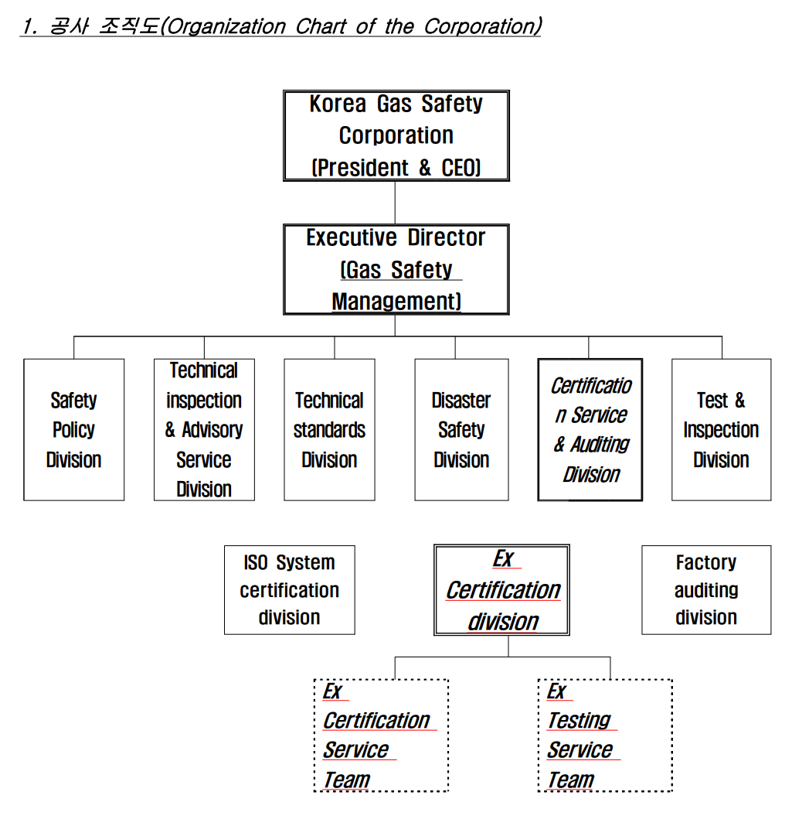

1. Organisation Chart of ExCB/ExTL

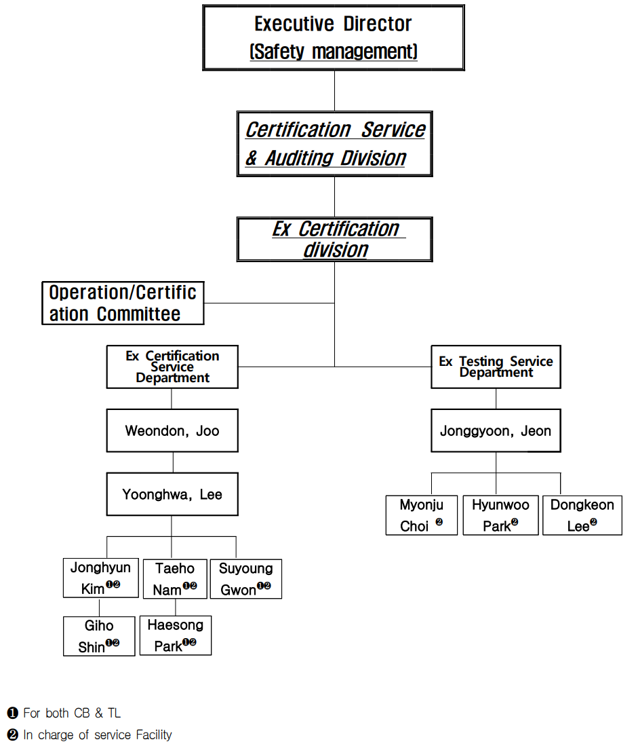

* CB personnel include TL personnel (CB personel can conduct test together)

* This organization chart includes IECEx service Facility personnel.

1. Accreditation Certificate for ISO/IEC 17065

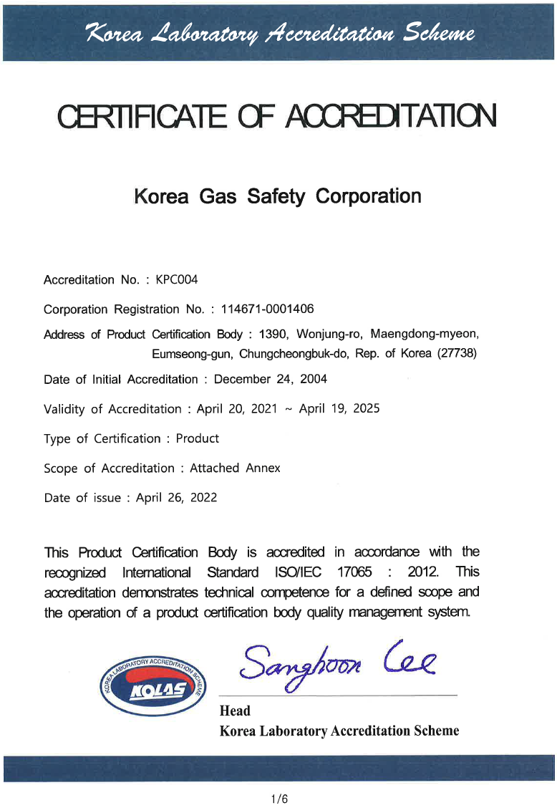

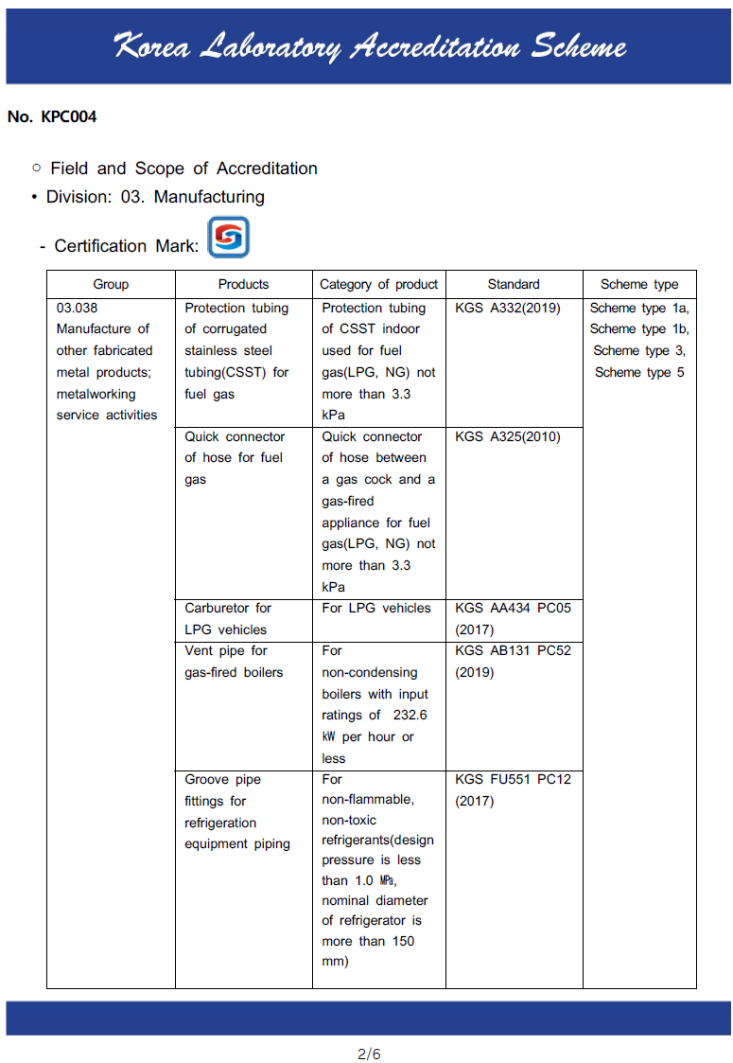 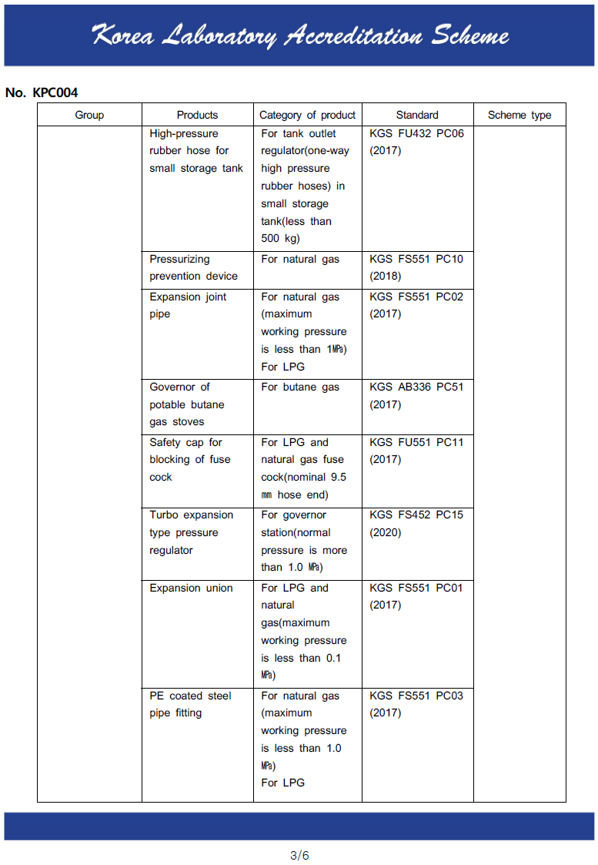 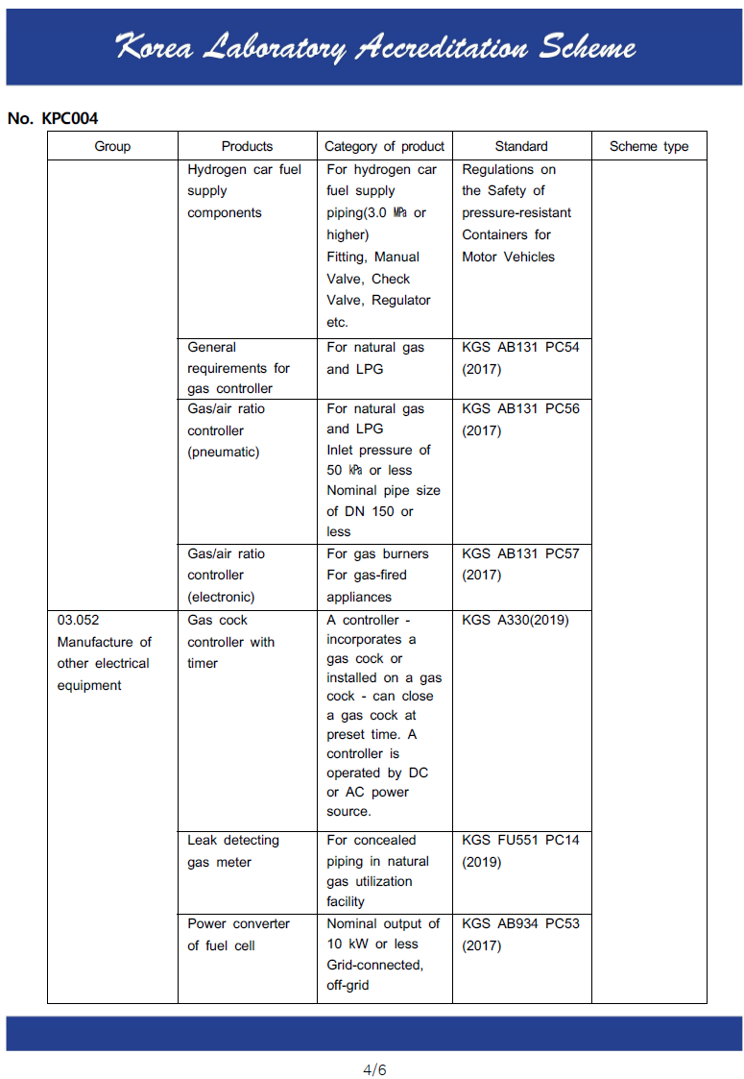 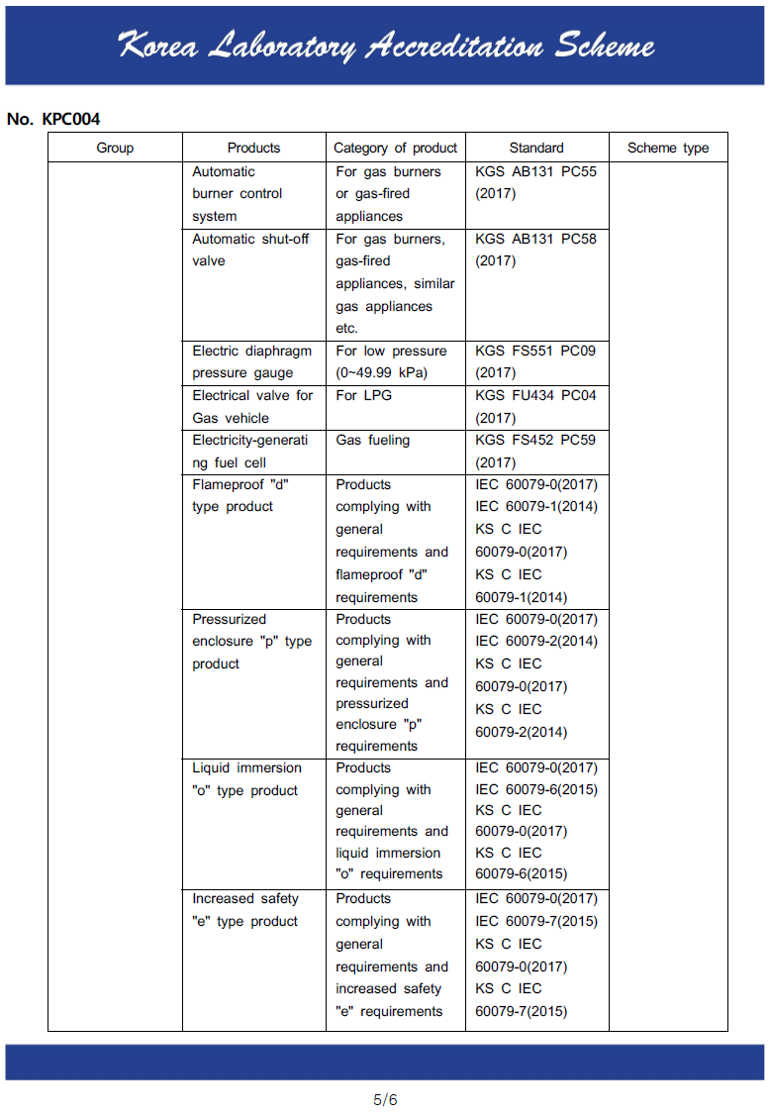 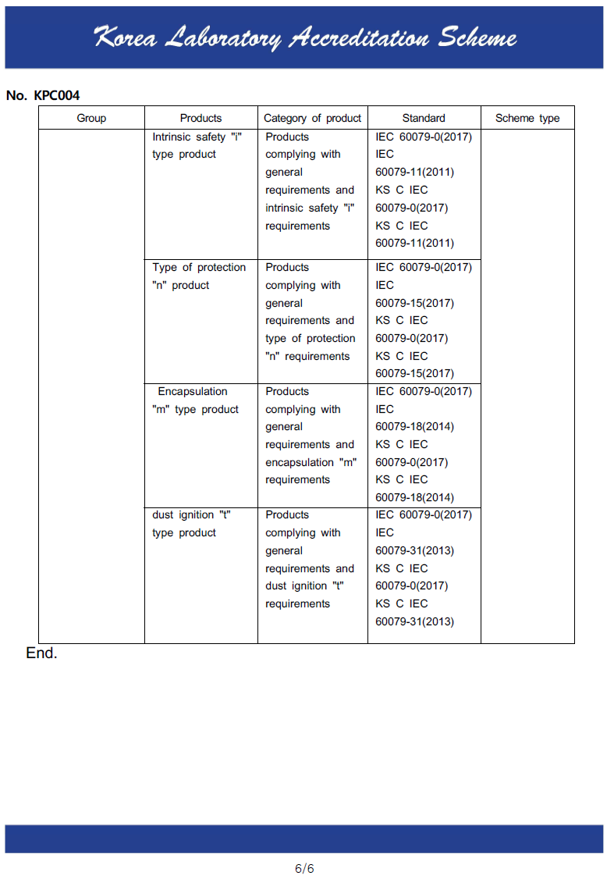

1. Accreditation Certificate for ISO/IEC 17025

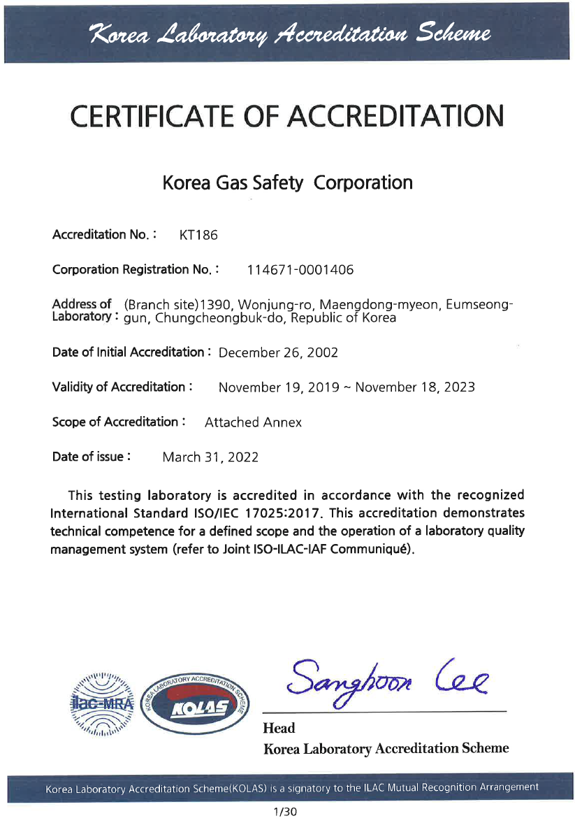

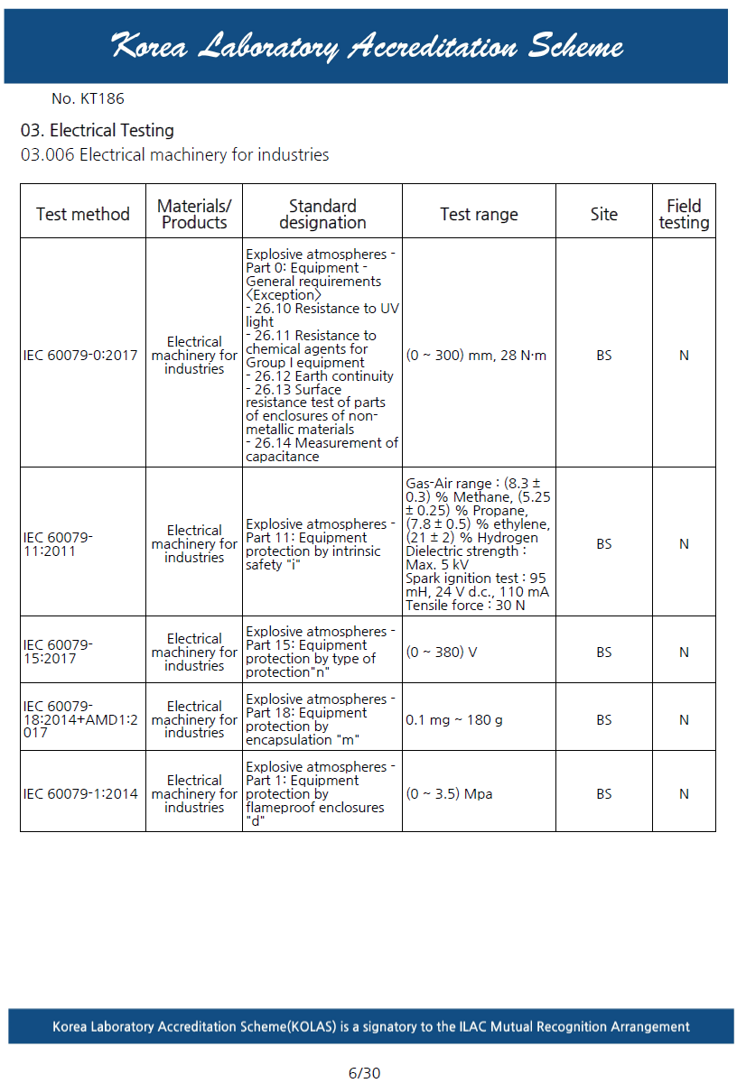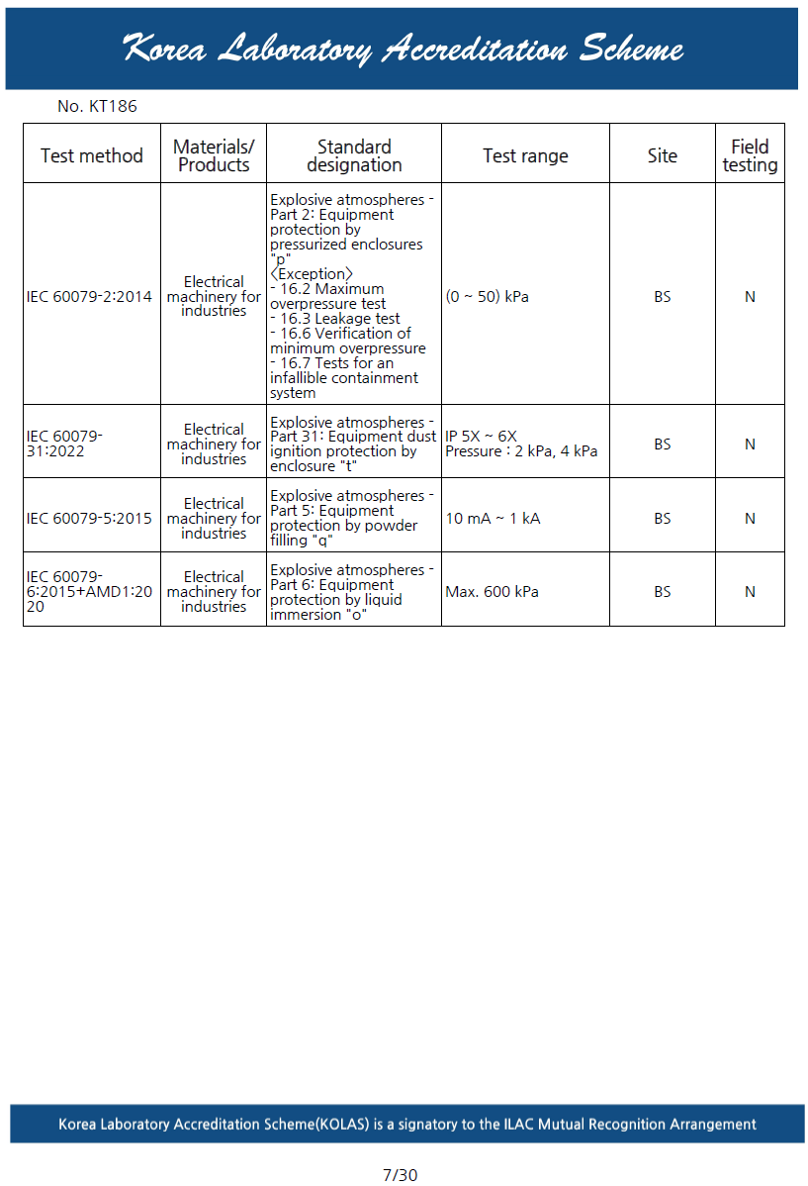 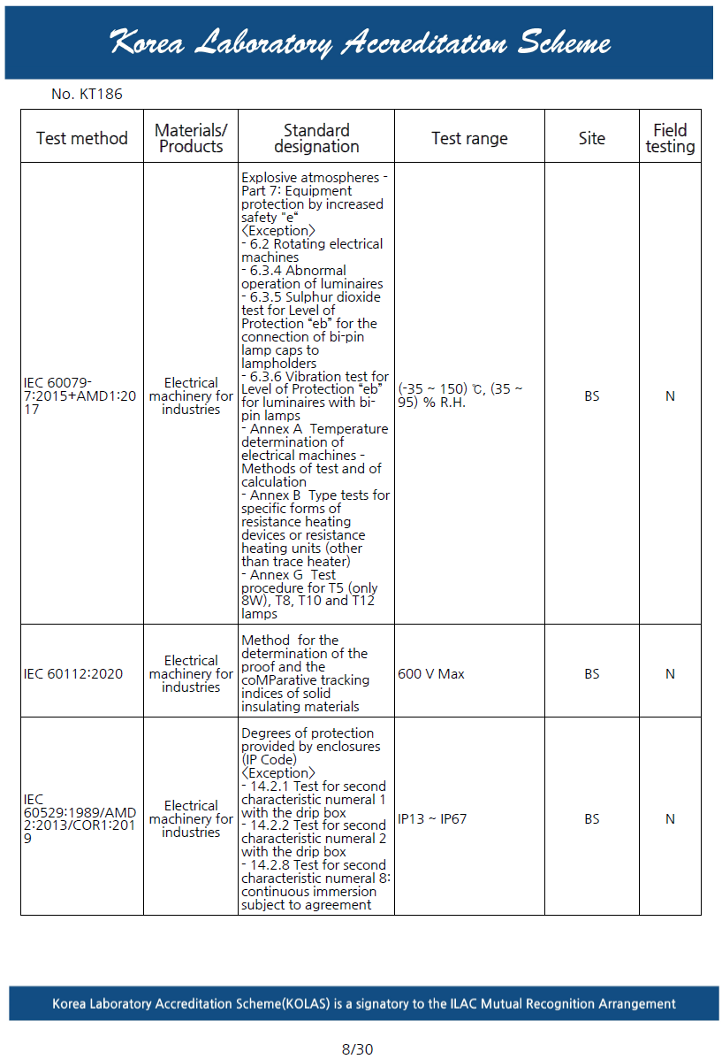 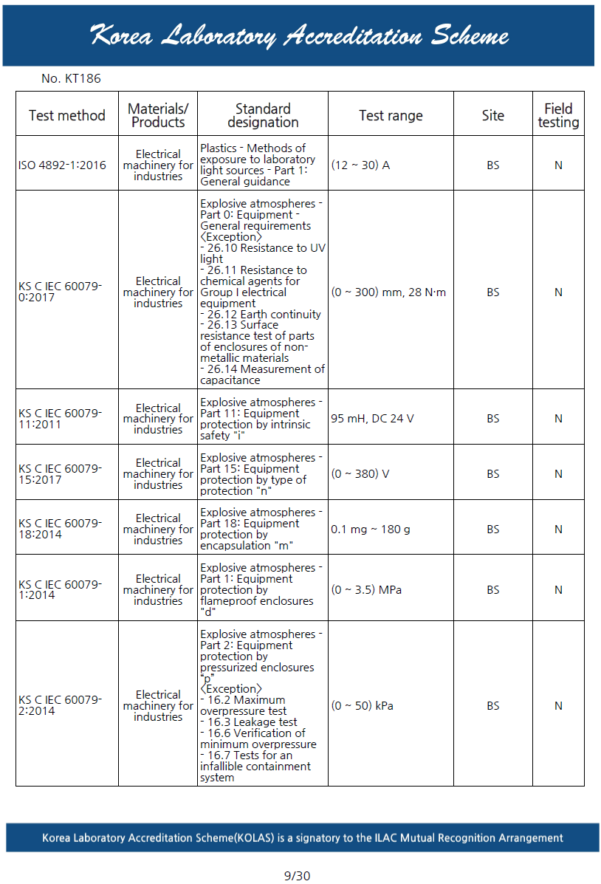 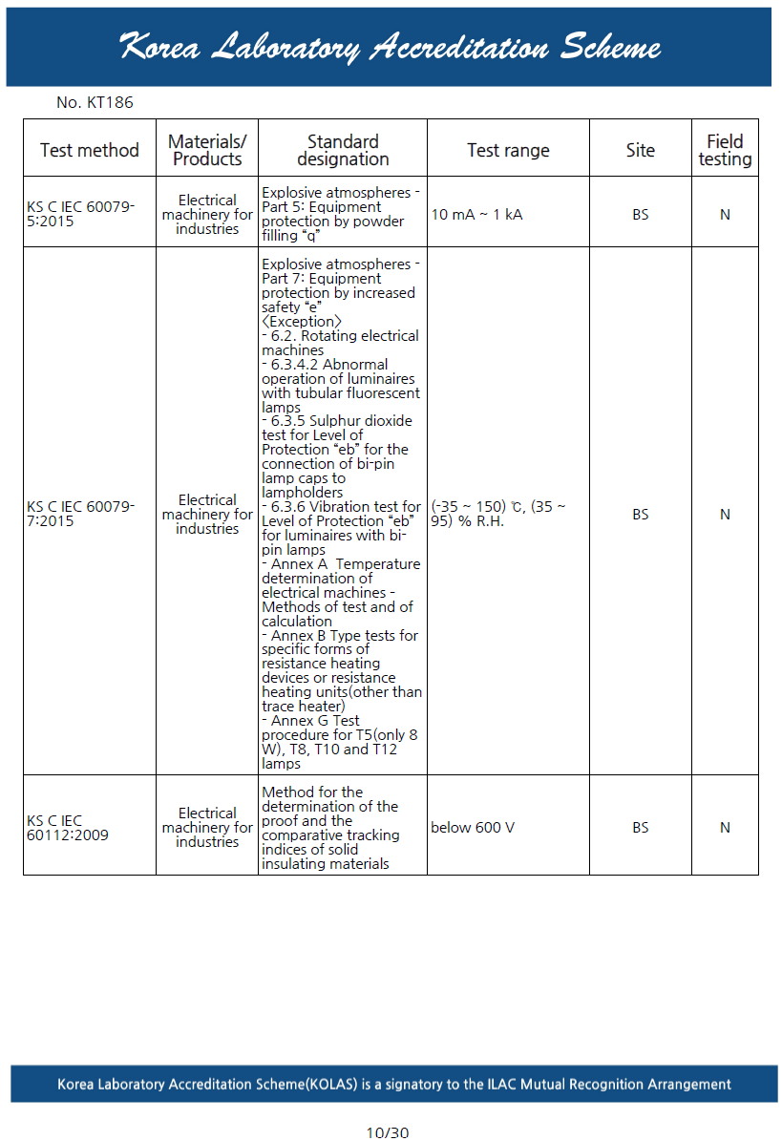 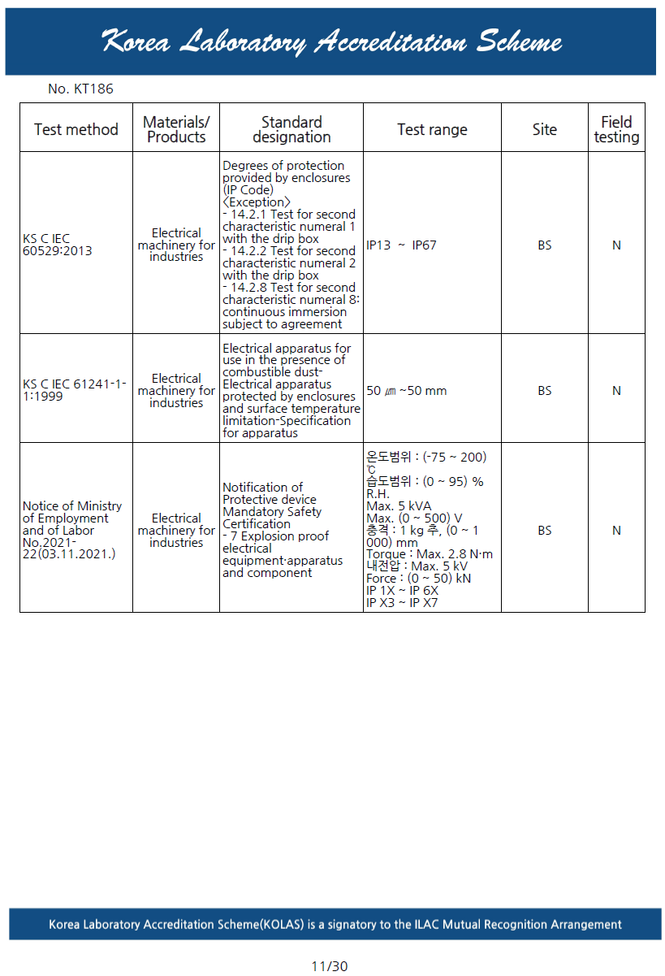

1. Accreditation Certificate for ISO/IEC 17024

Not applicable