**INTERNATIONAL ELECTROTECHNICAL COMMISSION SYSTEM FOR CERTIFICATION TO STANDARDS RELATING TO EQUIPMENT FOR USE IN EXPLOSIVE ATMOSPHERES (IECEx SYSTEM)**

**TITLE: Reassessment** **and scope extension report for CCTEG Shanghai Meike Test Technology Co.,Ltd/Shanghai Electric Explosion Proof Test Center of Coal Industry (SHC) an Accepted Ex Testing Laboratory (ExTL) in the Equipment Scheme 02,** **to include IEC 60079-33, ISO 80079-36 and ISO 80079-37 within their scope.**

**Circulation to: Members of the IECEx Management Committee, ExMC.**

**INTRODUCTION**

This document contains the Reassessment and scope extension report for CCTEG Shanghai Meike Test Technology Co., Ltd/Shanghai Electric Explosion Proof Test Center of Coal Industry (SHC) an Accepted Ex Testing Laboratory (ExTL) in the Equipment Scheme 02, to include IEC 60079-33, ISO 80079-36 and ISO 80079-37 within their scope.

|  |  |
| --- | --- |
| Number | Title |
| IEC 60079-33 Ed.1 | Explosive atmospheres - Equipment protection by intrinsic safety 'i' |
| ISO 80079-36 Ed.1 | Explosive atmospheres - Part 36: Non-electrical equipment for explosive atmospheres – Basic method and requirements |
| ISO 80079-37 Ed.1 | Explosive atmospheres - Part 37: Non-electrical equipment for explosive atmospheres – Non electrical type of protection constructional safety ”c” control of ignition source ”b”, liquid immersion ”k” |

The report is hereby submitted for voting by the ExMC.

***This document is hereby submitted for ExMC approval via correspondence using the IECEx on-line voting system.  ExMC Members are requested to submit their vote via the IECEx On-line*** [***Ballot System***](https://www.iecex.com/ballot) ***by the closing date 2024 05 02***

***Please refer to OD 050 for guidance on the “IECEx On-line voting system.”***

**IECEx Secretariat**

|  |  |
| --- | --- |
| **Address:**  **Level 17, Angel Place**  **123 Pitt Street**  **Sydney NSW 2000**  **Australia** | **Contact Details:**  **Tel: +61 2 46 28 4690**  **Fax: +61 2 46 27 5285**  **e-mail: info@iecex.com**  [**http://www.iecex.com**](http://www.iecex.com) |

IEC System for certification to standards relating to equipment for use in Explosive Atmospheres (IECEx System)

IECEx Assessment Report Form, F-003

IECEx assessment report form for use by IECEx assessment teams to report assessments conducted according to the relevant IECEx assessment procedures of:

Operational Document IECEx OD 003-2 for the Certified Equipment Scheme

IECEx ExTL Reassessment report for CCTEG Shanghai Meike Test Technology Co.,Ltd/Shanghai Electric Explosion Proof Test Center of Coal Industry (SHC)

INTERNATIONAL  
ELECTROTECHNICAL  
COMMISSION

CONTENTS

1.1 Type of body covered by this assessment: 7

1.2 Type of assessment: 7

1.3 Details of body 7

1.3.1 Country 7

1.3.2 Name of body 7

1.3.3 Name and title of nominated principal contact 7

1.4 Assessment information 7

1.4.1 Members of the assessment team 7

1.4.2 Place(s) of assessment 7

1.4.3 Assessment date(s) 8

1.5 Application information and background information on the assessment 8

1.6 Scopes 8

1.6.1 ExCB scope for equipment certification scheme 8

1.6.2 ExTL scope 8

1.6.3 ATF Scope 8

1.6.4 ExCB scope for Service Facilities Scheme 8

1.7 ExCB scope for Conformity Mark Licensing Scheme 8

1.8 ExCB scope for IECEx Personnel Competence Scheme 8

2 Common information 9

2.1 Legal entity of body 9

2.2 Financial support 9

2.3 History 9

2.4 Documentation 9

2.4.1 Quality manual 9

2.4.2 Procedures 9

2.4.3 Work instructions 9

2.4.4 Records (including test records where relevant) 10

2.4.5 Document change control 10

2.5 Confidentiality 10

2.6 Communication with public and customers (Hard copy and Electronic) 10

2.7 Recognitions and agreements 10

2.8 Internal audit 10

2.9 Management review 11

2.10 Contracting, subcontracting and witness testing 11

2.10.1 Contracting 11

2.10.2 Off-site and Witness testing 11

2.11 Training and competence 11

2.12 Complaints and appeals (including appeals to IECEx) 11

2.13 Impartiality 11

2.14 Active involvement in development of Decision Sheets 11

2.15 Special facts to be noted 11

2.16 Supporting documentation 11

2.17 Recommendations 12

3 ExCB for IECEx Certified Equipment Scheme 13

3.1 Assessment references 13

3.1.1 General references 13

3.1.2 Additional references applied for this assessment 13

3.2 Candidate ExCB persons interviewed 13

3.3 Associated ExTL(s) 13

3.4 Associated certification functions 13

3.5 National marks and certificates 13

3.6 Standards accepted 13

3.7 National differences to IEC standards 13

3.8 Organisation 13

3.8.1 Names, titles and experience of the senior executives 13

3.8.2 Name, title and experience of the quality management representative 13

3.8.3 Name and title of signatories for certification 13

3.8.4 Other employees in ExCB activity 13

3.9 Organizational structure 13

3.10 Indemnity insurance 13

3.11 Resources 13

3.12 Committees (such as governing or advisory boards) 14

3.13 Certification operations 14

3.13.1 National approval/certification methods 14

3.13.2 Certification policy 14

3.13.3 Application for certification 14

3.13.4 Certification decision 14

3.13.5 Suspension and cancellation of certificates 14

3.14 Certificates issued 14

3.15 National accreditation 14

3.16 Assessment of manufacturers and issue of QARs 14

3.17 Comments (including issues found during assessment) 14

4 ExTL for IECEx Certified Equipment Scheme 15

4.1 Assessment references 15

4.1.1 General references 15

4.1.2 Additional references applied for this assessment 15

4.2 ExTL persons interviewed 15

4.3 Associated ExCB(s) 15

4.4 Organisation 16

4.4.1 Names, titles and experience of the senior executives 16

4.4.2 Name, title and experience of the quality management representative 16

4.4.3 Other employees in ExTL activity 16

4.5 Organizational structure 16

4.6 Resources 16

4.7 Test reports issued 16

4.8 National accreditation 16

4.9 Calibration 16

4.10 Tests witnessed during the assessment visit 17

4.11 Participation in IECEx Proficiency Testing Programs 17

4.12 Comments (including issues found during assessment) 17

5 ATF for IECEx Certified Equipment Scheme 19

5.1 Assessment references 19

5.1.1 General references 19

5.1.2 Additional references applied for this assessment 19

5.2 Associated ExTL 19

5.3 Organisation 19

5.3.1 Names, titles and experience of the senior executives 19

5.3.2 Name, title and experience of the quality management representative 19

5.3.3 Other employees in ATF activity 19

5.4 Organizational structure 19

5.5 Resources 19

5.6 Test reports issued 19

5.7 National accreditation 19

5.8 Calibration 19

5.9 Tests witnessed during the assessment visit 20

5.10 Participation in IECEx Proficiency Testing Programs 20

5.11 Comments (including issues found during assessment) 20

6 ExCB for Certified Service Facilities Scheme 21

6.1 Assessment references 21

6.1.1 General references 21

6.1.2 Additional references applied for this assessment 21

6.2 Candidate ExCB persons interviewed 21

6.3 National marks and certificates 21

6.4 Standards accepted 21

6.5 National differences to IEC standards 22

6.6 Organisation 22

6.6.1 Names, titles and experience of the senior executives 22

6.6.2 Name, title and experience of the quality management representative 22

6.6.3 Name and title of signatories for certification 22

6.6.4 Other employees in ExCB activity 22

6.7 Organizational Structure 22

6.8 Indemnity insurance 22

6.9 Resources 22

6.10 Committees (such as governing or advisory boards) 22

6.11 Certification operations 22

6.11.1 National approval/certification Methods 22

6.11.2 Certification policy 22

6.11.3 Application for certification 22

6.11.4 Certification decision 22

6.11.5 Suspension and cancellation of certificates 22

6.12 Statistics 22

6.13 National accreditation 23

6.14 Assessment of service facilities and issue of FARs 23

6.15 Comments (including issues found during assessment) 23

7 IECEx Conformity Mark Licensing Scheme 24

7.1 Assessment references 24

7.2 Comments (including issues found during assessment) 24

8 ExCB for IECEx Personnel Competence Scheme 25

8.1 Assessment references 25

8.3 Candidate ExCB persons interviewed 25

8.4 National certificates 25

8.5 Organisation 25

8.5.1 Names, titles and experience of the senior executives 25

8.5.2 Name, title and experience of the quality management representative 25

8.5.3 Name and title of signatories for certification 25

8.5.4 Other employees in ExCB activity 25

8.6 Organizational Structure 26

8.7 Indemnity insurance 26

8.8 Resources 26

8.9 Committees (such as governing or advisory boards) 26

8.10 Certification operations 26

8.10.1 National approval/certification Methods 26

8.10.2 Certification policy 26

8.10.3 Certification application, assessment and examination processes 26

8.10.4 Issuing of IECEx Personnel Competence Assessment Report (PCAR) 26

8.10.5 Decision on Certification 26

8.10.6 Suspension and cancellation of certificates 26

8.11 Statistics 26

8.12 Question bank 26

8.13 National accreditation 26

8.14 Comments (including issues found during assessment) 26

9 Annexes 27

Annex A Scope for IECEx Certified Equipment Scheme 28

A.1 Current standards 28

A.2 Superseded standards 29

Annex B Overall Organisation Chart 30

Annex C Organisation Chart of ExTL 31

Annex D Accreditation Certificate for ISO/IEC 17065 32

Annex E Accreditation Certificate for ISO/IEC 17025 33

Annex F Accreditation Certificate for ISO/IEC 17024 34

# Assessment information

## Type of body covered by this assessment:

|  |  |
| --- | --- |
| ExCB for IECEx Certified Equipment Scheme |  |
| ExTL for IECEx Certified Equipment Scheme |  |
| ATF for IECEx Certified Equipment Scheme |  |
| ExCB for IECEx Certified Service Facilities Scheme |  |
| ExCB for IECEx Conformity Mark Licensing System |  |
| ExCB for IECEx Certification of Personnel Competency Scheme |  |

NOTE 1 ExCB - IECEx Certification Body

NOTE 2 ExTL - IECEx Testing Laboratory

NOTE 3 ATF - Additional Testing Facility

## Type of assessment:

|  |  |
| --- | --- |
| Pre-assessment for candidate body |  |
| Initial assessment for candidate body |  |
| Surveillance |  |
| Re-assessment |  |
| Scope extension |  |

## Details of body

### Country

China

### Name of body

CCTEG Shanghai Meike Test Technology Co.,Ltd/Shanghai Electric Explosion Proof Test Center of Coal Industry (SHC)

### Name and title of nominated principal contact

|  |  |  |
| --- | --- | --- |
| Name | Title | E-mail address |
| Qiaoying Chen | General Manager | 13671918299@163.com |

## Assessment information

### Members of the assessment team

|  |  |
| --- | --- |
| Name | Role |
| Eduardo Galera | IECEx Assessor |

### Place(s) of assessment

|  |  |
| --- | --- |
| CCTEG Shanghai Meike Test Technology Co.,Ltd/Shanghai Electric Explosion Proof Test Center of Coal Industry (SHC) | No. 369, Wutang Road, Nanqiao, Fengxian District Shanghai, China |

### Assessment date(s)

July 4th and 5th, 2023.

## Application information and background information on the assessment

The reassessment request was made on 20 July 2022 and reviewed by the IECEx Secretariat. Once the assessment team was assigned, significant time was spent ensuring the scope was clear and adequate information was present to start the assessment.

The scope of this audit is reassessment including scope extension to IEC 60079-33, ISO 80079-36 and ISO 80079-37 standards. The scope extension request document ExMC/251B/Q was filled by CCTEG and sent to secretariat last 2022-11-05.

Reassessment was to take in place in 2022 but due to travel restrictions to enter China and Visa application queue it has been agreed between IECEx assessor, ExTL and secretariat to postpone the audit for 2023.

The assessment has been conducted in English language. One of the CCTEG employees was available to support with translation. IECEx assessor used the App “Translator” to help with documentation review as mostly of the information was only available in Chinese.

## Scopes

### ExCB scope for equipment certification scheme

China Mining Products Safety Approval and Certification Center, (CMAC), China Quality Mark Certification Group Co., Ltd (CQM), China Quality Certification Center, (CQC), TestSafe Australia (TSA) and National Supervision and Inspection Centre for Explosion Protection and Safety of Instrumentation (NEPSI) will be the associated ExCBs for Testing Technology Research Centre of CCTEG-SHC (Shanghai Electric Explosion Proof Test Center of Coal Industry) covering all Standards in their scope.

### ExTL scope

The scope for the ExCB is shown in Annex A and includes the scope extension of IEC 60079-33, ISO 80079-36 and ISO 80079-37.

### ATF Scope

Not applicable as this is an ExTL only.

### ExCB scope for Service Facilities Scheme

Not applicable as this is an ExTL only.

## ExCB scope for Conformity Mark Licensing Scheme

Not applicable as this is an ExTL only.

## ExCB scope for IECEx Personnel Competence Scheme

Not applicable as this is an ExTL only.

# Common information

## Legal entity of body

Shanghai Meike Test Technology Co.,Ltd

## Financial support

CCTEG is a state-owned business. The money to establish the ExTL was received by Shanghai Co., Ltd. of China Coal Technology & Engineering Group from the Chinese government and then transferred to CCTEG-SHC.

Money is received from customers for issuance of test reports.

## History

CCTEG founded in June 1982, is attached in terms of administration to CCTEG Shanghai Co., Ltd. Located in Fengxian District.

In June 1987, the center was inspected by the former State Economic Commission and State Bureau of Technical Supervision and the center was authorized as the National Coal Mining Machinery for Quality Supervision and Inspection Center (certificate no: 021). In August 1993, the center was approved by the former Coal Industry Ministry to establish the electrical explosion-proof station for the coal industry.

In December 1997, the center was firstly appraised by Chinese Lab Recognition Committee. The Committee organized a trinity “on-the-spot appraisal’’ and authorized the center as a national laboratory (Certificate No: L0477) in accordance with ISO/IEC 17025. In May 2004, the center also won approval of the Bureau of National Safety Production Supervision & Administration’s. Also, the center was authorized as the first-grade inspection & testing agency for national security production (certificate no: 04002).

In August 2004, the China Coal Technology Institute approved the center establish a new center, called Shanghai Inspection & Testing Center for Coal safety production. The new center has the qualification of Independent Corporation. In June 2006, the Chinese Lab Recognition Committee evaluated and authorized the center as type-A inspection agency (certificate no: IB0068) in accordance with ISO/IEC 17020.

## Documentation

### Quality manual

The Quality Manual for the operation of the testing laboratory is contained in document Quality Manual Code: MK.ZL-I-2019 approved by Zhang bochao 2019-12-15 which fulfils the requirements of the IECEx system.

### Procedures

Procedures MK.CX-H-2016 (MK.CX-1-2016 through MK.CX-41-2022) are used for the operation of the testing laboratory and MK.CX 36-2019IECEx certification testing and other international certification procedure was set-up for IECEx system and implemented.

The procedures were reviewed by the assessment team and found to align with IECEx Rules and Operational Documents.

### Work instructions

Work instructions MK.JG-I-2019 (MK.JG02-001 through MK.JG02-121) are used by the test technicians and fulfils the requirements of the IECEx system.

### Records (including test records where relevant)

MK.CX 12-2016, Control of records procedure, specifies the records that are kept, most are kept hard copy, including signed test reports and test data. They are stored for 10 years after issuance.

MK.CX 13-2016, Archives management procedure, includes instructions for accessing records.

The records meets the requirements of IECEx OD 207 “Guidance on the Retention of Records”

### Document change control

CCTEG has set up and implemented MK.CX 01-2016 Documents Management Program. MK.CX--2019 reviewed by Wang CaiYan, Technical Manager, and approved by Zhang BoChao, Quality Manager. Only the latest version is available electronically, previous versions are kept hard copy.

MK.CX01-2016, Control of document procedure describes the arrangement of quality manual, procedure and work instructions, which is done electrically on the Laboratory Information Management System on the intranet.

## Confidentiality

Has set up and implemented MK.CX 07-2016, Confidentiality and the protection of proprietary rights procedure. Evidence of signed confidentiality requirements was viewed. In addition, they have MX CX37-2016, Ensure the impartiality and integrity. The procedures were reviewed and found to meet the requirements of the IECEx.

## Communication with public and customers (Hard copy and Electronic)

Maintains the website <http://www.testshm.com/> for communication with the public and clients. In addition, they have a hard copy document to provide to their clients.

## Recognitions and agreements

An agreement is signed between CCTEG and:

* China Quality Mark Certification Group Co. Ltd (CQM) - PEOPLES REPUBLIC OF CHINA
* Shanghai Inspection and Testing Institute of Instruments and Automatic Systems Co., Ltd. (SITIIAS)/ National Supervision and Inspection Centre for Explosion Protection and Safety of Instrumentation (NEPSI) - PEOPLES REPUBLIC OF CHINA
* TestSafe Australia (TSA) (MSC) - AUSTRALIA
* China Mining Products Safety Approval and Certification Center - PEOPLES REPUBLIC OF CHINA (CMAC)
* China Quality Certification Center (CQC) - PEOPLES REPUBLIC OF CHINA

## Internal audit

Set up and implemented MK.CX 14-2016 Internal audit procedures. CCTEG-SHC has organized the annual internal audit in June - August, 2022. There was a report issued for the internal audit dated 2022.9.3. There was one minor correction action identified for the Electrical & Explosion Proof Safety Test Institute. Evidence was provided that the issue was resolved in accordance with the procedure. IECEx was not included since it was not yet covered under CCTEG-SHC’s scope.

The IECEx certification testing and other international certification procedure, MK.CX36-2016, contains requirements for inclusion of IECEx in future internal audits in accordance with the IECEx Rules.

## Management review

Set up and implemented MK.CX 15-2016, Management review procedure, which includes IECEx work and found to meet the requirements of the IECEx.

CCTEG-SHC conducted the annual management review in Apil 2023, which was attended by top management as well as the Technical and Quality Managers of the Electrical & Explosion Proof Safety Test Institute.

The report from the last management review was reviewed and found to be in compliance with the requirements of the ISO/IEC 17025 and IECEx.

## Contracting, subcontracting and witness testing

### Contracting

CCTEG-SHC has set up and implemented MK.CX 05-2016, Investigations and review procedures for subcontracting. There isn’t subcontract work for explosion-proof test items at present.

### Off-site and Witness testing

CCTEG-SHC has reference to IECEx OD024 in MK.CX 36-2016, which is in compliance with the IECEx requirements. They have not implemented the procedure because they have not been accepted as an ExTL.

## Training and competence

CCTEG-SHC has set up and implemented MK.CX16-2016, Training of personnel control procedure. This procedure requires an annual training plan. Evidence of the 2023 training plan was provided. Evidence of training on the differences between IEC and GB standards for IEC 60079-0, -1, -2, was provided during the assessment.

Process was found to be satisfactory, meeting the requirements of the IECEx and ISO/IEC 17025.

## Complaints and appeals (including appeals to IECEx)

CCTEG-SHC procedure MK.CX39-2016 covers overall complaints. In addition to that CCTEG has created a specific procedure to cover IECEx requirements MK.CX36-2016 and complaints and appeals are properly described in the specific procedure.

## Impartiality

Procedure MK.CX35-2016 covers overall impartiality and risks control. In addition to that CCTEG has created a specific procedure to cover IECEx requirements MK.CX36-2016 and complaints and appeals are properly described in the specific procedure.

## Active involvement in development of Decision Sheets

CCTEG receives the draft Decision Sheets from CQM and they review together with their associated ExCBs. No other action has been recorded related to development of Decision Sheets.

## Special facts to be noted

None other than those included in this report.

## Supporting documentation

Copies of additional supporting information for this assessment have been provided to the applicant and the IECEx Secretariat. These are included in a site assessment report or provided separately and include:

* Details of issues raised and how these have been resolved
* Completed Technical Capability Document (TCD)
* Photos of the facilities/tests witnessed are included in the above TCD
* Information on competencies
* Assessors’ notes

## Recommendations

Based on the assessment performed on July 4th and 5th, 2023, CCTEG Shanghai Meike Test Technology Co.,Ltd/Shanghai Electric Explosion Proof Test Center of Coal Industry (SHC) is recommended for continued acceptance in the IECEx scheme as:

* An ExTL in the IECEx Certified Equipment Scheme

This is according to the scope of the standards listed in this document (including the extension of scope).

|  |
| --- |
| Eduardo G. Galera |
| IECEx Assessor |

Date: 2024 03 19

# ExCB for IECEx Certified Equipment Scheme

## Assessment references

### General references

Not applicable as this is an ExTL only.

### Additional references applied for this assessment

Not applicable as this is an ExTL only.

## Candidate ExCB persons interviewed

Not applicable as this is an ExTL only.

## Associated ExTL(s)

Not applicable as this is an ExTL only.

## Associated certification functions

Not applicable as this is an ExTL only.

## National marks and certificates

Not applicable as this is an ExTL only.

## Standards accepted

Not applicable as this is an ExTL only.

## National differences to IEC standards

Not applicable as this is an ExTL only.

## Organisation

Not applicable as this is an ExTL only.

### Names, titles and experience of the senior executives

Not applicable as this is an ExTL only.

### Name, title and experience of the quality management representative

Not applicable as this is an ExTL only.

### Name and title of signatories for certification

Not applicable as this is an ExTL only.

### Other employees in ExCB activity

Not applicable as this is an ExTL only.

## Organizational structure

Not applicable as this is an ExTL only.

## Indemnity insurance

Not applicable as this is an ExTL only.

## Resources

Not applicable as this is an ExTL only.

## Committees (such as governing or advisory boards)

Not applicable as this is an ExTL only.

## Certification operations

### National approval/certification methods

Not applicable as this is an ExTL only.

### Certification policy

Not applicable as this is an ExTL only.

### Application for certification

Not applicable as this is an ExTL only.

### Certification decision

Not applicable as this is an ExTL only.

### Suspension and cancellation of certificates

Not applicable as this is an ExTL only.

## Certificates issued

Not applicable as this is an ExTL only.

## National accreditation

Not applicable as this is an ExTL only.

## Assessment of manufacturers and issue of QARs

Not applicable as this is an ExTL only.

## Comments (including issues found during assessment)

Not applicable as this is an ExTL only.

# ExTL for IECEx Certified Equipment Scheme

## Assessment references

### General references

1. IECEx02 IECEx Certified Equipment Scheme covering equipment for use in explosive atmospheres – Rules of Procedure
2. IECEx OD003-2 Assessment, surveillance assessment and re-assessment of ExCBs and ExTLs operating in the IECEx 02, IECEx Certified Equipment Scheme
3. IECEx OD009 Issuing of CoCs, ExTRs and QARs
4. ISO/IEC 17025 General requirements for the competence of testing and calibration laboratories
5. IECEx OD 018 Harmonised check list for testing and calibration laboratories ISO/IEC 17025
6. IECEx TCD 60079, ISO 80079 Series and ISO 16852 Technical Capability Document
7. ExTAG decision sheets (DSs)
8. IECEx OD 202 IECEx Certified Equipment Scheme – IECEx Proficiency Testing Program

### Additional references applied for this assessment

OD 280 IECEx Certified Equipment Scheme – Guide to Certification of Non-electrical Equipment and Protective Systems Ed. 1.0

OD 233 IECEx Certified Equipment Scheme - Assessment of Ex “s" Equipment Ed. 3.0

## ExTL persons interviewed

|  |  |
| --- | --- |
| Name | Position |
| Schichen Jiang | Non-electrical lab technician |
| Binbin Zhang | IPX4 lab technician |
| Lishi Xiao | Capacitance lab technician |
| Jie Pan | Impact lab technician |
| Lixin Cai | IS lab technician |
| Chaolong Yu | IS lab technician |
| Qi Wang | Temperature lab technician |

## Associated ExCB(s)

* China Quality Mark Certification Group Co. Ltd (CQM) - PEOPLES REPUBLIC OF CHINA
* Shanghai Inspection and Testing Institute of Instruments and Automatic Systems Co., Ltd. (SITIIAS)/ National Supervision and Inspection Centre for Explosion Protection and Safety of Instrumentation (NEPSI) - PEOPLES REPUBLIC OF CHINA
* TestSafe Australia (TSA) (MSC) - AUSTRALIA
* China Mining Products Safety Approval and Certification Center - PEOPLES REPUBLIC OF CHINA
* China Quality Certification Center - PEOPLES REPUBLIC OF CHINA

## Organisation

### Names, titles and experience of the senior executives

|  |  |  |
| --- | --- | --- |
| Name | Title | Experience (years) |
| Chen Qiaoying | General Manager | 15 |

### Name, title and experience of the quality management representative

|  |  |  |
| --- | --- | --- |
| Name | Title | Experience (years) |
| Xi Lifeng | Assistant Manager | 22 |

### Other employees in ExTL activity

|  |  |  |
| --- | --- | --- |
| Name | Title/responsibility | Experience in Ex (years) |
| Longzaimeng | Quality Engineer | 14 |
| Liu XinYu | Test Technician | 15 |
| Li Bin | Staff Engineer | 33 |
| Chen Sizhong | Staff Engineer | 14 |
| Cai Lixin | Staff Engineer | 20 |
| Han muzi | Staff Engineer | 5 |
| Chang zefu | Staff Engineer | 5 |
| Ni Chunming | Staff Engineer | 35 |

## Organizational structure

See Annexes B and C.

## Resources

The laboratory is well resourced with sufficient staff, facilities and comprehensive procedures.

## Test reports issued

Number of test reports (ExTRs) issued under for the preceding two years for each type of protection. For new applications these should be for national or regional schemes and for currently accepted bodies IECEx ExTRs should be shown (test reports for other schemes may also be shown):

|  |  |  |  |  |
| --- | --- | --- | --- | --- |
| Standard numbers | Type of protection or other identifying information | Number of issued reports (ExTRs) (for last 2 years) | | Total |
| 2021 | 2022 |
| IEC 60079-1 | db | 1 | 1 | 2 |
| IEC 60079-7 | eb/ec |  | 1 | 1 |
| IEC 60079-11 | ia | 1 |  | 1 |
| IEC 60079-31 | tb | 1 |  | 1 |

## National accreditation

The national accreditation certification for ISO/IEC 17025 is shown in Annex E. All Standards included, as well as the standards requested under scope extension.

NOTE The national accreditation is checked annually by the IECEx Secretariat.

## Calibration

Has set up and implemented MK.CX 22-2016, Equipment management procedure, and MK.CX 24-2016, Measurement Traceability procedure cover calibration of the laboratory. CCTEG-SHC has a detailed procedure for the review and acceptance of calibration certificates.

## Tests witnessed during the assessment visit

The following tests were witnessed during the assessment visit:

|  |  |  |  |
| --- | --- | --- | --- |
| Standard and edition | Clause number | Test | Comments |
| IEC 60079-0 Edition 7.0 | 26.5.1 | Temperature measurement | Test performed competently |
| IEC 60079-0 Edition 7.0 | 26.4.2 | Resistance to impact test for Group I and II | Test performed competently |
| IEC 60079-11 Edition 6.0 | 10.1 | Use of spark test apparatus | Test performed competently. A couple of issues with the dust chamber were identified but later resolved. |
| IEC 60079-0 Edition 7.0 | 26.14 | Measurement of capacitance | Test performed competently |
| IEC 60079-0 Edition 7.0 and IEC 60529 Edition 2.1 | 26.4.5 | IPX4 test | Test performed competently |
| ISO 80079-36 Edition 1.0 | 6.2.4 | Maximum surface temperature | Test performed competently |

## Participation in IECEx Proficiency Testing Programs

Program: PTB Ex PT Scheme

|  |  |  |
| --- | --- | --- |
| Year(s) of participation | IECEx Proficiency Testing program | General information about results |
| 2017 | Explosion pressure | Participated – Issues resolved satisfactorily. |
| 2019 | Tests of Enclosures | See original report. No issued raised. |
| 2019 | Battery Testing | See original report. No issued raised. |
| 2021 | Flameproof Joints | See original report. No issued raised. |

## Comments (including issues found during assessment)

There were 4 issues raised during the assessment. Two of them were resolved prior to end of the assessment. The two resolved were related to impact testing procedure and related annual calibration and the other two issues raised required extra time as they need to update their existing agreements with different ExCB´s and also they need time to update internal procedures and move to approval process.

The details of the issues raised during the audit are described below:

1. CCTEG holds agreement with CQM, SITIIAS/NEPSI, TSA, CMPS and CQC. Only the agreement with CQM and TSA refers to IECEx and all other agreements are general and does not contain such reference. It is recommended to review the agreements to include reference from IECEx and OD001 for the list of standards. **Resolved. No further action required.**
2. Testing procedures does not contain references to IECEx Decision Sheets which may benefit CCTEG with good practices. An example of this was the different procedure observed from the surface temperature performed at the non-electrical equipment and the surface temperature of electrical enclosure (DS 2015/011ADS provides a guidance on it). **Resolved. No further action required.**
3. Review the procedure sent for the impact testing device and its annual calibration. **Resolved prior to the end of assessment. No further action required**.
4. ExTR CN/CQM/ExTR23.0005/00 was presented in draft during the audit but both ExTR and CoC (IECEx CQM 23.0007X) were published by CQM in the IECEx website as of today 2023-07-04. Further clarifications is needed to understand why the ExTR and CoC were issued without having the final ExTR signed and published. **Resolved prior to the end of the audit. No further action required**.

With the information presented on this clause, all issues were resolved to the satisfaction of the assessor.

# ATF for IECEx Certified Equipment Scheme

## Assessment references

### General references

1. IECEx02 IECEx Certified Equipment Scheme covering equipment for use in explosive atmospheres – Rules of Procedure
2. IECEx OD003-2 Assessment, surveillance assessment and re-assessment of ExCBs and ExTLs operating in the IECEx 02, IECEx Certified Equipment Scheme
3. ISO/IEC 17025 General requirements for the competence of testing and calibration laboratories
4. IECEx OD 018 Harmonised check list for testing and calibration laboratories ISO/IEC 17025
5. IECEx TCD 60079, ISO 80079 Series and ISO 16852 Technical Capability Document
6. ExTAG decision sheets (DSs)
7. IECEx OD 202 IECEx Certified Equipment Scheme – IECEx Proficiency Testing Program

NOTE The latest editions of the above documents were applied, unless otherwise specified.

### Additional references applied for this assessment

Not applicable as this is an ExTL only.

## Associated ExTL

Not applicable as this is an ExTL only.

## Organisation

Not applicable as this is an ExTL only.

### Names, titles and experience of the senior executives

Not applicable as this is an ExTL only.

### Name, title and experience of the quality management representative

Not applicable as this is an ExTL only.

### Other employees in ATF activity

Not applicable as this is an ExTL only.

## Organizational structure

Not applicable as this is an ExTL only.

## Resources

Not applicable as this is an ExTL only.

## Test reports issued

Not applicable as this is an ExTL only.

## National accreditation

Not applicable as this is an ExTL only.

The national accreditation certification for ISO/IEC 17025 is shown in Annex F.

NOTE 2 The national accreditation is checked annually by the IECEx Secretariat.

## Calibration

Not applicable as this is an ExTL only.

## Tests witnessed during the assessment visit

Not applicable as this is an ExTL only.

## Participation in IECEx Proficiency Testing Programs

Not applicable as this is an ExTL only.

## Comments (including issues found during assessment)

Not applicable as this is an ExTL only.

# ExCB for Certified Service Facilities Scheme

## Assessment references

### General references

1. IECEx 03-* IECEx Certified Service Facilities Scheme covering repair and overhaul of Ex equipment – Rules of Procedure for the Scheme (IECEx 03-0) and for “sub-Schemes” on particular service activities (IECEx 03-2, 03-3, 03-4 and 03-5)
2. IECEx OD 316-2 IECEx Certified Service Facilities Scheme – Part 2: Selection of Ex equipment and design of Ex installations Assessment procedures for IECEx acceptance of Candidate Certification Bodies (ExCBs) for the purpose of issuing IECEx Certificates to Ex Service Facilities providing selection of Ex equipment and design of Ex installations related services
3. IECEx OD 316-3 IECEx Certified Service Facilities Scheme – Part 3: Ex installation and initial inspection Assessment procedures for IECEx acceptance of Candidate Certification Bodies (ExCBs) for the purpose of issuing IECEx Certificates to Ex Service Facilities providing Ex installation and initial inspection service IECEx
4. IECEx OD 316-4 IECEx Certified Service Facilities Scheme – Part 4: Ex inspection and maintenance Assessment procedures for IECEx acceptance of Candidate Certification Bodies (ExCBs) for the purpose of issuing IECEx Certificates to Ex Service Facilities providing Ex installations related services
5. IECEx OD 316-5 IECEx Certified Service Facilities Scheme – Part 5: Repair, overhaul and reclamation of Ex equipment. Assessment procedures for IECEx acceptance of Candidate Certification Bodies (ExCBs) for the purpose of issuing IECEx Certificates to Ex Service Facilities involved in the repair, overhaul and reclamation of Ex equipment
6. ISO/IEC 17065 General requirements for bodies operating product certification systems Conformity assessment — Requirements for bodies certifying products, processes and services
7. IECEx TCD 60079-19, Technical Capability Document IEC 60079 -19: 2010, Explosive atmospheres - Parts 19: Equipment repair, overhaul and reclamation
8. IECEx OD 060 IECEx Guide for Business Continuity – Management of Extraordinary Circumstances or Events Affecting IECEx Certification Schemes and Activities
9. IEC 60079-17 Explosive atmospheres - Part 17: Electrical installations inspection and maintenance
10. IEC 60079-19 Explosive atmospheres – Part 19: Equipment repair, overhaul and reclamation
11. ExSFC Decision Sheets

NOTE The latest editions of the above documents were applied

### Additional references applied for this assessment

Not applicable as this is an ExTL only.

## Candidate ExCB persons interviewed

Not applicable as this is an ExTL only.

## National marks and certificates

Not applicable as this is an ExTL only.

## Standards accepted

Not applicable as this is an ExTL only.

## National differences to IEC standards

Not applicable as this is an ExTL only.

## Organisation

Not applicable as this is an ExTL only.

### Names, titles and experience of the senior executives

Not applicable as this is an ExTL only.

### Name, title and experience of the quality management representative

Not applicable as this is an ExTL only.

### Name and title of signatories for certification

Not applicable as this is an ExTL only.

### Other employees in ExCB activity

Not applicable as this is an ExTL only.

## Organizational Structure

Not applicable as this is an ExTL only.

## Indemnity insurance

Not applicable as this is an ExTL only.

## Resources

Not applicable as this is an ExTL only.

## Committees (such as governing or advisory boards)

Not applicable as this is an ExTL only.

## Certification operations

### National approval/certification Methods

Not applicable as this is an ExTL only.

### Certification policy

Not applicable as this is an ExTL only.

### Application for certification

Not applicable as this is an ExTL only.

### Certification decision

Not applicable as this is an ExTL only.

### Suspension and cancellation of certificates

Not applicable as this is an ExTL only.

## Statistics

Not applicable as this is an ExTL only.

## National accreditation

Not applicable as this is an ExTL only.

## Assessment of service facilities and issue of FARs

Not applicable as this is an ExTL only.

## Comments (including issues found during assessment)

Not applicable as this is an ExTL only.

# IECEx Conformity Mark Licensing Scheme

## Assessment references

1. IECEx 04 IECEx Certified Equipment Scheme covering equipment for use in explosive atmospheres – IECEx Conformity Mark Licensing Scheme – Rules
2. IECEx OD 422 IECEx Certified Equipment Scheme covering equipment for use in explosive atmospheres – Procedures for the granting of Licenses to issue and use the IECEx Conformity Mark
3. IECEx OD 423 IECEx Certified Equipment Scheme covering equipment for use in explosive atmospheres – Terms and Conditions for use of the IECEx Conformity Mark

NOTE The latest editions of the above documents were applied

## Comments (including issues found during assessment)

Not applicable as this is an ExTL only.

# ExCB for IECEx Personnel Competence Scheme

## Assessment references

1. IECEx 05 IEC System for Certification to Standards relating to Equipment for use in Explosive Atmospheres (IECEx System) IECEx Scheme for Certification of Personnel Competence for Explosive Atmospheres – Rules of Procedure
2. IECEx OD 501 IECEx Scheme for Certification of Personnel Competence for Explosive Atmospheres – Assessment procedures for IECEx acceptance of Certification Bodies (ExCBs) for the purpose of issuing and maintaining IECEx Certificates of Personnel
3. IECEx OD 503 IECEx Scheme for Certification of Personnel Competence for Explosive Atmospheres - ExCB Procedures for issuing and maintaining IECEx Certificates of Personnel Competencies
4. IECEx OD 504 IECEx Scheme for Certification of Personnel Competence for Explosive Atmospheres – Specification for Units of Competence Assessment Outcomes
5. IECEx OD 505 Site Re-Assessment Report for Assessment of IECEx Candidate and Accepted Ex Certification Bodies (ExCBs) for the IECEx 05 Certificate of Personal Competencies Scheme (CoPC)
6. IECEx OD 506 - Guidance on the use of the IECEx Certificates of Personnel Competence Scheme’s Assessment Question Bank by ExCBs IECEx OD 060 IECEx Guide for Business Continuity – Management of Extraordinary Circumstances or Events Affecting IECEx Certification Schemes and Activities
7. ISO/IEC 17024 Conformity assessment — General requirements for bodies operating certification of persons
8. IECEx OD 507 Check list for assessment to ISO/IEC 17024
9. ExPCC Decision Sheets

Additional references applied for this assessment

Not applicable as this is an ExTL only.

## Candidate ExCB persons interviewed

Not applicable as this is an ExTL only.

## National certificates

Not applicable as this is an ExTL only.

## Organisation

Not applicable as this is an ExTL only.

### Names, titles and experience of the senior executives

Not applicable as this is an ExTL only.

### Name, title and experience of the quality management representative

Not applicable as this is an ExTL only.

### Name and title of signatories for certification

Not applicable as this is an ExTL only.

### Other employees in ExCB activity

Not applicable as this is an ExTL only.

## Organizational Structure

Not applicable as this is an ExTL only.

## Indemnity insurance

Not applicable as this is an ExTL only.

## Resources

Not applicable as this is an ExTL only.

## Committees (such as governing or advisory boards)

Not applicable as this is an ExTL only.

## Certification operations

### National approval/certification Methods

Not applicable as this is an ExTL only.

### Certification policy

Not applicable as this is an ExTL only.

### Certification application, assessment and examination processes

Not applicable as this is an ExTL only.

### Issuing of IECEx Personnel Competence Assessment Report (PCAR)

Not applicable as this is an ExTL only.

### Decision on Certification

Not applicable as this is an ExTL only.

### Suspension and cancellation of certificates

Not applicable as this is an ExTL only.

## Statistics

Not applicable as this is an ExTL only.

## Question bank

Not applicable as this is an ExTL only.

## National accreditation

Not applicable as this is an ExTL only.

## Comments (including issues found during assessment)

Not applicable as this is an ExTL only.

# Annexes

1. Scope for IECEx Certified Equipment Scheme
   1. Current standards

| Number | Title | Comments |
| --- | --- | --- |
| IEC 60079-0  Edition 7.0 | Explosive atmospheres - Part 0: Equipment - General requirements | No changes to original application. |
| IEC 60079-1  Edition 7.0 | Explosive atmospheres - Part 1: Equipment protection by flameproof  enclosures “d” | No changes to original application. |
| IEC 60079-2  Edition 6.0 | Explosive atmospheres - Part 2: Equipment protection by pressurized  enclosure “p’ | No changes to original application. |
| IEC 60079-5  Edition 4.0 | Explosive atmospheres - Part 5: Equipment protection by powder filling “q” | No changes to original application. |
| IEC 60079-6  Edition 4.1 | Explosive atmospheres - Part 6: Equipment protection by oil immersion “o” | No changes to original application. |
| IEC 60079-7  Edition 5.1 | Explosive atmospheres - Part 7: Equipment protection by increased  safety "e" | No changes to original application. |
| IEC 60079-11  Edition 6.0 | Explosive atmospheres - Part 11: Equipment protection by intrinsic safety “i” | No changes to original application. |
| IEC 60079-13  Edition 2.0 | Explosive atmospheres -  Part 13: Equipment protection by pressurized room "p" and artificially ventilated room "v" | No changes to original application. |
| IEC 60079-15  Edition 5.0 | Explosive atmospheres – Part 15: Equipment protection by type of protection "n" | No changes to original application. |
| IEC 60079-18  Edition 4.1 | Explosive atmospheres – Part 18: Equipment protection by encapsulation “m” | No changes to original application. |
| IEC 60079-25  Edition 3.0 | Explosive atmospheres – Part 25: Intrinsically safe electrical systems | No changes to original application. |
| IEC 60079-26  Edition 3.0 | Explosive atmospheres - Part 26: Equipment with equipment protection level (EPL) Ga | No changes to original application. |
| IEC 60079-28  Edition 2.0 | Explosive atmospheres - Part 28: Protection of equipment and transmission systems using optical radiation | No changes to original application. |
| IEC 60079-29-1  Edition 2.1 | Explosive atmospheres - Part 29-1: Gas detectors – Performance requirements of detectors for flammable gases | No changes to original application. |
| IEC/IEEE 60079-30-1  Edition 1.0 | Explosive atmospheres – Part 30-1: Electrical resistance trace heating – General and testing requirements | No changes to original application. |
| IEC 60079-31  Edition 2.0 | Explosive atmospheres – Part 31: Equipment dust ignition protection by enclosure "t" | No changes to original application. |
| **IEC 60079-33**  **Edition 1.0** | **Explosive atmospheres – Part 33: Equipment protection by special protection “s”** | **Scope extension** |
| **IS0 80079-36**  **Edition 1.0** | **Explosive atmospheres - Part 36: Non-electrical equipment for explosive atmospheres – Basic method and requirements** | **Scope extension** |
| **ISO 80079-37**  **Edition 1.0** | **Explosive atmospheres - Part 37: Non-electrical equipment for explosive atmospheres – Non electrical type of protection constructional safety ”c” control of ignition source ”b”, liquid immersion ”k”** | **Scope extension** |

* 1. Superseded standards

The following superseded standards may form part of a body’s scope, generally for historical reasons.

| Number | Title | Comments |
| --- | --- | --- |
| IEC 60079-27  Edition 2.0 | Explosive atmospheres – Part 27: Fieldbus intrinsically safe concept (FISCO) | No changes to original application. |
| IEC 61241-0  Edition 1.0 | Electrical apparatus for use in the presence of combustible dust - Part 0: General requirements | No changes to original application. |
| IEC 61241-1  Edition 1.0 | Electrical apparatus for use in the presence of combustible dust - Part 1: Protection by enclosure “tD” | No changes to original application. |
| IEC 61241-4  Edition 1.0 | Electrical apparatus for use in the presence of combustible dust - Part 4: Protection by pressurization "pD" | No changes to original application. |
| IEC 61241-11  Edition 1.0 | Electrical apparatus for use in the presence of combustible dust – Part 11: Protection by intrinsic safety 'iD' | No changes to original application. |
| IEC 61241-18  Edition 1.0 | Electrical apparatus for use in the presence of combustible dust - Part 18: Protection by encapsulation "mD" | No changes to original application. |

1. Overall Organisation Chart

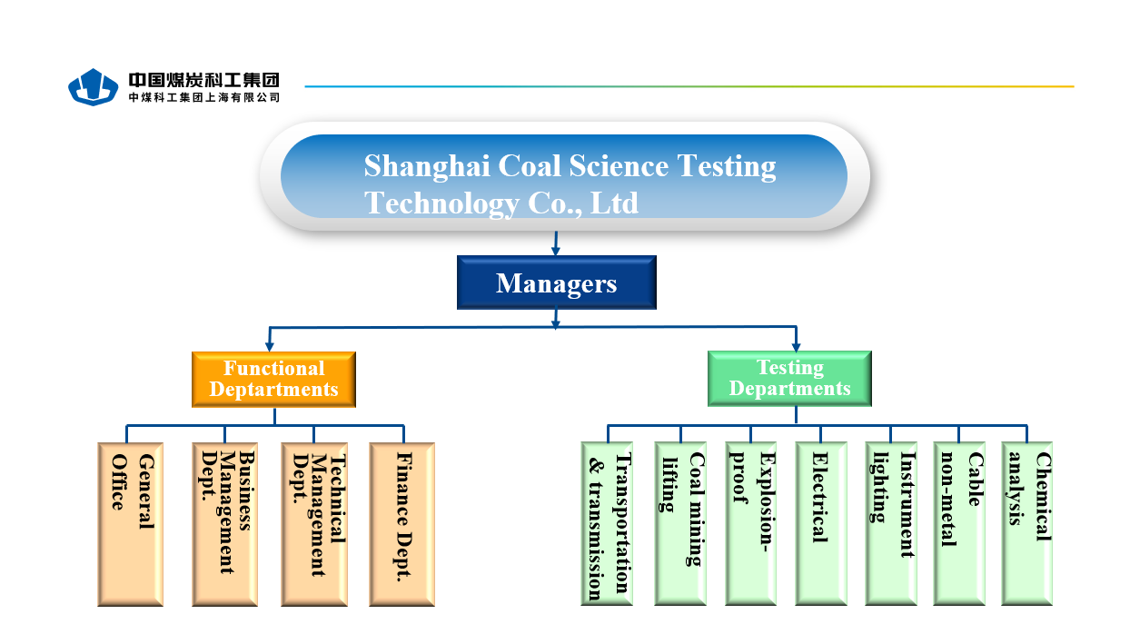

1. Organisation Chart of ExTL

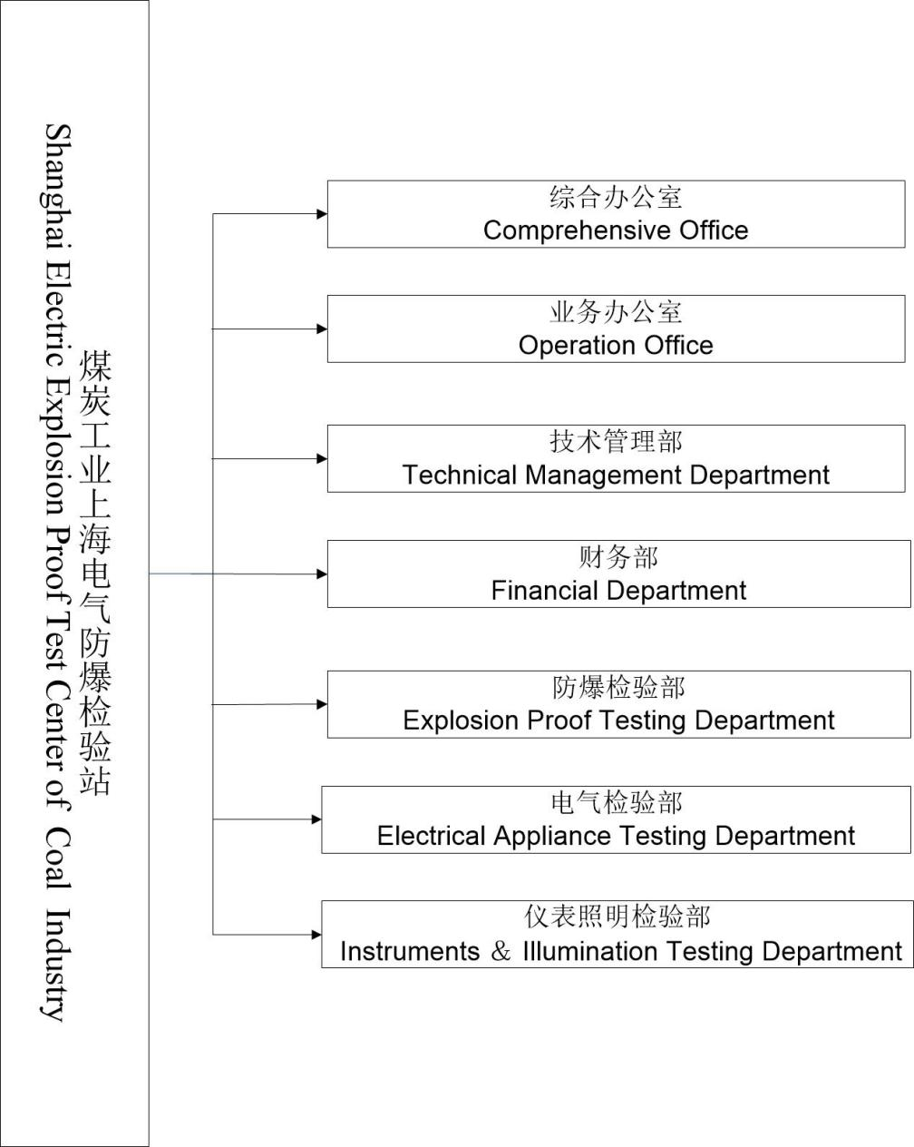

1. Accreditation Certificate for ISO/IEC 17065

Not applicable as this is an ExTL only.

1. Accreditation Certificate for ISO/IEC 17025

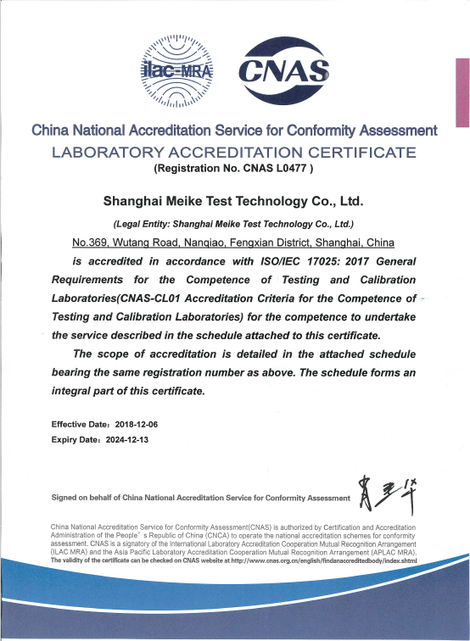

1. Accreditation Certificate for ISO/IEC 17024

Not applicable as this is an ExTL only.