INTERNATIONAL ELECTROTECHNICAL COMMISSION (IEC) SYSTEM
FOR CERTIFICATION TO STANDARDS RELATING TO EQUIPMENT FOR USE
IN EXPLOSIVE ATMOSPHERES (IECEx SYSTEM)

Title: Report from Tim Krause, Convenor ExTAG WG 10, Proficiency Testing
Circulated to: Ex Testing and Assessment Group (ExTAG)

INTRODUCTION

This document, ExTAG/733/R is a report prepared by Tim Krause the Convenor of ExTAG WG10, Proficiency Testing. The report will be presented by Mr. Tim Krause during the ExTAG 2024 IECEx Annual Meetings (Foz do Iguaçu, Brazil) for discussion and consideration.

ExTAG WG10
IECEx Secretariat



Report by the convenor of ExTAG WG 10 “Proficiency Testing”, Tim Krause, for the Annual ExTAG Meetings 2024 (Foz do Iguaçu, Brazil). The content of this report was discussed at the ExTAG WG10 meeting, which was held as a remote meeting on July 9, 2024.

- News about the IECEx/PTB Ex PT Scheme

- The first phases (Phase I) of the programs/test rounds of program cycle 2023/2024 “Explosion Pressure – Test Round 2023” (EP2023) and “Connection and Junction Boxes – Test Round 2023” (CJB2023) have been completed and the interim reports have been published (in June 2024)

- Phase II (improvement phase) has started and ends on August 31, 2024. The participants with action signals have been informed that Phase II is to be used to improve the results in order to remove the action signals for the final report

- The program cycle 2023/2024 is scheduled to be completed at the end of 2024 with the publication of the final report

- Start of program cycle 2025/2026 with the roll out of two new programs (to be defined) in March 2025
- The IECEx peer assessment of PTB as the IECEx PTS Provider, which demonstrates that the technical competence, facilities and management systems comply with ISO/IEC 17043, was successfully completed on March 5, 2024
- The following PT programs of the previous program cycles are closed:
- Explosion Pressure - Test Round 2010
- Spark Ignition - Test Round 2010
- Flame Transmission - Test Round 2013
- Temperature Classification - Test Round 2013
- Electrostatic Charge - Test Round 2015
- Intrinsic Safety - Test Round 2015
- Pressurized Enclosure - Test Round 2017
- Explosion Pressure - Test Round 2017
- Tests of Enclosures - Test Round 2019
- Battery Testing - Test Round 2019

The PT programs that are currently available are as follows:
- Flameproof Joints - Test Round 2021
- Small Component Temperature - Test Round 2021
- Connection and Junction Boxes - Test Round 2023
- Explosion Pressure - Test Round 2023

- Review and results of the IECEx/PTB Ex PT Program “EP2023” of cycle 2023/2024

- Normative background: For the program “Explosion Pressure (“EP2023”) - Test Round 2023” the general routine procedure is described by the standard “Explosive atmospheres - Part 1: Equipment protection by flameproof enclosures “d”” - IEC 60079-1, Edition 7, clause 15.2
- Participation: 91 Ex laboratories (3 latecomers), 81 results uploaded in Phase I, 81 out of 92 IECEx laboratories registered, 70 out of 81 registered IECEx laboratories have uploaded results in Phase I
- Results of the IECEx laboratories: In this Phase I, there were 28 participants with an action signal (13 of them have only an action* signal -> wrong measuring location chosen)

- Review and results of the IECEx/PTB Ex PT Program “CJB2023” of cycle 2023/2024

- Normative background: For the program “Connection and Junction Boxes (CJB) - Test Round 2023” the general routine procedure is described by the standard “Explosive atmospheres – Part 7: Equipment protection by increased safety "e"” - IEC 60079-7 Edition 5.1.
- Participation: 92 Ex laboratories (4 latecomers), 83 results uploaded in Phase I, 84 out of 92 IECEx laboratories registered, 76 out of 84 registered IECEx laboratories have uploaded results in Phase I
- Results of the IECEx laboratories: In this Phase I, there were 5 participants with an action signal

- Review of the PT Workshops 2024

- The PTB Ex PT Workshops 2024 took place at PTB from June 17 to 20, 2024. A total of 93 participants were involved
- The feedback from 8 participants was helpful for a critical analysis and significantly important for the improvement of the design of future workshops. However, it should be noted that the number of responses from participants in the survey was rather low. Nevertheless, it can be assumed that participants who were wholly or partially dissatisfied with the workshops or wanted to express criticism did so
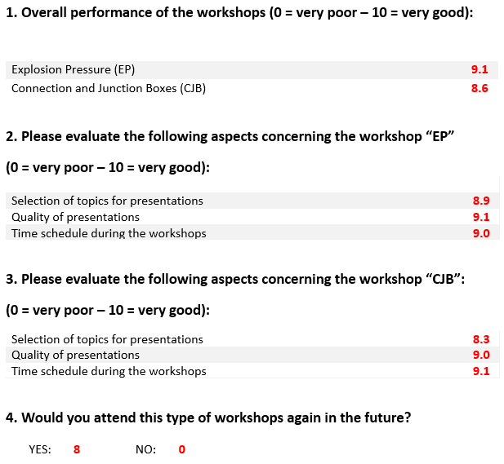
- The detailed analysis of the evaluation can be found in the following file:

- OD 202 - Draft paper to discuss

- Addition for section 4
4.4
warning signal
indication of a need to check the measurement-/testing procedures internally in case they indicate an emerging or recurrent problem from a proficiency test result
4.5
action signal
indication of a need for corrective action arising from a proficiency test result

- New draft wording of section 12

Unsatisfactory performance/results
On receipt of the “unsatisfactory results” notification due to an action signal from the IECEx PTS Provider, the individual IECEx test laboratory shall register this as a matter requiring attention in accordance with their quality management procedures. Action signal reports from the IECEx PTS Provider shall initiate the preparation of a corrective action plan by the IECEx test laboratory. This corrective action plan should consider seeking assistance from the IECEx PTS Provider.
An “unsatisfactory result” notification due to a warning signal does not require a specific corrective action plan from the IECEx test laboratory.
On receipt of the List of Laboratories with warning/action signals report by the IECEx PTS Provider, the Secretariat will file this for future reference when preparing DTRs. When the DTR is prepared for the initial, mid-term or re-assessment it will include a comment that the assessor shall review the IECEx test laboratory`s quality management procedures, which shall address any unsatisfactory performance results as a result of action signals together with corrective action plans.

NOTE Test results can appear in many forms, spanning a wide range of data types and underlying statistical distributions. The statistical methods used to analyze and evaluate the results need to be appropriate for each situation. The analysis and evaluation should be performed by the IECEx PTS Provider in accordance with ISO/IEC 17043 and ISO 13528. In some cases, due to the test method to be used or the non-physical measured variables, etc., no evaluation in the form of warning/action signals can be performed. In such cases, the IECEx PTS Provider should define other applicable evaluation criteria. If this is also not possible, the IECEx PTS Provider should identify the reasons for this and offer suggestions for improving the situation (for example, adaptation/improvement of the applied test methods, improvement measures to increase the comparability of the results, etc.).

- Program selection for cycle 2025/2026 (suggestions)

- Spark test apparatus calibration (IEC 60079-11:2023, section 9.1.3)
- Maximum surface temperature for electrical equipment of Group III, EPL Da (IEC 60079-0:2017. Section 26.5.1.3)
- … Further program proposals are being discussed and elaborated at the time of writing this ExTAG WG 10 report and will be presented during the ExTAG meeting.

- Adjustment of the participation fees for cycle 2025/2026

- PTB as the IECEx PTS Provider covers part of the personnel costs of the core PTS Team with the participation fees. All other costs such as further personnel costs, material and preparation costs for the test samples as well as shipping costs are borne by PTB
- Since the program cycle 2015/2016, the participation fees have been at the same level
- In the last years and especially during the last two cycles, there were significant increases in costs in the areas of personnel, materials, energy, shipping, etc. In order to be able to continue to finance the IECEx/PTB Ex PTS in a way that does not fully cover the costs, but is reasonably sufficient, the participant fees must be increased accordingly. For this reason, there will be an increase in participant fees for the program cycle 2025/2026:
  - Participation in both programs of the current program cycle is 6,000.00 EUR 7,000.00 EUR (VAT excluded),
  - Participation in a single program of the current program cycle is 3,500.00 EUR 4,000.00 EUR (VAT excluded),
  - Participation in a single program of a past program cycle is 1,500.00 EUR 1,750.00 EUR (VAT excluded)

