**INTERNATIONAL ELECTROTECHNICAL COMMISSION (IEC) SYSTEM FOR CERTIFICATION TO STANDARDS RELATING TO EQUIPMENT FOR USE IN EXPLOSIVE ATMOSPHERES (IECEx SYSTEM)**

**Circulated to: IECEx Management Committee members and ExTAG Members**

**Title: Revision of IECEx OD 202, Edition 4.0 (Proposed edition 5.0)**

**Introduction**

The following proposal (shown as Track Changes) for a revision of IECEx OD 202, Edition 4.0 prepared by ExTAG WG10 is now submitted for review by ExTAG during their 2024 BR Meeting, following which is expected to be submitted for ExMC member consideration during the 2024 ExMC meeting.

This draft is being submitted to both ExTAG and ExMC ahead of their respective meetings.

This draft is issued as a redline version to identify changes from the current edition.

**IECEx Executive Secretary**

|  |  |
| --- | --- |
| **Address:**  **Level 17, Angel Place**  **123 Pitt Street**  **Sydney NSW 2000**  **Australia** | **Contact Details:**  **Tel: +61 2 46 28 4690**  **e-mail:** [**info@iecex.com**](mailto:info@iecex.com)  [**http://www.iecex.com**](http://www.iecex.com) |



IECEx OD 202

IECEx OD 202:2024-05(en)

IECEx

OPERATIONAL DOCUMENT

Edition 5.0 2024-09

IECEx Certified Equipment Scheme –  
IECEx Proficiency Testing Scheme

IEC System for Certification to Standards Relating to Equipment for Use in Explosive Atmospheres (IECEx System)

|  |
| --- |
| **THIS PUBLICATION IS COPYRIGHT PROTECTED**  **Copyright © 2024 IEC, Geneva, Switzerland**  All rights reserved. Unless otherwise specified, no part of this publication may be reproduced or utilized in any form or by any means, electronic or mechanical, including photocopying and microfilm, without permission in writing from either IEC or IEC's member National Committee in the country of the requester. If you have any questions about IEC copyright or have an enquiry about obtaining additional rights to this publication, please contact the address below or your local IEC member National Committee for further information.  IEC Secretariat Tel.: +41 22 919 02 11  3, rue de Varembé [info@iec.ch](mailto:info@iec.ch)  CH-1211 Geneva 20 [www.iec.ch](https://www.iec.ch/)  Switzerland |

**About the IEC**

The International Electrotechnical Commission (IEC) is the leading global organization that prepares and publishes International Standards for all electrical, electronic and related technologies.

**About IEC publications**

The technical content of IEC publications is kept under constant review by the IEC. Please make sure that you have the latest edition, a corrigendum or an amendment might have been published.

**IEC publications search -** [**webstore.iec.ch/advsearchform**](https://webstore.iec.ch/advsearchform)

The advanced search enables to find IEC publications by a variety of criteria (reference number, text, technical committee, …). It also gives information on projects, replaced and withdrawn publications.

**IEC Just Published -** [**webstore.iec.ch/justpublished**](https://webstore.iec.ch/justpublished)

Stay up to date on all new IEC publications. Just Published details all new publications released. Available online and once a month by email.

**IEC Customer Service Centre -** [**webstore.iec.ch/csc**](https://webstore.iec.ch/csc)

If you wish to give us your feedback on this publication or need further assistance, please contact the Customer Service Centre: [sales@iec.ch](mailto:sales@iec.ch).

**IEC Products & Services Portal -** [**products.iec.ch**](https://products.iec.ch/)

Discover our powerful search engine and read freely all the publications previews. With a subscription you will always have access to up to date content tailored to your needs.

**Electropedia -** [**www.electropedia.org**](http://www.electropedia.org)

The world's leading online dictionary on electrotechnology, containing more than 22 300 terminological entries in English and French, with equivalent terms in 19 additional languages. Also known as the International Electrotechnical Vocabulary (IEV) online.



INTERNATIONAL  
ELECTROTECHNICAL  
COMMISSION

IECEx Certified Equipment Scheme –  
IECEx Proficiency Testing Scheme

IECEx OD 202

Edition 5.0 2024-09

IECEx

OPERATIONAL DOCUMENT

IEC System for Certification to Standards Relating to Equipment for Use in Explosive Atmospheres (IECEx System)

CONTENTS

FOREWORD 3

1 Purpose 4

2 Scope 4

3 Normative references 4

4 Definitions 4

5 Abbreviations 5

6 Participation 5

7 IECEx PTS Provider 6

8 Selection of programmes 7

9 Programme management 7

10 Programme results 8

11 Programme reports 9

12 Unsatisfactory performance/results 9

13 Outliers 10

14 Appeal by the laboratory 10

15 Completion of corrective actions 10

16 Workshops and “best practice papers”/decision sheets (DS) 11

Annex A (informative) Programme registration template as an example 12

Annex B (informative) Description and structure of the IECEx PTS 14

Figure B.1 – Overview of the structure of the IECEx PTS 14

Figure B.2 – Programme flowchart 15

INTERNATIONAL ELECTROTECHNICAL COMMISSION

____________

IECEx Operational Document OD 202 –

IECEx Certified Equipment Scheme –  
IECEx Proficiency Testing Scheme

FOREWORD

Following the successful application of the first global Ex proficiency testing scheme, the “IECEx PTS”, IECEx ExTAG and the IECEx Secretariat prepared this IECEx operational document as guidance to IECEx test laboratories on satisfying the requirements of ISO/IEC 17025 with respect to participation in proficiency testing programmes as conducted for inter-laboratory comparisons. The principles and requirements of ISO/IEC 17043 have been incorporated in or referenced from this operational document.

Decision 2014/53 taken at the 2014 IECEx Management Committee (ExMC) Meeting in The Hague and then adopted in the IECEx 02 Rules Edition 6.1 as a mandatory requirement.

**Document history**

|  |  |
| --- | --- |
| Date | Summary |
| September 2015 | Original issue (Edition 1.0) as approved for publication via ExMC Decision 2015/40 regarding ExMC/1040/CD and subsequent changes by ExTAG WG10 as detailed in ExMC(Christchurch/ExTAG WG10)05 |
| October 2017 | Issue of Edition 2.0 as circulated to 2017 ExMC Meeting as ExMC/1292/DV and subsequently approved for publication via Decision 2017/82 |
| July 2019 | Issue of Edition 3.0. Add IECEx test laboratories to define ExTL, applicant ExTL and Additional Testing Facility and further define role of IECEx PTS and IECEx Secretariat |
| May 2022 | Issue of Edition 4.0. Clarification on subcontracting and participation requirements for Applicant ExTLs and Applicant ATFs. Addition of registration templates as annex. |
| September 2024 | Issue of Edition 5.0; Addition of the definitions for warning signal and action signal and adaption of section 12 to provide a clearer description of the consequences of warning and action signals. |

Address:

IECEx Secretariat c/o IEC Sydney Office

Level 17 Angel Place

123 Pitt Street

Sydney, NSW 2000

Australia

Contact details:

[info@iecex.com](mailto:info@iecex.com)

[www.iecex.com](http://www.iecex.com)

IECEx Certified Equipment Scheme –  
IECEx Proficiency Testing Scheme

# Purpose

The purpose of this document is to describe the rules of operation of the IECEx Proficiency Testing Scheme (IECEx PTS), which has been developed in line with International Standard ISO/IEC 17043.

# Scope

The primary goal of the IECEx PTS is to increase the mutual confidence among the IECEx test laboratories operating within the IECEx System. In support of this goal the IECEx PTS has been designed to improve the consistency and reproducibility of test results.

# Normative references

The following publications contain provisions which, through reference in this text, constitute modification or additions of this operational document. Where an edition is not specified, the latest published version applies.

ISO/IEC 17025:2017, *General requirements for the competence of testing and calibration laboratories*

ISO/IEC 17043, *Conformity assessment – General requirements for proficiency testing*

ISO 13528, *Statistical methods for use in proficiency testing by interlaboratory comparison*

IECEx 02, *IEC System for Certification to Standards relating to Equipment for use in Explosive Atmospheres (IECEx System) – IECEx Certified Equipment Scheme covering equipment for use in explosive atmospheres – Rules of Procedure*

IECEx OD 024, *IECEx rules of procedure covering testing, or witnessing testing at a manufacturer’s, user’s or third party’s facility*

IECEx OD 003-2, *Assessment procedures for IECEx acceptance of applicant Ex Certification Bodies (ExCBs), Ex Testing Laboratories (ExTLs) and Additional Testing Facilities (ATFs) – Part 2: Assessment, surveillance assessment and re-assessment of ExCBs and ExTLs operating in the IECEx 02, IECEx Certified Equipment Scheme*

# Definitions

For the purpose of this publication, the definitions contained in ISO/IEC 17043 and the following apply:

proficiency testing programme

organization, performance and evaluation of measurements or tests on the same or similar items by two or more laboratories in accordance with predetermined conditions (see also ISO/IEC 17043)

IECEx test laboratory

includes all IECEx ExTLs, IECEx Applicant ExTLs, IECEx Additional Testing Facilities (ATFs) and IECEx Applicant ATFs, as defined in IECEx 02

NOTE This does not include laboratories operating under the provisions of IECEx OD 024*.*

Desktop Review Report

Secretariat report provided to the assessors which includes a summary of participation in the IECEx PTS and if the assessor should review the IECEx test laboratory`s internal management system which may provide further information on the IECEx test laboratorytaking corrective actions on unsatisfactory results. The secretariat report must not disclose confidential information

warning signal

indication of a need to check the measurement-/testing procedures internally in case they indicate an emerging or recurrent problem from a proficiency test result

action signal

indication of a need for corrective action arising from a proficiency test result

# Abbreviations

ATF Additional Testing Facility

ExMC IECEx Management Committee

ExTAG IECEx Testing and Assessment Group

ExTAG WG ExTAG Working Group

ExCB IECEx Certification Body

ExTL IECEx Testing Laboratory

IECEx PTS IECEx Proficiency Testing Scheme

DTR Desktop Review Report

PTP Proficiency Testing Programme

TCD Technical Capability Document

# Participation

In accordance with IECEx ExMC Decision 2014/53 and IECEx 02, participation in the IECEx PTS is mandatory for all the IECEx test laboratories, as defined in Clause 4 of this operational document. Laboratory participation is according to their scope of application and/or of their scope of acceptance in the IECEx System and is a condition for continued acceptance.

Applicant ExTLs and applicant ATFs are required to demonstrate their capability to satisfy the testing in recent proficiency testing programmes. This will be satisfied by the body becoming involved as early as possible with the PTS once they have identified their intention to become an ExTL or ATF. Evidence of their results from these programmes can then be considered during the assessment according to IECEx OD 003-2 and may lead to a reduction in time needed to witness testing during the initial assessment and each five-year re-assessment.

As a minimum, the applicants shall be enrolled in all current programmes relevant to their scope of application.

Where an applicant has not completed recent programmes (typically the last two rounds of programmes) prior to application, the following options are available:

1. complete earlier programmes relevant to their scope of application, where such programmes are still available

and/or

1. during the initial assessment, demonstrate appropriate results on artefacts from past programmes

NOTE 1 Such artefacts may be artefacts obtained from the IECEx PTS Provider, on loan from other bodies or manufactured according to the specification of the artefacts in the PTS documentation.

NOTE 2 Option 2 above can be expected to result in additional assessment time.

NOTE 3 It is anticipated the bodies will have prior/current involvement in IECEx or similar proficiency testing schemes to satisfy the requirements of ISO/IEC 17025.

IECEx test laboratories that need to borrow or rent measurement equipment to perform a specific test of a programme must still participate in the programme and submit the results for their test sample to the IECEx PTS Provider.

IECEx test laboratories that subcontract the entire test (permitted for a test without an asterisk in TCD) must still participate in the programme and submit the results for their test sample to the IECEx PTS Provider unless the laboratory to which the test was subcontracted is itself an IECEx testing laboratory that also participates in the same programme.

Costs incurred by borrowing, renting or subcontracting are to be covered by the IECEx testing laboratory.

In the event of unsatisfactory results in previous programmes, an IECEx test laboratory may be required to repeat a test round of a previous programme in addition to the current test rounds of the current programmes.

The number of programmes to take place each year shall be decided by the ExTAG with the maximum number of new programmes limited to two for every two-year cycle. Repeated programmes also require ExTAG approval.

During the regular programme cycle (two-year cycle), the IECEx test laboratories shall complete the programmes. If a laboratory performs previous programmes, the programmes must be completed within three months of receiving the test samples.

A programme is considered complete when the tests have been performed by the IECEx test laboratory, the results have been transmitted to the IECEx PTS Provider, and the report has been issued by the IECEx PTS Provider.

Each programme will identify the relevant IEC Standards within the scope of the IECEx Certified Equipment Scheme to which it applies.

The IECEx Secretariat shall ensure that each accepted IECEx test laboratory participates in the applicable programmes that fall within the scope of acceptance of the laboratory.

The participation of all IECEx test laboratories shall be monitored by the IECEx Secretariat with the support of the IECEx PTS Provider.

Evidence of participation in the IECEx PTS, completion of all applicable programmes and summary of the findings, shall form part of the input for the initial, a mid-term or re-assessment audit.

NOTE Although the purpose of a mid-term surveillance assessment is to carry out a technical review of IECEx Certification files and the related ExTRs and QARs for technical integrity, completeness and compliance with IECEx Rules and Operational Documents, it should also be used to discuss any concerns with the IECEx test laboratory, such as unsatisfactory programme results.

# IECEx PTS Provider

The programmes are coordinated and processed by an IECEx PTS Provider that is independent of the participating testing laboratories and operates in coordination with ExTAG Working Group 10, Proficiency Testing (ExTAG WG 10).

IECEx PTS Providers will be determined by the IECEx ExMC on recommendations from ExTAG WG 10 via ExTAG.

The competence of the IECEx PTS Provider shall be demonstrated by assessment. The general competence, efficiency, experience, familiarity with the relevant standards used for the programmes as well as compliance with ISO/IEC 17043 shall be assessed.

Accreditation by a recognized national accreditation body, where existing, shall be considered.

The ExMC shall decide upon the extent of the assessment that is necessary (considering the period of new programmes). Assessors approved by the ExMC shall carry out the assessment. The IECEx Executive Secretary appoints the assessment team to conduct the assessment of the IECEx PTS Provider. Assessors with prior experience in the field of proficiency testing and whose knowledge of standards is current should be used. The IECEx PTS Provider shall be given the opportunity to agree on the assessors chosen to carry out an assessment.

The IECEx PTS Provider to be assessed shall express its willingness to pay the professional fees of the assessors, the amount to be decided by the ExMC, and the reasonable travelling and living expenses arising from the assessment. An estimate of these expenses shall be provided to the IECEx PTS Provider in advance and agreed by the IECEx PTS Provider.

After the assessment, the IECEx Secretariat shall be given the documentation that supports the findings of the assessment and how any issues have been resolved.

IECEx PTS Providers shall be capable of developing and operating programmes for all IEC 60079 series of standards and selected standards from the ISO 80079 series.

To ensure continuity of the effectiveness of operation of the IECEx PTS, IECEx PTS Providers shall provide annual reports to the ExTAG and the IECEx Secretariat on activities, programme results and any issues arising that may have an impact on the effectiveness of the IECEx PTS.

# Selection of programmes

Suggestions for programmes can be made by the IECEx PTS Provider based on questionnaires circulated under all the IECEx test laboratories, by proposals of the ExTAG WG 10 or by other experts. The IECEx PTS Provider shall then take a decision on the programmes to provide, taking those suggestions and any recommendations by ExTAG into account.

All related costs (IECEx PTS Provider costs, in-house costs for the test laboratory staff, etc.) shall be estimated and compiled for consideration. After agreement by ExTAG the IECEx PTS Provider shall implement the programmes and request IECEx test laboratories for participation. The IECEx PTS Provider shall ensure that all available programmes can be performed by any IECEx test laboratory at any time. In case previous programmes must be closed (for example, due to instability of test samples, new programme versions, etc.), the IECEx PTS Provider shall report this information to the IECEx test laboratories, ExTAG and the IECEx Secretariat.

# Programme management

The IECEx Secretariat role is to assist the IECEx PTS including the activities of the IECEx PTS Provider ensuring that all IECEx test laboratories participate in the IECEx PTS.

The IECEx PTS Provider sends out the details for each programme to the IECEx test laboratories in advance.

Each IECEx test laboratory shall acknowledge its willingness to participate in individual programmes to the IECEx PTS Provider. This acknowledgement shall be made directly to the IECEx PTS Provider in writing prior to the sample shipping date provided with the programme details. Annex A provides an example of the informative template for participation registration.

The IECEx PTS Provider supplies the IECEx Secretariat with a list of IECEx test laboratories that have registered for each programme to enable a check if all IECEx test laboratories in scope of the relevant programme have registered.

This operational document is intended to fulfil part of the IECEx Certified Equipment Scheme Rules and the IECEx Secretariat shall follow up with IECEx test laboratories that are required to participate but have not registered.

The IECEx PTS Provider prepares the test samples and first subjects them to a round of homogeneity tests at a competent testing laboratory. The homogeneity test laboratory is chosen by the IECEx PTS Provider, if necessary, in consultation with ExTAG WG 10.

The IECEx PTS Provider sends out the detailed instructions and samples, then collects and analyzes the results.

The data analysis and evaluation of the results from the IECEx test laboratories shall be performed by the IECEx PTS Provider in accordance with ISO/IEC 17043 and ISO 13528.

Based on this, the IECEx PTS Provider completes the reports (participants are anonymous and publicly identified only by a code), circulates them to ExTAG WG 10 for information, and issues the reports to the participating laboratories. Only the participants and the IECEx Secretariat shall be provided with the anonymization codes by the IECEx PTS Provider.

A test round consists of two phases (Phase I and Phase II).

In Phase I, the IECEx test laboratories perform the tests and transmit the results to the IECEx PTS Provider. The IECEx PTS Provider evaluates the results and publishes the interim report. In addition to the evaluated results, the interim report contains initial aspects for discussion and interpretation.

Phase I is followed by the workshops (see Clause 16) assigned to the programmes.

Phase I and the workshops are followed by Phase II (improvement loop). In this phase the IECEx test laboratories can repeat their tests if they are not satisfied with their results from Phase I. The new results are then used to create the final report. If the IECEx test laboratories are satisfied with their Phase I results, they do not need repeat the Phase II tests. In this case, the results obtained in Phase I are used for the final report.

The final report is the decisive report for the assessment of the performance of the laboratories (unsatisfactory performance/results) and is the basis for the List of Laboratories with warning/action signals.

An overview and description of the IECEx PTS structure and the programme design can be found in Annex B.

# Programme results

The confidentiality of results of individual laboratories is essential.

The IECEx PTS Provider communicates the results only to the individual IECEx test laboratories and to the IECEx Secretariat. If requested by the IECEx Secretariat the IECEx PTS Provider provides a summary report about the performance of IECEx test laboratories to the IECEx Secretariat (see Clause 11). In preparation of an initial, mid-term or re-assessment the IECEx Secretariat provides the following information to assessment teams:

1. that individual IECEx test laboratories have participated in the programmes relevant to the scope of their application; and a) or b) below as appropriate
2. the results of an individual IECEx test laboratory suggests that they are in line with results obtained from other IECEx test laboratories in the programmes; or
3. the results of an individual IECEx test laboratory suggests that there may be issues that the assessment team should look at closely during their assessment.

The individual IECEx test laboratory may discuss its results with the IECEx assessment team or national accreditation bodies who may ask separately for the results of the programmes. It is not permitted to publish detailed programme results. Only general information about results of programmes may be published.

# Programme reports

The programme reports shall be prepared and distributed by the IECEx PTS Provider according to the requirements of ISO/IEC 17043. The programme reports include the following:

* Status of Participants Report
* Participants Results Summary Report (Interim & Final Report)
* List of Laboratories with warning/action signals (if used in the programme)
* Additional information/report regarding an IECEx test laboratory’s performance for a certain programme (if requested by the IECEx Secretariat)

In addition to programme reports, a separate report shall be prepared on an individual IECEx test laboratory about the overall performance of all programmes performed by the laboratory. This would be for the purposes of an initial, mid-term or re-assessment.

The Secretariat shall prepare a Desktop Review Report (DTR) as per Clause 10 for the assessment team in time for them to take it into account when preparing their assessment plan.

# Unsatisfactory performance/results

On receipt of the “unsatisfactory results” notification due to an action signal from the IECEx PTS Provider, the individual IECEx test laboratory shall register this as a matter requiring attention in accordance with their quality management procedures. Action signal reports from the IECEx PTS Provider shall initiate the preparation of a corrective action plan by the IECEx test laboratory. This corrective action plan should consider seeking assistance from the IECEx PTS Provider.

An “unsatisfactory result” notification due to a warning signal does not require a specific corrective action plan from the IECEx test laboratory.

On receipt of the List of Laboratories with warning/action signals report by the IECEx PTS Provider, the Secretariat will file this for future reference when preparing DTRs. When the DTR is prepared for the initial, mid-term or re-assessment it will include a comment that the assessor shall review the IECEx test laboratory`s quality management procedures, which shall address any unsatisfactory performance results as a result of action signals together with corrective action plans.

NOTE Test results can appear in many forms, spanning a wide range of data types and underlying statistical distributions. The statistical methods used to analyze and evaluate the results need to be appropriate for each situation. The analysis and evaluation should be performed by the IECEx PTS Provider in accordance with ISO/IEC 17043 and ISO 13528. In some cases, due to the test method to be used or the non-physical measured variables, etc., no evaluation in the form of warning/action signals can be performed. In such cases, the IECEx PTS Provider should define other applicable evaluation criteria. If this is also not possible, the IECEx PTS Provider should identify the reasons for this and offer suggestions for improving the situation (for example, adaptation/  
improvement of the applied test methods, improvement measures to increase the comparability of the results, etc.).

# Outliers

The IECEx PTS Provider shall limit the influence of outliers on summary statistics by use of robust statistical methods or appropriate tests to detect statistical outliers in accordance with ISO 13528.

Individual IECEx test laboratories may be informed of outliers, for example, if there are obvious errors in data transmission (number shifts, etc.) or other inadvertent errors.

# Appeal by the laboratory

An IECEx test laboratory that disagrees with the performance evaluation has the right to appeal.

Appeals shall be made in writing to the IECEx Secretariat, with a copy to the IECEx PTS Provider, within two months from the report issue date, and shall clearly indicate the basis for the appeal. This allowance of two months for the preparation of an appeal does not extend the three-month period allowed for completion of corrective actions.

For appeals that require technical input ExTAG WG 10 may be consulted. However, the identity of the IECEx test laboratory shall remain confidential for the duration of such consultation. ExTAG WG 10 shall respond within 15 working days upon receipt of the request from IECEx Secretariat and/or the IECEx PTS Provider.

# Completion of corrective actions

All action signals reported shall be investigated by the IECEx test laboratory as part of their planning of corrective and preventive actions.

Participants carrying out corrective actions shall follow the procedures outlined in Clauses 8.6 and 8.7 of ISO/IEC 17025:2017 and the results should be documented in their internal document management system.

Completed corrective action reports shall be sent to the IECEx PTS Provider (with a copy to the IECEx Secretariat) for inclusion and update of the programme status of the participant.

Copies of completed corrective action forms shall be held by the laboratory for review during the next on-site assessment.

The IECEx Secretariat, supported by the IECEx PTS Provider, is responsible for monitoring the corrective action status and shall perform this through the surveillance assessment programme but is not responsible for the technical validity of the actions undertaken.

IECEx test laboratories requiring more time to prepare corrective action plans, shall make a request in writing to the IECEx Secretariat with a copy to the IECEx PTS Provider.

IECEx test laboratories failing to complete the proposed corrective action within three months will be notified by the IECEx Secretariat.

The IECEx Secretariat shall subsequently follow-up on corrective actions in accordance with the IECEx procedures for planning the assessment of IECEx test laboratories as required by IECEx OD 003-2.

# Workshops and “best practice papers”/decision sheets (DS)

The IECEx PTS Provider shall offer workshops to promote experience exchange among IECEx test laboratories. These workshops shall provide scientific background of the objective of a programme, daily practice presented by volunteering IECEx test laboratories and practical training to be offered in a laboratory. After the workshops, “best practice papers” and decision sheets may be drafted by the IECEx PTS Provider and published at the end of each programme. All participants shall have access to the “best practice papers”. Laboratories considering becoming applicants may be provided with the papers for which a fee may be charged.

1. (informative)  
     
   Programme registration template as an example

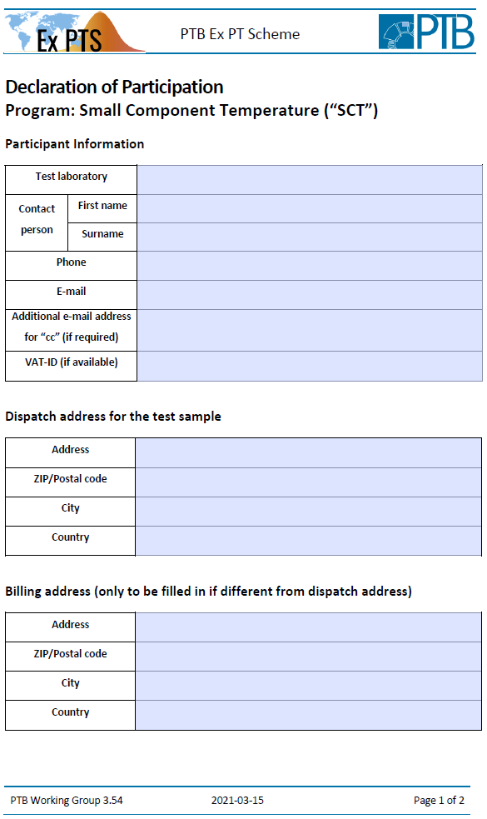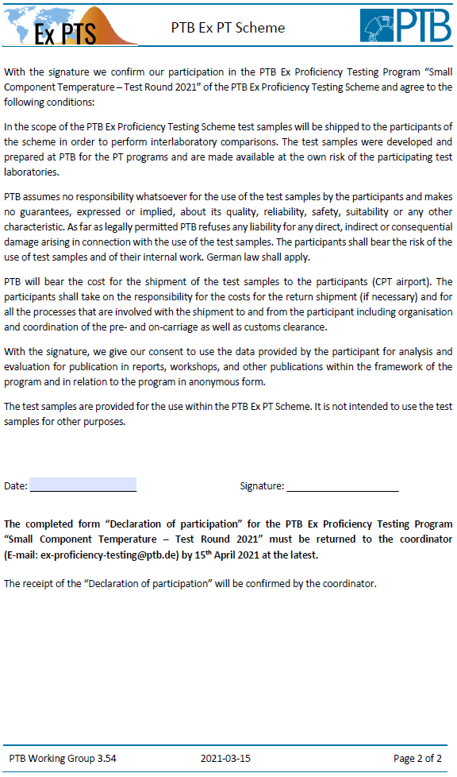

1. (informative)  
     
   Description and structure of the IECEx PTS

The IECEx PTS consists of different programmes regarding to different areas of testing in the field of explosion protection.

For conducting the programmes, the individual routine procedure of each IECEx test laboratory should be applied (used every day for achieving the test results for real projects).

The general routine procedure is described by the standards of the applicable type of protection. This means that the standard of the respective type of protection shall also be used as a basis when the quantities to be compared (measurands or characteristics of interest) are selected by the IECEx PTS Provider.

Each test round is unambiguously assigned to a programme and is indicated by the year of the roll-out. Each programme can have more than one test round. During each test round there will be a workshop on the corresponding topic. The following figure illustrates the structure:

Programme

Programme

Programme

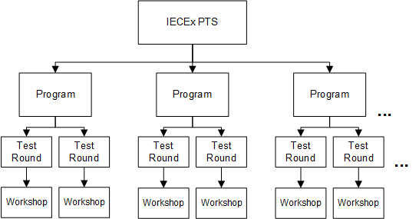

Figure B.1 – Overview of the structure of the IECEx PTS

The individual steps of the typical programme design are shown in the following programme flowchart. In any case of deviation from this structure this shall be addressed in the respective roll-out paper and procedure instruction by the IECEx PTS Provider.

Start

1. Development of a new programme

2. Development and preparation of a test

sample prototype

4. Registration phase for participation

5. Preparation and shipment of the test

samples to the participants

6. Performance of the tests by the IECEx test

laboratories and transmission of the results to

the IECEx PTS Provider (Phase I)

7. Analysis of the test results and publication

of the interim report by the IECEx PTS

Provider (Phase I)

8. Workshop

9. Repetition of the tests by the IECEx test

laboratories and transmission of the results

to the IECEx PTS Provider (Phase II)

10. Analysis of the repeated test results and

publication of the final report by the IECEx

PTS Provider (Phase II)

11. Publication of “best practice papers”,

decision sheets, etc.

End

3. Roll-out of the programme

Figure B.2 – Programme flowchart