INTERNATIONAL ELECTROTECHNICAL COMMISSION SYSTEM FOR CERTIFICATION TO STANDARDS RELATING TO EQUIPMENT FOR USE IN EXPLOSIVE ATMOSPHERES (IECEx SYSTEM)

Title: Re-assessment Report for the continued acceptance of Intertek Testing Services NA, Inc. US (ETL) an Accepted Certification Body, ExCB and an Accepted Test Laboratory (ExTL) within the IECEx Equipment Scheme 02 .

Circulation to: Members of the IECEx Management Committee, ExMC

In accordance with the 5 Year re-assessment plan for the surveillance and monitoring of bodies within the IECEx System, the following document contains the IECEx Reassessment Report for the continued acceptance of Intertek Testing Services NA, Inc. US (ETL) an Accepted Certification Body (ExCB) and an Accepted Test Laboratory (ExTL) within the IECEx Equipment Scheme 02.

This report is hereby submitted for endorsement during the 2025 ExMC Meeting.

Chris Agius

Visiting address:  IECEx Secretariat  Level 17 Angel Place  123 Pitt Street  Sydney NSW 2000  Australia | Contact Details:  Tel: +61 2 4628 4690  Fax: +61 2 4627 5285  E-mail: info@iecex.com  http://www.iecex.com

IEC System for certification to standards relating to equipment for use in Explosive Atmospheres (IECEx System)

IECEx Assessment Report Form, F-003

IECEx assessment report form for use by IECEx assessment teams to report assessments conducted according to the relevant IECEx assessment procedures of:

Operational Document IECEx OD 003-2 for the Certified Equipment Scheme

Operational Document IECEx OD 316-* for the Certified Service Facility Scheme

Operational Document IECEx OD 422 for the IECEx Conformity Mark Licensing Scheme

Operational Document IECEx OD 501 for the Personnel Competence Scheme

IECEx ExCB/ExTL/ATF assessment report for

Intertek Testing Services NA, Inc.

INTERNATIONAL
ELECTROTECHNICAL
COMMISSION

CONTENTS

1 Assessment information 6
1.1 Type of body covered by this assessment: 6
1.2 Type of assessment: 6
1.3 Details of body 6
1.3.1 Country 6
1.3.2 Name of body 6
1.3.3 Name and title of nominated principal contact 6
1.4 Assessment information 6
1.4.1 Members of the assessment team 6
1.4.2 Place(s) of assessment 7
1.4.3 Assessment date(s) 7
1.5 Application information and background information on the assessment 7
1.6 Scopes 7
1.6.1 ExCB scope for equipment certification scheme 7
1.6.2 ExTL scope 7
1.6.3 ATF Scope 7
1.6.4 ExCB scope for Service Facilities Scheme 7
1.7 ExCB scope for Conformity Mark Licensing Scheme 7
1.8 ExCB scope for IECEx Personnel Competence Scheme 7
2 Common information 8
2.1 Legal entity of body 8
2.2 Financial support 8
2.3 History 8
2.4 Documentation 9
2.4.1 Quality manual 9
2.4.2 Procedures 9
2.4.3 Work instructions 9
2.4.4 Records (including test records where relevant) 9
2.4.5 Document change control 10
2.5 Confidentiality 10
2.6 Communication with public and customers (Hard copy and Electronic) 10
2.7 Recognitions and agreements 10
2.8 Internal audit 10
2.9 Management review 10
2.10 Contracting, subcontracting and witness testing 11
2.10.1 Contracting 11
2.10.2 Subcontracting 11
2.10.3 Off-site and Witness testing 11
2.11 Training and competence 11
2.12 Complaints and appeals (including appeals to IECEx) 12
2.13 Impartiality 12
2.14 Active involvement in development of Decision Sheets 12
2.15 Special facts to be noted 12
2.16 Supporting documentation 12
2.17 Recommendations 13
3 ExCB for IECEx Certified Equipment Scheme 14
3.1 Assessment references 14
3.1.1 General references 14
3.1.2 Additional references applied for this assessment 14
3.2 Candidate ExCB persons interviewed 14
3.3 Associated ExTL(s) 14
3.4 Associated certification functions 14
3.5 National marks and certificates 15
3.6 Standards accepted 15
3.7 National differences to IEC standards 15
3.8 Organisation 15
3.8.1 Names, titles and experience of the senior executives 15
3.8.2 Name, title and experience of the quality management representative 15
3.8.3 Name and title of signatories for certification 15
3.8.4 Other employees in ExCB activity 15
3.9 Organizational structure 16
3.10 Indemnity insurance 16
3.11 Resources 16
3.12 Committees (such as governing or advisory boards) 16
3.13 Certification operations 16
3.13.1 National approval/certification methods 16
3.13.2 Certification policy 16
3.13.3 Application for certification 16
3.13.4 Certification decision 17
3.13.5 Suspension and cancellation of certificates 17
3.14 Certificates issued 17
3.15 National accreditation 18
3.16 Assessment of manufacturers and issue of QARs 18
3.17 Comments (including issues found during assessment) 18
4 ExTL for IECEx Certified Equipment Scheme 20
4.1 Assessment references 20
4.1.1 General references 20
4.1.2 Additional references applied for this assessment 20
4.2 Candidate ExTL persons interviewed 20
4.3 Associated ExCB(s) 20
4.4 Organisation 20
4.4.1 Names, titles and experience of the senior executives 20
4.4.2 Name, title and experience of the quality management representative 21
4.4.3 Other employees in ExTL activity 21
4.5 Organizational structure 21
4.6 Resources 21
4.7 Test reports issued 21
4.8 National accreditation 22
4.9 Calibration 23
4.10 Tests witnessed during the assessment visit 23
4.11 Participation in IECEx Proficiency Testing Programs 24
4.12 Comments (including issues found during assessment) 25
6 Annexes 26
Annex A Scope for IECEx Certified Equipment Scheme 27
A.1 Current standards 27
A.2 Superseded standards 28
Annex B Overall Organisation Chart 29
Annex C Organisation Chart of ExCB/ExTL/ATF 30
Annex D Accreditation Certificate for ISO/IEC 17065 31
Annex E Accreditation Certificate for ISO/IEC 17025 32

Assessment information

Type of body covered by this assessment:

ExCB for IECEx Certified Equipment Scheme
ExTL for IECEx Certified Equipment Scheme
ATF for IECEx Certified Equipment Scheme
ExCB for IECEx Certified Service Facilities Scheme
ExCB for IECEx Conformity Mark Licensing System
ExCB for IECEx Certification of Personnel Competency Scheme

NOTE 1 ExCB - IECEx Certification Body
NOTE 2 ExTL - IECEx Testing Laboratory
NOTE 3 ATF - Additional Testing Facility

Type of assessment:
Pre-assessment for candidate body
Initial assessment for candidate body
Surveillance
Re-assessment
Scope extension

Details of body

Country
United States of America

Name of body
Intertek Testing Services NA, Inc., hereafter called as “Intertek NA”

Name and title of nominated principal contact
Name | Title | E-mail address
William T. Fiske | Senior Director – Technical Affairs | Bill.fiske@intertek.com  Tel: +1 607 758 6286  Fax +1 607 758 6637
Kevin J. Wolf | Assistant Chief Engineer | Kevin.wolf@intertek.com  Tel. +1 607 758 6305

Assessment information

Members of the assessment team
Name | Role
Bernard Piquette | IECEx Lead Assessor
Eduardo Galera | IECEx Assessor (acting as Lead Assessor)

Place(s) of assessment
3933 US Route 11 South
Cortland, NY 13045
USA

Assessment date(s)
May 20 to May 22, 2024

Application information and background information on the assessment
No scope extension requested.

Scopes

ExCB scope for equipment certification scheme
The scope for the ExCB is shown in Annex A.
NOTE 1 Unless otherwise indicated, earlier editions of standards (even if with a different number) are considered to be covered in the above scope for the purposes of the assessment.

ExTL scope
The ExTL scope is the same as for the ExCB except for the IEC 60079-30-1 which is not in the scope of ExTL Cortland. See Annex A for details.

ATF Scope
Not applicable.
NOTE Where the body does not have all tests required by a standard, the scope should clearly identify the tests that form part of the scope. This may be achieved by either showing all tests included or all tests excluded, dependant on the number involved.

ExCB scope for Service Facilities Scheme
Not participating on the Service Facilities Scheme.

ExCB scope for Conformity Mark Licensing Scheme
Not participating on the Mark Licensing Scheme.

ExCB scope for IECEx Personnel Competence Scheme
Not participating on the Personnel Competence Scheme.

Common information

Legal entity of body
Intertek Testing Services NA, Inc. is incorporated under the laws of the State of New York, U.S.A., as a for-profit corporation. The legal license of business of Intertek NA with registration number 200402240121 59 was reviewed during site assessment.

Financial support
Intertek is getting its income from testing, certification, and training. The annual reports show a positive result (https://www.intertek.com/investors/).

History
Intertek Testing Services NA, Inc. is a wholly owned subsidiary of Intertek Group plc. Intertek Group plc is a technical services company registered in the UK. Product testing and certification-related consultancies are not provided by the Intertek Group plc.
Intertek Testing Services NA, Inc. has a chain of Testing Laboratories and a Certification Body throughout North America.
The Cortland Laboratory began as Electrical Testing Laboratories (ETL), originally located in New York City, was founded in 1896 as the Lamp Testing Bureau through the incorporation of five of the original Edison Illuminating Companies.
In 1972, Electrical Testing Laboratories established its first satellite laboratory near Atlanta, GA.
In 1977, the laboratory was relocated from New York City to the current site in Cortland NY.
In 1978, Electrical Testing Laboratories was renamed ETL Testing Laboratories, Inc., and shortly thereafter established a laboratory in South San Francisco, CA.
In 1988, ETL was purchased by Inchcape, plc and became part of Inchcape Testing Services.
In 1991, Inchcape Testing Services purchased Dash, Straus & Goodhue, Inc. (DS&G) located near Boston, MA.
In 1992, ETL and DS&G both enter IECEE CB Scheme.
In 1994, Inchcape Testing Services acquired SEMKO, located near Stockholm, Sweden.
In 1996, Inchcape Testing Services is sold and the company name is changed to Intertek Testing Services NA Inc. and incorporated under the laws of the State of New York as a for-profit corporation under the parent company Intertek Group plc.
In 2002, Intertek Group plc became a publicly traded company listed on the London Stock Exchange.
Since 2008 the laboratory operates in the CB Scheme under the NCB Intertek Semko and currently is accepted for the product categories HOUS, LITE, PV and BATT.
Under the Consumer & Electrical Division of Intertek Testing Services NA, Inc., there is a Certification Body in Cortland NY, and a chain of testing laboratories, including two Ex testing laboratories in Cortland NY and Plano TX.
The Certification Body and its integrated Ex testing laboratory in Cortland NY were initially assessed and accepted by IECEx Certified Equipment Scheme (IECEx 02) in 2010. The Ex testing laboratory in Plano TX was initially assessed and accepted by IECEx Certified Equipment Scheme (IECEx 02) in 2012. The associated Ex testing laboratory - Intertek Testing Services NA Ltd located in Edmonton, Canada was initially assessed and accepted as an ExTL in 2018.

Documentation

Quality manual
There is an Intertek Global Quality Policy Manual (GQPM) at revision date July 31st, 2023 at the time of the assessment visit, which describes company’s quality system structure. The QMS is structured within an internal SharePoint and shared across the board with Intertek UK. The complete quality systems consist of four levels:
Level 1: Global Quality Manual (GMS documents). A mass review has been conducted through out GMS documents to convert them into word document. A common effective date of October 3rd, 2023 was found for those reviews.
Level 2: Procedures (GMS for global, SMS for Scheme specific, RMS for regional and LMS for local).
Level 3: Work instructions (WI).
Level 4: Forms and templates (GFT for global, SFT for Scheme specific, RFT for regional and LFT for local).
The quality systems are based on, and compliant with, ISO/IEC 17065, ISO/IEC 17025, ISO/IEC 17020 and the relevant IECEx rules and procedures. All the documents are available on the Intertek SharePoint.
Global and general requirements applicable to different schemes are covered in the levels described above. Specific requirements related to IECEx Scheme are amended to SMS procedures. The same quality manual is relevant for the ExCB and ExTL. The documents were reviewed during the assessment and found to meet the requirements of the IECEx.

Procedures
The procedures concerning IECEx operation are implemented with direct links to the IECEx website inside SMS-IECEx-OP-19 with the revision date of April 1st, 2023. The procedure was reviewed during the assessment and found to meet the requirements of the IECEx.

Work instructions
Work instructions are stored electronically and are available on the Intertek SharePoint.
There are 23 Ex-related work instructions available at the Hazardous Locations SharePoint for Cortland.

Records (including test records where relevant)
Technical records are stored in electronic format at the Hazardous Location SharePoint. The Company policy on record and storage follows procedure GMS-FM-15 - Control and Disposal of Records, issued October 03, 2023, which specifies a minimum ten-year retention time after certification termination for all the product testing and certification records.
EPF (Electronic Project Files) is currently used for financial purposes only. It has been used for technical file storage in the past and now is considered a legacy system.
Standard IT backup process for all the records is described and found to meet the requirements of the IECEx OD 207 Guidance on the Retention of Records Should be referenced

Document change control
The procedure GMS-QC-16 - Control of Intertek Issued Controlled Document, issued October 3rd 2023, describes the document change control process, which applies to all documents and records, including internal quality documents and external standards used for testing, certification and inspection services. The procedure was reviewed and found to meet the requirements of the IECEx system.

Confidentiality
(For staff, contractors and members of advisory bodies)
The procedure GMS-QC-04 - Protection of Client Confidential Information and Proprietary Rights, issued October 3rd, 2023, describes the confidentiality topic. There is a global procedure and every employee in an annual basis needs to complete the online training and fill out the confidentiality test. The regional compliance officer has records to ensure this is completed successfully by all staff. Contractors, subcontractors, and members of the advisory board (safeguarding committee) sign a confidentiality agreement. For IECEx Scheme there is no contractor or subcontractor in place. The procedures as well as examples of signed confidentiality documents were reviewed during the assessment and found to meet the requirements of IECEx system.
In addition, Intertek NA has an open document “Our Code of Ethics” posted at Intertek website, which also properly declares the company policy on confidentiality.

Communication with public and customers (Hard copy and Electronic)
Intertek NA advertises its services via Internet. The relevant information can be found at http://www.intertek.com/hazardous-locations/ and that needs to be initially completed by body being assessed.

Recognitions and agreements
There is an agreement in place for the Intertek family of companies in the following locations: ExCB´s: Cortland and Leatherhead and for ExTL/ATF´s: Cortland, Edmonton, India, Italy, Leatherhead, Chester and Plano.
Furthermore, Intertek NA is also recognized by the US Occupational Safety and Health Administration (OSHA) as an NRTL (Nationally Recognized Testing Laboratory, a combination of testing and certification) # OSHA-2007-0039 valid through March 5th, 2026. List of harmonized US standards can be found here: https://www.osha.gov/nationally-recognized-testing-laboratory-program/its#asterisk

Internal audit
Intertek NA is implemented in a global internal audit plan. The local quality manager is responsible for these activities. The annual audit plan which combines a series of audits through the year can be taken from the SharePoint.
The detailed process is described in the procedure GMS-QC-13, issued October 3rd, 2023, and the resolution of non-conformances follows procedure GMS-QC-11, issued October 3rd, 2023.
The latest internal audit for 2023, report # 2023-3212-INT (for 17025 including all accreditors), at the time of this site assessment, was completed last December 15th, 2023. One IECEx project has been reviewed and no actions have been raised. The corresponding audit plan as well as the audit results and the process of resolving open issues was reviewed and noted that the internal audits included the assessment against additional IECEx requirements.

Management review
Management review is addressed in the procedure GMS-QC-08 - Management Review, issued October 3rd, 2023. The most recent management review meeting was held last December 5th, 2023. Management review cover 17025, 17065 and 17020 for all schemes. The procedure and the meeting minutes were reviewed during the assessment and found to meet the requirements of the IECEx.

Contracting, subcontracting and witness testing

Contracting
No contracting is done at the time of this assessment.

Subcontracting
For ISO 19880-1 some tests are subcontracted to BC Hydro Powertech Labs Inc, all tests for ISO 19880 standards
that we would subcontract are on SCC scope for ISO 17025 for BC hydro accredited laboratory
https://www.scc.ca/en/system/files/client-scopes/ASB_SOA_15669-PTL-Scope_v17_2023-07-26.pdf

Off-site and Witness testing
The procedure SMS-IECEx-OP-19 IECEx - Certified Equipment Scheme, includes reference to SMS-IECEx-OP-07a – Specific management system, April 1st, 2023 and IECEx OD 024. Hazardous location SharePoint site is used to retain agreements and form letter is to be used to notify the Secretariat of these activities for registration. The SharePoint drives the direction to register in the IECEx website all the witness testing facilities as per OD 024.
Intertek has an awareness that ExTRs where this is used shall be have the location noted in the appropriate field of the IECEx ExTR cover page.
Seven witness testing were registered since the implementation of the IECEx OD 024 Testing Register. The OD 024 activity is performed on a project basis and clients are assessed per project.
Two of the seven projects were reviewed during this assessment.
The witnesses testing procedure was found to meet the requirements of the IECEx.

Training and competence
The following procedures relates to staff training and competence qualification:
GMS-SP-01 - New Staff Training, issued October 3rd, 2023
GMS-SP-02 - General Staff Training, issued October 3rd, 2023
GMS-SP-03 - Managerial Staff Training, issued October 3rd, 2023
GMS-SP-04 - Technical Staff Training, issued October 3rd, 2023
GMS-SP-05 - Qualification of Technical Staff Competence, issued October 3rd, 2023
GMS-SP-06 - Qualification of Reviewers & Mandated Reviewers, issued October 3rd, 2023
GMS-SP-07 - Qualification of Certification Body Staff, issued October 3rd, 2023
GFT-SP-01A - Training record
GFT-SP-05A - Technical Personnel Qualification Tracking Record
Staff training needs and competencies are reviewed by the Hazloc Technical Manager on annual basis and stored in the Hazloc SharePoint. All records of training and qualification activities are maintained locally in the HazLoc SharePoint.
Details and list of staff competencies are included in the site assessment report.

Complaints and appeals (including appeals to IECEx)
Complaints and appeals follow the procedures GMS-QC-02 – Complaint handling, issued October 3rd, 2023, and GMS-QC-03- Appeals & disputes handling, issued October 3rd, 2023. The records for handling of complaints and appeals are stored in the CAPA database (inside of SharePoint).
The procedures were reviewed during the assessment and noted that there is a clear indication regarding the possible way of appeals to IECEx secretariat in the relevant procedures for example GMS-OP-28 - Certification complaints, issued October 3rd, 2023 as well as the SFT-IECEx-ATEX-SC-02 - Joint Application Form, issued May 14th, 2021.
Records indicated that in the years of 2022 and 2023 no complaints nor appeals related to IECEx nor hazardous location business were registered. All non-hazloc complaints are clearly registered in Intertek SharePoint, and actions were taken as scheduled.
The procedure was reviewed and found to meet the requirements of the IECEx system.

Impartiality
Intertek Global Quality Policy Manual (GQPM) addresses a statement that Intertek does not provide services, which may place the company in a position where a conflict of interest may occur. The company policy on independence and impartiality is also described in the document “Our Code of Ethics”, which is posted at Intertek Website.
Every project file contains “General confidentiality and impartiality” statement for each of the employees involved on that project. Also management review demonstrates that Intertek reviews and mitigate different types of risks to impartiality such as client confidentiality, peer pressure, pressure from other business lines or sites, family members, close friendly relationship with customers or breach of confidentiality.
The detailed requirements and processes can be found in the following procedures:
GMS-QC-02 Complaint Handling, issued October 3rd, 2023
GMS-QC-06 Investigating Claims of Non-Conforming or Potentially Dangerous Products, issued October 3rd, 2023
GMS-OP-42 Safeguarding Impartiality, issued October 3rd, 2023
The CAPA Database (available on SharePoint) records these issues and is controlled by the Quality Manager.
The procedures and the database were reviewed during the assessment and found to meet the requirements of the IECEx system.

Active involvement in development of Decision Sheets
ExTAG documents are received by email from the IECEx secretariat. Comments are reviewed internally and provided back to the IECEx secretariat on the documents as applicable.

Special facts to be noted
None.

Supporting documentation
Copies of additional supporting information for this assessment have been provided to the applicant and the IECEx Secretariat. These are included in a site assessment report or provided separately and include:
- Details of issues raised and how these have been resolved
- Completed Technical Capability Document (TCD)
- Photos of the facilities/tests witnessed are included in the above TCD
- Information on competencies
- Information on contracting/subcontracting
- Assessors notes
- Other
NOTE Assessors are to amend above list as appropriate

Recommendations
Based on the assessment performed on May 20-22, 2024, Intertek Testing Services NA, Inc. is recommended for continued acceptance in the IECEx scheme as:
- An ExCB in the IECEx Certified Equipment Scheme
- An ExTL in the IECEx Certified Equipment Scheme
This is according to the scope of the standards listed in this document.

Bernard Piquette | Eduardo Galera
IECEx Lead Assessor | IECEx Assessor (acting as Lead Assessor)
Date: August, 2024.

ExCB for IECEx Certified Equipment Scheme

Assessment references

General references
- IECEx 02 IECEx Certified Equipment Scheme covering equipment for use in explosive atmospheres – Rules of Procedure
- IECEx OD003-2 Assessment, surveillance assessment and re-assessment of ExCBs and ExTLs operating in the IECEx 02, IECEx Certified Equipment Scheme
- ISO/IEC 80079-34 Explosive atmospheres – Part 34: Application of quality systems for equipment manufacture
- IECEx OD 009 Issuing of CoCs, ExTRs and QARs
- IECEx OD 025 Guidelines on the Management of Assessment and Surveillance programs for the assessment of Manufacturer’s Quality Systems in accordance with the IECEx Scheme
- IECEx OD 026 IECEx Certified Equipment Scheme – Guidelines for the qualification of Lead Auditor and Auditors, in accordance with the IECEx System
- ISO/IEC 17065 General requirements for bodies operating product certification systems Conformity assessment — Requirements for bodies certifying products, processes and services
- IECEx OD 107 Harmonised check list for certification bodies ISO/IEC 17065
- IECEx OD 060 IECEx Guide for Business Continuity – Management of Extraordinary Circumstances or Events Affecting IECEx Certification Schemes and Activities
- IECEx Technical Capability Document (TCD)
- ExTAG decision sheets (DSs)
NOTE The latest editions of the above documents were applied, unless otherwise specified

Additional references applied for this assessment
NOTE To be added by assessment team. For example, ODs for non-electrical or Ex s where applicable

ExCB persons interviewed
Name | Position
Todd L. Relyea | Senior Project Engineer, Hazardous Locations
Terence J. O’Beirne | Regional Quality Manager, Commercial & Electrical
Kevin J. Wolf | Assistant Chief Engineer, Hazardous Locations
Hope Alm | Senior Engineer
Randy Hubbard | Associate Senior Engineer

Associated ExTL(s)
Intertek Testing Services NA, Inc. – Cortland, NY, USA
Intertek Testing Services NA, Inc. – Plano, TX, USA (*)
Intertek Testing Services NA Ltd – Edmonton, Canada (*)
(*) The associated ExTL´s at Plano and Edmonton were not covered by this assessment.

Associated certification functions
Intertek NA operates as an USA and Canada national certification body under NRTL/OSHA and SCC respectively. Intertek also participates in the IECEE CB Scheme and ATEX as per Directive 2014/34/EU as an issuing and recognizing NCB.
NOTE Associated certification functions may include certification of equipment that is not Ex Equipment, for example equipment tested under the IECEE System.

National marks and certificates
Intertek NA issues ETL Certification Mark for North America market.

Standards accepted
Standards commonly used with HazLoc business includes: FM, CSA, NFPA, UL/ULC and IEC/EN.

National differences to IEC standards
National differences to IEC standards are those for the US and Canada differences listed on the online IECEx System Bulletin.

Organisation

Names, titles and experience of the senior executives

Name | Title | Experience (years)
Andre Le Croix | CEO | 8 years with Intertek
Tim Corcoran | Vice President | 33 years with Intertek
Lincoln Billings | Director of Operations | 12 years with Intertek

Name, title and experience of the quality management representative

Name | Title | Experience (years)
Terence J. O’Beirne | Quality Manager | 25 years with Intertek

Name and title of signatories for certification

Name | Title | Comments
William T. Fiske | Senior Director – Technical Affairs  Electrical & Network Assurance | 51 years’ experience in engineering and management, 41 of these with Intertek, 40 in Ex
Todd L. Relyea | Sr. project Engineer, Hazardous Locations | 34 years’ experience in product safety, 21 years in Hazardous Locations, 15 years’ QAR/QAN
Kevin J. Wolf | Assistant Chief Engineer | 29 years’ experience in product safety, 16 years in Hazardous Locations, 11 years’ certification review
Donald D. Card | Engineer Part-Time | 28 years’ experience in laboratory management  21 years’ experience with Intertek of which last 9 years involved in Ex
Hope Alm | Senior Engineer | 14 years

Other employees in ExCB activity

Name | Title | Experience in Ex (years)
Markus Ehrmann | Auditor | 10 years in Ex
Andrew Browne | Assistant Chief Global Engineering | QAR Auditor, 12 years in Ex
Mel Chapman | Auditor | 25 years in Ex
Betsy Clendenning | Program Manager | 20 years in Ex
Michael Spector | Senior Staff Engineer

Organizational structure
Details of organizational structure have been reviewed at the time of the assessment and were added to Annex C.

Indemnity insurance
The Intertek Testing Services NA and subsidiary Companies hold an insurance from Zurich Insurance Plc. The number is CGA 1407408 and is valid from October 3rd, 2023 to October 1st, 2024.The document was presented via SharePoint and found to meet the requirements of the IECEx.

Resources
Intertek NA has one large building equipped with all necessary testing facilities in the State of N.Y., USA. The building is located in Cortland, NY USA with building area of 14,000 square meters. There are several qualified staff involved in Ex certification activities, in which ten people are active in the ExCB of Cortland NY, USA, and four experts are qualified as manufacturer auditors being two of them part-time.

Committees (such as governing or advisory boards)
Global Safeguarding Committee is described in procedure GMS-OP-43 - Safeguarding Impartiality Committee, issued October 3rd, 2023.
Intertek established a committee for safeguarding the independence, impartiality and risk control of Intertek’s product certification programs. The committee includes standing representatives of producer, user interest, and of Intertek’s certification operations, as well as temporary members invited to address specific aspects of certification. There are 16 members from eight countries. Intertek has 3 active members (being 2 from Intertek NA and 1 from Intertek UK).
The latest annual meeting for the year of 2023 was held on March 16th, 2023. The minutes were reviewed and found to meet the requirements of the procedure GMS-OP-43.

Certification operations

National approval/certification methods
National approval and certification methods are clearly stipulated in the procedures GMS-OP-19 - Basic Certification Program and GMS-OP-29 - Certification Maintenance, and in accordance with ISO/IEC 17065 and ISO/IEC 17025 in conjunction with additional requirements specified by different accreditation bodies such as SCC, OSHA, ANSI, IECEE, IECEx, etc.
National approval using IECEx documentation is described in SMS-IECEx-OP-19, issued April 1st, 2023, Section VI, GMS OP-32 - Certification Transfer, issued October 3rd, 2023 and SMS-ETL-OP-19 - ETL Certification Program, issued June 1st, 2020.

Certification policy
The certification policy is described in GQPM Clause 1.1 “Purpose and Quality Policy Statement”, GMS-OP-19 - Basic Certification Program and SMS-IECEx-OP-19 - IECEx Certified Equipment Scheme.

Application for certification
The application for certification is described in the procedures GMS-OP-20 - Certification Application Review and SMS-IECEx-OP-19 - IECEx Certified Equipment Scheme. Intertek Testing Services NA, Inc. uses a Joint Application Form (TF-IECEx-SC-02a, issued May 26th, 2021) for IECEx, ATEX, UKEx and ETL certifications.
The procedures and the application form were reviewed during the assessment and found to meet the requirements of the IECEx.

Certification decision
The certification decision is described in the procedures GMS-OP-22 - Certification Review, GMS-OP-23 Certification Granting and SMS-IECEx-OP-19 - IECEx Certified Equipment Scheme.
The procedures and form (TF-IECEx-SC-01a - Project Acceptance and Decision Checklist, issue 2) were reviewed during the assessment and found to meet the requirements of the IECEx system.

Suspension and cancellation of certificates
The following procedures cover suspension and cancellation of certificates:
GMS-OP-26 - Certification Suspension and Reinstatement, issued October 3rd, 2023.
GMS-OP-27 - Certification Withdraw and Termination, issued October 3rd, 2023.
SMS-IECEx-OP-19 - IECEx Certified Equipment Scheme, April 1st, 2023
SMS-IECEx-OP-24 - Certification Body Surveillance Management, April 1st, 2023
IECEx OD 025 is properly referenced by the procedure SMS-IECEx-OP-19 - IECEx Certified Equipment Scheme.
The procedures were reviewed and found in compliance with IECEx requirements.

Certificates issued
Number of certificates issued under for the preceding two years for each type of protection. For new applications these should be for national or regional schemes and for currently accepted bodies IECEx certificates should be shown (certificates for other schemes may also be shown):
Standard numbers | Type of protection or other identifying information | Number of issued certificates (for last 2 years) |  | Total
 |  | 2022 | 2023
IEC 60079-0 | Explosive atmospheres – Part 0: Equipment – General requirements | 114 | 107 | 221
IEC 60079-1 | Explosive atmospheres – Part 1: Equipment protection by flameproof enclosures "d" | 58 | 48 | 106
IEC 60079-2 | Explosive atmospheres – Part 2:  Equipment protection by pressurized enclosure "p | 14 | 11 | 25
IEC 60079-5 | Electrical apparatus for explosive gas atmospheres  Part 5: Powder filling "q" | 0 | 0 | 0
IEC 60079-6 | Explosive atmospheres - Part 6: Equipment protection by liquid immersion “o” | 2 | 2 | 4
IEC 60079-7 | Explosive atmospheres - Part 7: Equipment protection by increased safety “e” | 38 | 48 | 86
IEC 60079-11 | Explosive atmospheres - Part 11: Equipment protection by intrinsic safety "i". | 46 | 54 | 100
IEC 60079-13 | Explosive atmospheres - Part 13: Equipment protection by pressurized room "p" and artificially ventilated room "v" | 0 | 0 | 0
IEC 60079-15 | Explosive atmospheres - Part 15: Equipment protection by type of protection "n" | 15 | 15 | 30
IEC 60079-18 | Explosive atmospheres - Part 18:  Equipment protection by encapsulation “m” | 13 | 15 | 28
IEC 60079-25 | Explosive atmospheres - Part 25: Intrinsically safe electrical systems | 0 | 1 | 1
IEC 60079-26 | Explosive atmospheres - Part 26: Equipment with equipment protection level (EPL) Ga | 0 | 1 | 1
IEC 60079-28 | Explosive atmospheres - Part 28: Protection of equipment and transmission systems using optical radiation | 2 | 2 | 4
IEC 60079-31 | Explosive atmospheres – Part 31: Equipment dust ignition protection by enclosure “t” | 19 | 6 | 25
IEC 60079-40 | Explosive atmospheres - Part 40: Requirements for process sealing between flammable process fluids and electrical systems | 1 | 0 | 1
IEC 60079-46 | Explosive atmospheres – Part 46: Equipment assemblies | 0 | 0 | 0
IEC 80079-36 | Explosive atmospheres – Part 36: Non-electrical equipment for explosive atmospheres – Basic method and requirements | 4 | 6 | 10
IEC 80079-37 | Explosive atmospheres – Part 37: Non-electrical equipment for explosive atmospheres – Non electrical type of protection constructional safety “c”, control of ignition source “b”, liquid immersion “k” | 4 | 6 | 10
NOTE Above include certificates to IEC 60079-0 unless otherwise shown

National accreditation
The national accreditation certification for ISO/IEC 17065 is shown in Annex D.
As a Certification Body, Intertek Testing Services NA, Inc. holds accreditations of the Standards Council of Canada SCC File # 10014 in accordance with the requirements of ISO/IEC 17065. They are valid until 2027-06-07. Copy of the certificate issued by SCC are attached in Annex D. This scope includes ATEX harmonized standards.
This accreditation covers the scope of certification to equipment used in hazardous location.

Assessment of manufacturers and issue of QARs
The assessment of manufacturers is described in the SMS-IECEx-OP-19 and SMS-IECEx-OP-24. Intertek NA maintains a team of four auditors to satisfy the needs of a global market.
There are about 341 QARs issued by Intertek NA in the last five years. The QARs mainly issued for the types of protection: Ex d, Ex e, Ex n, Ex i, Ex m, Ex p and Ex tD. Examples of Assessment document package was reviewed during this assessment.

Comments (including issues found during assessment)
Issues were raised during the site assessment requiring action. These were cleared to the satisfaction of the assessment team. Details of issues and how these have been resolved are listed in Annex A of the site assessment report (F-004).
These included:
- Application of OD024
- Management of out-of-date QAR
- Participation on development of Decision Sheets

ExTL for IECEx Certified Equipment Scheme

Assessment references

General references
- IECEx02 IECEx Certified Equipment Scheme covering equipment for use in explosive atmospheres – Rules of Procedure
- IECEx OD003-2 Assessment, surveillance assessment and re-assessment of ExCBs and ExTLs operating in the IECEx 02, IECEx Certified Equipment Scheme
- IECEx OD009 Issuing of CoCs, ExTRs and QARs
- ISO/IEC 17025 General requirements for the competence of testing and calibration laboratories
- IECEx OD 018 Harmonised check list for testing and calibration laboratories ISO/IEC 17025
- IECEx TCD 60079, ISO 80079 Series and ISO 16852 Technical Capability Document
- ExTAG decision sheets (DSs)
- IECEx OD 202 IECEx Certified Equipment Scheme – IECEx Proficiency Testing Program
NOTE The latest editions of the above documents were applied, unless otherwise specified.

Additional references applied for this assessment
OD 280 IECEx Certified Equipment Scheme – Guide to Certification of Non-Electrical Equipment and Protective Systems Ed.1.0

ExTL persons interviewed
Name | Position
Michael Spector | Senior Staff Engineer
Lee Heim | Senior Engineer
Hope Alm | Staff Engineer
Kevin Wolf | Assistant Chief Engineer
Todd Relyea | Senior Project Engineer
Jedd Paulson | Engineer
Connor Lunduski | Project Engineer
Courtney Metcalf | Technical Analyst
William Beveridge | Engineer

Associated ExCB(s)
Intertek Testing Services NA, Inc – Cortland, NY - USA
Intertek Testing & Certification Limited UK – Leatherhead, Surrey – UK (*)
(*) The associated ExCB at Leatherhead was not covered by this assessment.

Organisation

Names, titles and experience of the senior executives

Name | Title | Experience (years)
Andre Le Croix | CEO | 8 years with Intertek
Tim Corcoran | Vice President | 33 years with Intertek
Lincoln Billings | Director of Operations | 12 years with Intertek

Name, title and experience of the quality management representative

Name | Title | Experience (years)
Terence J. O’Beirne | Quality Manager | 25 years with Intertek  Regional Quality Manager  13 years in quality management

Other employees in ExTL activity

Name | Title/responsibility | Experience in Ex (years)
William T. Fiske | Senior Director – Technical Affairs, Electrical & Network Assurance | 49 years’ experience in engineering and management  41 of these with Intertek, 37 in Ex
Todd L. Relyea | Senior Project Engineer | 31 years in Intertek, 16 in Ex
Kevin J. Wolf | Assistant Chief Engineer | 29 years in Intertek, 28 in Ex
Michael Spector | Senior Staff Engineer | 28 years in Intertek, 16 in Ex
Hope Alm | Senior Engineer | 11 years in Intertek, 11 in Ex
Jedd Paulson | Engineer | 2 years in Intertek, 2 in Ex
Conor Lunduski | Project Engineer | 4 years in Intertek, 4 in Ex
William Beridge | Engineer | 5 years in Intertek, 5 in Ex
Lee Heim | Senior Project Engineer | 8 years in Ex
Courtney Metcalf | Technical Analyst | 1 years in Intertek, 1 in Ex
Michael Williams | Lab Team Lead | 15 years in Intertek, 8 years in Ex
Rick Romano | Technician | 10 years in Intertek, 6 years in Ex
Randy Hubbard | Associate Engineer | 40 years in Intertek, 16 in Ex
David Nolan | Engineering Manager | 10 years in Intertek, 3 years in Ex

Organizational structure
Details of organizational structure have been reviewed at the time of the assessment and were added to Annex C.

Resources
Intertek NA has one huge building equipped with all necessary testing facilities in the State of N.Y., USA. The building is located in Cortland, NY USA with building area of 14,000 square meters at main location plus additional facility in separate building (for CTI testing). There are about 45 employees involved with Ex testing and certification activities throughout the Intertek NA and its associated ExTLs including Cortland, Plano and Edmonton (Canada), with 14 of the 45 located in Cortland.

Test reports issued
Number of test reports (ExTRs) issued under for the preceding two years for each type of protection. For new applications these should be for national or regional schemes and for currently accepted bodies IECEx ExTRs should be shown (test reports for other schemes may also be shown):
Standard numbers | Type of protection or other identifying information | Number of issued reports (ExTRs) (for last 2 years) |  | Total
 |  | 2022 | 2023
IEC 60079-0 | Explosive atmospheres – Part 0: Equipment – General requirements | 23 | 35 | 58
IEC 60079-1 | Explosive atmospheres – Part 1: Equipment protection by flameproof enclosures "d" | 12 | 21 | 33
IEC 60079-2 | Explosive atmospheres – Part 2:  Equipment protection by pressurized enclosure "p | 3 | 4 | 7
IEC 60079-5 | Electrical apparatus for explosive gas atmospheres  Part 5: Powder filling "q" | 0 | 0 | 0
IEC 60079-6 | Explosive atmospheres - Part 6: Equipment protection by liquid immersion “o” | 0 | 1 | 1
IEC 60079-7 | Explosive atmospheres - Part 7: Equipment protection by increased safety “e” | 9 | 17 | 26
IEC 60079-11 | Explosive atmospheres - Part 11: Equipment protection by intrinsic safety "i". | 7 | 13 | 20
IEC 60079-13 | Explosive atmospheres - Part 13: Equipment protection by pressurized room "p" and artificially ventilated room "v" | 0 | 0 | 0
IEC 60079-15 | Explosive atmospheres - Part 15: Equipment protection by type of protection "n" | 2 | 3 | 5
IEC 60079-18 | Explosive atmospheres - Part 18:  Equipment protection by encapsulation “m” | 3 | 3 | 6
IEC 60079-25 | Explosive Atmospheres - Part 25: Intrinsically safe electrical systems | 0 | 1 | 1
IEC 60079-26 | Explosive atmospheres - Part 26: Equipment with equipment protection level (EPL) Ga | 0 | 1 | 1
IEC 60079-28 | Explosive atmospheres - Part 28: Protection of equipment and transmission systems using optical radiation | 0 | 1 | 1
IEC 60079-31 | Explosive atmospheres – Part 31: Equipment dust ignition protection by enclosure “t” | 2 | 3 | 5
IEC 60079-40 | Explosive atmospheres - Part 40: Requirements for process sealing between flammable process fluids and electrical systems | 0 | 0 | 0
IEC 60079-46 | Explosive atmospheres – Part 46: Equipment assemblies | 0 | 0 | 0
IEC 80079-36 | Explosive atmospheres – Part 36: Non-electrical equipment for explosive atmospheres – Basic method and requirements | 0 | 1 | 1
IEC 80079-37 | Explosive atmospheres – Part 37: Non-electrical equipment for explosive atmospheres – Non electrical type of protection constructional safety “c”, control of ignition source “b”, liquid immersion “k” | 0 | 1 | 1
NOTE 1 Above include reports to IEC 60079-0 unless otherwise shown

National accreditation
Intertek NA holds an accreditation of the A2LA in accordance with the requirements of ISO/IEC 17025. A copy of the accreditation certificate # 1249.01 issued by A2LA, as attached in Annex E, is valid until March 31st, 2025. The corresponding accreditation scope was checked, and all the Ex-standards in the IECEx scope are listed in ANNEX A of this report are included.
The national accreditation certification for ISO/IEC 17025 is shown in Annex E.

Calibration
The equipment Calibration handling is described in the following procedures:
GMS-FM-13 - Equipment Calibration Handling, issued October 3rd, 2023
GMS-FM-14 - Calibration Results Validation and Suspect Equipment Handling, issued October 3rd, 2023
GMS-FM-17 - Internally Calibrated and Verified Test Equipment, issued October 3rd, 2023
The procedures specify that all the measuring equipment shall be calibrated normally at an interval not exceeding 12 months, and not exceeding 36 months for dimensional equipment. There is a calibration Database that covers all the measuring equipment of Intertek NA, Cortland. The equipment is identified by asset number. There is provision to send for calibration, repair etc. All equipment for calibration is then shown in a calibration turn-in sheet. The equipment is taken to Transcat (external calibration provider). Some of their operation is done on site. The Transcat are accredited by ANAB (certificate # AC-2489, valid through September 7, 2025) as a calibration laboratory according to ISO/IEC 17025. Each department at Intertek NA has its own calibration manager responsible for ensuring calibration is done on time.
Examples of calibration certificates as well as calibration review were reviewed, and the corresponding equipment were successfully verified that the relevant information on calibration label is identical to those indicated in certificates.

Tests witnessed during the assessment visit
The following tests were witnessed during the assessment visit:
Standard and edition | Clause number | Test | Comments
IEC 60079-0: 2017 General Requirements | 26.13 | "Surface resistance test of part of enclosure of non-metallic enclosure | Acceptable
 | 26.4.5 | "Degree of protection (IP) by enclosures | Acceptable
 | 26.14 | Measurement of capacitance | Acceptable
IEC 60079-1: 2014 Flameproof enclosures ‘d’ | 15.2.2 | "Determination of explosion pressure (reference pressure) | Acceptable
IEC 60079-7: 2015 Increased Safety ‘e’ | 6.3.4.1.1 | "Level of Protection “eb”, rectification test | Acceptable
IEC 60079-11: 2011 Intrinsic Safety ‘i’ | 10.1 | "Spark ignition test | Acceptable
 | 10.5.3 | "Spark ignition and surface temperature of cells and batteries | Acceptable
IEC 60079-18: 2014 Encapsulation | 8.1.2 | Dielectric strength | Acceptable
IEC 60079-15: 2017 Type of protection “n” | 11.2.3 | "Leakage tests on sealed devices | Acceptable
IEC 60079-31: 2013 Protection by enclosure “t” | 6.1.2 | "Thermal tests | Acceptable
IEC 60079-28: 2015 Protection of equipment and transmission systems using optical radiation | 5.2.2.2 | Measurement of the optical power | Acceptable

Participation in IECEx Proficiency Testing Programs
Program: PTB Ex PT Scheme

Year(s) of participation | IECEx Proficiency Testing program | General information about results
2011-2012 | Program 1 "Explosion pressure" | Acceptable
2011-2012 | Program 2 "Spark ignition” | acceptable after round 2
2013-2014 | Program 3 "Flame Transmission" | Acceptable
2013-2014 | Program 4 "Temperature Classification" | Acceptable
2015-2016 | Program 5 "Electrostatic Charge" | Acceptable after round 2
2015-2016 | Program 6 "Intrinsic Safety" | Acceptable after round 2
2017-2018 | Program 7 "Explosion Pressure" | Acceptable
2017-2018 | Program 8 "Pressured Enclosure" | Acceptable
2019-2020 | Program 9 "Tests of Enclosures (IP)" | Acceptable
2019-2020 | Program 10 "Battery Testing" | Acceptable
2021-2022 | Program "Flameproof Joints" | Acceptable
2021-2022 | Program "Small Component Temperature" | Acceptable
2023-2024 | Program "Explosion Pressure" | Registered
2023-2024 | Program "Connection and Junction Boxes" | Registered

Comments (including issues found during assessment)
An issue was raised during the site assessment requiring action. This was cleared to the satisfaction of the assessment team. Details of issue and how this has been resolved is detailed in Annex A of the site assessment report (F-004).
This included:
- Thermal testing according to IEC 60079-31

Annexes
- Scope for IECEx Certified Equipment Scheme
  - Current standards
Number | Title | Comments
IEC 60079-0  Edition 7.0 | Explosive atmospheres - Part 0: Equipment - General requirements
IEC 60079-1  Edition 7.0 | Explosive atmospheres - Part 1: Equipment protection by flameproof  enclosures “d”
IEC 60079-2  Edition 6.0 | Explosive atmospheres - Part 2: Equipment protection by pressurized  enclosure “p’
IEC 60079-5  Edition 4.0 | Explosive atmospheres - Part 5: Equipment protection by powder filling “q”
IEC 60079-6  Edition 4.1 | Explosive atmospheres - Part 6: Equipment protection by oil immersion “o”
IEC 60079-7  Edition 5.1 | Explosive atmospheres - Part 7: Equipment protection by increased  safety "e"
IEC 60079-11  Edition 6.0 | Explosive atmospheres - Part 11: Equipment protection by intrinsic safety “i”
IEC 60079-13  Edition 2.0 | Explosive atmospheres -  Part 13: Equipment protection by pressurized room "p" and artificially ventilated room "v"
IEC 60079-15  Edition 5.0 | Explosive atmospheres – Part 15: Equipment protection by type of protection "n"
IEC 60079-18  Edition 4.1 | Explosive atmospheres – Part 18: Equipment protection by encapsulation “m”
IEC 60079-25  Edition 3.0 | Explosive atmospheres – Part 25: Intrinsically safe electrical systems
IEC 60079-26  Edition 3.0 | Explosive atmospheres - Part 26: Equipment with equipment protection level (EPL) Ga
IEC 60079-28  Edition 2.0 | Explosive atmospheres - Part 28: Protection of equipment and transmission systems using optical radiation
IEC/IEEE 60079-30-1 | Explosive atmospheres - Part 30-1: Electrical resistance trace heating - General and testing requirements | Not in the scope of the ExTL
IEC 60079-31  Edition 2.0 | Explosive atmospheres – Part 31: Equipment dust ignition protection by enclosure "t"
IS0 80079-36  Edition 1.0 | Explosive atmospheres - Part 36: Non-electrical equipment for explosive atmospheres – Basic method and requirements
ISO 80079-37  Edition 1.0 | Explosive atmospheres - Part 37: Non-electrical equipment for explosive atmospheres – Non electrical type of protection constructional safety ”c” control of ignition source ”b”, liquid immersion ”k”
IEC TS 60079-40  Edition 1.0 | Explosive atmospheres - Part 40: Requirements for process sealing between flammable process fluids and electrical systems
IEC TS 60079-46  Edition 1.0 | Explosive atmospheres – Part 46 - Equipment assemblies
IECEx OD 290 | IECEx Certified Equipment Scheme - Harmonized procedures for IECEx certification of equipment, components and systems associated with the production, dispensing and use of gaseous hydrogen
ISO 19880-1 | Gaseous hydrogen - Fuelling stations Part 1 General requirements
  - Superseded standards
The following superseded standards may form part of a body’s scope, generally for historical reasons.
Number | Title | Comments
IEC 61241-0  Edition 1.0 | Electrical apparatus for use in the presence of combustible dust - Part 0: General requirements
IEC 61241-1  Edition 1.0 | Electrical apparatus for use in the presence of combustible dust - Part 1: Protection by enclosure “tD”
IEC 61241-4  Edition 1.0 | Electrical apparatus for use in the presence of combustible dust - Part 4: Protection by pressurization "pD"

- Overall Organisation Chart
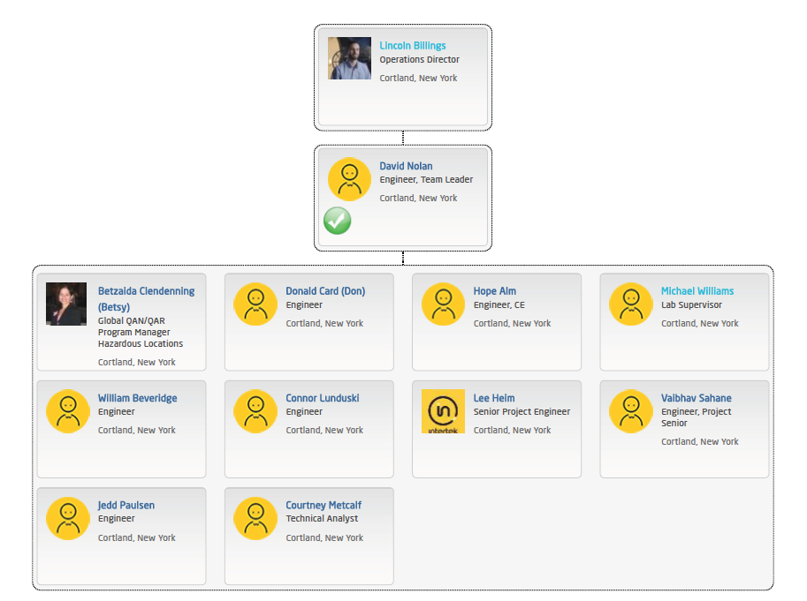
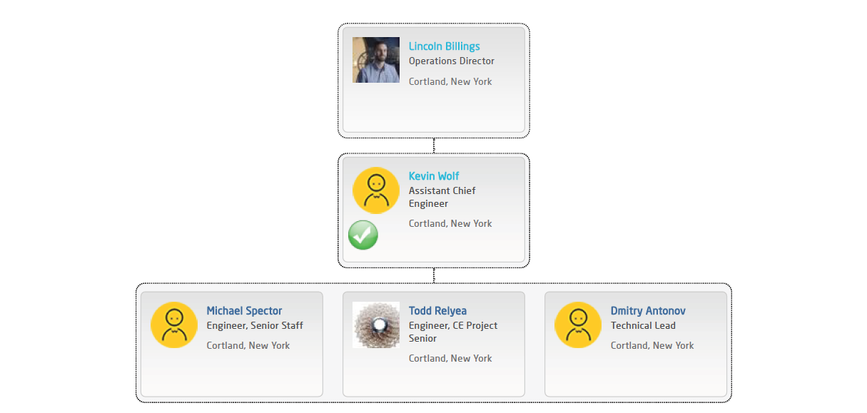
- Organisation Chart of ExCB/ExTL/ATF
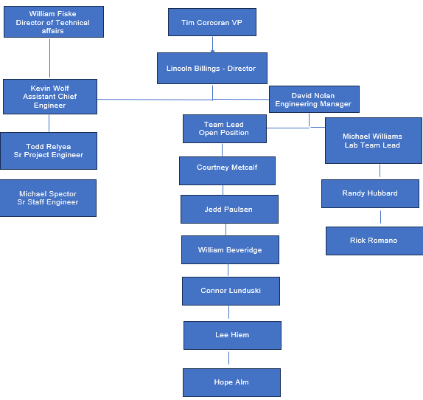
- Accreditation Certificate for ISO/IEC 17065

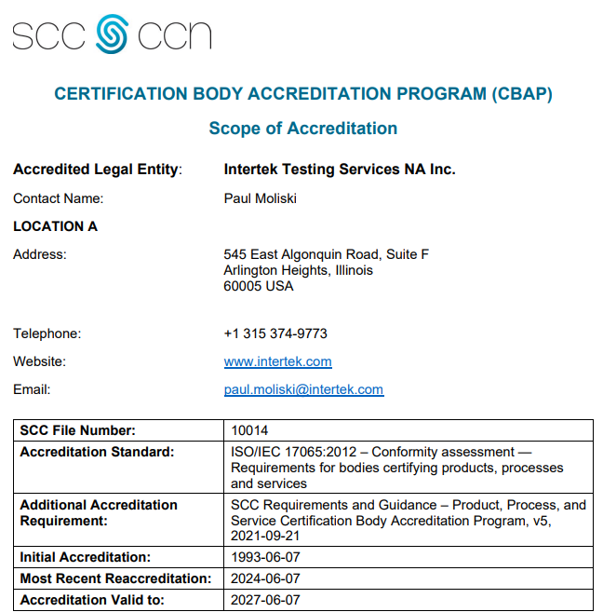
- Accreditation Certificate for ISO/IEC 17025
