COLLECTION OF IECEx / ExTAG DECISIONS
Standard:  IEC 60079-1:2014  IEC 60079-1:2007 | Clauses:  C.3.3.1  C.3.4.1  Table C.1 | December 2024  Decision Sheet:  ExTAG/720B/CD
Subject:  Tightening torque values of torque test for Ex blanking elements and Ex thread adapters  Status of document:  Approved | Key words:  - Tightening torque values  - Ex blanking elements  - Ex thread adapters | Date:  Originator of proposal:  CCCMT CN  TC/SC involved:  MT 600079-1
BACKGROUND:
The requirements of tightening torque values of torque test for Ex thread adapters have been given in Table C.1 of IEC 60079-1:2014. A sample Ex blanking element of each size shall be screwed into a steel test-block containing a threaded entry hole of size and form appropriate to the device under test. The sample shall be tightened to a torque at least equivalent to the appropriate torque given in Column 2 of Table C.1 or C.2, using a suitable tool. The test shall be deemed to be satisfactory if the correct thread engagement has been achieved and if, when dismantled, no damage invalidating the type of protection is found, except for failure of the shearable neck of a Figure C.1c – Example 3 plug which is required. Figure C.1b – Example 2 plugs shall be capable of being removed only by the appropriate tool. Metric Ex blanking elements of Figure C.1b – Example 2 shall then be subjected to a further test at a torque at least equivalent to the appropriate torque given in Column 3 of Table C.1, and shall be deemed to be satisfactory if the shoulder has not pulled fully into the thread.
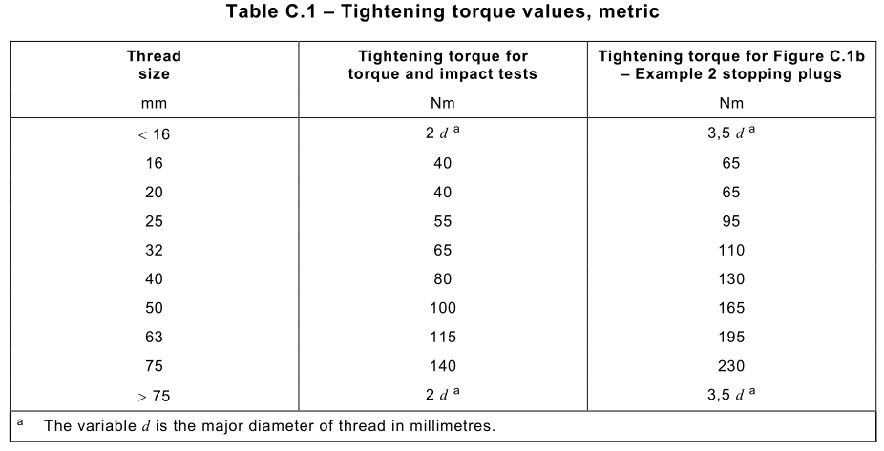
What is the tightening torque value for sizes other than those specified in Table C.1 ? In practice, it seems that different ExCBs/ExTLs have their different views. For example,If the thread size of Ex blanking element is 22 , what is the tightening torque value for the torque and impact test?
There are two perspectives to determine the torque value of thread size 22. Viewpoint 1: The tightening value of thread size 22 is based on the torque value equal to thread size 25 in Table C.1. Viewpoint 2:The tightening value of thread size 22 may be determined from a graph plotted using these values in Table C.1.

QUESTION:
How to determine the tightening torque values for other thread sizes other than those specified in Table C.1?
ANSWER:
The torque value may be calculated using linear interpolation between two values in Table C.1.

How the proposed draft decision sheet affects existing certified products :
The proposed draft decision just provides a suggested torque value, which is determined from a graph plotted using the values in Table C.1.For the existing certified products with Ex thread adapters and Ex blanking elements, the torque test is basically based on this torque value or the higher thread size value, which is more stringent.
The DS shall be applicable to:
– all issues (revisions) of the certifications issued after the publication of this DS.

