INTERNATIONAL ELECTROTECHNICAL COMMISSION SYSTEM FOR CERTIFICATION TO STANDARDS RELATING TO EQUIPMENT FOR USE IN EXPLOSIVE ATMOSPHERES (IECEx SYSTEM)

TITLE: Re-assessment and Scope Extension Report for the continued acceptance of Agencija za prostore ugrožene eksplozivnom atmosferom (Ex-Agencija) an Accepted Certification Body, (ExCB), and Ex Testing Laboratory (ExTL) within the IECEx System, Equipment Scheme 02.

Circulation to: Members of the IECEx Management Committee, ExMC

INTRODUCTION

In accordance with the 5 year re-assessment plan for the surveillance and monitoring of bodies within the IECEx System, the following document contains the IECEx Re-assessment and Scope Extension Report for the continued acceptance of Agencija za prostore ugrožene eksplozivnom atmosferom (Ex-Agencija) as an Accepted Certification Body (ExCB) and Ex Testing Laboratory (ExTL) within the IECEx System, Equipment Scheme 02.

During the re-assessment, the IECEx Assessment Team took the opportunity to also assess Ex-Agencija’s facilities, equipment and competence to undertake testing and certification to the Standards –

- IEC 60079-13 Explosive atmospheres - Part 13: Equipment protection by pressurized room 'p'
- ISO 80079-36 Explosive atmospheres - Part 36: Non-electrical equipment for
explosive atmospheres - Basic method and requirements
- ISO 80079-37 Explosive atmospheres - Part 37: Non-electrical equipment for
explosive atmospheres - Non electrical type of protection constructional safety
"c", control of ignition source "b", liquid immersion "k"

Please consider the assessment report and return the completed voting form,
(A separate Word document) to the

Chris Agius

IECEx Secretariat

IECEx Secretariat  Australia Square  Level 33, 264 George Street  Sydney NSW 2000  Australia | Tel: +61 2 4628 4690  Fax: +61 2 4625 3480  Email: chris.agius@iecex.com

IEC System for certification to standards relating to equipment for use in Explosive Atmospheres (IECEx System)

IECEx Assessment Report Form

IECEx Assessment Report Form for use by IECEx Assessment Teams to report Assessments conducted according to the IECEx Assessment Procedures of

- Operational Document IECEx OD 003-2 for the Certified Equipment Scheme
- Operational Document IECEx OD 016 for the Certified Service Facility Scheme
- Operational Document IECEx OD 022 for the IECEx Conformity Mark Licensing System

IECEx ExCB/ExTL assessment report for EXA:
Agencija za prostore ugrožene eksplozivnom atmosferom
(Ex-Agencija)
Industrijska 25
HR-10431 Sveta Nedelja
Croatia

INTERNATIONAL
ELECTROTECHNICAL
COMMISSION

CONTENTS
1 Assessment information 5
1.1 Type of Body covered by this assessment: 5
1.2 Type of assessment: 5
1.3 Details of body 5
1.3.1 Country Croatia 5
1.3.2 Name of body Agencija za prostore ugrožene eksplozivnom atmosferom (Ex-Agencija) 5
1.3.3 Name and title of nominated principal contact 5
1.4 Assessment information 5
1.4.1 Members of the assessment team 5
1.4.2 Place(s) of assessment 5
1.4.3 Assessment date(s) 5
1.5 Application information and background information on the assessment 5
1.6 Scopes 6
1.6.1 ExCB scope for equipment certification scheme 6
1.6.2 ExTL scope 7
1.6.3 ExCB scope for Service Facilities Scheme 7
1.6.4 ExCB scope for ExMark Scheme 7
2 Common information 8
2.1 Legal entity of body 8
2.2 Financial support 8
2.3 History 8
2.4 Documentation 8
2.4.1 Quality manual 8
2.4.2 Procedures 8
2.4.3 Work instructions 8
2.4.4 Records (including test records where relevant) 9
2.4.5 Document change control 9
2.5 Confidentiality 9
2.6 Communication with public and customers (Hard copy and Electronic) 9
2.7 Recognitions and agreements 9
2.8 Internal audit 9
2.9 Management review 9
2.10 Contracting, subcontracting and witness testing 9
2.10.1 Contracting 9
2.10.2 Subcontracting 10
2.10.3 Witness testing 10
2.11 Training and competence 10
2.12 Complaints and appeals (including appeals to IECEx) 10
2.13 Commenting on ExTAG Documents 10
2.14 Special facts to be noted 10
2.15 Supporting documentation 11
2.16 Recommendations 11
3 ExCB for IECEx Certified Equipment Scheme 12
3.1 Assessment references 12
3.2 Candidate ExCB persons interviewed 12
3.3 Associated ExTL(s) 12
3.4 Associated certification functions 12
3.5 National marks and certificates 12
3.6 Standards accepted 12
3.7 National differences to IEC standards 13
3.8 Organisation 13
3.8.1 Names, titles and experience of the senior executives 13
3.8.2 Name, title and experience of the quality management representative 13
3.8.3 Name and title of signatories for certification 13
3.8.4 Other employees in ExCB activity 13
3.9 Organizational structure 13
3.10 Indemnity insurance 13
3.11 Resources 14
3.12 Committees (such as governing or advisory boards) 14
3.13 Certification operations 14
3.13.1 National approval/certification methods 14
3.13.2 Certification policy 14
3.13.3 Application for certification 14
3.13.4 Certification decision 14
3.13.5 Suspension and cancellation of certificates 14
3.14 Certificates issued 15
3.15 National accreditation 16
3.16 Assessment of manufacturers and issue of QARs 16
3.17 Comments (including issues found during assessment) 16
4 ExTL for IECEx Certified Equipment Scheme 17
4.1 Assessment references 17
4.2 Candidate ExTL persons interviewed 17
4.3 Associated ExCB(s) 17
4.4 Organisation 17
4.4.1 Names, titles and experience of the senior executives 17
4.4.2 Name, title and experience of the quality management representative 17
4.4.3 Other employees in ExTL activity 18
4.5 Organizational structure 18
4.6 Resources 18
4.7 Test reports issued 18
4.8 National accreditation 20
4.9 Calibration 20
4.10 Witnessed Tests 20
4.11 Participation in IECEx Proficiency Testing Program 21
4.12 Comments (including issues found during assessment) 21
5 ExCB for Certified Service Facilities Scheme 22
Not applicable. 22
6 IECEx Conformity Mark Licensing System 22
7 Annexes 22
Annex A Overall Organisation Chart 23
Annex B Organisation Chart of ExCB and ExTL 24
Annex C Accreditation Certificate for ISO/IEC 17065 25
Annex D Accreditation Certificate for ISO/IEC 17025 26

Assessment information

Type of Body covered by this assessment:
ExCB for IECEx Certified Equipment Scheme | ✓
ExTL for IECEx Certified Equipment Scheme | ✓
ExCB for IECEx Certified Service Facilities Scheme
ExCB for IECEx Conformity Mark Licensing System

NOTE 1 ExCB - IECEx Certification Body
NOTE 2 ExTL - IECEx Testing Laboratory

Type of assessment:
Pre-assessment for candidate body
Initial assessment for candidate body
Surveillance
Re-assessment | ✓
Scope extension | ✓

Details of body

Country
Croatia

Name of body
Agencija za prostore ugrožene eksplozivnom atmosferom
(Ex-Agencija)

Name and title of nominated principal contact
Name | Title | E-mail address
Mr. Stipo Derek | Acting Director General | s.derek@ex-agencija.hr

Assessment information

Members of the assessment team
Name | Role
Heinz Farke | Lead Assessor
Bernard Piquette | Expert Assessor

Place(s) of assessment
Industrijska 25, HR-10431 Sveta Nedelja, Croatia

Assessment date(s)
13th to 15th June 2016

Application information and background information on the assessment
No further item to mention here.

Scopes

ExCB scope for equipment certification scheme
Number | Title | Comments, e.g.  if scope change
IEC 60079-0  Edition 6.0 | Explosive atmospheres - Part 0: Equipment - General requirements | Covered
IEC 60079-1  Edition 7.0 | Explosive atmospheres - Part 1: Equipment protection by flameproof  enclosures “d” | covered
IEC 60079-2  Edition 6.0 | Explosive atmospheres - Part 2: Equipment protection by pressurized  enclosure «p» | covered
IEC 60079-5  Edition 4.0 | Explosive atmospheres - Part 5: Equipment protection by powder filling «q» | covered
IEC 60079-6  Edition 4.0 | Explosive atmospheres - Part 6: Equipment protection by oil immersion «o» | covered
IEC 60079-7  Edition 5.0 | Explosive atmospheres - Part 7: Equipment protection by increased  safety "e" | covered
IEC 60079-11  Edition 6.0 | Explosive atmospheres - Part 11: Equipment protection by intrinsic safety “i” | covered
IEC 60079-13  Edition 1.0 | Explosive atmospheres - Part 13: Equipment protection by pressurized room 'p' | scope extension
IEC 60079-15  Edition 4.0 | Explosive atmospheres – Part 15: Equipment protection by type of protection "n" | covered
IEC 60079-18  Edition 4.0 | Explosive atmospheres – Part 18: Equipment protection by encapsulation “m” | covered
IEC 60079-25  Edition 2.0 | Explosive atmospheres – Part 25: Intrinsically safe electrical systems | covered
IEC 60079-26  Edition 3.0 | Explosive atmospheres - Part 26: Equipment with equipment protection level (EPL) Ga | covered
*IEC 60079-27  Edition 2.0 | Explosive atmospheres – Part 27: Fieldbus intrinsically safe concept (FISCO) | covered
IEC 60079-31  Edition 2.0 | Explosive atmospheres – Part 31: Equipment dust ignition protection by enclosure "t" | covered
*IEC 61241-0  Edition 1.0 | Electrical apparatus for use in the presence of combustible dust - Part 0: General requirements | covered
*IEC 61241-1  Edition 1.0 | Electrical apparatus for use in the presence of combustible dust - Part 1: Protection by enclosure “tD” | covered
*IEC 61241-4  Edition 1.0 | Electrical apparatus for use in the presence of combustible dust - Part 4: Protection by pressurization "pD" | covered
*IEC 61241-11  Edition 1.0 | Electrical apparatus for use in the presence of combustible dust – Part 11: Protection by intrinsic safety 'iD' | covered
*IEC 61241-18  Edition 1.0 | Electrical apparatus for use in the presence of combustible dust - Part 18: Protection by encapsulation "mD" | covered
IS0 80079-36  Edition 1.0 | Explosive atmospheres - Part 36: Non-electrical equipment for explosive atmospheres – Basic method and requirements | scope extension
ISO 80079-37  Edition 1.0 | Explosive atmospheres - Part 37: Non-electrical equipment for explosive atmospheres – Non electrical type of protection constructional safety ”c” control of ignition source ”b”, liquid immersion ”k” | scope extension
DS 2015/001A | IECEx Assessment and Certification of Equipment assemblies | covered
NOTE 1 Standards shown with an asterisk (*) are superseded standards
NOTE 2 Unless otherwise indicated, earlier editions of standards (even if with a different number) are considered to be covered in the above scope for the purposes of the assessment.
NOTE 3 The above list highlights any extension of scope in the list above for new standards or later editions of standards already in scope.

ExTL scope
The ExTL scope is the same as for the ExCB.

ExCB scope for Service Facilities Scheme
Not applicable

ExCB scope for ExMark Scheme
Not applicable

Common information

Legal entity of body
Ex-Agencija is a public, non-profit institution established by the Croatian government.
The certificate of registration shows the following details:
MBS: 080436643; Tt-15/16953-3;07th July 2015

Financial support
Ex-Agencija has the financial stability and resources required for the operation as a certification body from income from fees for testing, certification, auditing of manufacturers QMS, technical supervision of plants with explosive atmospheres and customer training. There is no financial support from the Government.

History

The former S-KOMISIJA (S-COMMISSION) was established as a “Commission for testing Ex-equipment” by decision of the Ministry of the former Yugoslavia, dated 16th July 1949. In 1992 S-Komisija became the national authorized body for testing and certification of Ex-equipment and technical supervision of plants in areas at risk of explosive atmospheres in the Republic of Croatia. In 2002 the status was changed by Government decision published in the “Official Gazette” no. 60/02, which established the Agencija za prostore ugrožene eksplozivnom atmosferom (officially shortened to Ex-Agencija), as a public non-profit institution that carries on the activities of S- Komisija.

Documentation

Quality manual
Ex-Agencija have a fully developed Quality Management system.
There are 354 QM documents in total.
The list of all the QM documents, incl. their revision date and issue number, can be seen in document number OD-012e.
The documents are named and marked in a certain structure, as mentioned below:
- PQx Quality Manual Document (Ex-Agencija, overall)
- DT-xxx Workflow
- OD-xxx General documentation (legal requirements,
- PO-xxx Procedures acc. to ISO 9001
- RU-xxx Work Instruction for laboratory
- B-xx Operational Procedures
- C-xx Forms
- TU-xx Customer information / procedures

Procedures
Refer to explanation in section 2.4.1 in this report.

Work instructions
Refer to explanation in section 2.4.1 in this report.

Records (including test records where relevant)
All records are appropriately maintained and stored in a separate, locked room. The system was found to meet the requirements of the IECEx.

Document change control
The control of documents is described in the QM-documentation, with respect to responsibilities and procedure. The personnel is being informed by e-mail and by regular meetings about new and updated documents.

Confidentiality
Item described and documented in Quality Manual PQC, Clause 4.2.6..
Each employee has to sign a working contract, which requires him to follow the
(QM-) rules, documents, confidentiality requirements,… (see clause 10 of contract). Examples of these were sighted by the team and found to meet the requirements of the IECEx.

Communication with public and customers (Hard copy and Electronic)
This is mainly done via the website: www.ex-agencija.hr
The describing document is: Quality Manual PQC, Clause 4.6.

Recognitions and agreements
There is a MOU with INERIS / France regarding cooperation in case of ex-testing.
Cooperative working agreements are established with some other organisations, e.g.: QPS / Canada; TÜV Italy s.r.l./Italy; SIQ; INSEMEX.

Internal audit
The internal audits are well planned, documented and performed. The results and findings were discussed in the team during a conclusion meeting. The findings are dealt with effectively and their status is controlled and documented. The system was found to meet the requirements of the IECEx.

Management review
Management review are done on an annually basis.
The last one was done on 29th April 2016 (Document: PQ C-62/1).
The ExCB / ExTL are covered therein as well and goals are defined and was found to meet the requirements of the IECEx.

Contracting, subcontracting and witness testing

Contracting
There are two persons who were Ex-Agencija employees in former times and who have been contracted to assist in the ExTL, for laboratory testing.
The certification decision within the ExCB is done completely internally.
The ExCB does not have any contracted persons.

Subcontracting
The following tests are, or may be, subcontracted by the body:
Tests that have been sub-contracted:
CTI-Testing
E-Static testing (IEC 60079-0: 2007, clause 26.14) (optionally: can be tested in house as well)
Vibration tests for lamps, batteries (IEC 60079-0, IEC 60079-7)

Witness testing
The OD024 is used for witness testing. The procedures are known. The Witness Testing Agreements are available and have been checked by spot check
NOTE The following should be addressed during the assessment to address compliance with OD024:
That if off-site and witness testing is done, or proposed to be done, OD024 is referenced and incorporated in procedures
If it is being done, that contracts have been put in place
For witness testing (only) - according to 6.3.5 of OD024 - Registration of the manufacturer or user test facility has been made with the IECEx Secretariat and updating of the current information in the Register
That ExTRs reviewed clearly indicate when there has been witness testing done

Training and competence
The responsibility and task is given to the “Certification Board” which is selected and established, dealing with these items. Document: PO-CO; Rev. 7, 02.09.2013.
A template document C-68, created by the “director” in February 2016 shows the programme for 2016. The file is being filled in by the director and controlled throughout the year.
The content was detailed spot checked and found to meet the requirements of the IECEx.

Complaints and appeals (including appeals to IECEx)
This topic is documented in Quality Manual PQC, Clause 4.6. These items are publicly available via the C-10-8 document that can be downloaded and need to be signed in case of an order. The content was checked and found to fulfil the requirements of IECEx.
`

Commenting on ExTAG Documents
Ex-Agencija provides answers, if the ExTAG covers their scope. They do not provide separate answers in case of “confirmation” and in case of “out of scope”.

Special facts to be noted
None

Supporting documentation
Copies of additional supporting information for this assessment have been provided to the applicant and the IECEx Secretariat. These are included in a site assessment report or provided separately and include:
- Details of issues raised and how these have been resolved
- Checklist for ISO/IEC 17065
- Checklist for ISO/IEC 17025
- Completed Technical Capability Document (TCD)
- Photos of the facilities/tests witnessed are included in the above TCD
- Assessors’ notes
- Quality Management, List of Documents. Document: PQ, OD-012e, 10 pages

Recommendations
Based on the assessment performed 13th to 15th June 2016, Ex Agencija (EXA)
is recommended for continued acceptance in the IECEx scheme as:
  - An ExCB in the IECEx Certified Equipment Scheme
  - An ExTL in the IECEx Certified Equipment Scheme
This is according to the scope of the standards listed in this document,
including the extension of scope.
For some standards and related types of protection the clause 2.3 of OD003-2 is applicable, that leads to an annual surveillance assessment, see comment sections below in this report (3.17 and 4.12).
As soon as HAA has taken over these standards the surveillance procedure can set up to the 5 years re-assessment/mid-term interval.

Heinz Farke | Bernard Piquette
Lead Assessor | Expert Assessor
Date: 07th September 2016

ExCB for IECEx Certified Equipment Scheme

Assessment references
- IECEx02 IECEx Certified Equipment Scheme covering equipment for use in explosive atmospheres – Rules of Procedure
- OD003-2 Assessment, surveillance assessment and re-assessment of ExCBs and ExTLs operating in the IECEx 02, IECEx Certified Equipment Scheme
- ISO/IEC 80079-34 Edition 1, Explosive atmospheres – Part 34: Application of quality systems for equipment manufacture
- OD009 Issuing of CoCs, ExTRs and QARs
- IECEx Document OD 025 Guidelines on the Management of Assessment and Surveillance programs for the assessment of Manufacturer’s Quality Systems in accordance with the IECEx Scheme
- OD0026 IECEx Certified Equipment Scheme – Guidelines for the qualification of Lead Auditor and Auditors, in accordance with the IECEx System
- ISO/IEC 17065: 2012, Edition 1, General requirements for bodies operating product certification systems Conformity assessment — Requirements for bodies certifying products, processes and services
- IECEx Document OD17 Drawing and documentation guidance
- IECEx Technical Capability Document (TCD)
- ExTAG decision sheets (DSs)
NOTE The latest editions of the above documents were applied

Candidate ExCB persons interviewed
Name | Position
Stipo Derek | Director of Sector for Certification and Testing
Marko Ruzic | Quality Management Representative, Certifier (QM)

Associated ExTL(s)
The ExCB and ExTL of ExAgencija are integral bodies located at the same address.

Associated certification functions
The national certification system for Ex products is that of the ATEX directive 2014/34/EU. Ex-Agencija have the European Notified Body number: NB 2465
The registration for the new directive 2014/34/EU was done on 2016-05-11.

National marks and certificates
Ex-Agencija has national accreditations according 17020, 17025, 17065.
Furthermore Ex-Agencija is the national body who is responsible for approval of “Explosion protection documents” acc. to European Directive 99/92/EG.

Standards accepted
See clause 1.6 of this report

National differences to IEC standards
National differences to IEC standards are those for the European differences listed in the latest version of the IECEx Scheme Bulletin.

Organisation

Names, titles and experience of the senior executives

Name | Title | Experience in Ex
Stipo Derek | Director of Sector for Certification and Testing | 22 years
Damir Korunić | Head of department of certification of management systems | 16 years
Marko Ružić | Quality Management Representative, Certifier (QAR) | 12 years

Name, title and experience of the quality management representative

Name | Title | Experience in Ex
Marko Ružić | QM-Representative | 12 years

Name and title of signatories for certification

Name | Title | Comments
Stipo Derek | Director of Sector for Certification and Testing | Abbreviations for internal use::  SD
Ana Hađak | Certifier Equipment / QM-Systems | AH
Marino Kelava | Head of Department Education, Certifier Equipment / QM-Systems | MK
Damir Korunic | Head of Department Equipment Certification,  Certifier Equipment / QM-Systems | DK
Tomislav Mlinac | Certifier Equipment | TM
Marko Ruzic | QM-Representative,  Certifier QM-Systems | MR
Rikard Slunjski | Certifier Equipment | RS
Ivan Stepanic | Certifier Equipment | IS
Ivan Štivičić | Certifier Equipment | IŠ

Other employees in ExCB activity

Name | Title | Responsibility, Experience in Ex
Other employees are active in testing and certification according to European ATEX Directive.

Organizational structure
See annex A to this report.

Indemnity insurance
Ex-Agencija holds professional indemnity and public liability insurance.
Documented in Quality Manual PQC, Clause 4.3.1.
Insurance available: Euroherc Osiguranje D.D.; Nr. 802286106; valid until: 15.04.2017; The cover is considered acceptable.

Resources
There are appropriate resources in terms of buildings, equipment, services and trained personnel. Ex-Agencija is governmentally driven and controlled.

Committees (such as governing or advisory boards)
Ex-Agencija has its own Certification Committee which acts as an advisory role.
(see organization chart in annex A). Furthermore employees of Ex-Agencija participate in standardisation committees, e. g. IEC SC 31J

Certification operations

National approval/certification methods
The national certification system for Ex products is that of the ATEX directive 2014/34/EU. Ex-Agencija have the European Notified Body number: NB 2465
The registration for the new directive 2014/34/EU was done on 2016-05-11.

Certification policy
The certification body has a top management commitment to impartiality, refer to document PQC, Clause 4.2.5. It is signed and available on the Ex-Agencija’s website. The IECEx rules are mentioned additionally in the Quality Policy (OD001e), Rev 8, 24.11.2014. This was seen to be in conformity with the requirements of ISO/IEC 17065 and IECEx 02.
NOTE Typically this may be a separate policy or included in the quality policy

Application for certification
Documented in Quality Manual PQC, Clause 4.1.2.2.. Related document “Agreement for Conformity Assessment Services”. Document: C-10-8.
Furthermore, in document C-3-1 (Application Form), the customer is asked for confirmation that some tests can be sub-contracted. (It is not mentioned which tests are going to be sub-contracted. It is expected that he asks in case of any concern.).
This procedure was checked and found to meet the requirements of the IECEx.

Certification decision
The certification decision according to 17065 is done internally. The certification process is described and controlled. The IECEx passwords are given to the related employees and handled accordingly.

Suspension and cancellation of certificates
The suspension and cancellation of certificates is defined in the QM-documentation.
The procedure was reviewed and found to meet the requirements of the IECEx .

Certificates issued
Number of certificates issued under for the preceding four years for each type of protection. For new applications these should be for national or regional schemes and for currently accepted bodies IECEx certificates should be shown (certificates for other schemes may also be shown):
Standard | Title | 2013 | 2014 | 2015 | 2016
IEC 60079-0 | General requirements | Part 0 included in numbers below
IEC 60079-1 | Flameproof enclosure "d" | 1 | 6 | 10 | 4
IEC 60079-2 | Pressurized enclosure "p" | - | - | - | -
IEC 60079-5 | Powder filling "q" | - | - | - | -
IEC 60079-6 | Oil immersion "o" | - | - | - | -
IEC 60079-7 | Increased safety "e" | 1 | 3 | 6 | 1
IEC 60079-11 | Intrinsic safety "i" | 1 | 1 | 6 | 3
IEC 60079-15 | Type of protection "n" | 1 | 1 | 8 | 5
IEC 60079-18 | Encapsulation "m" | - | - | 2 | -
IEC 60079-25 | IS electrical systems | - | - | - | -
IEC 60079-26 | Equipment protection level Ga | - | - | - | -
IEC 60079-27 | FISCO | - | - | - | -
IEC 60079-31 | Protection by enclosure "t" | 1 | 6 | 17 | 6
IEC 61241-0 | General requirements D
IEC 61241-1 | Protection by enclosure "tD" | - | - | - | -
IEC 61241-4 | Type of protection "pD" | - | - | - | -
IEC61241-11 | Intrinsic safety "iD" | - | - | - | -
IEC 61241-18 | Encapsulation "mD" | - | - | - | -
EN 13463-xx  (80079-36,  80079-37) | Non-electrical equipment,  figures are taken from Ex-Agencija's ATEX mechanical projects | 3 | 7 | 7 | -
DS 2015/001A | Equipment Assemblies  (projects done under ATEX directive, but covering the 60079-14) | 3 | - | - | -

National accreditation
Ex-Agencija has national accreditations according 17020, 17025, 17065 and is European ATEX ExNB according to directive 2014/34/EU.

Assessment of manufacturers and issue of QARs
A set of procedures addresses assessments of manufacturers. The report format includes all the requirements from the IECEx Scheme together with ATEX requirements.
For ATEX and IECEx certification schemes a set of documented procedures is in place to enable surveillance to be carried out in accordance with the criteria of the certification systems. The requirements for manufacturing surveillance activities (including initial and ongoing inspection of product during manufacture, audit of quality system and audit of products) are detailed within the relevant scheme rules and procedures.

Comments (including issues found during assessment)
Some issues were found during the assessment. These issues are listed in Annex A of the site assessment report. These items have been solved by Ex-Agencija to the satisfaction of the Assessment Team, with the following status:
The National HAA Accreditation according to 17025 and 17065 does not cover all the standards which are in scope of this assessment. For those standards and therewith the related types of protection that are covered by that HAA 17025 and 17065 accreditation the procedure according to OD003-2, Edition 2.0, 2015-01, clause 2.2 is applicable (mid-term/5 years re-assessment).
However, there is the following standard that is not covered by the HAA 17065 accreditation:

- IEC 60079-13 and ISO 80079-36 and ISO 80079-37

For these standards and related types of protection the clause 2.3 of OD003-2 is applicable, that leads to an annual surveillance assessment. As soon as HAA has taken over these standards the surveillance procedure can set up to the (mid-term/5 years re-assessment).
Ex-Agencija has a well-established system according to ISO/IEC 17065, which is mostly documented on a paper based system.

ExTL for IECEx Certified Equipment Scheme

Assessment references
- IECEx02 IECEx Certified Equipment Scheme covering equipment for use in explosive atmospheres – Rules of Procedure
- IECEx OD003-2 Assessment, surveillance assessment and re-assessment of ExCBs and ExTLs operating in the IECEx 02, IECEx Certified Equipment Scheme
- IECEx OD009 Issuing of CoCs, ExTRs and QARs
- ISO/IEC 17025:2005 Edition 2, General requirements for the competence of testing and calibration laboratories
- IECEx Document OD17 Drawing and documentation guidance
- IECEx Technical Capability Document (TCD)
- ExTAG decision sheets (DSs)
NOTE The latest editions of the above documents were applied.

Candidate ExTL persons interviewed
Name | Position / Abbreviation
Damir Korunić | Member of ExTL, DK
Tomislav Mlinac | Member of ExTL, TM
Rikard Slunjski | Member of ExTL, RS
Ivan Stepanić | Member of ExTL, IS
Slobodan Sertić | Member of ExTL, SS
Stjepan Peretin | Member of ExTL, SP
Predrag Stipković | Member of ExTL, PS
Željko Vujević | Member of ExTL, ŽV

Associated ExCB(s)
The ExTL is integral with the ExCB.

Organisation

Names, titles and experience of the senior executives
Name | Title | Experience in Ex
Mario Mackovic | Head of Department Laboratory for explosion protection | 12 years

Name, title and experience of the quality management representative

Name | Title | Experience in Ex
Marko Ružić | QM-Representative | 12 years

Other employees in ExTL activity

Name | Title/responsibility | Experience in Ex [years]
Stipo Đerek | SĐ | 22
Damir Korunić | DK | 16
Mario Mačković | MM | 12
Marino Kelava | MK | 15
Ana Hađak | AH | 16
Tomislav Mlinac | TM | 16
Rikard Slunjski | RS | 3
Ivan Stepanić | IS | 3
Slobodan Sertić | SS | 32
Stjepan Peretin | SP | 7
Predrag Stipković | PS | 14
Željko Vujević | ŽV | 17
Ivan Štivičić | IŠ | 11

Organizational structure
See annex B of this report.

Resources
The Ex operation at Ex-Agencija has several professional and technical staff involved in Ex testing. It has a comprehensive range of testing equipment and good facilities for this type of testing.

Test reports issued
Number of test reports (ExTRs) issued under for the preceding four years for each type of protection. For new applications these should be for national or regional schemes and for currently accepted bodies IECEx ExTRs should be shown (test reports for other schemes may also be shown):
Standard | Title | 2013 | 2014 | 2015 | 2016
IEC 60079-0 | General requirements | Part 0 included in numbers below
IEC 60079-1 | Flameproof enclosure "d" | 2 | 14 | 13 | 5
IEC 60079-2 | Pressurized enclosure "p" | - | 1 | 1 | -
IEC 60079-5 | Powder filling "q" | - | - | - | -
IEC 60079-6 | Oil immersion "o" | - | - | - | -
IEC 60079-7 | Increased safety "e" | 1 | 8 | 11 | 2
IEC 60079-11 | Intrinsic safety "i" | 1 | 1 | 7 | 3
IEC 60079-15 | Type of protection "n" | 1 | 1 | 8 | 5
IEC 60079-18 | Encapsulation "m" | - | - | 2 | -
IEC 60079-25 | IS electrical systems | - | - | - | -
IEC 60079-26 | Equipment protection level Ga | - | - | 1 | -
IEC 60079-27 | FISCO | - | - | - | -
IEC 60079-31 | Protection by enclosure "t" | 2 | 10 | 24 | 6
IEC 61241-0 | General requirements D
IEC 61241-1 | Protection by enclosure "tD" | - | - | - | -
IEC 61241-4 | Type of protection "pD" | - | - | - | -
IEC 61241-11 | Intrinsic safety "iD" | - | - | - | -
IEC 61241-18 | Encapsulation "mD" | - | - | - | -
EN 13463-xx  (80079-36,  80079-37) | Non-electrical equipment,  figures are taken from Ex-Agencija's ATEX mechanical projects | 3 | 7 | 7 | -
DS 2015/001A | Equipment Assemblies  (projects done under ATEX directive, but covering the 60079-14) | 3 | - | - | -

National accreditation
Ex-Agencija has a national 17025 accreditation given by HAA, which covers the related Ex-standards and test methods. Ex-Agencija do not have accreditation for IEC 60079-13, IEC 60079-26, IEC 60079-27 and 80079 series therefore they will be subject to annual surveillance until accreditation for their scope has been achieved.

Calibration
The test equipment is sent out to an 17025-calibration laboratory. This process is initiated annually. The calibration interval is based on ILAC G24 and IEC OP-PAC010.
A random sample of the test equipment used in Ex was chosen and the records for these examined.

Witnessed Tests
The following tests were witnessed during the assessment visit:
Standard: IEC 60079-0: 2011 General Requirements:
Clause 26.13 | Surface resistance test
Clause 26.4.5 | IP testing  (IP 6X testing)
Clause 26.14 | Measurement of capacitance  (unearthed metal part for group IIB, EPL Ga, Gb)
Standard: IEC 60079-1: 2014 Flameproof enclosures ‘d’
Clauses  15.2.2 / 15.2.3 | Determination of explosion pressure (reference pressure) /  Overpressure test  (group IIB testing)
Clause 15.3 | Test for non-transmission of an internal ignition  (group IIB testing)
Standard: IEC 60079-7: 2015 Increased Safety ‘e’

Clause 6.3.4.1.1 | Level of Protection “eb”, rectification test
Standard: IEC 60079-11: 2011 Intrinsic Safety ‘i’

Clause 10.1 | Spark ignition test  (group IIC, Ga testing)
Clause 10.5.3 | Temperature rise test on batteries
Standard: IEC 60079-18: 2014 Encapsulation

Clause 8.1.2 | Dielectric strength
Standard: IEC 60079-15: 2010 Type of protection “n”
Clause 22.5.3 | Tests on devices with free space
Standard: IEC 60079-31: 2013 Protection by enclosure “t”
Clause 6.1.1.3 | Pressure test  (“tb” testing)
Regarding Scope Extension for ISO 80079-36 and ISO 80079-37, the assessment team interviewed the relevant staff and found them to have a thorough understanding of both the Standards and the assessment required. A review of files relating to non-electrical Ex equipment (under the ATEX Directive) was also undertaken during the assessment and found to be satisfactory and complete with evidence that the concepts were well understood by the Staff.

Participation in IECEx Proficiency Testing Program
Program: PTB Ex PT Scheme
IECEx Proficiency Testing program | Program years | Particip-ated?  Y/N/NA | Results in relation to assigned value | Other comments, including whether results are considered satisfactory
Program 1 "Explosion pressure" | 2011-2012 | Y | Well within the standard deviation of assigned value | Satisfactory
Program 2 "Spark ignition | 2011-2012 | Y | Within the standard range/results | Satisfactory
Program 3 "Flame Transmission" | 2013-2014 | Y | Within the standard range/results | Satisfactory
Program 4 "Temperature Classification" | 2013-2014 | Y | Slight deviation to the “safe side” | Satisfactory
Program 5 "Electrostatic Charge" | 2015-2016 | Y | Well within the standard deviation of assigned value | Program still running
Program 6 "Intrinsic Safety" | 2015-2016 | Y | Found more than  “Mean value” | Program still running

Comments (including issues found during assessment)
Some issues were found during the assessment. These issues are listed in Annex B of the site assessment report. These items have been solved by Ex-Agencija to the satisfaction of the Assessment Team, with the following status:
The National HAA Accreditation according to 17025 and 17065 does not cover all the standards which are in scope of this assessment.
For those standards and therewith the related types of protection that are covered by that HAA 17025 and 17065 accreditation the procedure according to OD003-2, Edition 2.0, 2015-01, clause 2.2 is applicable(mid-term/5 years re-assessment interval)..
However, there are the following standards and therewith the related types of protection that are not covered by the HAA 17025 accreditation:
- IEC 60079-13; pressurized rooms “p” and
- IEC 60079-26; EPL Ga and
- IEC 60079-27; FISCO and
- ISO 80079-36
- ISO 80079-37 (EN 13463-5, -6)
For these standards and related types of protection the clause 2.3 of OD003-2 is applicable, that leads to an annual surveillance assessment.
As soon as HAA has taken over these standards the surveillance procedure can set up to the mid-term/5 years re-assessment interval.
Ex-Agencija has a well equipped laboratory for ex-testing and competent personnel to address all the requirements.

ExCB for Certified Service Facilities Scheme

Not applicable.

IECEx Conformity Mark Licensing System
Not applicable.

Annexes
ANNEX A Overall Organisation Chart
ANNEX B Organisation Chart of ExCB and ExTL
ANNEX C Organisation Chart of ExCB and ExTL
ANNEX D Accreditation Certificate for ISO/IEC 17025
- Overall Organisation Chart
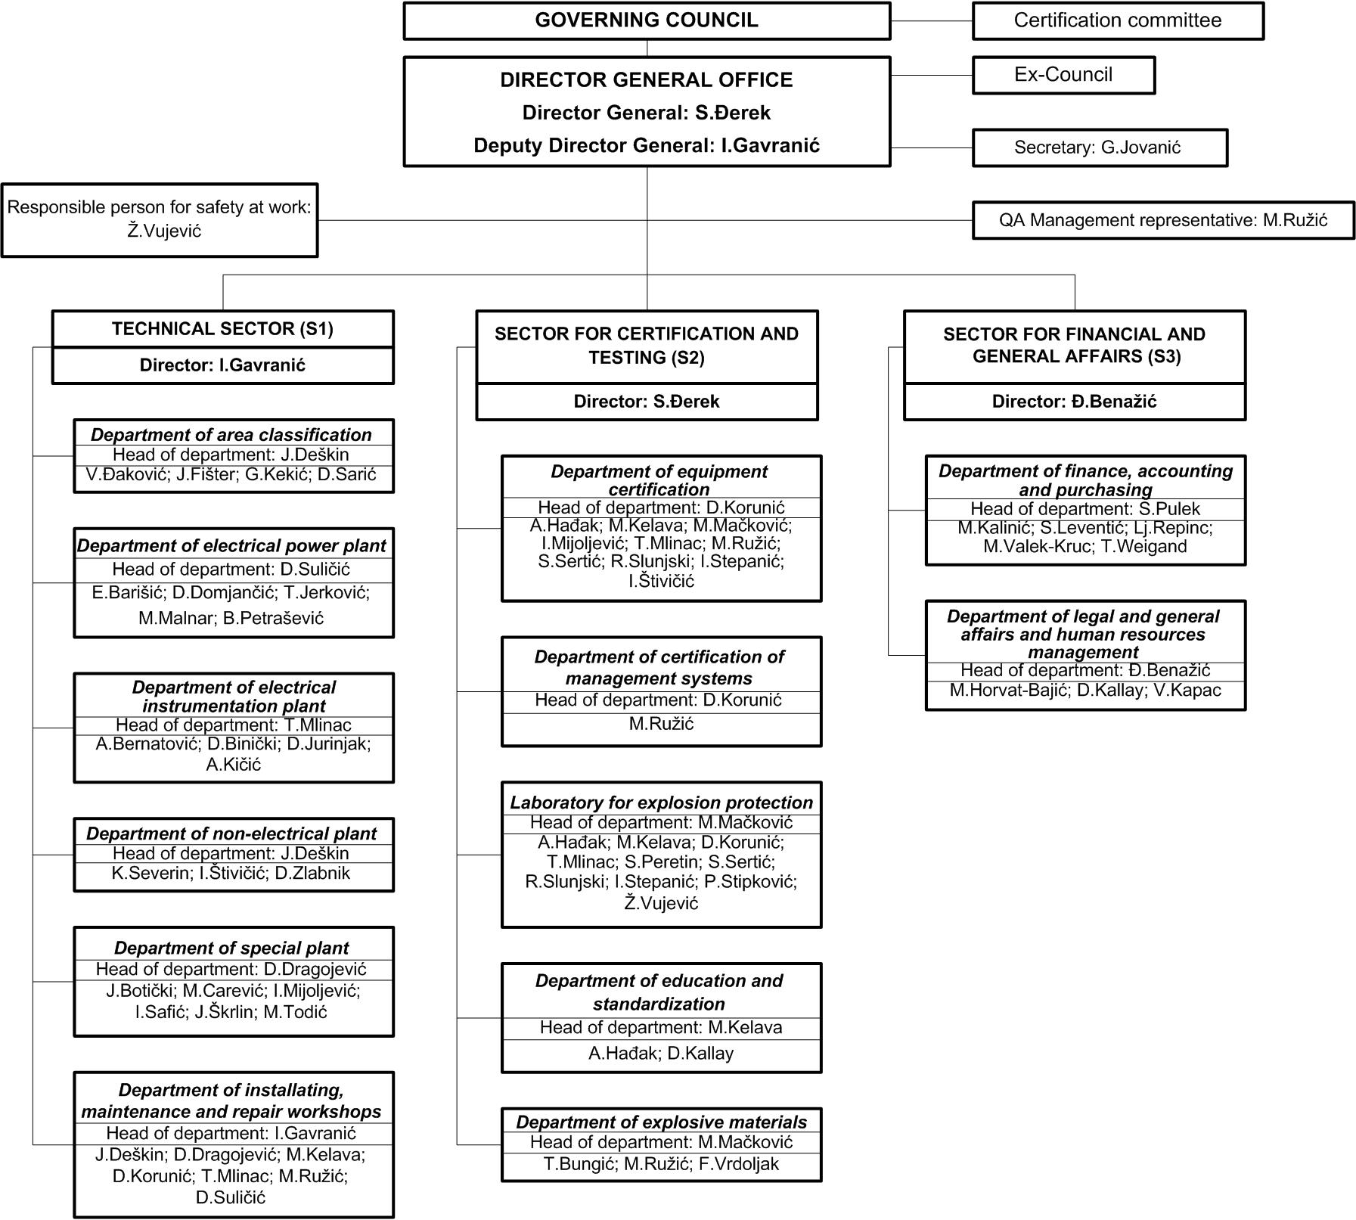
- Organisation Chart of ExCB and ExTL

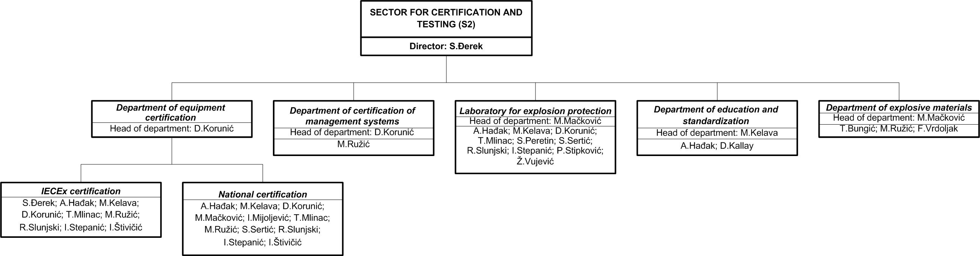
- Accreditation Certificate for ISO/IEC 17065

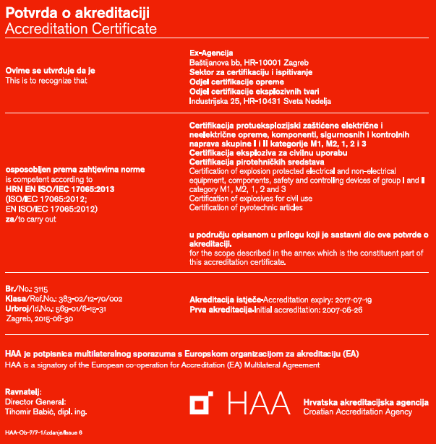
- Accreditation Certificate for ISO/IEC 17025

