COLLECTION OF IECEx / ExTAG DECISION
Standard:  IEC 60079-1:2014  (Edition 7.0)  IEC 60079-1:2007  (Edition 6.0)  ISO/IEC 80079-34:2011 | Clause:  5.2 & 5.2.3  5.2 & 5.2.3 | Date: 2014-12-12  Originator of proposal:  INERIS
Subject:  Spigot joints/Conical joint | Key words:  - Flameproof joints  - Spigot joint  - Conical joint  - Flanged joint | TC/SC involved:  MT 60079-1  Draft Decision Sheet:  ExTAG/353B/CD
Introduction :

A manufacturer needs to design a flameproof enclosure with a geometry as in the example of Figure 1. This enclosure could be manufactured with a joint either following the principle of the Figure 2 or following the principle of the Figure 3.

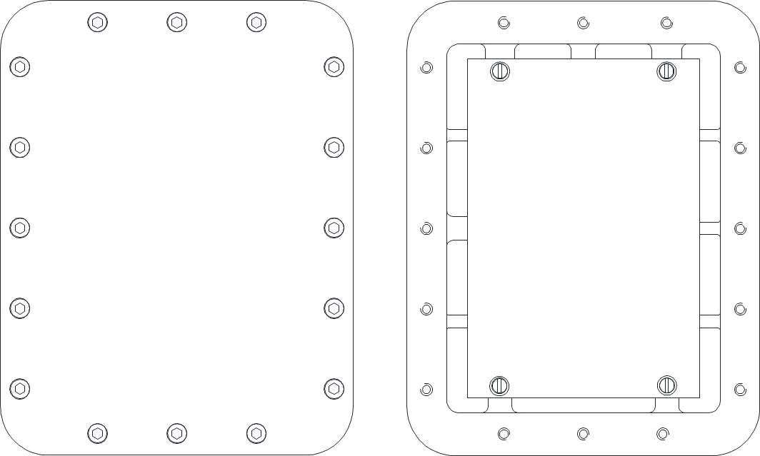
Figure 1 : Example of flameproof enclosure

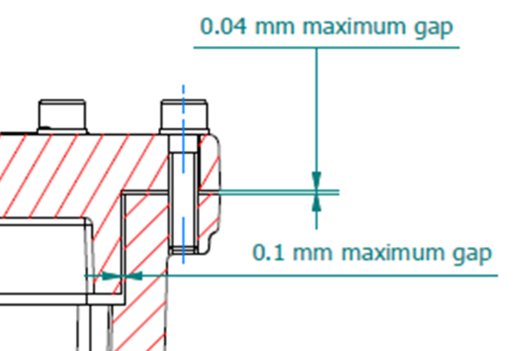

Figure 2 : Perpendicular assembly between the cover and the body

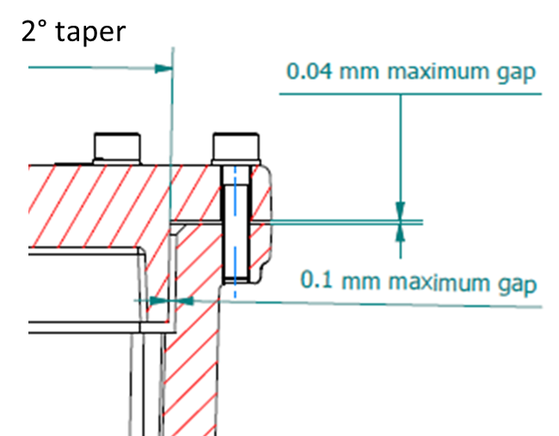
≤5° taper

Figure 3 : Conical assembly between the cover and the body

Background:

- A similar question has been assessed by the European ATEX Notified Bodies Group. The answer have been formalized in Clarification Sheet n°ExNB/00/031/CS with the following conclusion :

“Extract of Clarification Sheet n°ExNB/00/031/CS”

- According to the UL 1203 standard, a spigot (rabbet) joint consists of an axial segment and a radial segment which are arranged to be at right angles to each other. The actual shape of the enclosure parts is not considered, but only the right angle relationship of the segments. This is the same relationship as is shown in Figures 2 and 3 above. The construction must meet minimum lengths of the segments of the joint and maximum gaps, including acetylene atmospheres. Testing compliance must be achieved.

Similarly, IEC 60079-1:2014 construction and performance requirements are applied:
- the cross-section of this type of joint is reflected by the Figure 2a or 2b of width and gap of the flameproof joint in accordance with Table 3 as spigot joint,
- Testing compliance must be achieved

Question:

How these types of flameproof joints (Figure 2and Figure 3 shown above) could be considered according to 5.2 Non-threaded joints clause of IEC 60079-1 7th edition in order to be used for all the gas Group (I, IIA, IIB and IIC)?

Answer:

These joints can be considered as spigot joint according clause 5.2.3 of IEC 60079-1, provided that:

- in case of Figure 2

- The minimum values of width of joint and maximum gaps are in accordance with the Table 2 or 3 of IEC 60079-1:2014 standard (equivalent to Table 1 or 2 of IEC 60079-1:2007).

2) The equipment passed successfully the tests in accordance with 15.3.3 of the IEC 60079-1:2014 standard (equivalent to 15.2.2 of IEC 60079-1:2007).

NOTE :
Due to the critical aspect regarding the dimensional control for this type of construction, a particular attention should be given for the tests and production in order to measure accurately the parameters of flameproof joints (the width, gaps and cone angle).».

For example, when a Coordinate Measuring Machines (CMMs) equipment is used, CMM measurement uncertainty shall be suitable in comparison to the gap absolute measurement (e.g. a safe gap 40 µm all along the path according geometry) considering that the use of a CMM instrument with good performance does not imply to obtain good measurement results; it is because that the reliability of measurement results is not only attributed to the instrument, but also the environment, operator, and method are involved; therefore is mandatory to determine a measurement uncertainty to characterize the reliability of measurement results in order to guarantee an expected accuracy.

Furthermore, both parts of the cylindrical gap must be measured and analysed in a way that the precise value of the gaps can be calculated at each single measurement point. Average values are not allowed. To safeguard the compliance with the dimension requirements over the whole length of the gap, it is necessary to take the measurements over the length of the gap (e.g. 3 series: upper part, lower part and in the middle).The position of the values needs to be considered. This leads to the requirement that the position needs to be specified (the lid will not be allowed to be mounted 180° turned)

Regarding the production control in accordance with IEC 80079-34 and specially with the Annex A, 100% of measurement could be mandatory and sampling in production should be not allowed. The ExCB involved in QMS according ISO 80079-34 shall perform the audit considering the measurement process, in particular when evaluating the acceptance criteria in 16.5 of IEC 60079-1:2014 (equivalent to 16.3 of IEC 60079-1:2007), in consideration of the fact that the enclosure shall withstands the pressure without suffering permanent deformation of the joints, which means the measurement before and after the pressure test in order to evaluate a deformation.

- in case of Figure 3

as well as in case a), provided the same conditions above per Figure 3 and ensuring that the cone angle do not exceed 5° through the production measurement control as per the “NOTE” of a).

