INTERNATIONAL ELECTROTECHNICAL COMMISSION SYSTEM FOR
CERTIFICATION TO STANDARDS RELATING TO EQUIPENT FOR USE
IN EXPLOSIVE ATMOSPHERES (IECEx SYSTEM)

NOTICE OF MEETING
IECEx 2016 SERIES OF MEETINGS
TO BE HELD IN UMHLANGA, SOUTH AFRICA

Dear Madam/Sir

Further to information from the 2015 IECEx Christchurch Meetings, and following the kind invitation received from the South African IECEx National Committee, we are pleased to confirm that the 2016 Annual IECEx Meetings will take place in Umhlanga,
(near Durban) South Africa

We also confirm that the dates for the 2016 IECEx annual meetings will be held during the week commencing 5th September to 9th September 2016, as previously advised in-

ExMC/1072/DL Confirmed List of Decisions
The Seventeenth Meeting of the
ExMC held in Christchurch, New Zealand on
17th and 18th September 2015

Details relating to accommodation bookings, general information and meeting registration will be available via the IECEx Web Site in due course.

I thank you in anticipation of your assistance and invite you to contact me should you have any questions relating to the meetings

Kind regards
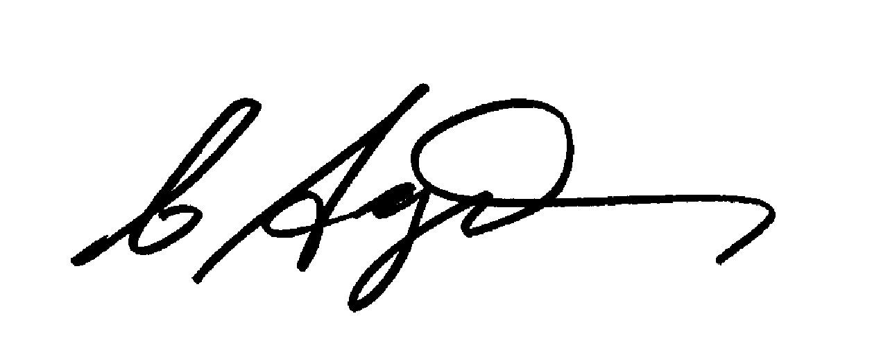
Chris Agius
IECEx Secretariat

Address:  Level 33, Australia Square  264 George Street  Sydney NSW 2000  Australia | Contact Details:  Tel: +61 2 4628 4690  Fax: +61 2 4627 5285  e-mail:chris.agius@iecex.com  http://www.iecex.com

