INTERNATIONAL ELECTROTECHNICAL COMMISSION SYSTEM FOR CERTIFICATION TO STANDARDS RELATING TO EQUIPMENT FOR USE IN EXPLOSIVE ATMOSPHERES (IECEx SYSTEM)

TITLE: Meeting Information Document for Buxton IECEx Meetings May/June 2013

INTRODUCTION

This document contains Registration and meeting details for the IECEx Executive and Operational meetings to be held in Buxton, United Kingdom, May/June 2013.

Members are requested to complete the registration form, ANNEX B and forward to info@iecex.com by 15th May 2013.

Chris Agius
IECEx Executive Secretary

IECEx Secretariat  Standards Australia Building  286 Sussex Street  Sydney NSW 2000  Australia | Tel: +61 2 8206 6940  Fax: +61 2 8206 6272  Email: chris.agius@iecex.com

GENERAL INFORMATION
Re: The IECEx Executive and Operational Meetings, May/June 2013

To be held in Buxton, United Kingdom
From Thursday 30th May 2013 to Friday 7th June 2013

MEETING PLACE

The meetings will be held at:

SGS Baseefa Limited
Rockhead Business Park
Staden Lane
Buxton, Derbyshire
SK17 9RZ
Tel: +44 1298 766600
Fax: +44 1298 766601
Contact Person/s: Mr Ron Sinclair, Ron.Sinclair@sgs.com
Ms Jayne Lingard, jayne.lingard@sgs.com
Website: www.baseefa.com

MEETING SCHEDULE

Date | Meeting
Thursday, 30th May 2013 | AM: IECEx ExMC WG 13  (Business Develpoment)
Thursday, 30th May 2013 | PM: IECEx ExMC WG 16  (Training Body Scheme)
Friday, 31st May 2013 | IECEx ExMC WG 15  (Non Electrical Equipement)
Saturday, 1st June 2013
Sunday, 2nd June 2013
Monday, 3rd June 2013 | IECEx ExMC WG 1 / WG 5  (IECEx Equipment Scheme)
Tuesday, 4th June 2013 | IECEx ExPCC (Personel Certification Committee)
Wednesday, 5th June 2013 | IECEx ExPCC (Personel Certification Committee)
Thursday, 6th June 2013 | AM: ExMarkCo
Thursday, 6th June 2013 | PM: IECEx Executive
Friday, 7th June 2013 | AM: IECEx Executive

A map showing the venue for the Meetings is attached as Annex A.

MEETING HOURS: 9.00 a.m. to 12.30 p.m.
1:30 p.m. to 5.00 p.m.

Please note that in respect to our hosts attendance is limited to members of the specified Working and Operational Groups for each day. The IECEx Secretariat would like to thank you for your co-operation.

ACCOMODATION:

The Palace Hotel:

Palace Road
Buxton, Derbyshire
SK17 6AG
United Kingdom
Phone: +44 (0) 1298 22001
Fax: +44 (0) 1298 72131
Webpage: http://www.pumahotels.co.uk/hotels/northern-england/barcelo-buxton-palace-hotel

Rating: 4 Star
Free WI-FI Free use of leisure centre, including swimming pool
Parking in hotel grounds charged
Cost: Corporate Rate £70 per night/ Bed and Breakfast
A block of rooms have been allocated for delegates at The Palace Hotel.
To obtain this corporate rate please contact Laura on +44 (0) 1298 767003 and quote reference number 13390921. Reservations close 15th May 2013.

Old Hall Hotel:

The Square
Buxton, Derbyshire,
United Kingdom
SK17 6BD
Tel: +44 (0) 1298 22841
Website: http://www.oldhallhotelbuxton.co.uk/

Rating: 3 Star
Parking on street – obtain vouchers from hotel reception
Cost: From £65 per night/ Bed and Breakfast

For reservations please contact the hotel directly using the above contact details.

Please Refer to ANNEX A for Map of the above hotels.

BUXTON

Buxton is a spa town in Derbyshire, England. It has the highest elevation of any market town in England (300m). Located close to the county boundary with Cheshire to the west and Staffordshire to the south, Buxton is described as the gateway to the Peak District National Park.

Travel Between The Palace Hotel and SGS Baseefa Meeting location:
Delegates are advised that while there are plenty of taxis in the Buxton centre, it is advisable to book a taxi the evening prior through the hotel staff. Approximate cost for a one way trip to SGS Baseefa meeting venue is approx. £7.00 (usually taking a maximum of four people) and takes about 10 mins.

The nearest bus stop to SGS Baseefa is at the end of Staden lane, about 300 metres. There is one regular bus per hour from Buxton Market Place plus others irregularly, so this is not normally a recommended route.

ARRIVAL BY AIR

Buxton does not have its own airport, but is easily accessible from Manchester Airport via either Taxi, Bus or by Train. For more information please visit www.manchesterairport.co.uk

Taxi
Taxis can be ordered by phone, hailed in the street or found at authorised taxi ranks in town, and at Manchester airport.

Arrow Cars

Official Manchester Airport Taxi Private Hire service provides passengers with a professional high quality and a seamless taxi service to and from Manchester Airport. Arrow Cars offer choice, convenience and comfort for affordable prices.
Why book with Arrow Cars?
- Desks at each of the 3 terminals at Manchester Airport
- User friendly on line booking facility with no credit card fees
- Know your fare before you travel with this easy to use, pre-paid service
- Same price 24/7
- All major credit cards accepted
- Book your return journey Inc. Free textback (a text when the vehicle arrives)
- Travel in comfort at affordable prices
- Cars immediately available
- Exclusive pick up/drop off points
- Eco-friendly Saloons and 7 seaters available
- Child seats available (3 to 7 year olds)
- Corporate accounts welcome.
For more information or to book please visit http://www.manchesterairport.co.uk/manweb.nsf/Content/arrowtaxi

PUBLIC TRANSPORT

TRAIN:
Frequent services run between Manchester Airport and Manchester Piccadilly Station with TransPennine Express and Northern Rail. They run 24 hours a day, 7 days a week.
Trains to Buxton, from Manchester Piccadilly run every hour, with additional trains at peak periods. The duration of the trip from Manchester Airport to Buxton is approx 1 ½ hours, plus any time waiting for a connection at Manchester Piccadilly. To view timetables and fare details please visit www.tpexpress.co.uk

BUSES:
There is a direct bus (Service 199) from Manchester Airport to Buxton, running half-hourly for most of the day, hourly on Sundays and in the evenings. Timing varies during the day because of expected traffic delays but typically takes 1 ¾ hour, which is usually quicker than the train and has the advantage of no changes and significantly less cost. See www.highpeakbuses.com/Documents/199%20-%20Skyline.pdf
The airport rail and bus stations are both accessed via the walkway between terminals 1 and 2.
At Buxton, alight from the bus at the rail station. The Palace Hotel is 100 meters walk

CLIMATE AND CLOTHING

During the months of May and June the average temperature for Buxton is between lows of 5˚C and highs of 22˚C. Periodic rainfall occurs year round.

CREDIT CARDS

American Express, Diners Club, Eurocard, MasterCard, Visa and some other credit cards are accepted in most hotels, restaurants and shops, although both American Express and Diners Club are less acceptable.

CURRENCY

In the United Kingdom the currency is the Pound Sterling £ (GBP). Banknotes are issued in the following denominations: £5, £10, £20, (and rarely £50). Coins in use are called Pence and are issued in the following denominations: 1p, 2p, 5p, 10p, 20p, 50p, £1, £2. (£1= 100p).

ELECTRICITY SUPPLY

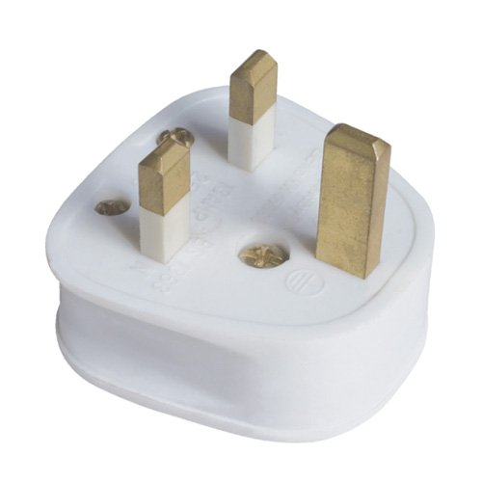 230 V

MEAL FACILITIES

A variety of restaurants and cafes are available in the vicinity of the hotels. However, as there are no facilities in the neighbourhood of the meeting venue, please note that Morning Tea, Lunch and Afternoon tea will be provided for delegates on meeting days.

Both hotels listed above in this document have meal facilities within the hotel.

PASSPORT, VISA AND VACCINATION

Participants are advised to check their local travel agency about regulations regarding passport, visa and vaccination and, particularly, the length of notice required for obtaining a visa, if required. In case of doubt, information can be obtained from the nearest British embassy.

However, if you need an Invitation Letter for Visa purposes please contact either Mr Ron Sinclair Ron.Sinclair@sgs.com or Ms Jayne Lingard jayne.lingard@sgs.com.

TIME ZONE

The Standard time zone for Buxton is No UTC/GMT offset.
However “Daylight Savings Time” starts on Sunday, 31 March 2013 at 1:00 AM meaning that clocks are put forward one hour.

ANNEX A
Buxton Map

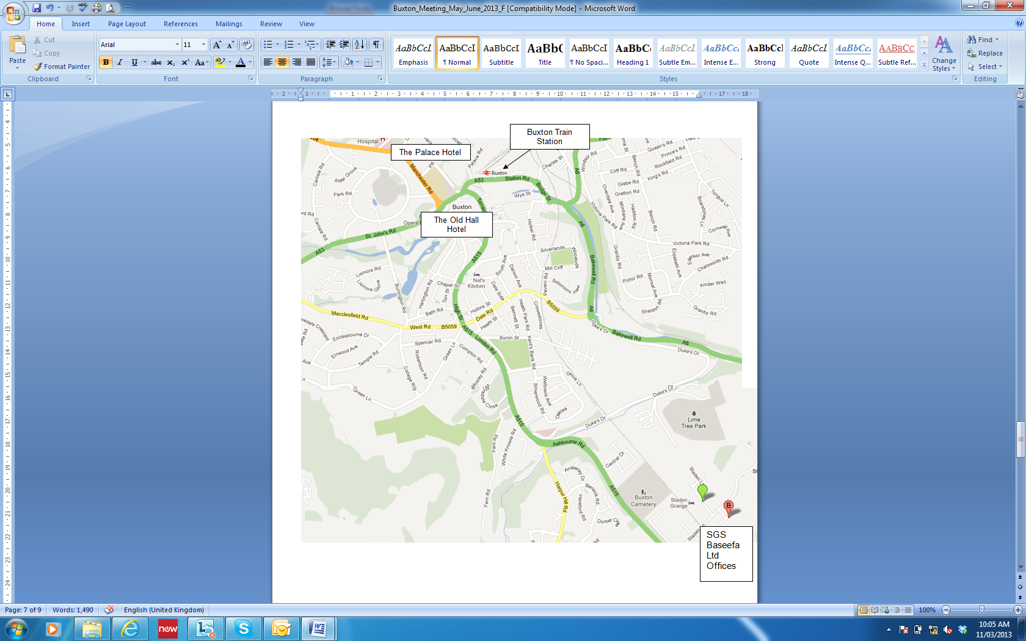
ANNEX B
Registration Form

MEETING REGISTRATION FORM
For attendance at the Buxton IECEx Executive and Operational meetings
30th May to 7th June 2013
SGS Baseefa Ltd Offices, Buxton UK

Yes. I will be attending the Buxton IECEx Meetings 30th May to 7th June 2013:
Please indicate which meetings you will be attending:

Date | Meeting | (Y) Yes / (N) No
Thursday, 30th May 2013 | AM: IECEx ExMC WG 13
Thursday, 30th May 2013 | PM: IECEx ExMC WG 16
Friday, 31st May 2013 | IECEx ExMC WG 15
Saturday, 1st June 2013
Sunday, 2nd June 2013
Monday, 3rd June 2013 | IECEx ExMC WG 1 / WG 5
Tuesday, 4th June 2013 | IECEx ExPCC
Wednesday, 5th June 2013 | IECEx ExPCC
Thursday, 6th June 2013 | AM: ExMarkCo
Thursday, 6th June 2013 | PM: IECEx Executive
Friday, 7th June 2013 | AM: IECEx Executive

No. I will not be attending the Buxton IECEx Meetings 30th May to 7th June 2013

Name
Organisation
E-Mail
Hotel
Comments

Please complete and return to info@iecex.com as soon as possible or by 2013-05-15

Please Note delegates are responsible for their own accommodation bookings. Please refer to Meeting Information Document ExMC/831/Inf

To check current Membership listing visit
For ExPCC Membership: http://www.iecex.com/expcc.htm (Document ExPCC/001/Inf)
For ExMarkCo: http://www.iecex.com/exmarkco.htm (Document ExMarkCo/01F/Inf)
For ExMC WGs: http://www.iecex.com/directory/working_groups/wg_list.asp

Chris AGIUS
IECEx Executive Secretary

E-Mail: chris.agius@iecex.com
Fax: +61 2 82066940
Tel: +61 2 82066940

