INTERNATIONAL ELECTROTECHNICAL COMMISSION IEC SYSTEM FOR
CERTIFICATION TO STANDARDS RELATING TO EQUIPMENT FOR USE IN
EXPLOSIVE ATMOSPHERES (IECEx SYSTEM)

TITLE: IECEx Re-assessment Report for an extension of scope for Korea Gas Safety Corporation (KGS) an existing Accepted Ex Certification Body (ExCB) to include IEC 60079-6 and IEC 60079-31 within their scope.

INTRODUCTION

This document contains the IECEx Re-assessment Report for Korea Gas Safety Corporation (KGS), an existing Accepted Ex Certification Body (ExCB) to include IEC 60079-6 and IEC 60079-31, within their scope.

The report is hereby submitted for voting by the ExMC

Please consider the assessment report and return the completed voting form to the Secretariat by 2013 08 08.

Your speedy response to the voting process will be very much appreciated.

Chris Agius

IECEx Secretariat

IECEx Secretariat  Standards Australia Building  286 Sussex Street  Sydney NSW 2000  Australia | Tel: +61 2 8206 6940  Fax: +61 2 8206 6272  Email: chris.agius@iecex.com

IECEx RE-ASSESSMENT REPORT FOR KGS ExCB
(IECEx Certification Body)

Type of Assessment: (please mark)

Re-Assessment of ExCB X

Scope Extension of ExCB X

- OBJECT AND FIELD OF APPLICATION

  - Country:
Republic of Korea

  - Name of Candidate ExCB

Korea Gas Safety Corporation (KGS)

  - Members of the Assessment Team

Ron Webb, Explosion Safety Consultant- Lead Assessor
Vijay Varma, Intertek Testing & Certification Ltd – Expert assessor

  - Place and Date of Assessment

KGS
332-1 Daeya Dong, Shiyhung-Shi
Gyonggi-Do
KOREA 429-712

20-22 November 2012 (6 man-days)

  - Assessment References
- IECEx 02 IECEx Certified Equipment Scheme covering equipment for use in explosive atmospheres - Rules of Procedure
- IECEx 03 IECEx Certified Service Facilities Scheme covering repair and overhaul of - Rules of Procedure
- IECEx OD 003 Part 2 IECEx Assessment procedures
- IECEx OD 005 -1 Quality System requirements for manufacturers
- IECEx OD 005 -2 Quality System requirements for manufacturers
- IECEx OD 009 Issuing of CoCs, ExTRs and QARs
- IECEx Document OD25 Second Edition 2010-08 Management of assessment and surveillance programs for manufacturers (includes QAR forms)
- ISO/IEC 80079-34 First Edition 2011-04
- IECEx OD 014 V2 Quality Management System requirements for IECEx Service Facilities
- IECEx OD 015 V2 Additional requirements for IECEx Service Facilities
- ISO/IEC Guide 65:1996
- IECEx Document OD 17 Drawing and documentation guidance

  - Scope of Application (to be selected)

Number | Title
60079-0 | Electrical apparatus for explosive gas atmospheres  Part 0: General requirements - EDITION 6
60079-1 | Electrical apparatus for explosive gas atmospheres  Part 1: Construction and verification test of flameproof enclosures of electrical apparatus - EDITION 6
60079-2 | Electrical apparatus for explosive gas atmospheres  Part 2: Electrical apparatus, type of protection 'p' (Pressurization) EDITION 5
60079-6 | Electrical apparatus for explosive gas atmospheres  Part 6: Equipment protection by oil immersion 'o' - EDITION 3
60079-7 | Electrical apparatus for explosive gas atmospheres  Part 7: Increased safety 'e' – EDITION 4
60079-11 | Electrical apparatus for explosive gas atmospheres  Part 11: Intrinsic safety 'i' EDITION 6
60079-15 | Electrical apparatus for explosive gas atmospheres  Part 15: Electrical apparatus with type of protection 'n' (Non-Sparking) EDITIONS 3 and 4
60079-18 | Electrical apparatus for explosive gas atmospheres  Part 18: Encapsulation 'm' EDITION 3
60079-31 | Electrical apparatus for explosive dust atmospheres  Part 31: Equipment dust ignition protection by enclosure 't' - EDITION 1

The Scope extension request is for IEC 60079-6 and IEC 60079-31.
The scope is for Group II applications only.

  - Candidate ExCB Persons Interviewed

Name | Position
Young Jin Park | Department Leader
Ja Song Koo | Certification Engineer

  - Legal Entity of the Candidate ExCB

KGS is a public body established under Article 28 of the High Pressure Gas Safety Control Law. There is a certificate of registration 133-82-02018 with the Taxation Department for KGS.

  - Associated Testing Laboratories

The ExTL is integral with the ExCB.

  - Associated Certification Functions

KGS issues certificates for gas appliances; it issues certification to ISO 9001 for all areas; to ISO 14000; and national Ex certification.

  - National Marks and Certificates

There is a national mark and certificate for Ex.

There is a KGS mark that is used in other areas.

  - Financial Support

KGS receives about 50% financial support from the Government. The rest is met from inspection, training, R&D, testing and certification income.

  - History

Initially established in 1974 with the name KGS being used since 1979. In 1995 the Institute of Gas Safety Technology was established as an annex research centre. In 1998 it became an affiliate of the Ministry of Commerce, Industry and Energy, and was designated as a certification body for electrical explosion-proof performance.

  - Standards Accepted

See clause 1.6 of this report

  - National Differences to IEC Standards

National differences to IEC standards are listed in the latest version of the IECEx Scheme Bulletin.

- ORGANISATION

  - Names, Titles and Experience of the Senior Executives

Name | Title | Experience
Seok Jeong Yoon | General Manager | 17 years mostly at KGS but not specifically in Ex.
Young-Jin Park | Department Leader | 27 years mostly at KGS but not specifically in Ex.

  - Name, Title and Experience of the Quality Management Representative

Name | Title | Experience
Young-Jin Park | General Manager, Ex Testing Service Department, and Quality Manager | 27 years mostly at KGS but not specifically in Ex.

  - Name and Title of Nominated Principal Contact

Name | Title | Comments
Young-Jin Park | As above | yjp@kgs.or.kr

  - Name and Title of Signatories for Certification

Name | Title | Comments
Young Jin Park | As above
Seok Jeong Yoon | As above | Only when Young Jin Park not available

  - Other Employees in ExCB activity

Name | Title | Responsibility
JaSong Koo | Certification Engineer | 7 years at KGS in Ex

  - Organizational Structure

There have been some changes in structure and staff since the re-assessment 2007. The total staff of the ‘Hazardous Locations’ group in KGS is now 16 with four personnel in the ExCB. The most recent change in structure was in July 2012 when the reporting structure of the group was changed and Young Jin Park became Department Leader of the group in addition to his role as head of the ExCB. He in turn reports to a newly appointed Director, Young-Dae Kim.

The organisational structures are shown in Annex 1 and 2 of this report and also appear in Ex-M-02 of the Manual.

  - Administration

    - Administrative Structure

See Annex 1

    - Indemnity Insurance

KGS indemnity is covered by the government as it is a government agency. But in addition it has an indemnity insurance cover for of KRW10,000,000,000. This policy was viewed.

- RESOURCES

There are four dedicated people in the ExCB. In addition the General Manager also has some roles in the ExCB operation, including Chairman of the Certification Committee.

- COMMITTEES / Governing Board / Appeals / Advisory Board

There is a Certification Committee with its terms of reference defined in the procedure Ex-P-18 Certification and Test (4.5, 5.5). The General Manager is the Chairman of this committee. It comprises minimum 5 members, including the General Manager from KGS and 4 other people both from within and outside the Ex Testing & Certification Service Department. There are no external people. The committee members see the ExTR and QAR that will be used to issue a CoC and vote secretly on acceptance with a majority needed to accept. This is provides the decision on certification.

There is an internal audit group for auditing of finances and implementation of policies, compliance with regulations etc. The head of this group is appointed by the Government.

KGS also has a board that covers a range of high level functions, including supervision of finances, approval of major capital expenditure, major policy issues and the structure of KGS. It is not directly involved with certification functions.

- CERTIFICATION OPERATIONS

  - National Approval/Certification Methods

See 1.11.

  - Certification Policy

The quality policy is defined in the Manual in Ex-M-0B. The policy includes reference to ISO/IEC 17025 and Guide 65 and specific reference to certification and testing. The policy is signed by the General Manager under delegation from the President.

  - Application for Certification

KGS has an application form for clients to use when applying for IECEx certification. The procedures for dealing with applications for certification are contained in Ex-P-18 Certification and Test. This document defines the responsibilities of the relevant personnel and the Certification Committee, and the scope.

Feedback is obtained in accordance with procedure Ex-P-08 Service to the Client. This is done by means of a questionnaire. A recent example of the survey and results was viewed.

As seen in Annex 2, separation between ExCB and ExTL is achieved through the use of different personnel in each area. In addition, as noted earlier, the certification committee also provides an independent role in the certification process.

  - Withdrawal and Cancellation of Certificates
Ex-I-02 Maintenance of Certification Registration addresses withdrawal and cancellation of certificates and ExTRs. The decision on cancellation is taken by the Certification Committee.

- STATISTICS

  - Certificates Issued
Number of certificates issued under the IECEx, national or regional schemes in the preceding four years for each type of protection.

Local certificates issued:

 | 2009 | 2010 | 2011 | Oct 31 2012
Ex d | 205 | 165 | 229 | 226
Ex e | 131 | 132 | 137 | 219
Ex p | 18 | 31 | 44 | 27
Ex i | 4 | 8 | 13 | 5
Ex n | 7 | 3 | 26 | 51
DP | 1 | 1 | 23 | 27
Total | 366 | 340 | 472 | 555

IECEx certificates issued:

 | 2009 | 2010 | 2011 | Oct 31 2012
Ex d | 4(Ex d)  1(Ex dpx) | 31(Ex d)  20(Ex de)  4(Ex demb) | 14(Ex d)  24(Ex d/de)  2(Ex de)  3(Ex demb) | 11(Ex d)  8(Ex de)
Ex e |  | 1(Ex ed)  1(Ex emb)  2(Ex emb/demb) |  | 1
Ex p | 1(Ex pz) | 2(Ex pz) |  | 1(Ex pz)
Ex i
Ex n | 13(Ex nA) |  |  | 1(Ex nR)  1(Ex nA)
DP
Total | 19 | 61 | 43 | 23

- DOCUMENTATION

The following documents were reviewed and noted to meet IECEx requirements

  - Quality Manual

The main quality manual used for the Ex operation is called ‘Manual’ and is structured in accordance the clauses of ISO/IEC 17025 with each section numbered Ex-M-xx.

  - Procedures

The next level in the system is the procedures which are numbered Ex-P-xx

  - Work Instructions

At the next level are the guidance documents that are numbered Ex-I-xx.

  - Records

All records are retained in hard copy form.

  - Document Change Control

Document control is covered in Ex-P-04. All procedures and related documents are in printed form and subject to a document change control process.

- CONFIDENTIALITY

Confidentiality is addressed in Ex-M-27. Each staff member is required to sign a confidentiality agreement. The file containing these was viewed.

- PUBLICATIONS

There is a magazine that is circulated by KGS every month.

- NATIONAL ACCREDITATION

The Government authorises KGS to issue National Ex certificates. They also have formal accreditation as a certifying body to ISO/IEC Guide 65 from the Korea Accreditation System (KAS) – See Annex 3 This is valid until 5 April 2013. The scope of accreditation that forms part of the certificate does not explicitly mention Ex activities. The scope Category covers section 281 – ‘Electrical equipments manufacturing: motor, generator, electrical converter, electrical supply controller manufacturing. KAS accreditation according to the scope of Guide 65 however does not specifically cover the Ex protection standards therefore on this basis an annual surveillance assessment by IECEx is to continue.

- RECOGNITION AND AGREEMENTS

There are mutual recognition agreements in place with a number of bodies including SGS Baseefa, Sira in the UK, LCIE in France, NANIO CCVE in Russia, NEPSI in China, Simtars in Australia and FTZU in the Czech Republic. There is to be a mutual recognition agreement with PTB in the near future.

- INTERNAL AUDIT AND PERIODIC MANAGEMENT REVIEW

Management review is in Ex-M-15 and Ex-P-15. The internal audit for 29-30 March 2012 was viewed. It used a lead ISO auditor and a technical expert who is also an external auditor of manufacturers (not in the Ex field). The audit indicates it covers ISO/IEC 17025 and 17020.

- SUBCONTRACTING, USE OF OTHER LABS AND USE OF OTHER LOCATIONS

KGS subcontract with KTL (an existing ExTL) for the measurement of screw threads, vibration tests for bi-pin tubes in luminaires, the impact test for Ex e batteries and the charging test in IEC 60079-0. There is no sub-contracting to other bodies. There is a file covering the subcontracting to KTL which shows the tests covered, the relevant accreditation from KOLAS is included in file and there is a signed contract that also includes a confidentiality agreement.

Witness testing requirements are contained in Ex-P-18 Certification and Test.
A sample test file was reviewed and was found to use the methods required by OD24.

- TRAINING

The computer system is used to record all external training, duty statements and qualifications.

A plan is developed for training each year and recorded in a file. The file shows the information about who attended the training and all the information about what was covered.

Procedure Ex-I-06 Certification of Employee addresses the assigning of competency to staff members. Ex-P-23 Assuring the Quality also covers how a plan is made for employees. There a personal competency certificates for each person and also a competency matrix. These were viewed and considered acceptable in meeting IECEx requirements

- ASSESSMENT OF MANUFACTURERS AND ISSUE OF QARS

The manufacturing assessments are generally done by Mr Koo but use may be made by Ex experts from the ExTL. Mr Kim is also under training as an IECEx assessor of manufacturers. The procedure for this is Ex-I-01.

Three QARs were reviewed as follows

QAR KR/KGS/QAR12.0001/00 – CHK CO.,LTD– Ex d initial audit. The report was comprehensive and a non-conformity raised during the audit was appropriately resolved.

QAR KR/KGS/QAR12.0002/00 – TECHCROSS – Ex d,e initial audit. A team of 3 people was used for this audit (one was in training). This report was also comprehensive and and a non-conformity raised during the audit was appropriately resolved.

QAR KR/KGS/QAR07.0001/05 – DAEYANG Electric Co.,LTD – Ex d,e,p,m,n Re-Assessment. A team of 4 people was used for this audit (one was in training). This report was also comprehensive and satisfactory.

- COMPLAINTS AND APPEALS (Including appeals to IECEx)

Procedure Ex-P-09 addresses appeals, complaints and disputes. It includes specific reference to the potential to use of the IECEx Board of Appeal by the ExCB or the applicant. The process is managed by the Quality Manager. The applicant is informed of the appeal provision in the application form in Ex-P-18.

- SPECIAL FACTS TO BE NOTED

  - Supporting Documentation
Copies of additional supporting information for this assessment have been provided to the ExCB and the IECEx Secretariat. These include:
- A site assessment report with details of issues raised and how these have been resolved
- Checklist for ISO/IEC Guide 65
- Photos of the facilities

- COMMENTS (Including issues found during assessment)

Details of the issues found are outlined earlier and are also included in the site assessment report.

- RECOMMENDATION

Based on the assessment performed on 20-22 November 2012, KGS is recommended for continued acceptance in the IECEx scheme as an IECEx Certification Body (ExCB) according to the scope of the standards listed in this document, including the extension of scope to include IEC 60079-6 and IEC 60079-31.

Ron Webb  Lead Assessor | Vijay Varma  Expert Assessor

Date: 27 May 2013

List of Annexes:
- Overall Organization Chart of KGS
- Organization Chart of the Hazardous Locations Group
- Accreditation to ISO/IEC Guide 65

Annex 1
Overall Organization Chart of KGS

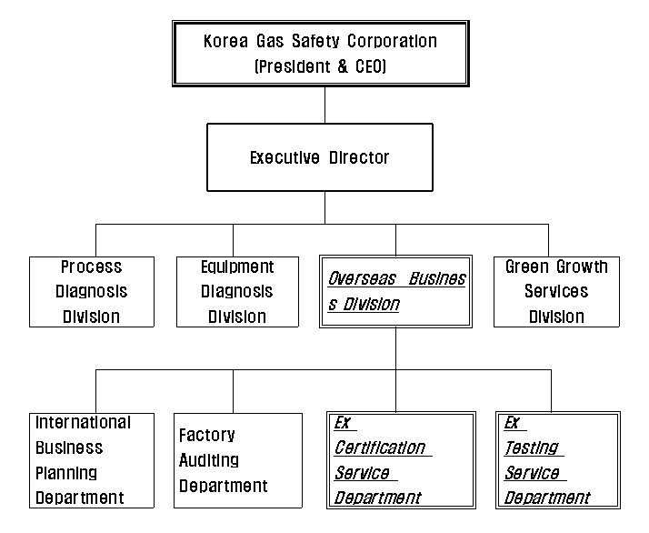

Annex 2
Organization Chart of the Hazardous Locations Group

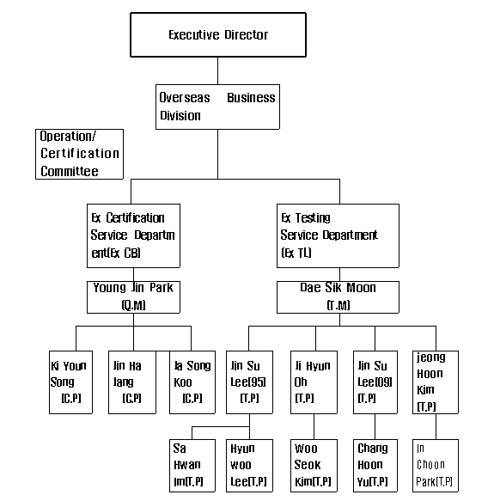
Annex 3

Accreditation to ISO/IEC Guide 65

