INTERNATIONAL ELECTROTECHNICAL COMMISSION IEC SYSTEM FOR
CERTIFICATION TO STANDARDS RELATING TO EQUIPMENT FOR USE IN
EXPLOSIVE ATMOSPHERES (IECEx SYSTEM)

TITLE: IECEx Re-assessment Report for an extension of scope for Korea Gas Safety Corporation (KGS) an existing Accepted Ex Test Laboratory, ExTL, to include IEC 60079-6 and IEC 60079-31 within their scope.

INTRODUCTION

This document contains the IECEx Re-assessment Report for Korea Gas Safety Corporation (KGS), an existing Accepted Ex Test Laboratory, ExTL, to include IEC 60079-6 and IEC 60079-31, within their scope.

The report is hereby submitted for voting by the ExMC

Please consider the assessment report and return the completed voting form to the Secretariat by 2013 08 08.

Your speedy response to the voting process will be very much appreciated.

Chris Agius

IECEx Secretariat

IECEx Secretariat  Standards Australia Building  286 Sussex Street  Sydney NSW 2000  Australia | Tel: +61 2 8206 6940  Fax: +61 2 8206 6272  Email: chris.agius@iecex.com

IECEx RE-ASSESSMENT REPORT FOR KGS ExTL
(IECEx TEST LABORATORY)

Type of Assessment: (please mark)

Re-Assessment of ExTL X

Scope Extension of ExTL X

- OBJECT AND FIELD OF APPLICATION

  - Country:
Republic of Korea

  - Name of Candidate TL

Korea Gas Safety Corporation (KGS)

  - Members of the Assessment Team
Ron Webb, Explosion Safety Consultant- Lead Assessor
Vijay Varma, Intertek Testing & Certification Ltd – Expert assessor

  - Place and Date of Assessment
KGS
332-1 Daeya Dong, Shiyhung-Shi
Gyonggi-Do
KOREA 429-712

20-22 November 2012 (6 man-days)

  - Assessment References

- IECEx 02 IECEx Scheme rules of procedure
- IECEx Operational Document OD/003 IECEx Assessment procedures
- IECEx Operational Document OD/009 Issuing of CoCs, ExTRs and QARs
- ISO/IEC 17025:2005
- IECEx Technical Guidance Documents (TGDs)
- ExTAG decision sheets (DSs)

  - Scope of Application (to be selected)

Number | Title
60079-0 | Electrical apparatus for explosive gas atmospheres  Part 0: General requirements - EDITION 6
60079-1 | Electrical apparatus for explosive gas atmospheres  Part 1: Construction and verification test of flameproof enclosures of electrical apparatus - EDITION 6
60079-2 | Electrical apparatus for explosive gas atmospheres  Part 2: Electrical apparatus, type of protection 'p' (Pressurization) EDITION 5
60079-6 | Electrical apparatus for explosive gas atmospheres  Part 6: Equipment protection by oil immersion 'o' - EDITION 3
60079-7 | Electrical apparatus for explosive gas atmospheres  Part 7: Increased safety 'e' – EDITION 4
60079-11 | Electrical apparatus for explosive gas atmospheres  Part 11: Intrinsic safety 'i' EDITION 6
60079-15 | Electrical apparatus for explosive gas atmospheres  Part 15: Electrical apparatus with type of protection 'n' (Non-Sparking) EDITIONS 3 and 4
60079-18 | Electrical apparatus for explosive gas atmospheres  Part 18: Encapsulation 'm' EDITION 3
60079-31 | Electrical apparatus for explosive dust atmospheres  Part 31: Equipment dust ignition protection by enclosure 't' - EDITION 1
The Scope extension request is for IEC 60079-6 and IEC 60079-31.
The scope is for Group II applications only.

  - Candidate TL Persons Interviewed

Name | Position
Dae Sik Moon | Manager ExTL
Jin Su Lee (09) | Increased safety ‘e’, moulding ‘m’
Ji Hyun Oh | Type of protection ‘n’, dust ’t’
Jeong Hoon Kim | Flameproof ‘d’
Hyun Woo Lee | Pressurization ‘p’ , oil immersion ‘o’
Woo Seok Kim | Intrinsic safety ‘i’

  - Legal Entity of The Candidate TL

KGS is a public body established under Article 28 of the High Pressure Gas Safety Control Law. There is a certificate of registration 133-82-02018 with the Taxation Department for KGS.

  - Associated ExCB

The ExCB is integral with the ExTL.

  - Financial Support

KGS receives about 50% financial support from the Government. The rest is met from inspection, training, R&D, testing and certification income.

  - History

Initially established in 1974 with the name KGS being used since 1979. In 1995 the Institute of Gas Safety Technology was established as an annex research centre. In 1998 it became an affiliate of the Ministry of Commerce, Industry and Energy, and was designated as a certification body for electrical explosion-proof performance.

- ORGANISATION
  - Names, Titles and Experience of the Senior Executives

Name | Title | Experience
Young Jin Park | Department Leader | 27 years in KGS
Dae Sik Moon | Manager ExTL | 11 years in Ex

  - Name, Title and Experience of the Quality Management Representative

Name | Title | Experience
Young Jin Park | Department Leader, Ex Testing Service Department, and Quality Manager | 27 years mostly at KGS but not specifically in Ex.

  - Name and Title of Nominated Principal Contact

Name | Title | Comments
Young Jin Park | As above

  - Employees

Name | Title | Experience in Ex
DaeSik Moon | Manager ExTL | Major concepts : Ex “i” Ex “e” Ex”n”  11 years Ex “m”
JinSu Lee (95) | Certification Engineer | Major concepts : Ex “e” Ex “d” Ex “p”  17 years
JinSu Lee (09) | Certification Engineer | Major concepts : Ex “e” Ex “d”  3 years
JiHyun Oh | Certification Engineer | Major concepts : Ex “d” Ex “n” Ex “t”  3 years
JeongHoon Kim | Certification Engineer | Major concepts : Ex “d” Ex “t”  2 years
HyunWoo Lee | Certification Engineer | Major concepts : Ex “p” Ex “d  2years
WooSeok Kim | Certification Engineer | Major concepts : Ex “d” Ex “i”  1 years
ChangHoon Yu | Certification Engineer | Major concepts : Ex “d”  1 years
Sa Hwan Im | Certification Engineer | Major concepts : Ex “e”  1 years
InChoon Park | Certification Engineer | Major concepts : Ex “d”  1 years

  - Organizational Structure
See Annex 1.

- RESOURCES

The ExTL has a shared General Manager with the ExCB and nine staff. It is well resourced with test equipment and has a new test laboratory constructed in December 2007.

- DOCUMENTATION

The following document were reviewed and noted to meet IECEx requirements

  - Quality Manual

The main quality manual used for the Ex operation is called ‘Manual’ and is structured in accordance with the clauses of ISO/IEC 17025 with each section numbered Ex-M-xx.

  - Test Methods/Procedures
The next level in the system is the procedures which are numbered Ex-P-xx.

  - Test Records
There are test records kept for most tests and in general found to be quite good.

  - Document Change Control
Document control is covered in Ex-P-04. All procedures and related documents are in printed form and subject to a document change control process. However, they are also available on the intranet system.

- TEST REPORTS
  - Test Reports Issued
Number of test reports issued under the IECEx, national or regional schemes in the preceding four years for each type of protection:

Local Reports - only for internal use. These test reports are not issued to the clients:

 | 2009 | 2010 | 2011 | Oct 31 2012
Ex d | 205 | 165 | 229 | 226
Ex e | 131 | 132 | 137 | 219
Ex p | 18 | 31 | 44 | 27
Ex i | 4 | 8 | 13 | 5
Ex n | 7 | 3 | 26 | 51
DP | 1 | 1 | 23 | 27
Total | 366 | 340 | 472 | 555

IECEx test reports issued:

 | 2009 | 2010 | 2011 | Oct 31 2012
Ex d | 4(Ex d)  1(Ex dpx) | 31(Ex d)  20(Ex de)  4(Ex demb) | 14(Ex d)  24(Ex d/de)  2(Ex de)  3(Ex demb) | 11(Ex d)  8(Ex de)
Ex e |  | 1(Ex ed)  1(Ex emb)  2(Ex emb/demb) |  | 1
Ex p | 1(Ex pz) | 2(Ex pz) |  | 1(Ex pz)
Ex i
Ex n | 13(Ex nA) |  |  | 1(Ex nR)  1(Ex nA)
DP
Total | 19 | 61 | 43 | 23

- CALIBRATION

Most equipment is calibrated externally but there is some internal calibration, mainly for pressure and length measurement. There is a database on the intranet that shows all equipment and its calibration status. There are calibration labels on equipment showing the calibration date

- CONFIDENTIALITY

Confidentiality is addressed in Ex-M-27. Each staff member is required to sign a confidentiality agreement. The file containing these was viewed.

- NATIONAL ACCREDITATION

KGS has national accreditation from KOLAS number 186 (see Annex 2). At the time of the assessment visit the scope of this accreditation did not cover the latest editions of the standards covered by the scope shown in this report and IEC 60079-31 was not listed. The assessment was carried out in July 2012. Annex 2 includes relevant extracts of the scope from the accreditation.

- RECOGNITION AND AGREEMENTS

There are mutual recognition agreements in place with a number of bodies including SGS Baseefa, Sira in the UK, LCIE in France, NANIO CCVE in Russia, NEPSI in China, Simtars in Australia and FTZU in the Czech Republic.

- INTERNAL AUDIT AND PERIODIC REVIEW

Management review is in Ex-M-15 and Ex-P-15. The internal audit for 29-30 March 2012 was viewed. It used a lead ISO auditor and a technical expert who is also an external auditor of manufacturers (not in the Ex field). The audit indicates it covers ISO/IEC 17025 and 17020.

- COMPLAINTS AND APPEALS (Including appeals to IECEx)

Procedure Ex-P-09 addresses appeals, complaints and disputes. It includes specific reference to the potential to use of the IECEx Board of Appeal by the ExCB or the applicant. The process is managed by the Quality Manager. The applicant is informed of the appeal provision in the application form in Ex-P-18.

- SPECIAL FACTS TO BE NOTED
  - Supporting Documentation

Copies of additional supporting information for this assessment have been provided to the ExTL and the IECEx Secretariat. These include:
- Details of issues raised and how these have been resolved to the satisfaction of the assessment team
- Checklist for ISO/IEC 17025
- Photos of the facilities

  - Tests Witnessed

The following tests were witnessed during the assessment visit:
- Flameproof pressure determination (for Group IIB)
- Use of spark test apparatus
- Electrostatic measure
- A temperature rise test of a luminaire
- An IP6X/5X test

  - ExTRs Reviewed

The following ExTRs were reviewed and where appropriate issues or comments were made and have been detailed in the site report. All issues were subsequently resolved to the satisfaction of the assessment team.
KR/KGS/ExTR12.0016X/00
KR/KGS/ExTR10.0005X/04
KR/KGS/ExTR12.0017/00
KR/KGS/ExTR12.0013/00
KR/KGS/ExTR10.0004X/00
KR/KGS/ExTR12.0002X/00
KR/KGS/ExTR08.0002X/01
KR/KGS/ExTR10.0028/00
KR/KGS/ExTR12.0004/00

The following National Certification report was checked relating to the Intrinsic Safety:
Project No 733179 dated 2011-Oct-07
Certificate No 11-GA2B0-0350X

- COMMENTS (Including issues found during assessment)

In general KGS was found to be well equipped and with a competent range of skilled staff. However, a number of issues were found that were subsequently resolved to the satisfaction of the assessment team.

- RECOMMENDATION

Based on the assessment performed on 20-22 November 2012, KGS is recommended for continued acceptance in the IECEx scheme as an IECEx Testing Laboratory (ExTL) according to the scope of the standards listed in this document including an extension of scope to include IEC 60079-6 and IEC 60079-31.

Ron Webb  Lead Assessor | Vijay Varma  Expert Assessor

Date: 27 May 2013

List of Annexes:

- Overall Organization Chart of KGS
- Organization Chart of the Hazardous Locations Group
- Accreditation to KGS ISO/IEC 17025

Annex 1
Overall Organization Chart of KGS

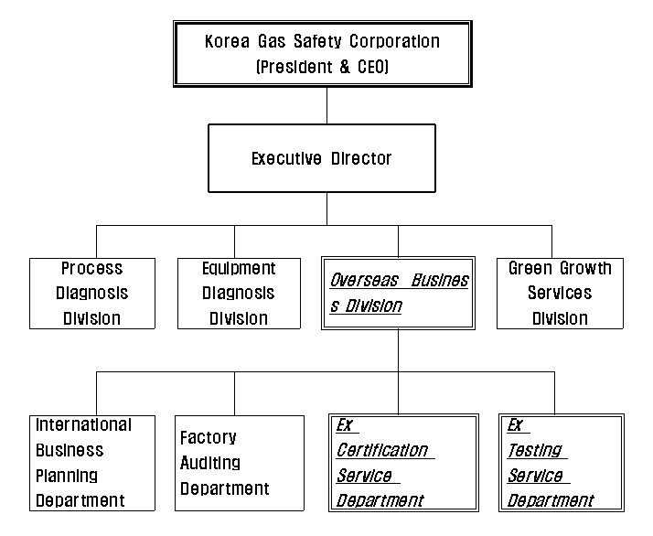

Annex 2
Organization Chart of the Hazardous Locations Group

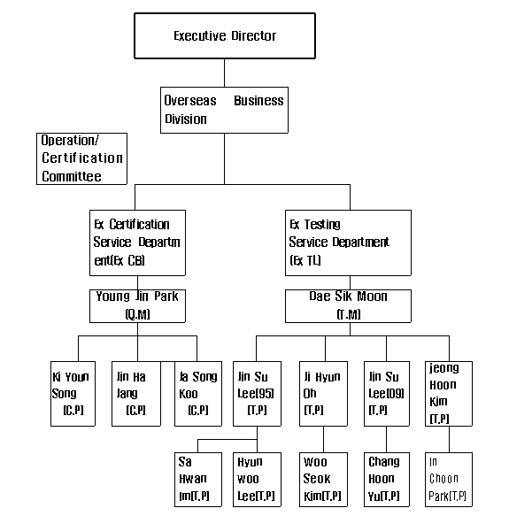
Annex 3
Accreditation to ISO/IEC 17025

