INTERNATIONAL ELECTROTECHNICAL COMMISSION SYSTEM FOR CERTIFICATION TO STANDARDS RELATING TO EQUIPMENT FOR USE IN EXPLOSIVE ATMOSPHERES (IECEx SYSTEM)

Title: Draft revision of IECEx 04A - Guidance for the use of the IECEx Conformity Mark

Circulation to: ExMC Members

Introduction

This document, prepared by the IECEx Secretariat on behalf of the ExMarkCo is submitted for ExMC consideration at the 2013 Fortaleza meeting of ExMC as a part response to Action Item #16 from the ExMC 2012 Calgary meeting (refer ExMC/819A/RM).

The remainder of the response to Action Item #16 is provided in ExMC/867/CD.

This draft revision of IECEx 04A incorporates all comments of the ExMarkCo on an earlier draft in their June 2013 meeting in Buxton.

It is intended that this draft, once finalised, will be published as Edition 2.0 of IECEx 04A.

Chris Agius
IECEx Executive Secretary

Visiting address:  IECEx Secretariat  SAI Global Building  286 Sussex Street  Sydney NSW 2000  Australia | Contact Details:  Tel: +61 2 8206 6940  Fax: +61 2 8206 6272  E-mail: chris.agius@iecex.com  http://www.iecex.com

CONTENTS
1 Overview of the IECEx Scheme 4
1.1 General 4
1.2 Objective 4
1.3 Need for IECEx Conformity Mark 4
1.4 Voluntary system 5
1.5 Owner of the Mark 5
2 Rules and Procedures for the Licensing System 6
3 Application process 7
4 Making an application 8
5 IECEx Conformity Mark 9
5.1 Master symbol for photographic reproduction 9
5.2 Proportional dimensions of the symbol 9
5.3 Guidance for colours used in the Mark 9
5.4 Available electronic formats 10
5.5 Use of the Mark 10
6 IECEx Conformity Mark License sample 12
7 IECEx Conformity Mark License & Schedule availability 13

INTERNATIONAL ELECTROTECHNICAL COMMISSION
____________

Rules and guidance for making applications for and use of
IECEx Conformity Mark, IECEx 04

INTRODUCTION
This document has been prepared to provide rules and guidance for applicants wishing to gain IECEx Conformity Mark Licenses (e.g. manufacturers), as well as guidance on the use of the Marks on products and packaging and other material. It shows the steps and processes required for manufacturers to gain and use an IECEx Conformity Mark License.
The IECEx Publication IECEx 01B defines the rules and provides guidance for the use of the IECEx Logo.
Also it has been prepared to assist in the understanding that while technically rigorous, the process of achieving an IECEx Conformity Mark License is rather straightforward.
The details of the rules and process are given in other IECEx documents available
from the IECEx website or the IECEx Secretariat via the IEC Central Office. http://www.iecex.com
Document History
Date | Summary
July 2008 | Original Issue (Version 1)
August 2013 | This issue includes details regarding the use of the IECEx Conformity Mark that have been transferred from IECEx 01B Edition 1.0.
Address:
IECEx Secretariat
SAI Global Building
286 Sussex Street
Sydney NSW 2000
Australia

Contact Details:
Tel: +61 2 8206 6940
Fax: +61 2 8206 6272
e-mail: chris.agius@iecex.com
http://www.iecex.com

Rules and guidance for making applications for and use of
IECEx Conformity Mark, IECEx 04

Overview of the IECEx Scheme

General
The IECEx Scheme is the System of the IEC for Conformity Assessment to Standards relating to Equipment for Use in Explosive Atmospheres, as provided for in accordance with Article 2 of the IEC Statutes and Rules, 2001 edition (incorporating amendments approved by Council in 2004 and 2005).
The IECEx facilitates the operation of certification programs in strict accordance with the IECEx Scheme Basic Rules, IECEx 01, as approved by the IEC Conformity Assessment Board (CAB). The IECEx, through the IECEx Management Committee (ExMC) approves the appointment of Certification Bodies that may operate in the IECEx Schemes. These Certification Bodies are known as ExCBs and take the sole decision when issuing Certificates of Conformity under the IECEx Certified Equipment Scheme (IECEx 02 Scheme).

Objective
The objective of the IECEx Certified Equipment Scheme is to facilitate international trade in equipment intended for use in explosive atmospheres (referred to as Ex equipment) and services related to that industry. It is a voluntary certification scheme intended to facilitate global trade as follows:
- Reducing testing and certification costs to manufacturer
- Reducing barriers to entry in to established and emerging market places
- Reduced time to market
- Providing International confidence in the assessment process of Ex products and services
- Providing one international database listing of all issued reports, certificates and licenses
The final objective of the IECEx System is world-wide acceptance of one standard, one certificate and one mark.

Need for IECEx Conformity Mark
While the IECEx Certificates of Conformity, issued by ExCBs, provide evidence of conformity, there is a need to display such conformance through the use of an “IECEx Conformity Mark”.
The use of Marks on products and packaging and other material, to demonstrate conformity is widespread. The IECEx Conformity Mark is a single Global Mark that is intended to negate the need for separate individual Marks being used. The growing industry support and use of the IECEx System has fuelled the demand for an International Mark in this field.
The Ex Mark provides greater assurance and ultimately enhanced confidence for governments, safety regulators, customers and industry that the equipment being operated, repaired or supplied for use in explosive atmospheres meets the worlds most respected and vigorous safety standards as established by the IEC.
Gaining an IECEx Conformity Mark License and Using the Mark on products and packaging and other material demonstrates the following to users and consumers:
- That the marked products comply with the requirements of the relevant IEC Standard(s) without any national differences and/or Essential Differences in Requirements (EDRs), and comply with other IECEx recognized normative documents that have been approved by the IECEx Management Committee
- That the manufacturer is operating a dedicated quality management system, meeting the specific IECEx requirements
- That the manufacturer is under on-going surveillance by an Internationally assessed and recognised IECEx Certification Body (ExCB)
As proof of this achievement the International IECEx Conformity Mark Licensing Schedule is on FULL public display via the IECEx website http://www.iecex.com.

Voluntary system
IECEx Conformity Mark License System like the IECEx Certified Equipment Scheme is not mandatory and is a voluntary marking system. As such manufacturers may elect to mark their entire Ex Product range provided the following conditions are met:
- The Manufacturer holds a valid IECEx Certificate of Conformity (CoC) for each and every product
- The Manufacturer holds an IECEx Conformity Mark License, with those CoC’s listed in the Mark License Schedule and where the IECEx CoC and IECEx Conformity Mark License has been issued by the same ExCB
Where valid IECEx CoC’s have been issued by different ExCB’s over a product range, an IECEx Conformity Mark License needs to be obtained from each of the ExCB’s where the IECEx CoC’s have been issued by the ExCB. Issued Mark License Schedules shall only cover product IECEx CoC’s issued by the issuing ExCB.

Owner of the Mark
The IEC is not a certifier (i.e. like other third-party notified bodies PTB, TUV, CESI, SIRA etc). The IEC owns the Mark and authorises approved IECEx Certification bodies such as those listed on the IECEx website the right to issue the Mark Licenses to qualified manufacturers meeting the IECEx requirements.

Rules and Procedures for the Licensing System
The IECEx Conformity Mark Licensing System – Regulations document IECEx 04 & Operational Documents OD 022 and OD 023 – can be found on the IECEx website http://www.iecex.com.
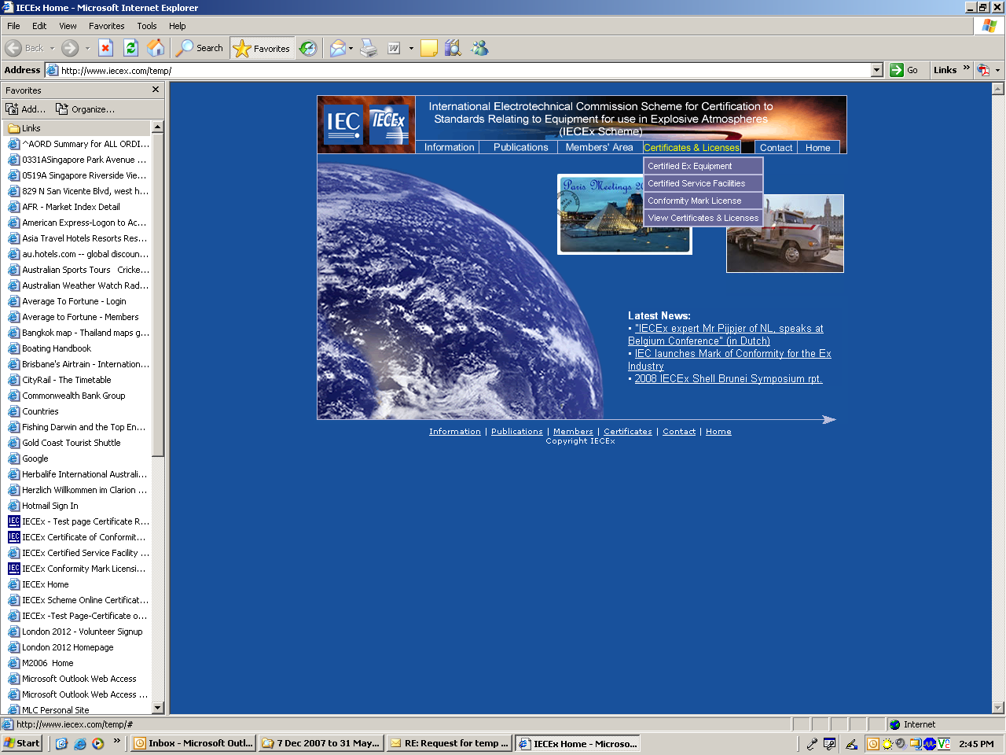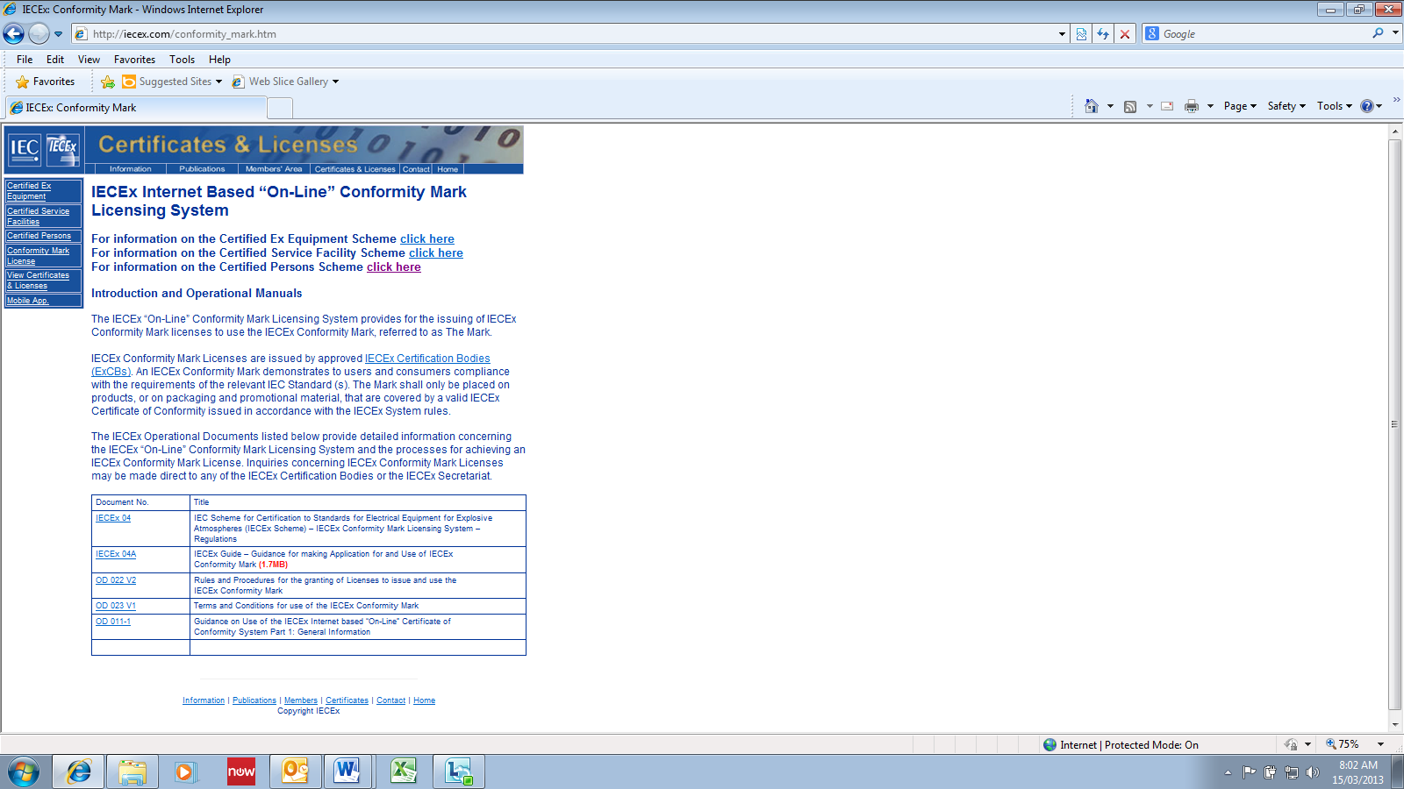
A full and up-to-date listing of ExCBs approved to operate The IECEx Conformity Mark Licensing System under the IECEx Scheme is maintained on the IECEx website http://www.iecex.com.
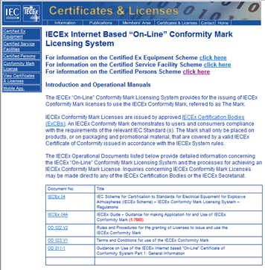

Application process
Applicant applies to a Conformity Mark Licensing System authorised ExCB
Refer to HYPERLINK "http://www.iecex.com"
www.iecex.com under “Information > ExCBs”
ExCB assesses the applicant to ensure control of the usage of the Mark in accordance with IECEx 04, OD 022 & OD 023

Application successful
–
License issued
by the ExCB

Applications for an IECEx Conformity Mark License, under the IECEx Conformity Mark Licensing System, are lodged directly with IECEx Certification Bodies (ExCBs) whom themselves have successfully undertaken the IECEx Peer Assessment program for acceptance into the IECEx System.

Making an application
The application for IECEx Conformity Mark License begins with manufacturers contacting the ExCB, as required by the IECEx Rules, IECEx 04. A special form may not be necessary, but the following information will generally be required by the ExCB:
- Letter formally requesting an IECEx Conformity Mark License
- Exact details of the nominated products (including valid IECEx Certificate of Conformity Numbers) to be covered by the License
- Exact details on how each nominated product is to be marked with the Mark; including documentation, packaging and promotional material as well as usage in catalogues and on websites
- Demonstration that the manufacturer’s quality management system details how they protect the use of the IECEx Mark, such as:
- A policy that the IECEx Mark shall only be used and associated with Ex products covered by an IECEx Certificate of Conformity, listed on the IECEx Mark License Schedule and in accordance with IECEx rules and operational documents (e.g. IECEx 04, OD 022 & OD 023) (refer 2)
- Defined procedures for the design and release of promotional material, including websites to ensure the above policy is maintained and an indication of which position within the organisation that shall have this responsibility and authority
- The manufacturer shall ensure that all requirements of the IECEx Conformity Mark Licensing System Rules and Procedures have been met
The ExCB will estimate the time and cost to complete the License application.
Upon acceptance of the application, the ExCB will review the nominated IECEx CoC’s for validity.
Upon a successful review of the nominated IECEx CoC’s the ExCB will undertake the assessment and audit of the applicant’s procedures for compliance with the IECEx requirements.
If the audit of the applicant’s procedures is successful, the ExCB will conduct an assessment and audit of the applicant’s proposed design and use of the IECEx Conformity Mark.
Upon a successful application the license is registered on the IECEx website and the applicant is informed of the license being issued.

IECEx Conformity Mark

Master symbol for photographic reproduction
The IECEx Conformity Mark as shown in Figure 1 is a single Global Mark that is intended to identify that Ex equipment bearing this Mark are covered by an IECEx Certificate of Conformity. The growing industry support and use of the IECEx Schemes has fuelled the demand for an International Mark in this field.
The IEC is the legal owner of the Mark and authorises approved IECEx Certification bodies (ExCBs) such as those listed on the IECEx website, the right to issue the Mark Licenses to qualified manufacturers meeting the IECEx requirements.
The IECEx Conformity Mark provides greater assurance and ultimately enhanced confidence for governments, safety regulators, customers, industry and end users that the equipment being operated, repaired or supplied for use in explosive atmospheres meets the worlds most respected and vigorous safety standards as established by the IEC.
Notes:
- The dotted line around the logo does not form part of the Logo. It only indicates that the two elements are used together.
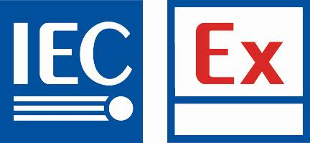

Figure 1 IECEx Conformity Mark
The box under the “Ex” symbol is for the License number which includes the identifier code of the ExCB who has delivered the IECEx Conformity Mark and this clearly indicates the difference with the IECEx logo which does not include such a feature. The IECEx Conformity Mark is valid only when the License number is inserted.
An example of the License number is as follows: XXX 001 where XXX is the ExCB Identifier code and 001 is a sequential number which indicates the number of Licenses issued by the ExCB.
The validity of the Mark and License Code can be verified by visiting the IECEx website at www.iecex.com

Proportional dimensions of the symbol
All reproductions of the IECEx Conformity Mark shall comply with the dimensional and colour proportions as determined by the IECEx Management Committee and specified by the ExCB issuing the IECEx Conformity Mark License.
The Mark shall have a minimum IEC logo text size of 2.5mm in height.
The Identification Code issued by the ExCB shall be placed in the box indicated in Error: Reference source not found; the Identification Code font shall be “Arial” with a minimum character (Text) size of 1mm in height.

Guidance for colours used in the Mark
The colours used in the Mark may be identified as follows:

- For the web, presentations and jpeg images (RGB)

Red: Red 230 Green 48 Blue 39
Blue: Red 0 Green 91 Blue 161
Black: Red 0 Green 0 Blue 0

- For printer, posters and TIFF images (CMYK and Pantone)
Where C, M, Y, and K are the percent values for the cyan, magenta, yellow, and black values of the colour.

Red: C 0 M 91 Y 87 K 0 Pantone 032 CV
Blue: C 100 M 60 Y 0 K 6 Pantone 286 CV
Black C 0 M 0 Y 0 K 106 Pantone Black
Notes:
- Guidance on RGB colours may be found in IEC 61966-2-5 Mulitmedia Systems and equipment-Colour Measurement and management-Part 2-5 Colour management-Optional RGB colour space-opRGB
- The information on colours CMYK comes from a variety of sources.

Available electronic formats
The Mark is available in a verity of different electronic file formats including but not limited to *.eps, *.ps, *.ai, *.jpg, *.dwg, and,*.dxf. These are available from the IECEx Conformity Mark License issuing ExCBs.

Use of the Mark

General
The Mark shall only be placed on such products, or their documentation, packaging and promotional material, which are covered by a valid IECEx Certificate of Conformity (CoC), as listed on the issued IECEx Conformity Mark License Schedule.
The Mark shall remain traceable at all times; the Identification Code shall appear with the IECEx Conformity Mark, wherever it is used.
The Mark shall not be used for any purpose other than to indicate that all the requirements of the Mark Licensing System are being met.
All details of the usage and placement of the Mark must be approved by the ExCB issuing the IECEx Conformity Mark License.

Use – Product marking
- The Mark shall, in principle, be placed on the product itself in close proximity to the IECEx certification marking or on a label directly affixed to the product. If this is not practical, due to size limitations, the Mark may be placed on the product packaging, a label attached to the product, the Instructions for use or other accompanying documentation (refer 5.4.3)
- The Mark may be enlarged or reduced arbitrarily in the same form and ratio, provided that the letters and identification code remain well legible, however, not smaller than 6 x 13 mm and shall be in accordance with 5.2
- The colour of the mark is shown in Figure 1. Use of black or white and an appropriate transparent background colour is permitted provided that it is not less than 100% coverage of the total label marking and upon agreement by the ExCB issuing the IECEx Conformity Mark License. In all cases the Mark shall remain well legible (See Example in Figure 1)
- It is not permissible to modify the colour of the Mark
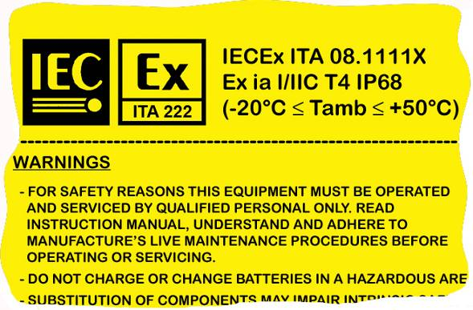
NOTE The pictogram shown above is for illustrative purposes only.
Figure 1 – Example of a contrasting colour being used.

Use – Documentation, Packaging and Promotional Material:
- The Mark may be affixed to the product packaging, or used in Instructions for use or other accompanying documentation only where such products are covered by a valid IECEx Certificate of Conformity (CoC) and listed on the IECEx Conformity Mark License Schedule
- The Mark may only be used in advertising where there is a clear association with the products covered by a valid IECEx CoC and listed on the IECEx Conformity Mark License Schedule
- The Mark may only be used in catalogues and on websites where there is a clear association with the products covered by a valid IECEx CoC and listed on the IECEx Conformity Mark License Schedule
- It is not permissible to use the Mark in catalogues or on websites where a list contains products which are not covered by a valid IECEx CoC and listed on the IECEx Conformity Mark License Schedule
- The Mark may be enlarged or reduced arbitrarily in the same form and ratio, provided that the letters and identification code remain well legible, however, not smaller than 10 × 21.5 mm and shall be in accordance with 5.2
- It is not permissible to modify the colour of the Mark. Use of black and white is permitted

IECEx Conformity Mark License sample
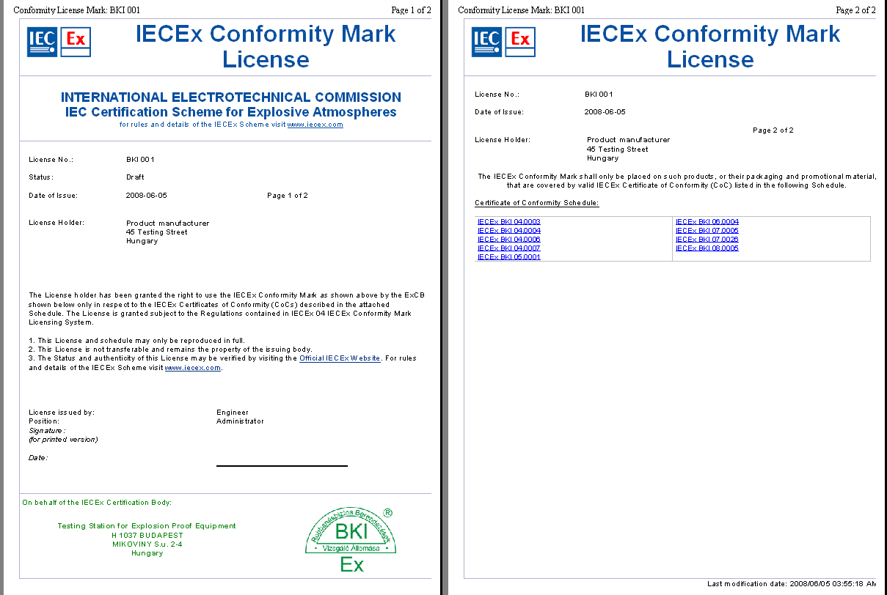
NOTE The pictograms shown above are for illustrative purposes only, the format may change without notice.

IECEx Conformity Mark License & Schedule availability
The IECEx Conformity Mark License is available live on the “Online Certificates” database http://www.iecex.com.
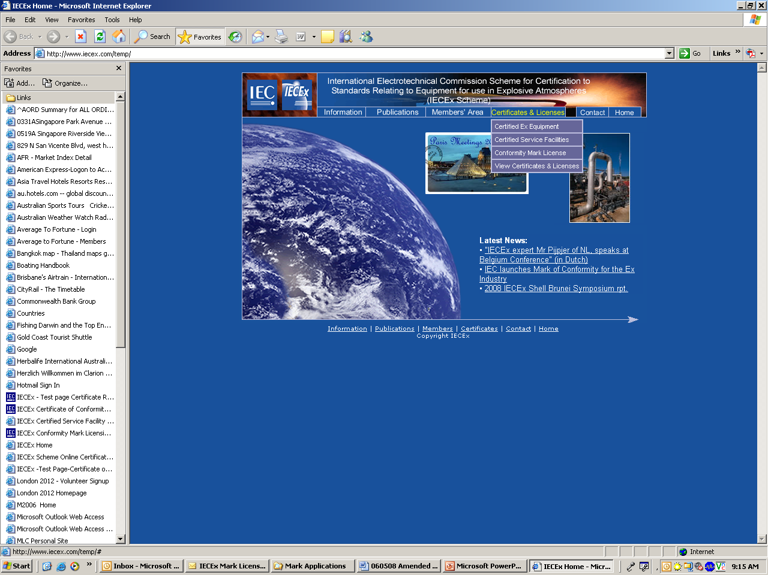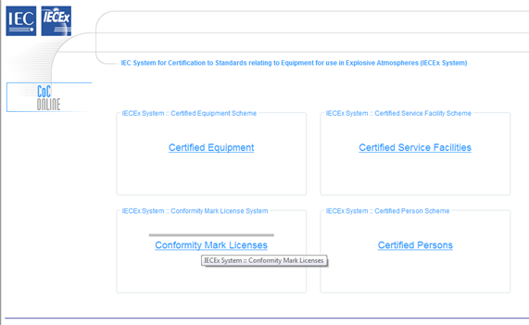

*** End of Draft ***

