INTERNATIONAL ELECTROTECHNICAL COMMISSION SYSTEM FOR CERTIFICATION TO STANDARDS RELATING TO EQUIPMENT FOR USE IN EXPLOSIVE ATMOSPHERES (IECEx SYSTEM)

TITLE: IECEx Assessment Report for the acceptance of LabTest Certification Inc., Canada as an Accepted IECEx Test Laboratory (ExTL) within the IECEx System

Circulation to: Members of the IECEx Management Committee, ExMC

INTRODUCTION

This document contains the IECEx Assessment Report for the acceptance of LabTest Certification Inc., Canada as an Accepted Test Laboratory IECEx (ExTL) within the IECEx System.

This report is hereby submitted for consideration during the ExMC Fortaleza Meeting.

Chris Agius

IECEx Secretariat

Address:  SAI Global Building  286 Sussex Street  Sydney NSW 2000  Australia | Contact Details:  Tel: +61 2 8206 6940  Fax: +61 2 8206 6272  e-mail: chris.agius@iecex.com  http://www.iecex.com

IECEx ASSESSMENT REPORT FOR
LabTest Certification Inc., Richmond, British Columbia, Canada
(IECEx TEST LABORATORY ExTL )

Type of Assessment: (please mark)

Initial assessment for Candidate ExTL X

Re-Assessment of ExTL

Scope Extension of ExTL

- OBJECT AND FIELD OF APPLICATION

  - Country:

Canada

  - Name of Candidate TL

LabTest Certification Inc.

  - Members of the Assessment Team

Heinz Berger – IECEx Officer - IECEx Lead Assessor
Herbert Peters – IECEx Expert Assessor

  - Places and Date of Assessment

3133-20800 Westminster Hwy., Richmond, British Columbia, V6V 2W3, Canada

October 24th – 26th, 2011, September 11th - 12th, 2012 and April 8th - 10th, 2013

  - Assessment References

- IECEx 02 Equipment Scheme Rules (current version)
- IECEx OD 003 Assessment Procedures (current version)
- IECEx OD 005-1, -2 and -3; Manufacturer Assessment (current version)
- IECEx OD 009 Equipment Scheme Procedures(current version)
- IECEx OD 18 Checklist 17025(current version)
- IECEx OD 024 Witness Testing/manufacturer and users Facility
- ISO/IEC 17025:2005
- IECEx Technical Guidance Documents (TGDs)
- ExTAG decision sheets (DSs)
- OD's related to technical issues (if applicable)
- ExTL application documents dated June 19th, 2011
- Application for additional standards dated July 24th, 2012
- Application for additional standards as per Email dated September 10th, 2012
- Application for additional standards (60079-1 and 60079-31) dated February 10th, 2013

  - Scope of Application

Number | Title | Acceptance
60079-0  Edition 5  Edition 6 | Explosive atmospheres -  Part 0: Equipment - General requirements | YES
60079-1  Edition 6 | Explosive atmospheres -  Part 1: Equipment protection by type "d" | YES
60079-2  Edition 4  Edition 5 | Explosive atmospheres -  Part 2: Equipment protection by pressurized enclosures 'p' | YES
60079-6  Edition 2  Edition 3 | Explosive atmospheres -  Part 6: Equipment protection by oil immersion 'o' | YES
60079-11  Edition 6 | Explosive atmospheres -  Part 11: Equipment protection by intrinsic safety 'i' | YES
60079-15  Edition 3  Edition 4 | Explosive atmospheres -  Part 15: Equipment protection by type of protection 'n' | YES
60079-18  Edition 2  Edition 3 | Electrical apparatus for explosive gas atmospheres -  Part 18: Construction, test and marking of type of protection encapsulation 'm' electrical apparatus | YES
60079-31  Edition 1 | Explosive atmospheres -  Part 31: Equipment dust ignition protection by enclosure "t" | YES

  - Candidate TL Persons Interviewed

Name | Position
Ruben Ugarte | Quality Manager / Safety Testing Engineer
Sandeep Bhayana | Safety Testing Manager
Eugen Rapa | Laboratory Technician
Amreen Grewal | Project Handler
George Lapidez | Laboratory Technician

  - Legal Entity of The Candidate TL

LABTEST CERTIFICATION INC. is incorporated under the laws of British Columbia, Canada, under the number 673313 since July 11th, 2003. The document was checked during the assessment and found to meet the requirements of the IECEx.

  - Associated ExCB

The ExTL is integral with the ExCB

  - Financial Support

LABTEST Certification Inc. is self-financed by its income from testing, certification and inspections.

  - History

LabTest was incorporated under the laws of British Columbia, Canada, July 2003. Its principal line of business was product safety testing, soon after the incorporation LabTest was qualified and accepted as testing subcontractor by several international certification bodies. (CSA, UL, TUV Rheinland and SÜD, and DNV)

In February 2007 LabTest was accredited by International Accreditation Service (IAS) for electrical safety, EMC, environmental & energy, and maritime product evaluation and testing to ISO 17025.

In July 2007, LabTest was accredited by the Standards Council of Canada (SCC) for electrical safety certification under ISO Guide 65, in April 2011 LabTest acquired accreditation to 17020 as an Inspection Body.

- ORGANISATION

  - Names, Titles and Experience of the Senior Executives

Name | Title | Experience
Kavinder Dhillon | Certification Manager | 18 years; 21 years Certification and testing, considerable managerial experience operating accredited organization.

  - Name, Title and Experience of the Quality Management Representative

Name | Title | Experience in Ex
Ruben Ugarte | Quality Manager | 3 years Certification and Testing, 7 years Quality ISO 9001
Kavinder Dhillon | Deputy Quality Manager | 18 years; 21 years Certification and testing, considerable managerial experience operating accredited organization.

  - Name and Title of Nominated Principal Contact

Name | Title | Comments
Kavinder Dhillon | Certification Manager | kdhillon@labtestcert.com

  - Employees

Name | Title | Experience in Ex
Sandeep Bhayana | Safety Testing Manager | 5 years
Eugen Rapa | Technician | 5 years.
Ruben Ugarte | Quality Manager | 3 years Certification and Testing, 6 years Quality ISO 9001
Douglas Kirk | Project Handler | 10 years
Amreen Grewal | Project Handler | In Training
George Lapidez | LaboratoryTechnician | In Training

  - Organizational Structure

See attached organization charts in ANNEXES 1a and 1b

- RESOURCES

Seven persons are active in the IECEx field including administration personnel. The test area is approximately 150 m2.

- DOCUMENTATION

  - Quality Manual

There are two quality manuals. One is related to certification and inspection (Guide 65), the other quality manual concerns testing and evaluation (ISO/IEC 17025).

- Document # 2001: Policy Manual Certification and Inspection
- Document # 1003: Policy Manual Laboratory Program Testing and Evaluation

The quality manual, sub-manuals, procedures, forms, etc, are available to all personnel through a web interface (Intranet). The latest version document is available and documents are protected from alteration. Search function is provided by document number or keyword.

Parts of the quality manuals and selected procedures were checked during the assessment and found to meet the requirements of the IECEx.

  - Procedures

Procedures for proper calibration, environment, equipment usage, a.s.o. are found in the quality manual such as:

2027 Critical consumables procedure
1046 Equipment Calibration and Maintenance
1072 Laboratory environmental conditions policy
1003 Laboratory Program Testing and Evaluation Policy Manual
1073 Laboratory Housekeeping Policy
1011 Sample handling and Identification

  - Work Instructions

Work instructions were available for all witness tests and further work instructions were presented during the assessment.

They were checked during the assessment and found to meet the requirements of the IECEx.

  - Records

Test records are retained according to the retention policy (# 1003 quality manual, Laboratory Program Testing and Evaluation Policy Manual, chapter 4.13. "Control of records"). Test records and project information is 100% electronically stored, maintained and accessible by using secured passwords given to authorized persons.

  - Document Change Control

Document control is described in a subdocument carrying the number 1027. The last version (Rev. 3, dated 2011-02-02) was checked during the assessment and found to meet the requirements of the IECEx.

  - Test Records

See clause 4.4.

- TEST REPORTS

  - Test Reports Issued

Number of test reports issued under the IECEx (if any), national or regional schemes in the preceding four years for each type of protection:

Standards | Title | Number of issued certificates
 |  | 2008 | 2009 | 2010 | 2011/  2012/  2013 | Total
60079-0 | Explosive atmospheres -  Part 0: Equipment - General requirements |  |  |  |  | Part 0 included in numbers below
60079-1 | Explosive atmospheres -  Part 1: Equipment protection by type "d" | --- | --- | 1 | 5 | 6
60079-2 | Explosive atmospheres  Part 2: Equipment protection by pressurized enclosures 'p' | --- | --- | --- | 2 | 2
60079-6 | Explosive atmospheres  Part 6: Equipment protection by oil immersion 'o' | 1 | --- | --- | 7 | 8
60079-11 | Explosive atmospheres  Part 11: Equipment protection by intrinsic safety 'i' | --- | --- | 1 | 2 | 3
60079-15 | Explosive atmospheres  Part 15: Equipment protection by type of protection 'n' | 2 | 2 | 1 | 6 | 11
60079-18 | Electrical apparatus for explosive gas atmospheres -  Part 18: Construction, test and marking of type of protection encapsulation 'm' electrical apparatus | --- | --- | --- | --- | 0
60079-31 | Explosive atmospheres  Part 31: Equipment dust ignition protection by enclosure "t" | --- | --- | --- | 2 | 2

- CALIBRATION

Calibrations are done by accredited 17025 Calibration Laboratories identified in the “Approved Suppliers Database” under the Approved Suppliers section. There is a calibration database for verification of calibration and information about recalibration.

Procedures are in place that requires all equipment used in the ExTL to be calibrated before use by 17025 calibration lab including borrowed, rented, repaired and similar situations.

During the assessment, the calibration issues were checked and found to meet the requirements of the IECEx.

- CONFIDENTIALITY

The confidentiality issue is described in # 2001 quality manual in chapter 4.10. Several documents are available such as "1019 Subcontractor Agreement", 1039 Service Agreement, dealing with confidentiality. The content of this clause was checked during the assessment and found to meet the requirements of the IECEx.

Some on the CV's were checked and properly signed confidentiality agreements were found in the employment documentation.

- NATIONAL ACCREDITATION

LabTest Inc. holds an accreditation certificate by International Accreditation Service (IAS), for ISO/IEC 17025. The number of the certificate is TL-367. It covers the scope of standards applied for IECEx operation. The current certificate was revised on March 21th, 2013. See ANNEX 2 for the certificate.

IAS certificate: http://www.iasonline.org/PDF/TL/TL-367.pdf

- RECOGNITION AND AGREEMENTS

There are presently two agreements in the area of Ex. DNV (Norway), Intertek UK.

- INTERNAL AUDIT AND PERIODIC REVIEW

Internal audits are described in the # 2001 quality manual in chapter 4.7. The audit plan for 2013 was presented. The audits will be performed until the end of September 2013.

Management reviews are described in the # 2001 quality manual in chapter 4.7. The last management meeting was held on December 11th, 2012. The minutes were reviewed during the assessment. The next meeting is scheduled for June 2013. It is planned to perform two management meetings per year.

- COMPLAINTS AND APPEALS (Including appeals to IECEx)

Complaints and appeals are described in the # 2001 quality manual in chapter 7. The content of this chapter was checked and found to meet the requirements of the IECEx.

- SPECIAL FACTS TO BE NOTED

  - Supporting Documentation

Copies of additional supporting information for this assessment have been provided to the audited organization and the IECEx Secretariat. These include:

- Details of issues raised and how these have been resolved
- Checklist for ISO/IEC 17025
- Completed technical guidance notes (TGDs)
- Photos of the facilities

  - Tests Witnessed and test procedures discussed

Witnessed tests and discussions included:

Standard: IEC 60079-0 (5ed.) General Requirements
7.1.3 | TI- / RTI-value
26.4.2 | Resistance to impact
26.4.3 | Drop test
26.4.5 | Degree of protection (IP) by enclosures – dust test
26.4.5 | Degree of protection (IP) by enclosures – water test
26.5 | Thermal tests
26.5.3 | Small component ignition test (Group I and Group II)
26.6 | Torque test for bushings
26.8 | Thermal endurance to heat
26.10 | Resistance to light
26.11 | Resistance to chemical agents for Group I electrical equipment
26.12 | Earth continuity
26.13 | Surface resistance test of parts of enclosures of non-metallic materials
26.14 | Charging test
26.15 | Measurement of capacitance
A.3.1 | Tests of clamping of non-armored and braided cables
A.3.2 | Tests of clamping of armored cables

Standard: IEC 60079-1 (6th edition): Equipment protection by type "d"
Chapter 5 |  | Measurement of gaps
 | 15.1.2 |  | Tests of ability of the enclosure to withstand pressure
15.1.3.1 |  | Overpressure test – First method (static)
15.1.3.2 |  | Overpressure test – Second method (dynamic)
15.2 |  | Test for non-transmission of an internal ignition
15.4 |  | Tests of flameproof enclosures with breathing and draining devices
19.3.1.3 |  | Test of erosion by flame
19.3.2 |  | Flammability
B.1.2 + 3 |  | Bubble test
C.3.1 |  | Sealing test
C.3.2 |  | Test of mechanical strength
C.3.3.1 |  | Torque test
C.3.4.3 |  | Over-pressure test

Standard: IEC 60079-2 (5ed) Pressurized enclosures
16.1 | Maximum overpressure test
16.2 | Leakages test
16.3 | Purging test for pressurized enclosures with no internal source of release
16.4.1 | Purging and dilution tests for a pressurized enclosure with an internal source of Release - Purging test
16.4.2 | Purging and dilution tests for a pressurized enclosure with an internal source of Release - Dilution tests
16.5 | Verification of the minimum overpressure
16.6 | Test for an infallible containment system
16.7 | Overpressure test for a containment system with a limited release
16.8 | Verifying ability of the pressurized enclosure to limited internal pressure

Standard: IEC 60079-6 (3rd) oil-immersion “o”
5.1.1 | over pressure test on sealed enclosures
5.1.2 | Reduced pressure test on sealed enclosures
5.1.3 | over pressure test on unsealed enclosures

Standard: IEC 60079-11 (6th) intrinsic safety “i”
10.1 | Spark ignition test
10.2 | Temperature test
10.3 | Dielectric strength test
10.4 | Determination of parameters of loosely specified components
10.5 | Test for cells and batteries
10.6 | Mechanical tests
10.7 | Test for apparatus containing piezoelectrical devices
10.8 | Type tests for safety barriers and safety shunts
10.9 | Cable pull test
10.10 | Transformer test
Standard: IEC 60079-15 (3ed)Type of protection ‘n’
6.7.2 |  | Creepage value (CTI)
33.3.2 |  | Thermal endurance to heat
33.3.3.1 |  | Resistance to impact
33.3.3.2 |  | Drop test
33.3.4.2.1 |  | Degree of protection (IP) by enclosures – dust test
33.3.4.2.2 |  | Degree of protection (IP) by enclosures – water test
33.4 |  | Enclosed break tests
33.5 |  | Sealed devices test
33.6 |  | Assessment and test of energy-limited apparatus and circuits
33.8 |  | Screw lamp holder tests
33.9 |  | Starter holder test (for luminaries)
33.10 |  | Electronic starter tests
33.11 |  | Test for wiring of luminaries subject to high-voltage impulses from igniters
33.12 |  | Mechanical shock test for batteries
33.13 |  | Insulation resistance test for batteries
33.14 |  | Ignition tests for large or high-voltage machines

Standard: IEC 60079-18 Encapsulation “m”
8.1 | Test of compound - water absorption test
8.2.3.3 | Thermal cycling test
8.2.4 | Dielectric strength test
8.2.5 | Cable pull test
8.2.6 | Pressure test
8.2.7.1 | Resettable thermal protective devices with switching contacts
8.2.7.2 | Resettable thermal protective devices without switching contacts
8.2.8 | Sealing test for build-in protective devices

Standard: IEC 60079-31 Protection by enclosure “t”
6.1.1 | Type tests for dust exclusion by enclosures
6.1.2 | Thermal tests
6.1.3 | Pressure test

- COMMENTS (Including issues found during assessment)

During the assessment several non conformances were found in the area of calibration, missing equipment, performance of tests, preparation of tests. All issues were resolved
to the satisfaction of the assessment team.

- RECOMMENDATION

Based on the initial assessment performed from October 24th to 26th, 2011 and September 11th & 12th, 2012, the ExTL of LabTest Inc. is recommended for acceptance in the IECEx scheme as an IECEx Testing Laboratory (ExTL) according to the scope of the standards listed in this document.

Lead Assessor  Heinz Berger | Expert Assessor  Herbert Peters

Dates: October 26th, 2011, September 12th, 2012 and April 10th, 2013

List of Annexes:

Annex 1a: Overall Organization Chart of LabTest Inc.
Annex 1b: Organization Chart of Ex activities
Annex 2: Accreditation Certificate for LabTest Inc. for ISO/IEC 17025

ANNEX 1a: Overall Organization Chart of LabTest Inc. and

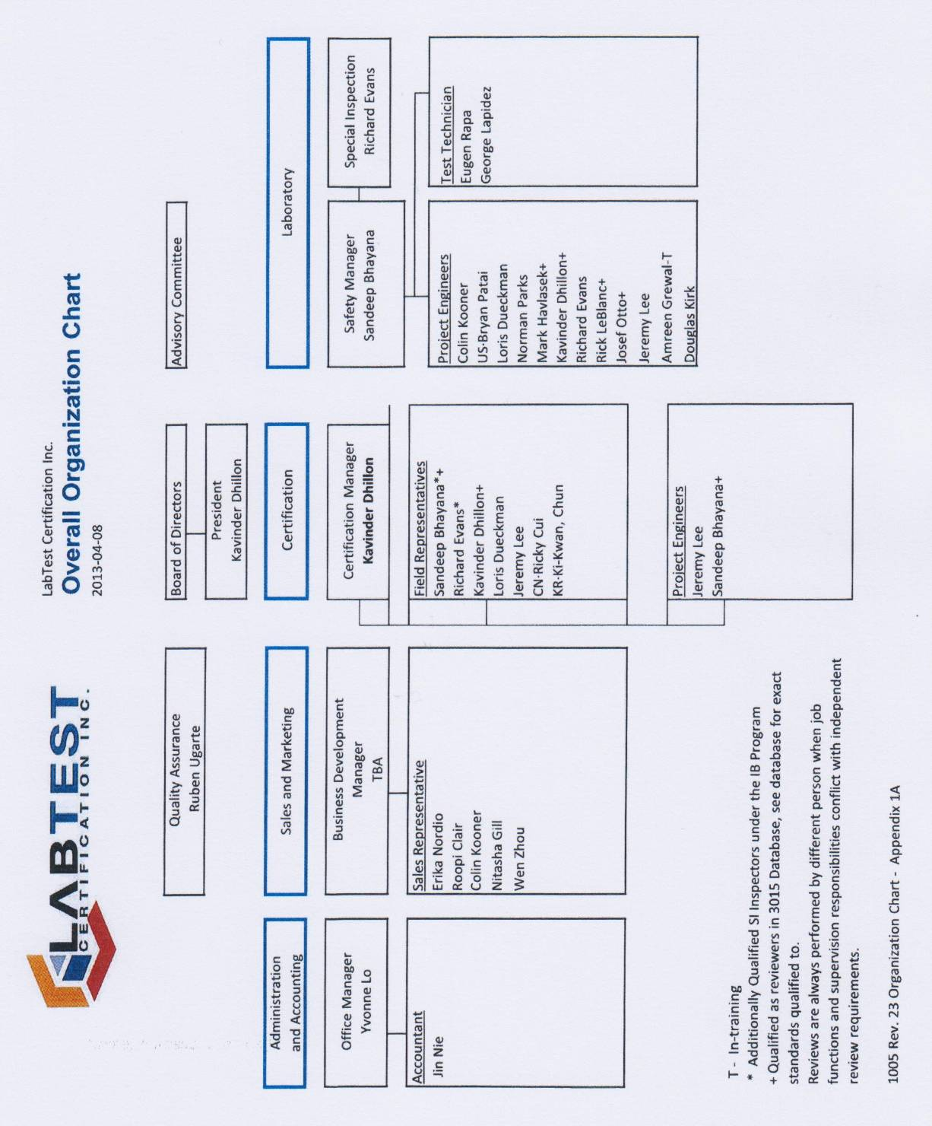

ANNEX 1b: Organization Chart of Ex activities

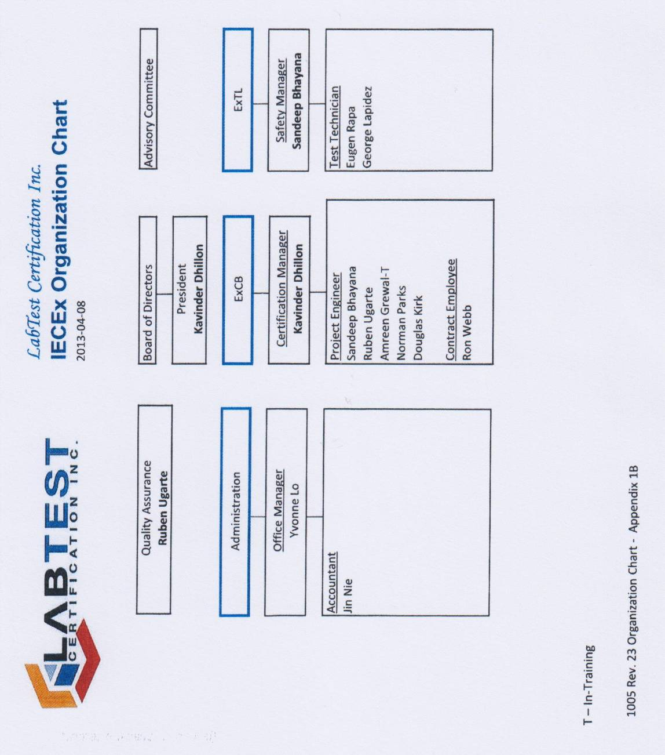

ANNEX 2: Accreditation Certificate for LabTest Inc. for ISO/IEC 17025

