INTERNATIONAL ELECTROTECHNICAL COMMISSION SYSTEM FOR CERTIFICATION TO STANDARDS RELATING TO EQUIPMENT FOR USE IN EXPLOSIVE ATMOSPHERES (IECEx SYSTEM)

TITLE: Re-assessment Report for the continued acceptance of TÜV Rheinland Industrie Service GmbH as an Accepted Certification Body (ExCB)

Circulation to: Members of the IECEx Management Committee, ExMC

INTRODUCTION

In accordance with the 5 year re-assessment plan for the surveillance and monitoring of bodies within the IECEx System, the following document contains the IECEx Re-assessment Report for the continued acceptance of TÜV Rheinland Industrie Service GmbH as an Accepted IECEx Certification Body (ExCB)

This report is hereby submitted for endorsement during the ExMC 2014 the Hague, Netherlands, Meeting.

Chris Agius

IECEx Secretariat

Address:  SAI Global Building  286 Sussex Street  Sydney NSW 2000  Australia | Contact Details:  Tel: +61 2 8206 6940  Fax: +61 2 8206 6272  e-mail: chris.agius@iecex.com  http://www.iecex.com

IECEx ASSESSMENT REPORT
TÜV Rheinland Industry Service GmbH, Germany
IECEx Certification Body (ExCB)

Type of Assessment:

Initial Assessment for Candidate ExCB

Re-Assessment of ExCB X

Scope Extension of ExCB

Surveillance Assessment of ExCB X

- OBJECT AND FIELD OF APPLICATION

  - Country:

Germany

  - Name of Candidate ExCB

TÜV Rheinland Industrie Service GmbH
Am Grauen Stein
51105 Cologne
Germany

  - Members of the Assessment Team

Heinz Berger – IECEx Officer - IECEx Lead Assessor
Qiao LU – IECEx Expert Assessor

  - Place and Date of Assessments

TÜV Rheinland Industrie Service GmbH,
Am Grauen Stein,
51105 Cologne
Germany

October 4th – 6th, 2011 and June 26th - 28th 2013

  - Assessment References

- IECEx 02 Equipment Scheme Rules (current version)
- IECEx OD/003 Assessment Procedures (current version)
- IECEx OD 005-1, -2 and -3; Manufacturer Assessment (current version)
- IECEx OD/009 Equipment Scheme Procedures(current version)
- IECEx OD/007 Checklist Guide 65 (current version)
- IECEx OD 17 Drawings and Documentation(current version)
- IECEx OD 024 Witness Testing/manufacturers and users Facility
- IECEx OD 025 Guidelines Manufacturer Assessments(current version)
- ISO/IEC 80079-34 Application of Quality Systems for Manufacture
- IECEx Document F-001 (QAR Form)
- ISO/IEC Guide 65:1996

  - Scope of Application

Number | Title | Acceptance
60079-0  6th Edition | Explosive atmospheres -  Part 0: Equipment - General requirements | YES
60079-1  6th Edition | Explosive atmospheres -  Part 1: Equipment protection by flameproof enclosures 'd' | YES
60079-2  5th Edition | Explosive atmospheres -  Part 2: Equipment protection by pressurized enclosures 'p' | YES
60079-5  3rd Edition | Explosive atmospheres -  Part 5: Equipment protection by powder filling 'q' | YES
60079-6  3rd Edition | Explosive atmospheres -  Part 6: Equipment protection by oil immersion 'o' | YES
60079-7  4th Edition | Explosive atmospheres -  Part 7: Equipment protection by increased safety 'e' | YES
60079-11  6th Edition | Explosive atmospheres -  Part 11: Equipment protection by intrinsic safety 'i' | YES
60079-15  4th Edition | Explosive atmospheres -  Part 15: Equipment protection by type of protection 'n' | YES
60079-18  3rd Edition | Electrical apparatus for explosive gas atmospheres -  Part 18: Construction, test and marking of type of protection encapsulation 'm' electrical apparatus | YES
60079-25  2nd Edition | Explosive atmospheres -  Part 25: Intrinsically safe systems | YES
60079-26  2nd Edition | Explosive atmospheres -  Part 26: Equipment with equipment protection level (EPL) Ga | YES
60079-27  2nd Edition | Explosive atmospheres -  Part 27: Fieldbus intrinsically safe concept (FISCO) | YES
60079-28  1st Edition | Explosive atmospheres -  Part 28: Protection of equipment and transmission systems using optical radiation | YES
60079-31  1st Edition | Explosive atmospheres -  Part 31: Equipment dust ignition protection by enclosure "t" | YES
61241-0  1st Edition | Electrical apparatus for use in the presence of combustible dust - Part 0: General requirements | YES
61241-1  1st Edition | Electrical apparatus for use in the presence of combustible dust - Part 1: Protection by enclosures 'tD' | YES
61241-4  1st Edition | Electrical apparatus for use in the presence of combustible dust - Part 4: Type of protection 'pD' | YES
61241-11  1st Edition | Electrical apparatus for use in the presence of combustible dust - Part 11: Protection by intrinsic safety 'iD' | YES
61241-18  1st Edition | Electrical apparatus for use in the presence of combustible dust - Part 18: Protection by encapsulation 'mD' | YES

  - Candidate ExCB Persons Interviewed

Name | Position
Klauspeter Graffi | Head of Product Certification
Heinz Farke | Deputy Head of Product Certification

1.8. Legal Entity of the Candidate ExCB

TÜV Rheinland Industrie Service GmbH is registered by the "Handelsregisteramt B des Amtsgerichts Köln" under the number HRB 26876 in positions # 18 and # 37. The document was checked during the assessment and found to meet the requirements of the IECEx.

  - Associated Testing Laboratories

The main laboratory for IECEx testing is located at TÜV Rheinland Industrie Service GmbH, Am Grauen Stein, 51105 Cologne, Germany. The engineering department is located in TÜV Rheinland Industrie Service GmbH, Haumannplatz 4, 45130 Essen, Germany.

  - Associated Certification Functions

TÜV Rheinland Industrie Service GmbH is a NB according to the ATEX directive 94/9/EC. The NB number is CE 0035. Furthermore, the NB is active as a national surveillance body according to directive 1999/92/EC (Ex installation requirements).

  - National Marks and Certificates

No National Marks and Certificates are issued.

  - Financial Support

The income is created with testing, certification and auditing activities.

  - History

1872 Industrialists set up DÜV on their own initiative
to safeguard their production facilities
1904 Automobile inspections and driving tests
1926 First laboratory for testing materials
1969 Product testing and certifications
1970 First subsidiary outside Germany
1970 TÜV Academy trains qualified personnel
1991 System certifications to international standards
2000 Security and quality in local and global data and communication networks
2002 ATEX Notified Body (NB)
2003 Fusion with TÜV Pfalz e. V. to TÜV Rheinland-Berlin Brandenburg Pfalz e. V.
2006 IECEx ExCB and ExTL
Ultimately becoming the TÜV Rheinland Group

  - Standards Accepted

See clause 1.6 of this report.

  - National Differences to IEC Standards

National differences to IEC standards are listed in the latest version of the IECEx Scheme Bulletin.

- ORGANISATION

2.1 Names, Titles and Experience of the Senior Executives

Name | Title | Experience Ex/Overall
Bodo Henk | Dipl. Ing., Head of Business Field  Electrical Engineering and Building Technology
Klauspeter Graffi | Dipl. Ing., Head of Product Certification | 12 years
Andreas Maschke | Dipl. Ing., Head of System Certification | 22 years
Ralf Biegalla | Dipl. Ing., Deputy Head of System Certification | 17 years
Heinz Farke | Dipl. Ing., Deputy Head of Product Certification

2.2 Name, Title and Experience of the Quality Management Representative

Name | Title | Experience
Burkhard Daske | Dipl. Ing. Head of Quality Management | 26 years
Tina Görünmez | Deputy Head of Quality Management | - years
2.3 Name and Title of Nominated Principal Contact

Name | Title | Comments
Heinz Farke | Dipl. Ing., Deputy Head of Product Cert. | heinz.farke@de.tuv.com

  - Name and Title of Signatories for Certification

Name | Title | Comments
Klauspeter Graffi | Dipl. Ing., Head of Product Certification | klauspeter.graffi@de.tuv.com
Heinz Farke | Dipl. Ing., Deputy Head of Product Cert. | heinz.farke@de.tuv.com

  - Other Employees in ExCB activity

Name | Title | Responsibility and Experience in Ex
Peter Grote | Dipl. Ing., QAR Auditor | 12 years
Holger Wegener | Dipl. Ing., QAR Auditor | 12 years
Markus Hubig | Dipl. Ing., QAR Auditor | 4 years
Giorgio Caspani | Dipl. Ing., QAR Auditor | 8 years
Petra Frey | Secretariat
Michael Behrens | Secretariat

  - Organizational Structure

As of June 2013, the organization is changed as stated in the organization charts in ANNEXES 1a, 1b and 1c.

2.7. Administration (including Indemnity Insurance)

2.7.1 Administrative Structure

The certification department is supported by Mrs. Petra Frey and Mr. Michael Behrens in the secretariat.

2.7.2 Terms of Reference of the Governing Board

The Governing Board is described in QM Declaration 32, clause 3. The regulation MS-0002850_de concerning the Governing Board was reviewed during the assessment as well as the minutes of the last meeting. The documents were found to meet the requirements of the IECEx.

2.7.3 Indemnity Insurance

TÜV Rheinland Industrie Service GmbH holds indemnity insurance from GERLING Insurance Company. The policy No. is 30-661542-01046. The insurance is current until 1.1.2014 and be renewed for another year. The certificate was presented during the assessment.

- RESOURCES

Two persons are active in the Certification Body concerning IECEx and additional six persons deal with QARs. Mrs. Petra Frey and Mr. Michael Behrens are supporting the certification team in an administrative basis.

- COMMITTEES / Governing Board / Appeals / Advisory Board

See clause 2.7.2 (Advisory Board).

- CERTIFICATION OPERATIONS

  - National Approval/Certification Methods

TÜV Rheinland Industrie Service GmbH is a Notified Body (NB) according to the ATEX directive 94/9/EC. The NB number is CE 0035. Furthermore, the NB is active as a national surveillance body according to directive 1999/92/EC (Ex installation requirements).

  - Certification Policy

The certification policy is given with Annex 1 of document QMA 3.103.01, revision 6. The document concerns the IECEx and the ATEX certification process. The document was found to meet the requirements of the IECEx.

  - Application for Certification

The certification policy is given with Annex 1 of document QMA 3.103.01, revision 6. The document concerns the IECEx and the ATEX order and certification process. The order process is described in clause 6.1.The document was found to meet the requirements of the IECEx.

  - Certification Decision

The certification policy is given with Annex 1 of document QMA 3.103.01, revision 6. The document concerns the IECEx and the ATEX certification process. Certification decision is described in clause 6.3. The document was found to meet the requirements of the IECEx.

  - Suspension and Cancellation of Certificates

Procedure MS-3098 describes the process of cancellation and suspension of certificates in clause 6.1. The document was found to meet the requirements of the IECEx.

- STATISTICS

  - Certificates Issued
Number of certificates issued under the IECEx, national schemes in the preceding four years for each type of protection:

Standards | Title | Number of issued certificates
 |  | 2009 | 2010 | 2011 | 20122013 | Total
60079-0 | Explosive atmospheres -  Part 0: Equipment - General requirements |  |  |  |  | Part 0 included in numbers below
60079-1 | Explosive atmospheres -  Part 1: Equipment protection by flameproof enclosures 'd' | 13 | 14 | 13 | 79 | 119
60079-2 | Explosive atmospheres -  Part 2: Equipment protection by pressurized enclosures 'p' | 1 | 12 | 10 | 26 | 49
60079-5 | Explosive atmospheres -  Part 5: Equipment protection by powder filling 'q' | 0 | 0 | 0 | 19 | 19
60079-6 | Explosive atmospheres -  Part 6: Equipment protection by oil immersion 'o' | 0 | 0 | 0 | 2 | 2
60079-7 | Explosive atmospheres -  Part 7: Equipment protection by increased safety 'e' | 7 | 14 | 13 | 103 | 137
60079-11 | Explosive atmospheres -  Part 11: Equipment protection by intrinsic safety 'i' | 11 | 9 | 13 | 107 | 140
60079-15 | Explosive atmospheres -  Part 15: Equipment protection by type of protection 'n' | 4 | 5 | 15 | 22 | 46
60079-18 | Electrical apparatus for explosive gas atmospheres -  Part 18: Construction, test and marking of type of protection encapsulation 'm' electrical apparatus | 1 | 2 | 7 | 26 | 36
60079-25 | Explosive atmospheres -  Part 25: Intrinsically safe systems | 0 | 0 | 0 | 0 | 0
60079-26 | Explosive atmospheres -  Part 26: Equipment with equipment protection level (EPL) Ga | 0 | 0 | 1 | 1 | 2
60079-27 | Explosive atmospheres -  Part 27: Fieldbus intrinsically safe concept (FISCO) | 0 | 0 | 0 | 0 | 0
60079-28 | Explosive atmospheres -  Part 28: Protection of equipment and transmission systems using optical radiation | 1 | 0 | 8 | 17 | 26
60079-31 | Explosive atmospheres -  Part 31: Equipment dust ignition protection by enclosure "t" | 0 | 3 | 2 | 41 | 46
61241-0 | Electrical apparatus for use in the presence of combustible dust -  Part 0: General requirements |  |  |  |  | Part 0 included in numbers below
61241-1 | Electrical apparatus for use in the presence of combustible dust -  Part 1: Protection by enclosures 'tD' | 5 | 14 | 17 | 67 | 103
61241-4 | Electrical apparatus for use in the presence of combustible dust -  Part 4: Type of protection 'pD' | 0 | 0 | 0 | 0 | 0
61241-11 | Electrical apparatus for use in the presence of combustible dust -  Part 11: Protection by intrinsic safety 'iD' | 4 | 0 | 10 | 30 | 44
61241-18 | Electrical apparatus for use in the presence of combustible dust -  Part 18: Protection by encapsulation 'mD' | 0 | 0 | 0 | 1 | 1

- DOCUMENTATION

  - Quality Manual

The quality system of TÜV Rheinland consists of the following parts:

- Framework Manual
- Guidelines
- Process Description and Procedures
- Work Instructions
- Templates

All QM documents are available on the database (called blueye) and accessible by all employees. The QM system was checked during the assessment and found to meet the requirements of the IECEx.

  - Procedures

Procedures are described in QMV 3.103, rev. 7. The procedures are available on blueye and cover IECEx requirements.

  - Work Instructions

The work instructions for the ExCB are available on blueye. In case of IECEx document modification(s), work instructions are modified accordingly. A number of the
work instructions were checked during the assessment and found to meet the requirements of the IECEx.

  - Records

Certifications records are stored on network drives under customer folders. This includes a certification checklist and review report. A certification checklist was reviewed during the assessment and found to meet the requirements of the IECEx.

  - Document Change Control

The document and change control is described in TÜV Rheinland Group QM, clause 2.5. The procedure was reviewed during the assessment and found to meet the requirements of the IECEx.

- CONFIDENTIALITY

The confidentiality issue is described in the QM (Framework Manual) of the TÜV Rheinland clause 3.5, QMA Kommunikation and in QM declaration QME 32. All employees sign the confidentiality clause with the employment agreement. Some of the contracts were checked during the assessment and found to meet the requirements of the IECEx.

- PUBLICATIONS

Ex activities are presented in the Internet www.de.tuv.com and with brochures.

- NATIONAL ACCREDITATION

TÜV Rheinland Industrie Service GmbH holds an accreditation certificate from DAkkS for ISO/IEC Guide 65 (EN 45011). The certificate number is D-ZE-11052-03-00. It is valid until May 20th, 2018. The certificate and the schedule was checked during the assessment and found to meet the requirements of the IECEx. See ANNEX 2 for the certificate.

TÜV Rheinland Industrie Service GmbH holds an accreditation certificate from Darks for ISO/IEC 17021. The certificate number is D-ZM-11052-01-00. It is valid until May 20th, 2018. The certificate and the schedule was checked during the assessment and found to meet the requirements of the IECEx. See ANNEX 3 for the certificate.

TÜV Rheinland Industrie Service GmbH holds an ISO 9001 certificate from SGS. It is valid until May 2nd, 2016. See ANNEX 4 for the certificate.

TÜV Rheinland Industrie Service GmbH holds an accreditation for product certification for the ATEX directive 94/9/EC. The certificate was presented during the assessment. The Notified Body number is CE 0035.

- RECOGNITION AND AGREEMENTS

TÜV Rheinland Industrie Service GmbH has agreements with TÜV Rheinland Australia (former ITACS, Australia), NEPSI, China, PCEC China and CQST China for the exchange of IECEx documentation.

- INTERNAL AUDIT AND PERIODIC MANAGEMENT REVIEW

Internal audits and the management review are described in (QMM TRG = Quality Management Manual, clause 7, for TÜV Rheinland Group).

The internal audit plan for 2013 was presented as well as the internal audit report for the certification body for 2012 including accepted corrective actions.

The last management review meeting (concerning 2012) was held on March 8th, 2013. The next meeting will take place in early 2014. The report was presented during the assessment and found to meet the requirements of the IECEx.

- SUBCONTRACTING, USE OF OTHER LABS AND USE OF OTHER LOCATIONS

TÜV Rheinland Industrie Service GmbH operates his own laboratories in TÜV RH facilities in Cologne, Halle and Essen (all in Germany) depending on standards and clauses, with Ex Testing conducted at Cologne. TÜV RH has agreements with subcontractors in Germany for testing (IEC 60079-1, IEC 60079-7, IEC 60079-11, IEC 60079-28). All these activities are mentioned in the "List of subcontractors and contractors". All necessary contracts have been presented and found to meet the requirements of the IECEx.

- TRAINING

A general training plan QMV 2.071 was presented. For the Ex area a special training plan exists. Participation is mandatory for all personnel active in the Ex field.

- ASSESSMENT OF MANUFACTURERS AND ISSUE OF QARS

Assessments are performed according to QMV 3.104. A complete list of assessors involved in QAR activities was provided. The procedure and the performance of QA was checked during the assessment and found to meet the requirements of the IECEx.

The following QARs were reviewed during the assessment:

- DE/TUR/QAR/09.0008/00, Customer in Germany, protection types "d" and "n"
- DE/TUR/QAR/09.0005/00, Customer in Germany, protection types "q", "e", "i", "m", op"is" and "tD"
- DE/TUR/QAR/09.0007/00, Customer in Germany, protection types "d", "e", "i" and "m"
- DE/TUR/QAR/09.0009/00, Customer in Japan, protection types "i" and "tD"
- DE/TUR/QAR/11.0002/00, Customer in USA, protection types "e", "i", "d", "m" and "n"
- DE/TUR/QAR/09.0003/00, Customer in Italy, protection types "d"

- COMPLAINTS AND APPEALS (Including appeals to IECEx)

The complaints procedure is described in procedure QMV 2.004.The appeals are described in clause 2.7.2 (Advisory Board).

- SPECIAL FACTS TO BE NOTED

  - Supporting Documentation

Copies of additional supporting information for this assessment have been provided to the applicant and the IECEx Secretariat. These include:

- Details of issues raised and how these have been resolved
- Competence Matrix
- List of Subcontractors and Contractors
- Checklist for ISO/IEC Guide 65

- COMMENTS (Including issues found during assessment)

During the assessment, the assessment team has visited the company Schorch Elektrische Maschinen und Antriebe AG in Mönchengladbach, Germany, in order to audit the activities of employees of TÜV Rheinland using test equipment of this company.

- RECOMMENDATION

Based on the re-assessment performed from October 4th to 6th, 2011 an a surveillance assessment from June 26th - 28th 2013 , the ExCB of TÜV Rheinland IS GmbH is recommended for continued acceptance in the IECEx Scheme as an IECEx Certification Body (ExCB) according to the scope of the standards listed in this document including the extension of scope.

Lead Assessor  Heinz Berger | Expert Assessor  Qiao LU

Date: June 28th, 2013

List of Annexes:

ANNEX 1a: Overall Organization Chart of TÜV Rheinland Group
ANNEX 1b: Organization Chart of TÜV Rheinland Industrie Service GmbH
ANNEX 1c: Organization chart concerning the activities in the IECEx Scheme
ANNEX 2: ExCB Accreditation Certificate from DAkkS
ANNEX 3: Accreditation Certificate for ISO/IEC 17021 from DAkkS
ANNEX 4: ISO 9001 Certificate from SGS

ANNEX 1a: Overall Organization Chart of TÜV Rheinland Group

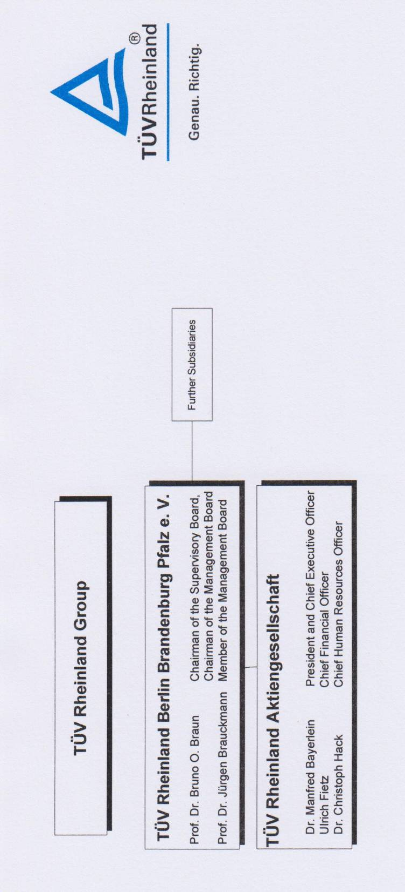

ANNEX 1b: Organization Chart of TÜV Rheinland Industrie Service GmbH

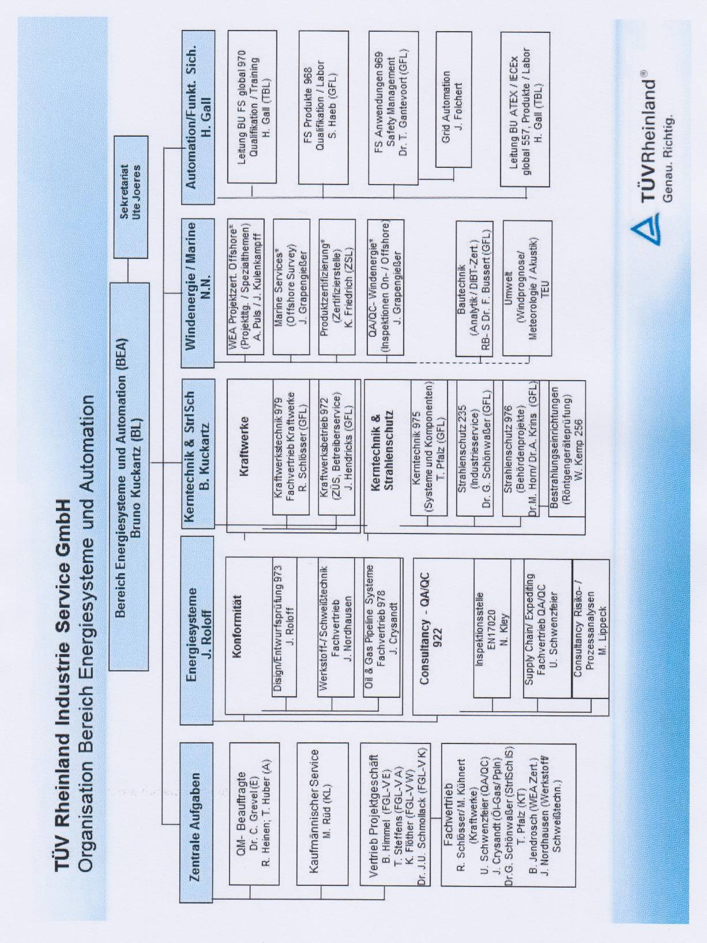

Annex 1c: Organization chart concerning the activities in the IECEx Scheme

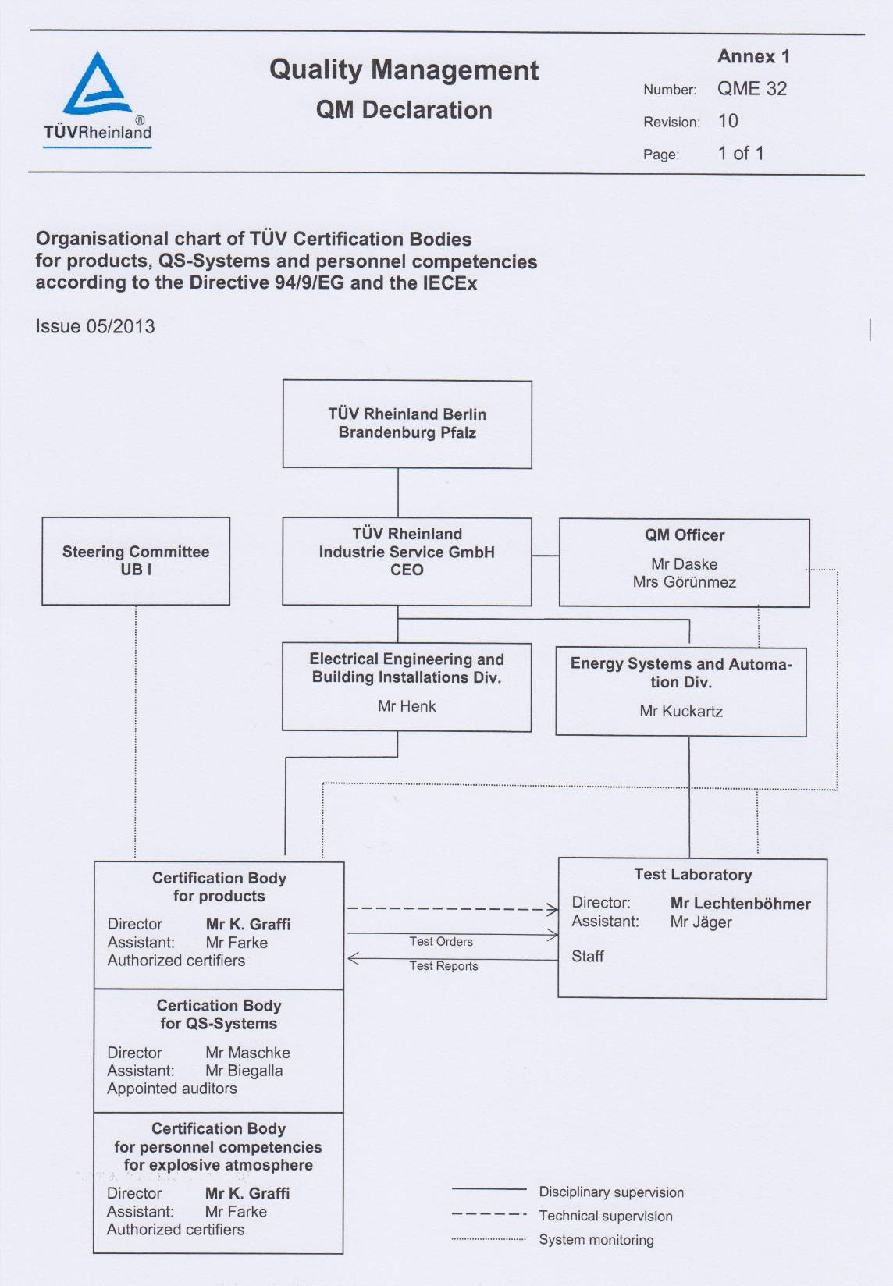

ANNEX 2: ExCB Accreditation Certificate from DAkkS

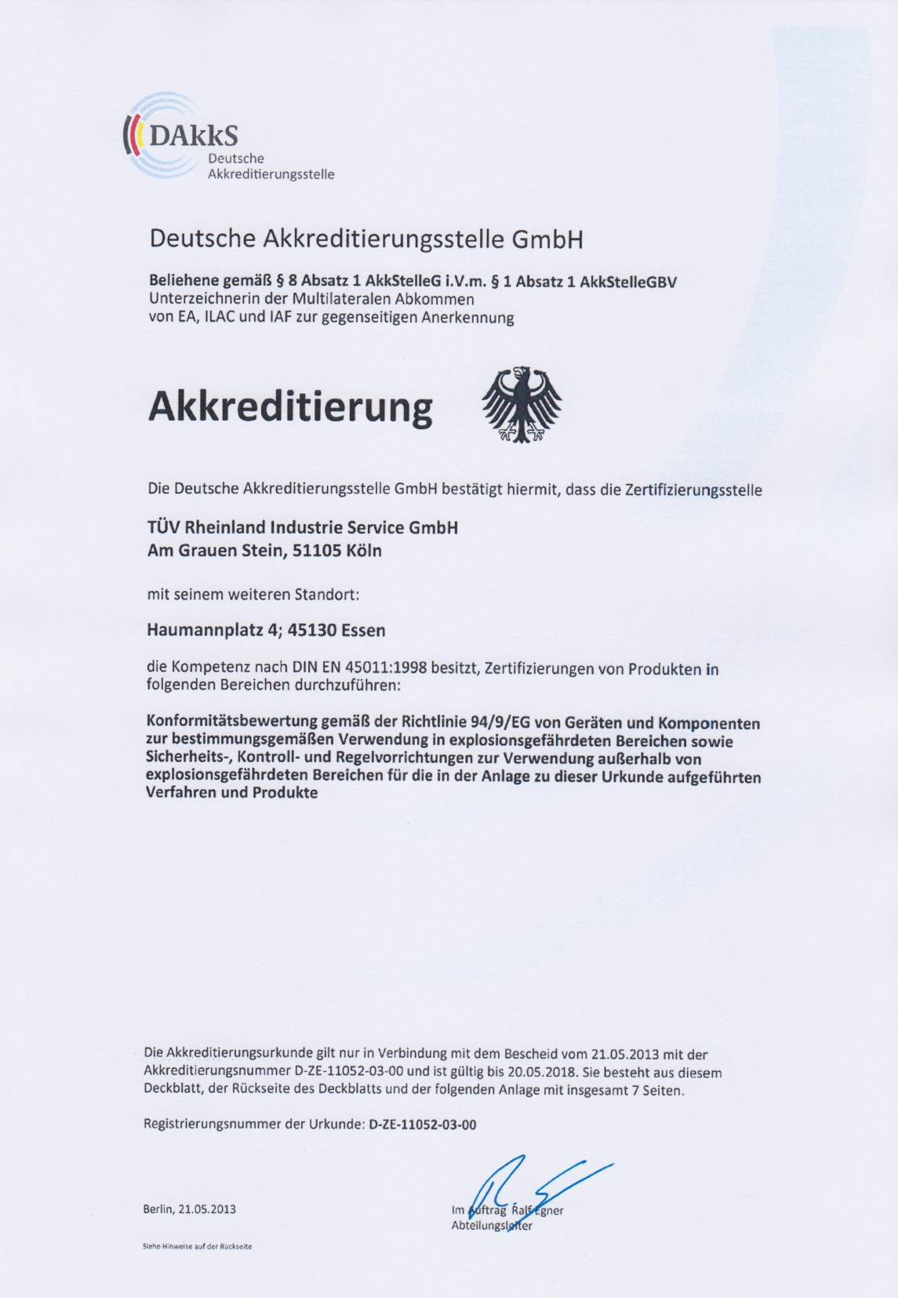

ANNEX 3: Accreditation Certificate for ISO/IEC 17021 from DAkkS

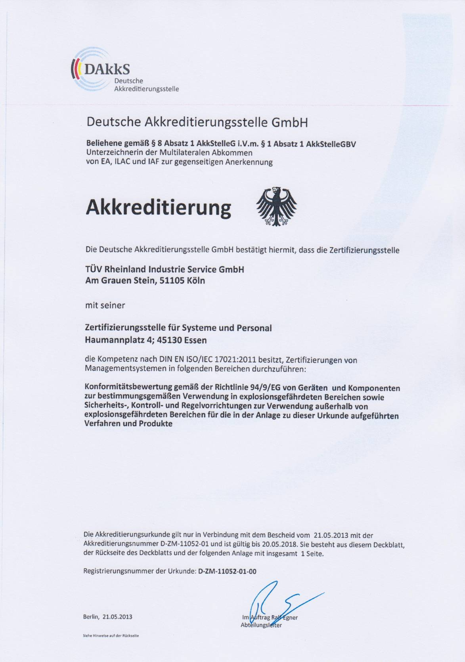
ANNEX 4: ISO 9001 Certificate

