INTERNATIONAL ELECTROTECHNICAL COMMISSION SYSTEM FOR CERTIFICATION TO STANDARDS RELATING TO EQUIPMENT FOR USE IN EXPLOSIVE ATMOSPHERES (IECEx SYSTEM)

TITLE: Re-assessment Report for the continued acceptance of ZELM Explosionsschutz GmbH as an Accepted Ex Certification Body (ExCB) and Accepted Ex Testing Laboratory (ExTL) within the IECEx System

Circulation to: Members of the IECEx Management Committee, ExMC

INTRODUCTION

In accordance with the 5 year re-assessment plan for the surveillance and monitoring of bodies within the IECEx System, the following document contains the IECEx Re-assessment Report for the continued acceptance of ZELM Explosionsschutz GmbH as an Accepted Ex Certification Body (ExCB) and Accepted Ex Testing Laboratory (ExTL) within the IECEx System.

This report is hereby submitted for endorsement during the ExMC 2014 The Hague, Netherlands, Meeting.

Chris Agius

IECEx Secretariat

IECEx Secretariat  Australia Square  Level 33, 264 George Street  Sydney NSW 2000  Australia | Tel: +61 2 4628 4690  Fax: +61 2 4625 3480  Email: chris.agius@iecex.com

IEC System for certification to standards relating to equipment for use in Explosive Atmospheres (IECEx System)

IECEx Assessment Report Form

IECEx Assessment Report Form for use by IECEx Assessment Teams to report Assessments conducted according to the IECEx Assessment Procedures of

- Operational Document IECEx OD 003-2 for the Certified Equipment Scheme
- Operational Document IECEx OD 016 for the Certified Service Facility Scheme
- Operational Document IECEx OD 022 for the IECEx Conformity Mark Licensing System

IECEx ExCB/ExTL assessment report for ZELM Explosionsschutz GmbH

INTERNATIONAL
ELECTROTECHNICAL
COMMISSION

1 Assessment information 4
1.1 Type of Body covered by this assessment: 4
1.2 Type of assessment: 4
1.3 Details of body 4
1.3.1 Country 4
1.3.2 Name of body 4
1.3.3 Name and title of nominated principal contact 4
1.4 Assessment information 4
1.4.1 Members of the assessment team 4
1.4.2 Place(s) of assessment 4
1.4.3 Assessment date(s) 4
1.5 Scopes 4
1.5.1 ExCB scope for equipment certification scheme 4
1.5.2 ExTL scope 6
2 Common information 6
2.1 Legal entity of body 6
2.2 Financial support 6
There is no financial support. ZELM Explosionsschutz GmbH is self-funded from certification, testing and quality assessment activities. 6
2.3 History 6
2.4 Documentation 7
2.4.1 Quality manual 7
2.4.2 Procedures 7
2.4.3 Work instructions 7
2.4.4 Records (including test records where relevant) 7
2.4.5 Document change control 7
2.5 Confidentiality 7
2.6 Publications (Hard cover and Electronic) 7
2.7 Recognition and agreements 7
2.8 Internal audit and periodic management review 8
2.9 Contracting, subcontracting, use of other labs and use of other locations 8
2.10 Training and competence 8
2.11 Complaints and appeals (including appeals to IECEx) 8
2.12 Special facts to be noted 8
2.12.1 Supporting documentation 8
2.13 Recommendations 8
3 ExCB for IECEx Certified Equipment Scheme 10
3.1 Assessment references 10
3.2 Candidate ExCB persons interviewed 10
3.3 Associated ExTL(s) 10
3.4 Associated certification functions 10
3.5 National marks and certificates 10
3.6 Standards accepted 10
3.7 National differences to IEC standards 11
3.8 Organisation 11
3.8.1 Names, titles and experience of the senior executives 11
3.8.2 Name, title and experience of the quality management representative 11
3.8.3 Name and title of signatories for certification 11
3.8.4 Other employees in ExCB activity 11
3.9 Organizational structure 11
3.10 Administration 11
3.10.1 Administrative structure 11
3.10.2 Indemnity insurance 11
3.11 Resources 11
3.12 Committees (such as governing or advisory boards) 12
3.13 Certification operations 12
3.13.1 National approval/certification methods 12
3.13.2 Certification policy 12
3.13.3 Application for certification 12
3.13.4 Certification decision 12
3.13.5 Suspension and cancellation of certificates 12
3.14 Certificates issued 12
3.15 National accreditation 13
3.16 Assessment of manufacturers and issue of QARs 14
4 ExTL for IECEx Certified Equipment Scheme 15
4.1 Assessment references 15
4.2 Candidate ExTL persons interviewed 15
4.3 Associated ExCB(s) 15
4.4 Organisation 15
4.4.1 Names, titles and experience of the senior executives 15
4.4.2 Name, title and experience of the quality management representative 15
4.4.3 Other employees in ExTL activity 15
4.5 Organizational structure 16
4.6 Resources 16
4.7 Test reports issued 16
4.8 National accreditation 17
4.9 Calibration 17
4.10 Comments (including issues found during assessment) 17
5 Annexes 17
Annex A Overall Organisation Chart 18
Annex B Organisation Chart of ExCB and ExTL 19
Annex C Accreditation Certificate for Product Certification 21
Annex D Accreditation Certificate to ISO/IEC 17025 22

Assessment information

Type of Body covered by this assessment:
ExCB for IECEx Certified Equipment Scheme | ✓
ExTL for IECEx Certified Equipment Scheme | ✓
ExCB for IECEx Certified Service Facilities Scheme
ExCB for IECEx Conformity Mark Licensing System

NOTE 1 ExCB - IECEx Certification Body
NOTE 2 ExTL - IECEx Testing Laboratory

Type of assessment: <retain appropriate marks>
Pre-assessment for candidate body
Initial assessment for candidate body
Surveillance
Re-assessment | ✓
Scope extension

Details of body

Country
Germany

Name of body
ZELM Explosionsschutz GmbH

Name and title of nominated principal contact
Name | Title | E-mail address
Thomas Zelm |  | tzelm@zelm.de

Assessment information

Members of the assessment team
Name | Role (modify as necessary)
Heinz Berger | Team Leader
David P. Walker | Expert Assessor

Place(s) of assessment
Siekgraben 56, 38124 Braunschweig, Germany

Assessment date(s)
July 16th to 18th, 2013

  - Scopes

ExCB scope for equipment certification scheme
Number | Title | Acceptance
IEC 60079-0  Edition 4  Edition 5  Edition 6 | Explosive atmospheres - Part 0: Equipment - General requirements | YES
IEC 60079-1  Edition 4  Edition 5  Edition 6 | Explosive atmospheres - Part 1: Equipment protection by flameproof enclosures “d” | YES
IEC 60079-2  Edition 4  Edition 5 | Explosive atmospheres - Part 2: Equipment protection by pressurized enclosure «p» | YES
IEC 60079-5  Edition 2  Edition 3 | Explosive atmospheres - Part 5: Equipment protection by powder filling «q» | YES
IEC 60079-6  Edition 2  Edition 3 | Explosive atmospheres - Part 6: Equipment protection by oil immersion «o» | YES
IEC 60079-7  Edition 3  Edition 4 | Explosive atmospheres - Part 7: Equipment protection by increased safety "e" | YES
IEC 60079-11  Edition 4  Edition 5  Edition 6 | Explosive atmospheres - Part 11: Equipment protection by intrinsic safety “i” | YES
IEC 60079-15  Edition 2  Edition 3  Edition 4 | Explosive atmospheres – Part 15: Equipment protection by type of protection "n" | YES
IEC 60079-18  Edition 1  Edition 2  Edition 3 | Explosive atmospheres – Part 18: Equipment protection by encapsulation “m” | YES
IEC 60079-25  Edition 1  Edition 2 | Explosive atmospheres – Part 25: Intrinsically safe electrical systems | YES
IEC 60079-26  Edition 1  Edition 2 | Explosive atmospheres - Part 26: Equipment with equipment protection level (EPL) Ga | YES
*IEC 60079-27  Edition 1  Edition 2 | Explosive atmospheres – Part 27: Fieldbus intrinsically safe concept (FISCO) | YES
IEC 60079-28  Edition 1 | Explosive atmospheres - Part 28: Protection of equipment and transmission systems using optical radiation | YES  "op is" only
IEC 60079-30-1  Edition 1 | Explosive atmospheres – Part 30-1: Electrical resistance trace heating – General and testing requirements | YES
IEC 60079-31  Edition 1 | Explosive atmospheres – Part 31: Equipment dust ignition protection by enclosure "t" | YES
IEC 60079-35-1  Edition 1 | Explosive atmospheres – Part 35-1: Caplights for use in mines susceptible to firedamp – General requirements – Construction and testing in relation to the risk of explosion | YES
*IEC 61241-0  Edition 1 | Electrical apparatus for use in the presence of combustible dust - Part 0: General requirements | YES
*IEC 61241-1  Edition 1 | Electrical apparatus for use in the presence of combustible dust - Part 1: Protection by enclosure “tD” | YES
IEC 61241-4  Edition 1 | Electrical apparatus for use in the presence of combustible dust - Part 4: Protection by pressurization "pD" | YES
*IEC 61241-11  Edition 1 | Electrical apparatus for use in the presence of combustible dust – Part 11: Protection by intrinsic safety 'iD' | YES
*IEC 61241-18  Edition 1 | Electrical apparatus for use in the presence of combustible dust - Part 18: Protection by encapsulation "mD" | YES
*IEC 62013-1  Edition 1  Edition 2 | Caplights for use in mines susceptible to firedamp - Part 1: General requirements - Construction and testing in relation to the risk of explosion | YES
IEC 62086-1  Edition 1 | Explosive atmospheres - Part 1: Electrical resistance trace heating – General and testing requirements | YES
NOTE 1 Standards shown with an asterisk (*) are superseded standards
NOTE 2 Unless otherwise indicated, earlier editions of standards (even if with a different number) are considered to be covered in the above scope for the purposes of the assessment.
NOTE 3 The above list highlights any extension of scope in the list above for new standards or later editions of standards already in scope.

ExTL scope
The ExTL scope is the same as for the ExCB.
- Common information

Legal entity of body
ZELM Explosionschutz GmbH is a registered company under number HRB 9963 since April 20, 2005. Prior to this date ZELM Ex e.K. was active as a sole proprietorship.

Financial support

There is no financial support. ZELM Explosionsschutz GmbH is self-funded from certification, testing and quality assessment activities.

History
In 1993 the company was founded as a consultancy company to help their customers obtain certification with other bodies.

In the year 1997 it was decided to grow the company and expand to the new site, engaging 6 new employees.

Since the 2nd of December 1998 ZELM has been accredited by the ZLS as a European Notified Body according EN45001 and 45011 with Notified Body number 0820. They produce test reports and issue EC-Type-Certificates of Conformity in every type of protection which are valid throughout Europe. In addition ZELM has accreditation according EN45012 and is able to issue certificates for quality systems based on the EN13980.

Since August 1999 ZELM has had an agreement with Factory Mutual (FM) in the USA. This agreement covers the complete test laboratory and allows them to make tests needed for the North American market. Test reports are exchanged to facilitate the issuing of certificates.

Documentation

Quality manual
The Quality Manual consists of three levels. The general part, the part with procedures and work instructions and forms. The whole QM is complete and accessible by all employees on the intranet. Several parts of the QM were checked during the assessment and found to meet the requirements of the IECEx.

Procedures
There are 23 chapters dealing with procedures. A sample were reviewed and found to meet the requirements of the IECEx.

Work instructions
Staff work instructions for certification are described in the QM under Chapters 22 and 23. Several work instructions were reviewed during the assessment and found to meet the requirements of the IECEx.

Records (including test records where relevant)
All certificates issued by ZELM are shown on the Internet under www.zelm-ex.com. The IECEx Certificates will be shown on the IECEx Web Site CoC page. All other documents are digital data and secured on mainframe server. Hardcopy data have a standardized procedure for storage and disposal.

Document change control
Document change control is described in the QM chapter 5, clause 5.2.4. Document control is handled by the Quality Manager as the sole owner of the change control password. This procedure was checked in detail and found to meet the requirements of the IECEx.

Confidentiality
The confidentiality issue is described in QM chapter 1. A confidentiality declaration is signed by all employees. Furthermore, there is a clause in the work contract covering the confidentiality issue. The declarations of all employees were checked during the assessment and found to be correct and to comply with IECEx requirements.

Publications (Hard cover and Electronic)
ZELM is presenting itself and offering their services on the Internet under the URL http://www.zelm.de

Recognition and agreements
ZELM has a co-operation with Factory Mutual Research Corporation, Norwood, Massachusetts, USA. The scope of the agreement deals with the exchange of test reports concerning ENs and ANSI/ISA. The agreement was signed in August 1999 and was valid until end of June 2013. Negotiations for further operations are underway.
ZELM is accepted laboratory for the U.S. Coast Guard.
ZELM is the associated ExTL for TÜV SÜD Product Service

Internal audit and periodic management review
The process for internal audits is described in QM chapter 17. All chapters of the QM are checked during a one year period. Management reviews are described in the QM in chapter 1, clause 1.8. and are performed one time a year, usually at the first quarter of a year.

Contracting, subcontracting, use of other labs and use of other locations
The assessment team reviewed the ZELM procedures for selection, use and monitoring of Subcontractors and found to meet IECEx requirements, noting the following tests being subcontracted.
- Atlas Material Testing Technology GmbH (Resistance to light)
- Siemens AG (mechanical tests, e.g. vibration)
- PTB (Small component ignition test, optical radiation)
- Harting (Sulphur dioxide, vibration)

Training and competence
Training is described in QM chapter 18. Training is performed by ZELM employees having the relevant competences. A detailed record of training with the signatures of each participant was presented during the assessment. Auditors active in manufacturer assessments visit external seminars. The training plan for 2013 was presented during the assessment and found to meet IECEx requirements.

Complaints and appeals (including appeals to IECEx)
Chapter 4 of quality manual covers both complaints and appeals. There are presently no complaints listed.

Special facts to be noted

Supporting documentation
Copies of additional supporting information for this assessment have been provided to the applicant and the IECEx Secretariat. These are included in a site assessment report and include:
- Details of issues raised and how these have been resolved
- Checklist for ISO/IEC Guide 65
- Checklist for ISO/IEC 17025
- Completed technical guidance notes (TGDs) for (listed in on-site assessment report)
- Photos of the facilities/tests witnessed
- Assessors’ notes

Recommendations
Based on the assessment performed on from July 16th to 18th, 2013, ZELM Explosionsschutz GmbH is recommended for continued acceptance in the IECEx scheme as:
- An ExCB in the IECEx Certified Equipment Scheme
- An ExTL in the IECEx Certified Equipment Scheme
This is according to the scope of the standards listed in this document.
Heinz Berger | David P. Walker
Team Leader | Expert Assessor

Dates: July 16th to 18th, 2013

ExCB for IECEx Certified Equipment Scheme

Assessment references
- IECEx02 IECEx Certified Equipment Scheme covering equipment for use in explosive atmospheres – Rules of Procedure
- OD003-2 Assessment, surveillance assessment and re-assessment of ExCBs and ExTLs operating in the IECEx 02, IECEx Certified Equipment Scheme
- OD005-1 IECEx Quality System Requirements for Manufacturers – Part 1: Guidance on the establishment and maintenance of a quality system
- OD005-2 IECEx Quality System Requirements for Manufacturers – Part 2: Audit Checklist. (This is available in a Word format for use by ExCBs)
- ISO/IEC 80079-34 Edition 1, Explosive atmospheres – Part 34: Application of quality systems for equipment manufacture
- OD009 Issuing of CoCs, ExTRs and QARs
- IECEx Document OD 025 Guidelines on the Management of Assessment and Surveillance programs for the assessment of Manufacturer’s Quality Systems in accordance with the IECEx Scheme
- OD0026 IECEx Certified Equipment Scheme – Guidelines for the qualification of Lead Auditor and Auditors, in accordance with the IECEx System
- ISO/IEC Guide 65:1996, Edition 1, General requirements for bodies operating product certification systems
- IECEx Document OD17 Drawing and documentation guidance
- IECEx Technical Guidance Documents (TGDs)
- ExTAG decision sheets (DSs)
NOTE The latest editions of the above documents were applied

Candidate ExCB persons interviewed
Name | Position
Harald Zelm | Certification Manager
Thomas Zelm | Quality Manager

Associated ExTL(s)
The ExTL is integral with ExCB at the same site.

Associated certification functions
ZELM Explosionsschutz GmbH is a Notified Body according to the ATEX directive 94/9/EC since 1998. The Notified Body # is 0820.

National marks and certificates
There are no national Marks and Certificates issued.

Standards accepted
See clause 1.5.1 of this report

National differences to IEC standards
National differences to IEC standards are those for Germany as well as European Group differences listed in the latest version of the IECEx Scheme Bulletin.

Organisation

Names, titles and experience of the senior executives

Name | Title | Experience
Harald Zelm | Dipl. Ing. | 29 years
Christian Roder | Dipl. Ing. | 5 years
Thomas Zelm | Auditor (TGA/EOQ) | 13 years

Name, title and experience of the quality management representative

Name | Title | Experience
Thomas Zelm | Auditor (TGA/EOQ) | 13 years

Name and title of signatories for certification

Name | Title | Comments
Harald Zelm | Dipl. Ing. | hzelm@zelm.de
Christian Roder | Dipl. Ing. | croder@zelm.de

Other employees in ExCB activity

Name | Title | Responsibility and Experience in Ex
Henning Richter | Dr. | QAR
Waltraud Zelm |  | Certification Administration
Walpurga Kraatz |  | Archive/Records
Silke Zelm-Baum |  | Archive, Accounting
Natalia Scholz

Organizational structure
The organizational structure is shown in Annexes A & B

Administration

Administrative structure
Certification administration is organized in order to handle all documentation and correspondence with view to certification activities. 1 ½ positions are related to this activities.

Indemnity insurance
Insurance contract issued by the „Öffentliche Versicherung Braunschweig“. The number is 49414901/73 and is valid until 1.1.2014.

Resources
A total of eight (8) employees are involved in certification activities which includes administration, certificate release, manufacturer auditing, general handling, customer service, accreditations, trainings, etc.

Committees (such as governing or advisory boards)
A list with the members of the advisory board was presented during the re-assessment as well as the signed confidentiality agreement of all members.

Certification operations

National approval/certification methods
ZELM Explosionsschutz GmbH is a Notified Body according to the ATEX directive 94/9/EC since 1998. The Notified Body # is 0820.

Certification policy
The IECEx certification procedure is described in the quality handbook chapters 22 and 23 which is based on document IECEx OD 009. The detailed certification instruction is described in clause 4 of the QH. Chapters 22 and 23 were checked during the assessment and found to meet the requirements of the IECEx.

Application for certification
ZELM has developed a certification application form also covering IECEx. The form was checked during the assessment and found to meet the requirements of the IECEx.

Certification decision
Certification decisions are described in the procedure of the QM chapter 4, clauses 4. The procedure was checked during the assessment and found to meet the requirements of the IECEx.

Suspension and cancellation of certificates
The withdrawal and cancellation process is described in the QM in chapter 4, clause 5. The procedure was checked during the assessment and found to meet the requirements of the IECEx.

Certificates issued
Number of certificates issued under for the preceding four years for each type of protection. For new applications these should be for national or regional schemes and for currently accepted bodies IECEx certificates should be shown (certificates for other schemes may also be shown):
Standard numbers | Type of protection or other identifying information | Number of issued certificates (for last 4 years)
Gas atmosphere |  | 2009 | 2010 | 2011 | 2012
lEC 60079-0 |  |  |  |  |  | part 0 included in below numbers
lEC 60079-1 |  | 9 | 6 | 5 | 13 | 33
lEC 60079-2 |  | 0 | 0 | 0 | 0 | 0
lEC 60079-5 |  | 0 | 0 | 0 | 0 | 0
lEC 60079-6 |  | 0 | 0 | 0 | 0 | 0
lEC 60079-7 |  | 8 | 3 | 5 | 7 | 23
lEC 60079-11 |  | 63 | 42 | 39 | 41 | 185
lEC 60079-15 |  | 4 | 4 | 5 | 5 | 18
lEC 60079-18 |  | 4 | 2 | 1 | 3 | 10
lEC 60079-25 |  | 0 | 0 | 0 | 0 | 0
lEC 60079-26 |  | 30 | 16 | 17 | 24 | 87
lEC 60079-27 |  | 3 | 3 | 1 | 1 | 8
lEC 60079-28 |  | 3 | 5 | 1 | 2 | 11
IEC 60079-30-1 |  | 0 | 0 | 0 | 1 | 1
IEC 60079-31 |  | 0 | 1 | 5 | 7 | 13
Combustible dust
lEC 61241-0 |  |  |  |  |  | part 0 included in below numbers
lEC 61241-1 |  | 8 | 4 | 1 | 3 | 16
lEC 61241-1-1/  EN 50281-1-1 |  | 0  1 | 0  0 | 0  0 | 0  0 | 0  1
lEC 61241-4 |  | 0 | 0 | 0 | 0 | 0
lEC 61241-11 |  | 36 | 14 | 11 | 9 | 70
lEC 61241-18 |  | 0 | 1 | 1 | 1 | 3
lEC 62086-1 |  | 1 | 0 | 0 | 0 | 1

National accreditation
ZELM holds accreditations for DIN EN 45011 (equivalent to ISO/IEC Guide 65) and DIN EN 45012 (equivalent to ISO/IEC Guide 62) from the German Accreditation Service ZLS and a Notification Certificate from the Federal Ministry of Labour and Social Affairs of Germany for the ATEX Directive 94/9/EG. The Notified Body number is 0820.
The ZLS certificate for the ExCB is valid until 31.12.2013. The re-accreditation assessment is planned for December 2013.

Assessment of manufacturers and issue of QARs
The following QARs were checked during the assessment and found to meet the requirements of the IECEx:
DE/ZLM/QAR09.0003/02 Manufacturer in Germany; protection types "i" and "m"
DE/ZLM/QAR12.0002/00 Manufacturer in Germany; protection type "e"
DE/ZLM/QAR13.0002/00 Manufacturer in Switzerland; protection type "i"
DE/ZLM/QAR09.0002/01 Manufacturer in Germany
DE/ZLM/QAR10.0001/01 Manufacturer in Germany

3.17 Comments (including issues found during assessment)
A number of issues were raised during this re-assessment in the area of subcontracting, calibration and test reports. Subsequently all the issues have been resolved to the satisfaction of the assessment team.

ExTL for IECEx Certified Equipment Scheme

Assessment references
- IECEx02 IECEx Certified Equipment Scheme covering equipment for use in explosive atmospheres – Rules of Procedure
- IECEx OD003-2 Assessment, surveillance assessment and re-assessment of ExCBs and ExTLs operating in the IECEx 02, IECEx Certified Equipment Scheme
- IECEx OD009 Issuing of CoCs, ExTRs and QARs
- ISO/IEC 17025:2005 Edition 2, General requirements for the competence of testing and calibration laboratories
- IECEx Document OD17 Drawing and documentation guidance
- IECEx Technical Guidance Documents (TGDs)
- ExTAG decision sheets (DSs)
NOTE The latest editions of the above documents were applied.

Candidate ExTL persons interviewed
Name | Position
Harald Zelm | Certification Manager
Thomas Zelm | Laboratory Manager and Quality Manager
Christian Roder | Test Engineer
Daniel Lampe | Test Engineer
Stefan Voigtländer | Test Engineer

Associated ExCB(s)
The ExTL is integral with ExCB at the same site.

Organisation

Names, titles and experience of the senior executives

Name | Title | Experience
Thomas Zelm | Auditor (TGA/EOQ) | 13 years
Harald Zelm | Dipl. Ing. | 29 years

Name, title and experience of the quality management representative

Name | Title | Experience
Thomas Zelm | Auditor (TGA/EOQ) | 13 years

Other employees in ExTL activity

Name | Title/responsibility | Experience in Ex
Thomas Zelm | Auditor (TGA/EOQ) | tzelm@zelm.de

4.4.4 Employees

Name | Title | Experience
Christian Roder | Dipl. Ing. | 5 years
Daniel Lampe | Dipl. Ing. | 3 years
Wadim Kapralov | Dipl. Ing. | 1 year
Stefan Voigtländer | Lab Technician | 14 years
Andreas Brief | Lab Technician | 1 year

Organizational structure
The organization charts can be found in Annexes A.

Resources
A total of seven (7) employees are involved in testing activities.

Test reports issued
Number of test reports (ExTRs) issued under for the preceding four years for each type of protection. For new applications these should be for national or regional schemes and for currently accepted bodies IECEx ExTRs should be shown (test reports for other schemes may also be shown):
Standard numbers | Type of protection or other identifying information | Number of issued  Test Reports (for last 4 years)
Gas atmosphere |  | 2009 | 2010 | 2011 | 2012
lEC 60079-0 |  |  |  |  |  | part 0 included in below numbers
lEC 60079-1 |  | 9 | 6 | 5 | 14 | 34
lEC 60079-2 |  | 0 | 0 | 0 | 0 | 0
lEC 60079-5 |  | 0 | 0 | 0 | 0 | 0
lEC 60079-6 |  | 0 | 0 | 0 | 0 | 0
lEC 60079-7 |  | 8 | 3 | 5 | 7 | 23
lEC 60079-11 |  | 64 | 42 | 39 | 41 | 186
lEC 60079-15 |  | 4 | 4 | 5 | 5 | 18
lEC 60079-18 |  | 4 | 2 | 1 | 3 | 10
lEC 60079-25 |  | 0 | 0 | 0 | 0 | 0
lEC 60079-26 |  | 30 | 16 | 17 | 24 | 87
lEC 60079-27 |  | 3 | 3 | 1 | 1 | 8
lEC 60079-28 |  | 3 | 5 | 1 | 2 | 11
IEC 60079-30-1 |  | 0 | 0 | 0 | 1 | 1
IEC 60079-31 |  | 0 | 1 | 5 | 7 | 13
Combustible dust
lEC 61241-0 |  |  |  |  |  | part 0 included in below numbers
lEC 61241-1 |  | 8 | 4 | 1 | 3 | 16
lEC 61241-1-1/  EN 50281-1-1 |  | 0  1 | 0  0 | 0  0 | 0  0 | 0  1
lEC 61241-4 |  | 0 | 0 | 0 | 0 | 0
lEC 61241-11 |  | 36 | 14 | 11 | 9 | 70
lEC 61241-18 |  | 0 | 1 | 1 | 1 | 3
lEC 62086-1 |  | 1 | 0 | 0 | 0 | 1

National accreditation
ZELM holds an accreditation for ISO/IEC17025 from the German Accreditation Service Zentralstelle der Lander fur Sicherheitstechnik, ZLS, (see Annex D) and a Notification Certificate from the Federal Ministry of Labour and Social Affairs of Germany for the ATEX Directive 94/9/EG. The Notified Body number is 0820.
The ZLS certificate for the ExTL is valid until 31.12.2013. The re-accreditation assessment is planned for December 2013.

Calibration
The calibration process is described in QM chapter 11. A list of all test equipment is available on the Intranet. With this tool, the calibration process can be properly controlled. The procedure and the list on the Intranet was checked during the assessment and found to meet the requirements of the IECEx.

Comments (including issues found during assessment)
See ExCB report.

Annexes
- Overall Organisation Chart
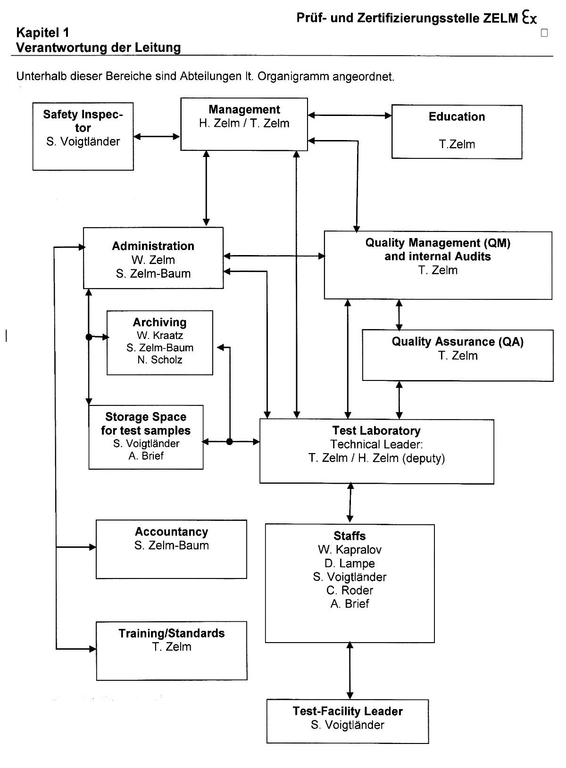
- Organisation Chart of ExCB and ExTL
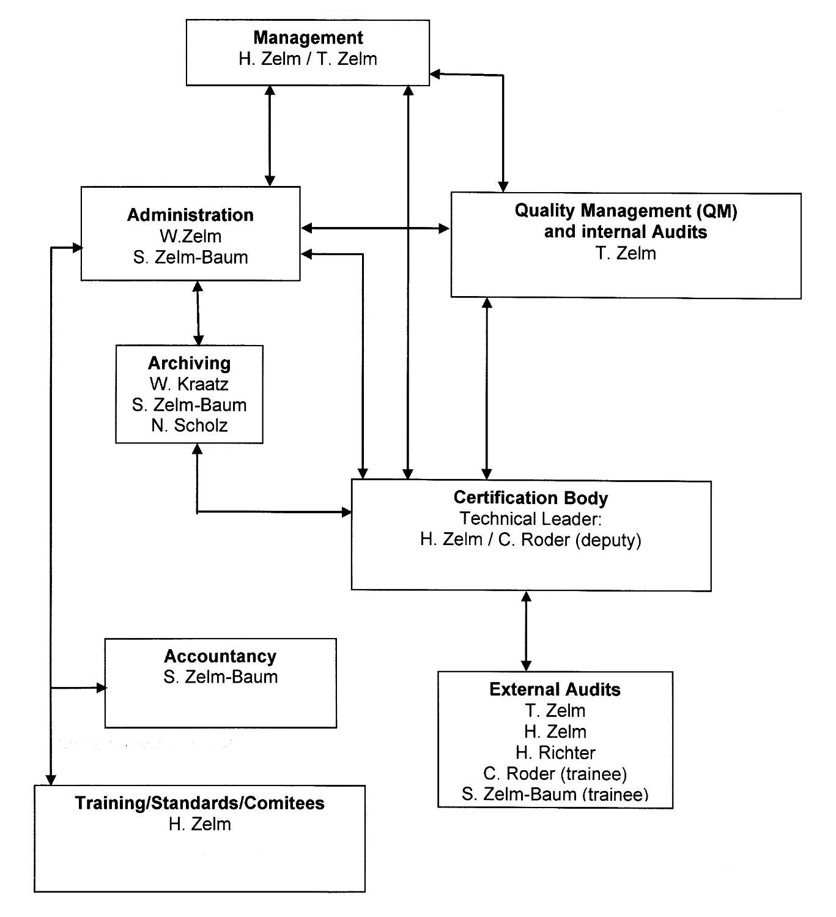
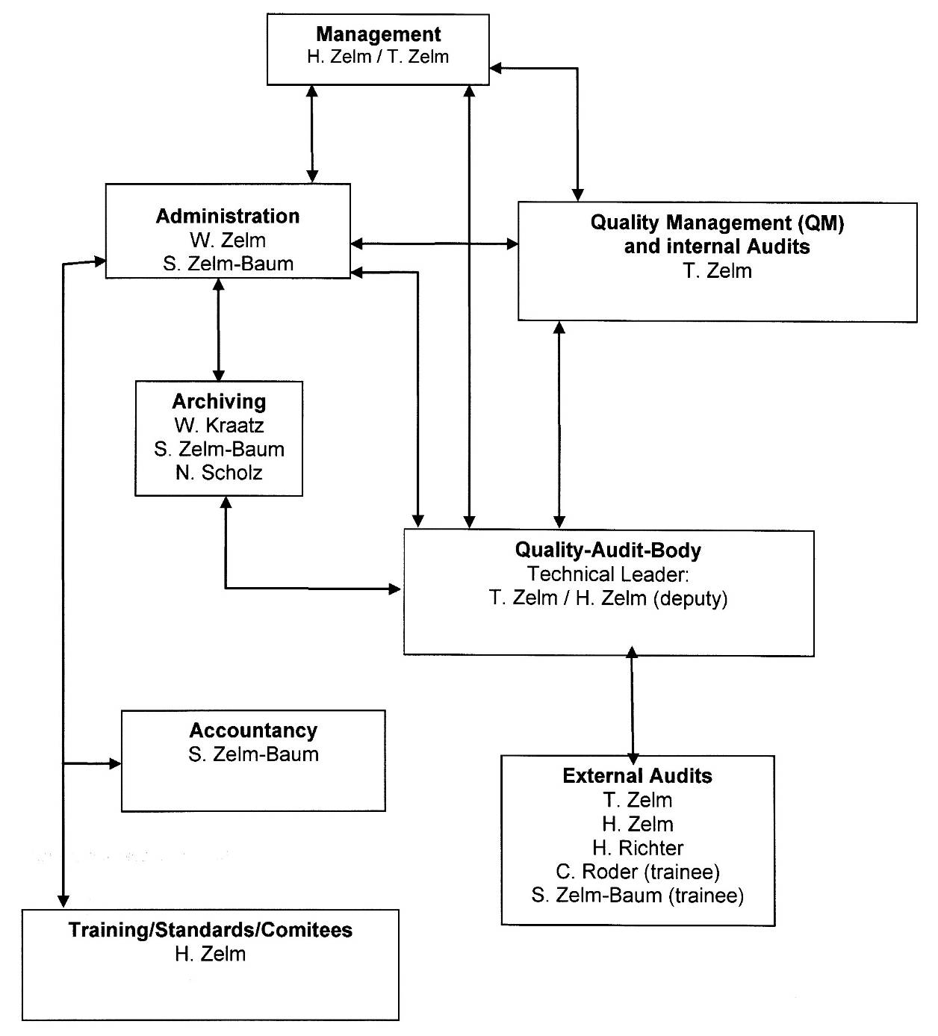
- Accreditation Certificate for Product Certification
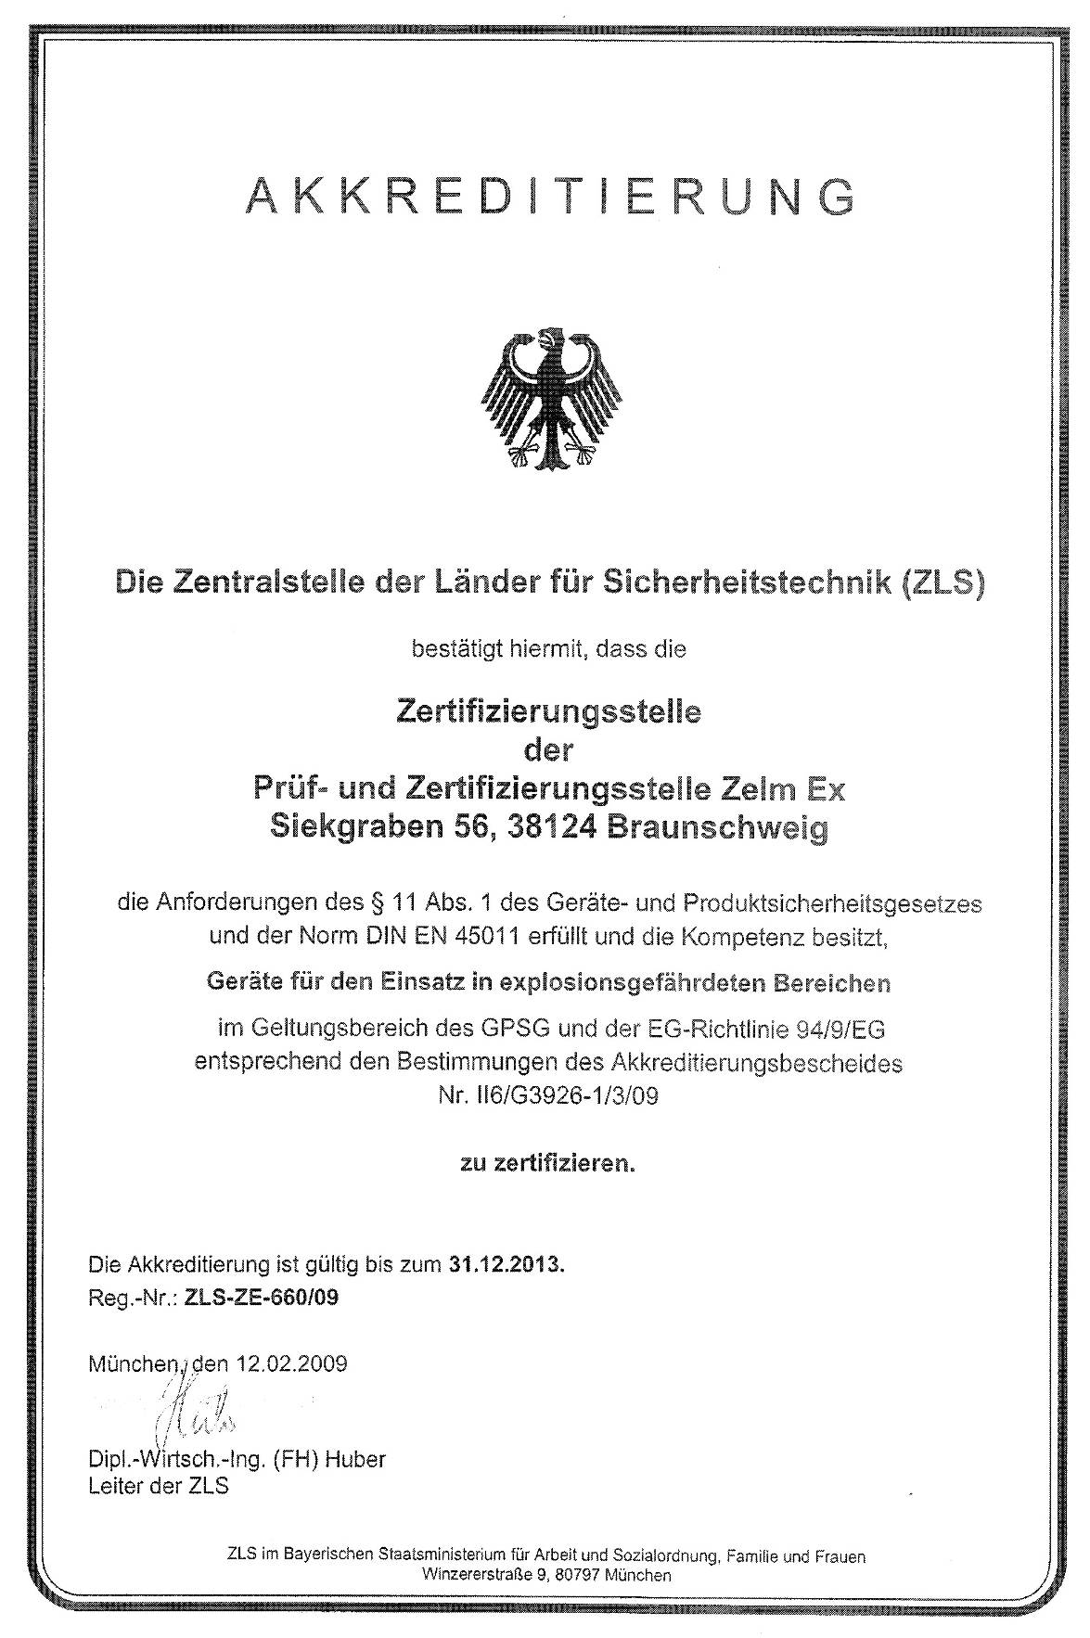
- Accreditation Certificate to ISO/IEC 17025
