 | ExMC/936/CD  July 2014
INTERNATIONAL ELECTROTECHNICAL COMMISSION (IEC) SYSTEM
FOR CERTIFICATION TO STANDARDS RELATING TO EQUIPMENT FOR
USE IN EXPLOSIVE ATMOSPHERES (IECEx SYSTEM)

For Consideration by Members of the IECEx Management Committee, ExMC

Title: Draft new Operational Document “Guidance on the use of the IECEx Certificates of Personnel Competence Scheme’s Assessment Question Bank by IECEx Certification Bodies“

------------------

Introduction

This document, prepared by the IECEx Secretariat and endorsed by ExPCC Working Group 3, is a proposed new Operational Document that is intended to provide guidance on the use and maintenance of the Question Bank provided to accepted IECEx Certification Bodies (ExCBs) participating in IECEx Scheme for Certification of Personnel Competence for Explosive Atmospheres to assist in the preparation for asessment activities associated with the issue of the IECEx Certificates of Personnel Competence.

This document is presented to this meeting of the IECEx ExMC for consideration and approval for publication.

Chris Agius
IECEx Secretary

Visiting address:  IECEx Secretariat  Level 33 Australia Square  264 George Street  Sydney NSW 2000  Australia | Contact Details:  Tel: +61 2 4628 4690  Fax: +61 2 4627 5285  E-mail: info@iecex.com  http://www.iecex.com
IECEx OD 503:2014(E)

IEC System for Certification to Standards relating to Equipment for use
in Explosive Atmospheres (IECEx System)
Atmospheres
IECEx Scheme for Certification of Personnel Competence for Explosive

 | IECEx OD 506
 | Edition 1.0 2014-08

IECEx
OPERATIONAL DOCUMENT

Guidance on the use of the IECEx Certificates of Personnel Competence Scheme’s Assessment Question Bank by ExCBs

 | THIS PUBLICATION IS COPYRIGHT PROTECTED Copyright © 2014 IEC, Geneva, Switzerland
All rights reserved. Unless otherwise specified, no part of this publication may be reproduced or utilized in any form or by any means, electronic or mechanical, including photocopying and microfilm, without permission in writing from either IEC or IEC's member National Committee in the country of the requester.
If you have any questions about IEC copyright or have an enquiry about obtaining additional rights to this publication, please contact the address below or your local IEC member National Committee for further information.
IEC Central Office Tel.: +41 22 919 02 11
3, rue de Varembé Fax: +41 22 919 03 00
CH-1211 Geneva 20 info@iec.ch
Switzerland www.iec.ch
About the IEC
The International Electrotechnical Commission (IEC) is the leading global organization that prepares and publishes International Standards for all electrical, electronic and related technologies.
About IEC publications
The technical content of IEC publications is kept under constant review by the IEC. Please make sure that you have the latest edition, a corrigenda or an amendment might have been published.

Useful links:
IEC publications search - www.iec.ch/searchpub
The advanced search enables you to find IEC publications by a variety of criteria (reference number, text, technical committee,...).
It also gives information on projects, replaced and withdrawn publications.
IEC Just Published - webstore.iec.ch/justpublished
Stay up to date on all new IEC publications. Just Published details all new publications released. Available on-line and also once a month by email.
Electropedia - www.electropedia.org
The world's leading online dictionary of electronic and electrical terms containing more than 30 000 terms and definitions in English and French, with equivalent terms in additional languages. Also known as the International Electrotechnical Vocabulary (IEV) on-line.
Customer Service Centre - webstore.iec.ch/csc
If you wish to give us your feedback on this publication or need further assistance, please contact the Customer Service Centre: csc@iec.ch.

 | IECEx OD 506
 | Edition 1.0 2014-08

IECEx
OPERATIONAL DOCUMENT

IEC System for Certification to Standards relating to Equipment for use in Explosive Atmospheres (IECEx System)
IECEx Scheme for Certification of Personnel Competence for Explosive Atmospheres

Guidance on the use of the IECEx Certificates of Personnel Competence Scheme’s Assessment Question Bank by ExCBs

INTERNATIONAL ELECTROTECHNICAL COMMISSION

INTERNATIONAL ELECTROTECHNICAL COMMISSION
IECEx Operational Document 506
IECEx Scheme for Certification of
Personnel Competence for Explosive Atmospheres

Guidance on the use of the IECEx Certificates of Personnel Competence Scheme’s Assessment Question Bank by IECEx Certification Bodies

This document is supplementary to the IECEx rules, other IECEx operational documents and procedures operated by IECEx Certification Bodies (ExCBs), approved by the IECEx Management Committee to issue IECEx Certificates of Personnel Competence (CoPCs).
The purpose of this Operational Document is to ensure that each ExCB, accepted by the ExMC for the purposes of issuing IECEx CoPCs, assesses certification candidates in a consistent manner.
This Operational Document, OD 506, provides guidance on the use and maintenance of the Question Bank provided to accepted IECEx Certification Bodies (ExCBs) participating in IECEx Scheme for Certification of Personnel Competence for Explosive Atmospheres to assist in the preparation for asessment activities associated with the issue of the IECEx Certificates of Personnel Competence.
This Operational Document is intended to support the implementation of IECEx OD 503 and IECEx OD 504 and should be read in conjunction with the requirements defined in these documents.

Document History

Date | Summary
March 2014 | Original issue (Edition 1.0)

Address:
IECEx Secretariat
Level 33, Australia Square
264 George Street
Sydney NSW 2000 Australia

Contact Details:
Tel: +61 2 4628 4690
Email: info@iecex.com
Web: http://www.iecex.com

Guidance on the use of the IECEx Certificates of Personnel Competence Scheme’s Assessment Question Bank by IECEx Certification Bodies

1 Scope
This operational document provides guidance on the use and maintenance of the Question Bank provided to accepted IECEx Certification Bodies (ExCBs) participating in IECEx Scheme for Certification of Personnel Competence for Explosive Atmospheres to assist in the preparation for asessment activities associated with the issue of the IECEx Certificates of Personnel Competence to personnel involved in activities such as but not limited to:
- of equipment in explosive atmospheres
- overhaul and repair of explosion-protected equipment
- testing electrical installations in or associated with explosive atmospheres
- performing visual and close inspection of electrical installations in or associated with explosive atmospheres
- performing detailed inspection of electrical installations in or associated with explosive atmospheres
- designing electrical installations in or associated with explosive atmospheres
- performing audit inspection of electrical installations in or associated with explosive atmospheres
This Operational Document is intended to support the implementation of IECEx OD 503 and IECEx OD 504 and should be read in conjunction with the requirements defined in these documents.
This Operational Document should also be read in conjunction with the Basic Rules of the IECEx System, as given in Publication IECEx 01 and the Rules of Procedure of the IECEx Scheme for Certification of Personnel Competence for Explosive Atmospheres, as given in Publication IECEx 05.
2 Document Control of the Question Bank

The IECEx Certificates of Personnel Competence Scheme’s Assessment Question Bank is provided to accepted ExCBs for this IECEx Scheme (05) in two separate Microsoft Excel files containing:

- Questions (and acceptable answers) requiring a short written response, and

- Questions, mulitple answer options and the most correct answer option

The questions and answers included in the Question Bank are a combination of those provided by accepted ExCs as a condition of their acceptance into the 05 Scheme – the source of questions and answers are not identified in the Question Bank.

As the contributions of the ExCBs represent a valuable asset of commercial sensitivity it is essential that the security of the Question Bank is maintained - ExCBs are encouraged to establish internal procedures to assure this. These procedures must ensure that only questions and not the associated answers are ever provided to certification candidates and parties other than suitably authorised staff of the ExCB.

Similarly, it is essential that ExCBs using the Question Bank operate consistently with all other ExCBs participating in the Scheme – for this reason ExCBs are encouraged to establish internal procedures for ensuring that (i) only the latest version of the Question Bank is used to develop questions for the assessment of certification candidates and (ii) that as new and existing ExCBs edit or add questions and answers to the Bank the latest version as maintained and circulated by the IECEx Secretariat is implemented and maintained.

New issues of the the Question Bank will be circulated by the IECEx Secretariat as regularly as necessary to reflect additons or changes to content. The method of circulation will be via an email to each participating ExCBs nominated contact person and this email will include a link to a database from which the new issue can be downloaded. The link will be maintained for a maximum of one month.

3 Use of the Question Bank

According to the requirements of IECEx OD 503, Clauses 4.3.1 and 4.3.2 when preparing to assess candidates for certification ExCBs are required to select knowledge examination questions from the IECEx Certification of Personnel Competence Question Bank relevant to the Unit(s) of Competence being assessed.

3.1 Sorting by Competence Unit

When preparing for an assessment for a particular Competence Unit or set of Competence Units only those questions relevant to that unit(s) are relevant – to assist in this the Question Bank Excel files incorporate a Sorting/ Filtering tool that is provided to assist in displaying only the questions relevant to the Unit(s) of interest. Once sorted the ExCB can select at random the number and type of questions required by IEC Operational Document OD503 from the displayed list.

An example of the use of the sort function for Competence Units follows:

- to isolate questions for assessment against Unit Ex 002 you will need to display all the Short Written Response type questions related to Competence Module 2. To do this you must first open the Excel file of SWA Questions – the file name of the master file distributed by the IECEx Secretariat = “CoPC Question Bank – Short Written QA Version x, xxxx”
then expand the Competence Modules box, allowing it to show all module numbers, by clicking the drop down arrow as indicated below:

- then un-tick the ‘Select All’ box

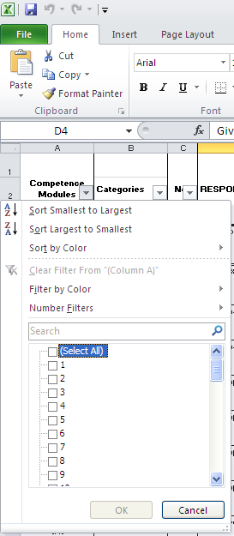

- scroll through the list of module numbers and tick all boxes that include the number “2”

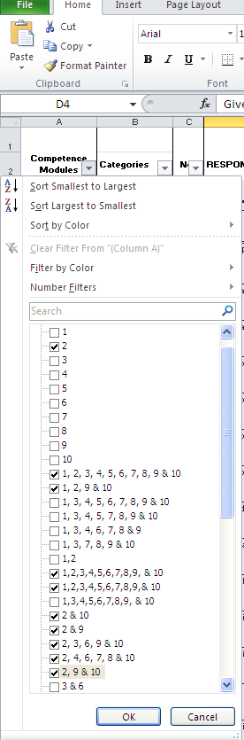

- To finish the filter click ‘OK’ – this step will initiate the display of only the questions that are relevant to the Unit Ex 002

- To cancel the sort tool to enable sorting for other Competence Units, click the ‘Select All’ option, then repeat the process for a different Unit from Step 1.

3.2 Sorting by IECEx OD 504 Clauses and Categories

“Categories” in the Question Bank files relate to the clause number in the IECEx Operational Document OD504.

If you only require questions through a certain ‘category’ a similar method as previously demonstrated for sort/filtering can be used – details of this method follow:

- to isolate questions for assessment against a specific Clause of IECEx OD 504 first open the Excel file of SWA Questions – the file name of the master file distributed by the IECEx Secretariat = “CoPC Question Bank – Short Written QA Version x, xxxx”
then expand the ‘Categories’ drop down tab, allowing it to show all categories.

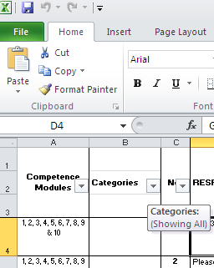
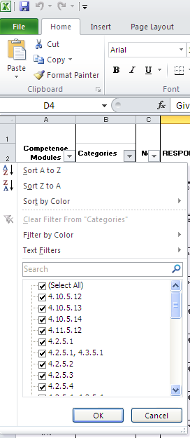

- You must then un-tick the ‘Select All’ option, so there are no boxes selected.

- Scroll through the categories and select the appropriate category.

NOTE: If you wish to use multiple categories, for example, ‘4.2.5.4, or 4.2.5.1’ you must select each box that contains those categories (as shown in the picture below)

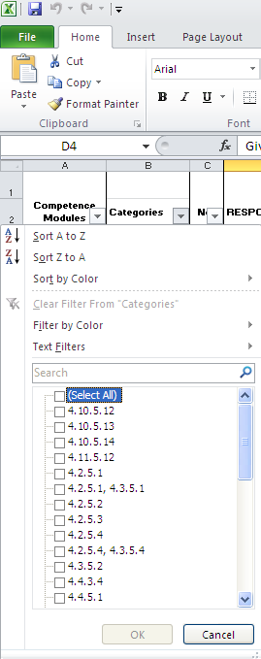
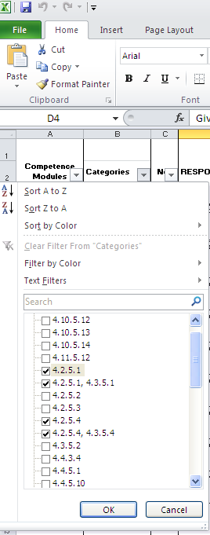

- To finish sorting click ‘OK’ – this step will initiate the display of only the required ‘Categories’

- To cancel the sort tool to enable sorting for other ‘Categories’, click the ‘Select All’ option, then repeat the process for a different Category from Step 1.

INTERNATIONAL ELECTROTECHNICAL COMMISSION
3, rue de Varembé PO Box 131
CH-1211 Geneva 20 Switzerland
Tel: + 41 22 919 02 11 Fax: + 41 22 919 03 00 info@iec.ch
www.iec.ch

