INTERNATIONAL ELECTROTECHNICAL COMMISSION (IEC) SYSTEM FOR CERTIFICATION TO STANDARDS RELATING TO EQUIPMENT FOR USE IN EXPLOSIVE ATMOSPHERES (IECEx SYSTEM)

Circulated to: ExMC

Title: Assessment Report of CNEX-Global of The Netherlands

Introduction

CNEX Global located in the Netherlands submitted an application for consideration as an ExCB operating in the IECEx 02 Certified Equipment Scheme, working with CQST of China as their associated ExTL.

As part of the overall evaluation of the CNEX Global application an On-Site assessment was arranged according to both IECEx 02 Rules and IECEx Operational Document OD 003-2 procedures.

This document provides the formal report of the IECEx Site Assessment Team and is submitted for consideration by ExMC during the 2014 ExMC meeting in The Hague, 28+29 August 2014.

As raised during the ExMC WG1 2104 Dubai meeting (to inform of the IECEx Member Body endorsing the application), I therefore advise that the CNEx Global application to IECEx was endorsed by the IECEx Member Body of the Netherlands.

Members will be requested to consider this report at the ExMC 2014 meeting.

Chris Agius

IECEx Executive Secretary

Address:  Level 33, Australia Square  264 George Street  Sydney NSW 2000  Australia | Contact Details:  Tel: +61 2 46 28 4690  Fax: +61 2 46 27 5285  e-mail: chris.agius@iecex.com  http://www.iecex.com

IECEx ASSESSMENT REPORT FOR CNEX-Global B.V., Arnhem, The Netherlands

ExCB
(IECEx Certification Body)

Type of Assessment:

Pre-Assessment

Initial Assessment for Candidate ExCB X

Re-Assessment of ExCB

Scope Extension of ExCB

- OBJECT AND FIELD OF APPLICATION

  - Country:

The Netherlands

  - Name of Candidate ExCB

CNEX-Global B.V.

  - Members of the Assessment Team

Heinz Berger – IECEx Officer - IECEx Lead Assessor
Herbert Peters, Expert Assessor

  - Places and Dates of Assessment

Utrechtseweg 310, 6812AR, Arnhem, The Netherlands

June 18th – 19th, 2014

  - Assessment References

- IECEx 02 Equipment Scheme Rules (current version)
- IECEx OD/003 Assessment Procedures (current version)
- IECEx OD 005-1, -2 and -3; Manufacturer Assessment (current versions)
- IECEx OD/009 Equipment Scheme Procedures(current version)
- IECEx OD 107 Checklist ISO/IEC 17065 (current version)
- IECEx OD 17 Drawings and Documentation(current version)
- IECEx OD/24 Witness Testing/manufacturers and users Facility
- IECEx OD 025 Guidelines Manufacturer Assessments(current version)
- IEC 80079-34 Explosive atmospheres - Part 34: Application of quality systems for equipment manufacturers
- IECEx Document F-001 (QAR Form)
- ISO/IEC 17065:2012
- ExCB application documents dated May 9th, 2014

  - Scope of Application

Number | Title | Acceptance
60079-0  Edition 6 | Explosive atmospheres -  Part 0: Equipment - General requirements | YES
60079-1  Edition 6 | Explosive atmospheres -  Part 1: Equipment protection by flameproof enclosures 'd' | YES
60079-2  Edition 5 | Explosive atmospheres -  Part 2: Equipment protection by pressurized enclosures 'p' | YES
60079-5  Edition 3 | Explosive atmospheres -  Part 5: Equipment protection by powder filling 'q' | YES
60079-6  Edition 3 | Explosive atmospheres -  Part 6: Equipment protection by oil immersion 'o' | YES
60079-7  Edition 4 | Explosive atmospheres -  Part 7: Equipment protection by increased safety 'e' | YES
60079-11  Edition 6 | Explosive atmospheres -  Part 11: Equipment protection by intrinsic safety 'i' | YES
60079-13  Edition 1 | Explosive atmospheres -  Part 13: Construction and use of rooms or buildings protected by pressurization | YES
60079-15  Edition 4 | Explosive atmospheres –  Part 15: Equipment protection by type of protection "n" | YES
TR 60079-16  Edition 1 | Electrical apparatus for explosive gas atmospheres -  Part 16: Artificial ventilation for the protection of analyzer (s) houses | YES
60079-18  Edition 3 | Explosive atmospheres –  Part 18: Equipment protection by encapsulation "m" | YES
60079-25  Edition 2 | Explosive atmospheres –  Part 25: Intrinsically safe electrical systems | YES
60079-26  Edition 2 | Explosive atmospheres -  Part 26: Equipment with equipment protection level (EPL) Ga | YES
60079-27  Edition 2 | Explosive atmospheres -  Part 27: Fieldbus intrinsically safe concept (FISCO) | YES
60079-30-1  Edition 1 | Explosive atmospheres -  Part 30-1: Electrical resistance trace heating - General and testing requirements | YES
60079-31  Edition 2 | Explosive atmospheres -  Part 31: Equipment dust ignition protection by enclosure "t" | YES
61241-0  Edition 1 | Electrical apparatus for use in the presence of combustible dust -  Part 0: General requirements | YES
61241-1  Edition 1 | Electrical apparatus for use in the presence of combustible dust -  Part 1: Protection by enclosures 'tD' | YES
61241-4  Edition 1 | Electrical apparatus for use in the presence of combustible dust -  Part 4: Type of protection 'pD' | YES
61241-11  Edition 1 | Electrical apparatus for use in the presence of combustible dust -  Part 11: Protection by intrinsic safety 'iD' | YES

NOTE: Unless otherwise indicated, earlier editions of standards (even if with a different number) are considered to be covered in the above scope for the purposes of the assessment.

  - Candidate ExCB Persons Interviewed

Name | Position
Wang Jun | General Manager
Fred Lankamp | Technical &Quality Manager
Alice Kou | Development Manager
Jim Munro | Contractor (Certification Officer)
Diane Verboort | Office Manager

  - Legal Entity of the Candidate ExCB

CNEX-Global is a registered company with the full name CNEX-Global B.V. in The Netherlands and hence is a legal entity that can be held legally responsible for all its certification activities. Its directors are Wang Jun, the General Manager of CNEX-Global, and Fred Lankamp, the Technical and Quality Manager of CNEX-Global. The registration document shows the company as being registered on 19 March 2014. All shares in the CNEX-Global B.V. are owned by Nanyang Explosion Protected Electric Apparatus Research Institute Co. Ltd (CNEx) based in Nanyang, China. CNEx is also the sole owner of CQST, the company being used as the ExTL for CNEX-Global.

The documentation was reviewed during the assessment and found to meet the requirements of the IECEx.

  - Associated Testing Laboratories

CNEX-Global uses CQST which is an IECEx accepted ExTL based in Nanyang, China, as its associated testing laboratory. Some staff and management are common to both bodies with procedures in place to ensure a clear separation between ExCB and ExTL responsibilities for each project undertaken.

There is a signed agreement between CNEX-Global and CQST dated 18 June 2014 which details how the relationship works. The relationship is further clarified in the CNEX-Global procedures.

CNEX-Global will be periodically auditing CQST as its ExTL. An internal audit of CQST, prior to CNEX-Global making application to IECEx, was done on 7 May 2014 by Jim Munro.

  - Associated Certification Functions

The activities of CNEX-Global B.V. are focused on Ex certification at this time and is not involved in any other type of certification.

  - National Marks and Certificates

CNEX-Global works together with CQST under the parent company of CNEx in the certification scheme within China for Ex and accepts IECEx ExTRs for certification.

In addition CNEX-Global is in the process of applying to become a Notified Body in Europe so it can issue ATEX certificates and other related ATEX documents in Europe. CNEX-Global will recognize IECEx ExTRs and QARs for the purpose of issuing 'ATEX' EU Type Examination Certificates and Product Qualification Assurance Notifications.

  - Financial Support

During the start up-stage CNEX-Global is being financially supported by CNEx. Once fully operational, CNEX-Global will become self-supporting based on the income derived from its certification activities.

During the assessment a current financial statement was presented.

  - History

CNEX-Global is a newly established legal entity but through its parent company and senior staff has a long history of involvement in Ex certification. Wang Jun, the General Manager of CNEX-Global is also the Director of CQST and he also has long experience in the Ex field. Jim Munro, Managing Director of Jim Munro International Compliance Pty Ltd, has been working with CNEx/CQST to establish CNEX-Global and will continue to have involvement with its operation once established. He has a long history in the Ex field and has previously been involved in the establishment and operation of TestSafe Australia as an ExCB as its Director.

In 1958 the predecessor of CNEx/CQST was founded in northeast China as Research House of Ex-motor of First Machinery Industrial Department. In 1970, it moved to Nanyang as the Nanyang Explosion Protected Electrical Apparatus Research Institute (CNEx), becoming State owned explosion protection research institute and establishing Ex-Testing Station. In 1977, the first formal China National Standards (GB-1336-77) were drawn up. In 1995, Ex-Testing Station of CNEx was approved as China National Test Center for Explosion Protected Electrical Products (CQST), representing China to carry out science research, testing, certification, quality supervision and other management functions. In 2005 CQST was accepted as an IECEx ExTL and had a successful re-assessment in 2010.

  - Standards Accepted

See clause 1.6 of this report.

  - National Differences to IEC Standards

Please refer to the latest IECEx Bulletin for national differences for The Netherlands.

- ORGANISATION

  - Names, Titles and Experience of the Senior Executives

Name | Title | Experience Ex/Overall
Wang Jun | General Manager | 28 years/28 years
Fred Lankamp | Technical and Quality Manager (Ad interim Deputy General Manager) | 18 years/18 years
Mu Dayu | Auditing Manager (China) | 27 years/ 27 years
Kou Xiaoguang (Alice) | Development Manager | 32 years/ 32 years

  - Name, Title and Experience of the Quality Management Representative

Name | Title | Experience
Fred Lankamp | Technical and Quality Manager | 18 years

  - Name and Title of Nominated Principal Contact

Name | Title | Comments
Fred Lankamp | Technical and Quality Manager | fred.lankamp@cnex-global.com

  - Name and Title of Signatories for Certification

Name | Title | Comments
Wang Jun | General Manager
Fred Lankamp | Technical and Quality Manager
Kou Xiaoguang (Alice) | Development Manager
Jim Munro | Certification Officer | Contractor

  - Other Employees in ExCB activity

Name | Title | Responsibility and Experience in Ex
Diane Verboort | Office Manager | Office management and bookkeeping.
Jim Munro | Certification Officer | Contractor

  - Organizational Structure

See attached organization charts in ANNEXES 1a and 1b

  - Administration (including Indemnity Insurance)

Diane Verboort as the Office Manager has responsibility for the administrative aspects of the operation, including records management and financial systems. IT support is available through CQST or local providers as appropriate.

CNEX Global B.V. holds indemnity insurance from the Netherlands Branch of Allianz Global Corporate & Specialty S.E. as part of the Master Policy on behalf of CNEx /CQST in the P.R. of China. The documents were checked and found to meet the requirements of the IECEx.

- RESOURCES

CNEX-Global currently has three staff members who will be located full-time or part-time in the office in Arnhem. Fred Lankamp will be full-time in the office. Alice Kou is expected to spend about 50% of her time in Europe doing work associated with CNEX-Global with much of her time in the office. Mu Dayu is expected to spend about 50% of his time in CNEX-Global. Diane Verboort will be working in the office part-time as Office Manager. Other staff will be available on an as-needs basis. All the procedures and records of CNEX-Global can be accessed by authorized staff anywhere in the world using the 'cloud' application DropBox.

Authorizations and Responsibilities for ExCB staff and contained in procedure CNEX-QP-410E.

- COMMITTEES / Governing Board / Appeals / Advisory Board

CNEX-Global has established a Certification Committee comprising representatives from CNEX-Global and industry aimed at ensuring impartiality in accordance with ISO/IEC 17065. Details of the role, composition and procedures for the Certification Committee are contained in procedure CNEX-QP-200E. The main focus of the Certification Committee is to address the impartiality requirements of ISO/IEC 17065.

During the assessment the procedure was reviewed and found to meet the requirements of the IECEx.

- CERTIFICATION OPERATIONS

  - National Approval/Certification Methods

In China CNEx issues certification for both below ground (Group I) and above ground Ex equipment. It also operates in conjunction with CQM as an accepted IECEx ExCB for clients seeking IECEx certificates. CNEX-Global will be operating closely with CNEx/CQST to assist manufacturers from outside of China getting Chinese certification.

CNEX-Global will also be issuing 'ATEX' certificates and associated documents once it has been accepted as a notified body in the Netherlands.

  - Certification Policy

The CNEX-Global certification policy is incorporated in its quality policy statement, CNEX-QM-105E which includes reference to the need to work strictly in line with documents such as the IECEx Rules IECEx 02 and ISO/IEC 17065.

The procedure was reviewed during the assessment and found to meet the requirements of the IECEx.

  - Application for Certification

CNEX-Global will be accepting applications for IECEx certificates and related documents using a comprehensive application form (CNEX-FM-100E) located on its website - www.cnex-global.com. The form also includes provision to make application for ATEX services and Chinese certification.

The full certification process is detailed in procedure CNEX-QP-100E_IECEx CoCs ExTRs and QARs which is based IECEx OD009. IECEx Unit verification is covered by procedure CNEX-QP-115E.

The procedures were reviewed during the assessment and found to meet the requirements of the IECEx.

  - Certification Decision

The above procedure makes it clear that the certification decision, as defined by ISO/IEC 17065, is taken when the IECEx certificate is made ‘current’ on the IECEx “On-Line” system via the password protected system using the higher level password.

The members of staff having the authority to make the certification decision are detailed in CNEX-QP-410E Authorizations and Responsibilities for ExCB staff. Those currently authorized are shown in Clause 3.4 of this report.

The procedure was reviewed during the assessment and found to meet the requirements of the IECEx.

  - Suspension and Cancellation of Certificates

All procedures to be following for the 'termination, reduction, suspension or withdrawal' of certification are detailed in Clause 7.11 of the Quality Manual. It notes that any action related to suspension, withdrawal or cancellation of IECEx Certificates, ExTRs and/or QARs will be taken in conjunction with the IECEx Secretariat, noting that only the Secretariat can change the status of a certificate to ‘SUSPENDED’ or ‘CANCELLED’.

- STATISTICS

  - Certificates Issued

CNEX-Global B.V. has not issued any certificates up to date.

The numbers indicated in the table below show the experience of CQST as the ExTL under contract with CNEX-Global. B.V.

Type of protection | Chinese standards and corresponding IEC standards | Quantity
Type of protection | Chinese standards and corresponding IEC standards | 2011 | 2012 | 2013 | 2014 | Total
Ex d | GB3836.2-2010  IEC 60079-1 Explosive atmospheres –  Part1: Equipment protection by flameproof enclosure "d" | 672 | 809 | 765 | 268 | 2514
Ex e | GB3836.3-2010  IEC 60079-7 Explosive atmospheres - Part 7: Equipment protection by increased safety "e" | 105 | 191 | 214 | 83 | 593
Ex i | GB3836.4-2010  IEC 60079-11 Explosive atmospheres - Part 11: Equipment protection by intrinsic safety "i" | 242 | 195 | 231 | 97 | 765
Ex p | GB3836.5-2004  IEC 60079-2 Explosive atmospheres – Part 2:  Equipment protection by pressurized enclosure "p" | 19 | 37 | 13 | 3 | 72
Ex n | GB3836.8-2003  IEC 60079-15 Explosive atmospheres - Part 15: Equipment protection by type of protection "n" | 64 | 87 | 59 | 28 | 238
Ex m | GB3836.9-2006  IEC 60079-18 Explosive atmospheres – Part 18: Equipment protection by encapsulation "m" | 91 | 112 | 127 | 27 | 357
Ex t/tD | GB12476.1-2000  IEC 61241-0 and -1 Electrical Apparatus for Part 0: General Requirements Use in the Presence of Combustible Dust and  Part 1: Protection by enclosures 'tD' | 65 | 127 | 144 | 25 | 361

- DOCUMENTATION

  - Quality Manual

CNEX-Global has a comprehensive Quality Manual (CNEX-QM-100E) documenting compliance with ISO/IEC 17065 Conformity assessment. The quality system consists of 3 levels:

CNEX-QM: High level documents
CNEX-QP: Procedures
CNEX-FM: Forms

High level documents:

- CNEX-QM-000E List of Quality Documents
- CNEX-QM-105E Quality Policy incorporating a certification policy
- CNEX-QM-110E Organization, including organization chart
- CNEX-QM-115E Management commitment statement
- CNEX-QM-120E Documentation structure

  - Procedures

The above manual and documents are supplemented by a suite of comprehensive procedures documenting compliance with all relevant IECEx rules and procedures and other activities of CNEX-Global such as ATEX activities.

All procedures and other quality documents are available in English (identified by a suffix 'E'). Where documents are also required in Chinese the suffix 'C' is used.

All procedures reviewed during the assessment were found to meet the requirements of the IECEx.

  - Work Instructions

CNEX-Global has no work instructions.

  - Records

CNEX-Global has a comprehensive suite of forms with identification in the following form CNEX-FM-xxx. The number may be followed by E, C or EC to indicate the language. Once the completed, these forms become records of the quality system and certification processes of CNEX-Global.

All records are stored in DropBox (Corporate Version), a widely used 'cloud' storage facility. This provides effective and dependable backup and archiving of all records and other documents. In addition, data security and back up procedures provide for additional local backup. All records will be stored in electronic form especially all certification records. Where the need for storage of hard copy documents is identified, there will still be 'mirror' records in electronic form.

Procedure CNEX-QP-103E Retention of Documents details document retention policies, including the retention time for records.

All procedures reviewed during the assessment were found to meet the requirements of the IECEx.

  - Document Change Control

Document change control is addressed in the Quality Manual Clause 8.4 and 8.5 and procedures CNEX-QP-150E Control of records and CNEX-QP-125E Control of documents. Only the electronic version of quality documents is controlled. Any printed copies are considered to be uncontrolled. Quality documents carry a statement regarding this in the footer.

The procedures reviewed during the assessment were found to meet the requirements of the IECEx.

- CONFIDENTIALITY

Confidentiality is addressed in the Quality Manual Clause 6.1.3 and procedure CNEX-QP-120E - Confidentiality and conflict of interest. CNEX-Global requires personnel involved in the certification process to sign a document, CNEX-FM-130, by which they commit themselves to confidentiality and avoiding conflict of interest. This includes staff of CNEX-Global, contracted staff and members of the certification committee.

Confidentiality agreements of all personnel dealing with CNEX-Global B.V. were checked and found to meet the requirements of the IECEx.

- PUBLICATIONS

CNEX-Global does not issue or intend to issue any publications. It will be using its website www.cnex-global.com as the main method of conveying information.

- NATIONAL ACCREDITATION

CNEX-Global is seeking accreditation from the Accreditation Council in the Netherlands (the ‘Raad van de Accreditatie’, RvA) Netherlands to ISO/IEC 17065 and 17021. The application was sent to RvA on June 2nd, 2014.

Note: Once received it will then be seeking recognition as an ATEX Notified Body under the new European Directive 2014/34/EU and the older 94/9/EC.

- RECOGNITION AND AGREEMENTS

CNEX-Global has agreements with CQST (acting as the ExTL) and Jim Munro International Compliance Pty Ltd (Jim Munro acting as Certification Officer).

- INTERNAL AUDIT AND PERIODIC MANAGEMENT REVIEW

Internal audit is addressed in the Quality Manual in Clause 8.6 and procedure CNEX-QP-155E Internal Audits. This is supported by two forms, CNEX-FM-150E Internal Audit Planning and CNEX-FM-151 Internal Audit Checklist. CNEX-Global had its first internal audit during its development phase on 5 May 2014.

Management review is addressed in the Quality Manual in Clause 8.5 and procedure CNEX-QP-160E. It is supported by CNEX-FM-170E Management Review Form which has the dual purpose of providing agendas and documenting meetings. CNEX-Global had its first management review during its development phase on 9 May 2014.

The procedures were reviewed during the assessment and found to meet the requirements of the IECEx.

The internal audit plan for 2014 and 2015 was presented during the assessment as well as the report from the internal audits, dated 5th & 6th May, 2014.

The first management review was held on May 9th, 2014. The report of the meeting was presented during the assessment.

- SUBCONTRACTING, USE OF OTHER LABS AND USE OF OTHER LOCATIONS

CNEX-Global does have agreements for contracting services (QAR assessments and certification activities). If required, CNEX-Global can use procedures laid down in OD 024. Details are described in procedure CNEX-QP-175E.

The procedure was reviewed during the assessment and found to meet the requirements of the IECEx.

- TRAINING

The CNEX-Global approach for training of staff is addressed in CNEX-QP-165E Personnel training and development.

CNEX-QP-110E Qualification of auditors addresses the requirements for qualification of auditors and lead auditors. It is based on IECEx operational document OD026.

A matrix of all staff and their competencies is maintained a copy is included in the site assessment report.

Prior to applying for IECEx acceptance, CNEX-Global carried out training of candidate auditors. Candidate lead assessors have been witnessed doing assessments of manufacturers to IECEx requirements.

- ASSESSMENT OF MANUFACTURERS AND ISSUE OF QARS

CNEX-Global has a very experienced team of auditors. Details of audits they have done in recent years are documented in their personal data in DropBox. The auditors based at CQST have been doing audits for CQM in China and for Nemko in Norway (now Presafe). In addition Fred Lankamp and Jim Munro carried out two witnessed assessments in China to assess two of the candidate lead assessors. The results of the witnessed assessments were documented.

- COMPLAINTS AND APPEALS (Including appeals to IECEx)

Complaints and appeals are addressed in the Quality Manual in Clause 7.3 and in procedure CNEX-QP-135E. They are logged on form CNEX-Global-FM-460E. For formal appeals, the Certification Committee will be responsible for making the decision on the appeal. However, the applicants are made aware of their opportunity to have the complaint heard by the IECEx Board of Appeal (see IECEx02, clause 10.4). This is included in the terms and conditions for each project and addressed in the CNEX-Global procedures.

- SPECIAL FACTS TO BE NOTED

  - Supporting Documentation

Copies of additional supporting information for this assessment have been provided to the applicant and the IECEx Secretariat. These include:

- Details of issues raised and how these have been resolved
- Competence Matrix
- List of Contractors
- Checklist for ISO/IEC Guide 17065
- TCD document

- COMMENTS (Including issues found during assessment)

Beside the staff members of CNEX-Global, the Director/General Manager of CNEx, Mr. WANG Jun and Mr. Jim Munro (contracted Certification Officer) were present during the whole assessment.
During the assessment it was found, that issues concerning the Certification Committee and the indemnity insurance needed to be resolved. All these issues were resolved within the time agreed.

- RECOMMENDATION

Based on the initial assessment performed on June 18th & 19th, 2014, the ExCB of CNEX Global B.V. is recommended for acceptance in the IECEx Scheme as an IECEx Certification Body (ExCB) according to the scope of standards listed in this document.

Heinz Berger Herbert Peters
Lead Assessor Expert Assessor

Dates: June 19th, 2014

List of Annexes:

ANNEX 1a: Overall Organization Chart of CNEx-CQST-CNEX-Global B.V.
ANNEX 1b: Organization Chart of Ex activities (ExCB)

ANNEX 1a: Overall Organization Chart of CNEx-CQST-CNEX-Global B.V.

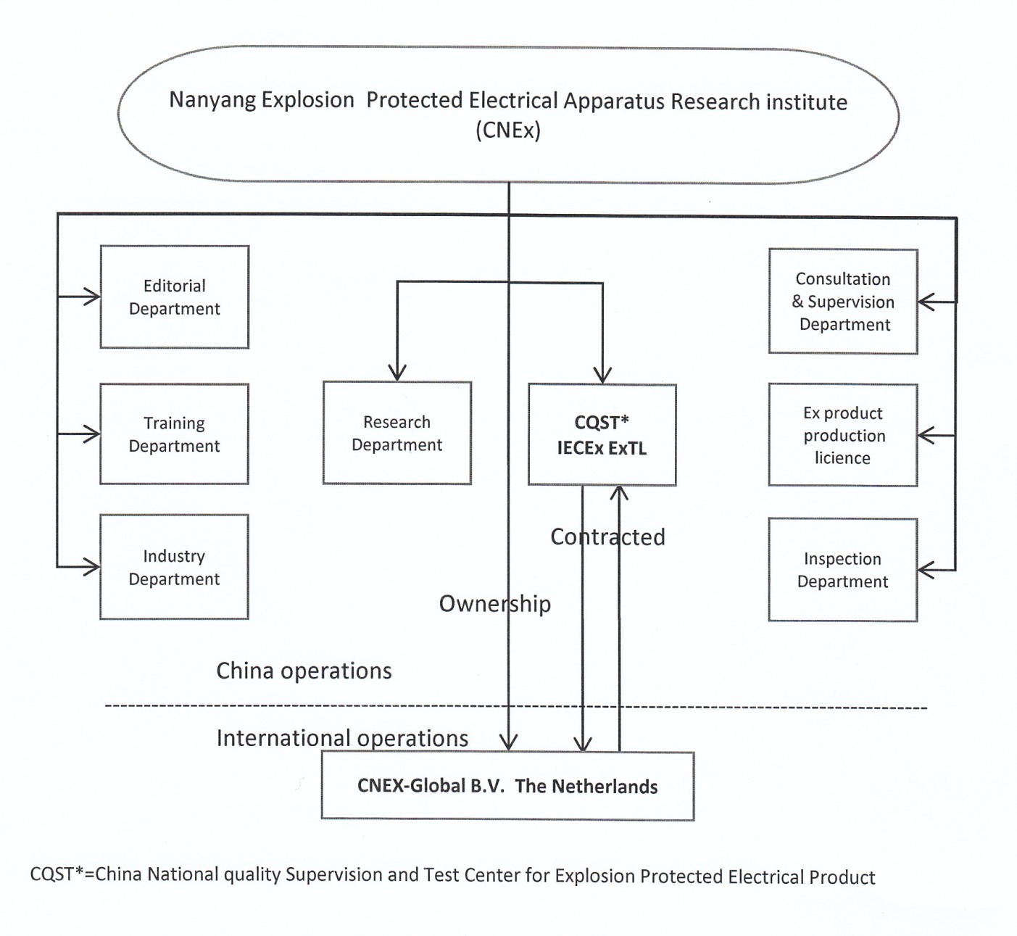

ANNEX 1b: Organization Chart of Ex activities (ExCB)

